NEA – Coffee Shop Order App

Table of Contents

[Analysis 4](#_Toc497683634)

[Description of Problem 4](#_Toc497683635)

[Current and Proposed System 4](#_Toc497683636)

[Client, Users and Needs 4](#_Toc497683637)

[Potential Solutions 5](#_Toc497683638)

[System Limitations 5](#_Toc497683639)

[Data Source and Destination 6](#_Toc497683640)

[Volume of Data 7](#_Toc497683641)

[Data Dictionary 7](#_Toc497683642)

[Data Flow Diagrams 8](#_Toc497683643)

[Objectives 18](#_Toc497683644)

[Scoping 22](#_Toc497683645)

[Appendix 23](#_Toc497683646)

[Documented Design 24](#_Toc497683647)

[Overview 24](#_Toc497683648)

[Description of Modular Structure of System 24](#_Toc497683649)

[UI Diagrams 28](#_Toc497683650)

[Data Entry Selections 50](#_Toc497683651)

[Font Selections 51](#_Toc497683652)

[Data Validation 52](#_Toc497683653)

[Data Structure 53](#_Toc497683654)

[Security Measures 53](#_Toc497683655)

[Pseudo Code 54](#_Toc497683656)

[User Interface Designs 55](#_Toc497683657)

[Database Structure 55](#_Toc497683658)

[Test Plan 61](#_Toc497683659)

[Table of Contents 78](#_Toc497683660)

[Order App vW Resources 78](#_Toc497683661)

[Order App vW Gradle Scripts 81](#_Toc497683662)

[Order App vW Layout 82](#_Toc497683663)

[Order App vW Code 96](#_Toc497683664)

[Order App vC Resources 128](#_Toc497683665)

[Order App vC Gradle Scripts 131](#_Toc497683666)

[Order App vC Layout 132](#_Toc497683667)

[Order App vC Code 149](#_Toc497683668)

[Testing 192](#_Toc497683669)

[Test Plan 192](#_Toc497683670)

[Test Results 207](#_Toc497683671)

[Evaluation 234](#_Toc497683672)

[Functional Objectives 234](#_Toc497683673)

[HCI Objectives 241](#_Toc497683674)

[Data Storage & Security Objectives 242](#_Toc497683675)

[Environmental Objectives 243](#_Toc497683676)

[Feedback 244](#_Toc497683677)

[Analysis of Feeback 244](#_Toc497683678)

[Possible Improvements of System 245](#_Toc497683679)

# Analysis

## Description of Problem

In the districts of Ghubrah, in Muscat, Oman, there lies a coffee shop that I frequently go to. The coffee shop cooks meals from south-east asian countries. Frequently in the evening, the coffee shop gets a lot of calls asking for a home delivery order. The worker would note down the order and delivery address on a piece of paper that would later be thrown away after completion.

My project is inspred from this little situation. What if some of the customer calls didn’t get through because the line was busy? I seek to build a system to improve the current state of the customer to coffee shop interaction.

## Current and Proposed System

At the moment, the coffee shop simply receives a phone call from a customer and notes down the order and address details on a piece of paper. After the delivery of the food is complete, the piece of paper containing the details would simply be thrown away. This makes the process repititive and highly redundant. If a frequent customer were to order from the coffee shop once a day, they would have to repeatedly state their address each day.

I believe creating a phone application can solve this problem. Having a phone application will allow two customers to order at the same time, instead of one connecting to the line and the other getting a “the line is busy at the moment” on the phone call. Customers can create accounts on the app that will have data of their address so that when they make an order the coffee shop will already know where to deliver the food to. As features, customers can also view what they had ordered in the past in case they would like to see what the tasty thing they ordered back then was.

Customers can also take a pamphlet that contains the menu of the coffee shop when they want to order for home delivery via mobile phone. However, if there is a new item, they will not know. Therefore, the coffee shop workers should be able to update their menu on the app so that the latest version will always be there for the customers.

## Client, Users and Needs

Client – Coffee Shop owner

Users – Workers of the coffee shop, Customers of the coffee shop

The primary user of this sytem will be the customers. By using this system, they will make the life of the coffee shop workers easier. They make orders for the workers to view on the app, the workers can receive multiple orders at once, compared to the old system where they can only receive one order per time. They also have accounts, and order history is stored. This helps, as if they have ordered at least 15 times on that account, they will get a discount, and this will automatically calculate the new prices.

Another primary user of this system will be the workers. Their main use is simply to view the customer’s orders. However, they can also update their menu items on the app, so that the customers will get the newest version of the menu straight away. They can also send notifications to the customers to give them a status on their order. Other than that, they can also delete user accounts in case the storage space is getting full.

## Potential Solutions

1. Develop Current System
   1. Have multiple phones to contact
   2. Install an answering call (like they have in KFC or Papa Johns)
   3. Store phone number and address in an address book. This however will become overflowed if a lot of unique customers make an order, and flipping through the pages to find the address will be annoying. Even if it is sorted in chronological order, it will be a lot of pages to flip through.
2. Website
   1. Everyone can access a website from their home
   2. The coffee shop would require to have a computer in their shop to check orders and editing menu
   3. Not a lot of open space in the shop
3. Phone Application
   1. If this was created, only customers with the same operating system can use it. E.g. if an Android app is made, Apple or Windows users cannot use it.
   2. Practical – Customers can order on their way home from work, for example.
   3. If home WiFi is down, customers can use 3G
   4. Doesn’t take up shop space

The best solution I believe would be option 3. I have decided to make an Android app, as the workers of the coffee shop have an Android phone.

## System Limitations

* Only customers that have an Android phone may use the app. People with other OS such as Apple or Windows cannot.
* Customers can only order for home delivery if they have access to the internet, meaning customers without wifi or 3/4G cannot.
* If the number of customers exceeds 5GB (which is highly unlikely as it is just storing text), the coffee shop would have to start paying monthly for the online database
* The coffee shop would need internet for the workers’ phone during work hours so that they can receive orders, this may get costly.

## Data Source and Destination

|  |  |  |  |  |
| --- | --- | --- | --- | --- |
| Source (Input) | Process | User | Output | Destination |
| New Menu item | User enters details of item | Workers | New menu item | Screen output, new database record |
| Edit Menu items | User updates (change or delete) details of items | Workers | Updated menu items | Screen output, updated database record |
| Send Notification | User selects/types message, user presses button | Workers |  | Screen output on for customer |
| View Customer Details | User presses button | Workers |  | Screen output |
| Delete Account | User selects account to delete, Confirmation,  Typing in master password | Workers |  | Updated database record,  Screen output |
|  |  |  |  |  |
| New Account | User enters account details | Customers | New account | Screen output, new database record, access to |
| Edit Account | User changes account details | Customers | Updated account | Screen output, updated database record |
| Make Order | User chooses items from menu | Customers | New order for worker to view | Screen output, updated database record |
| View History | User presses button | Customers | - | Screen output |

## Volume of Data

The volume of data in the system isn’t really that large. Most of the data in the system will be simple text.

Both the Input and Output volume is the same. Texts including user’s details and menu items and price is what will be downloaded and uploaded to and from the database.

## Data Dictionary

Menu & Order Data

|  |  |  |  |  |
| --- | --- | --- | --- | --- |
| Data Item | Data Type | Formatting | Comments | Description |
| Menu Item | String | String less than 15 |  | The names of each Item e.g. “Lemon Chicken” |
| Price | Float | 2 digits | Measured in Rials | The cost of each item e.g. “2.3” |
| Quantity | Integer | Greater than 0 | To disable useless information orders, e.g. The user wants 0 Lemon Chicken. Or to disable messing up calculation of cost, e.g. The user wants -3 Lemon Chicken, hence the cost which is (-3\*Y) is added to the total cost which would reduce the total cost. | The amount of the item the user would like to order e.g. “2” |
| Total Price | Float | 4 digits |  | The total cost of the order e.g. “12.6” |
| Order Number | String |  |  | “Order 2” or “Order 31” |
| Date | String | 10 digits | It is easier to work in string for comparing and using in texts | 26/02/2016 |
| Time | String | 4 digits | It is easier to work in string for comparing and using in texts | 1632 |

Customer Data

|  |  |  |  |  |
| --- | --- | --- | --- | --- |
| Data Item | Data Type | Formatting | Comments | Description |
| Name | String | None |  | The name of the user e.g. “Stevenson” |
| Username | String | String less than 12 |  | The username of the user e.g. “TinyMusic” |
| Password | String | Digits > 6 | Has to be at least 6 characters | The password of the user e.g. “coool31” |
| Region | String | Option Selection | Only 2 options of Azaiba or Ghubrah | The Region of the user e.g. “Azaiba” |
| Street Address | String | None |  | The Street Address of the user e.g. “Way 4618” |
| House Address | String | None |  | The House Address of the user e.g. “Villa 1100A” |

## Data Flow Diagrams

***Current System***

***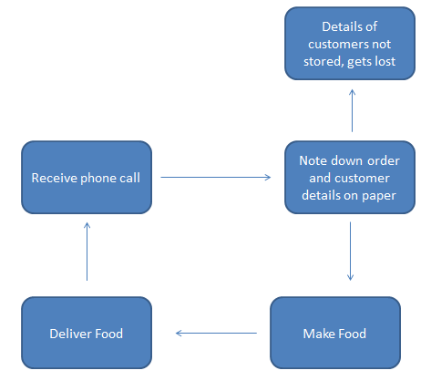***

***Context View***

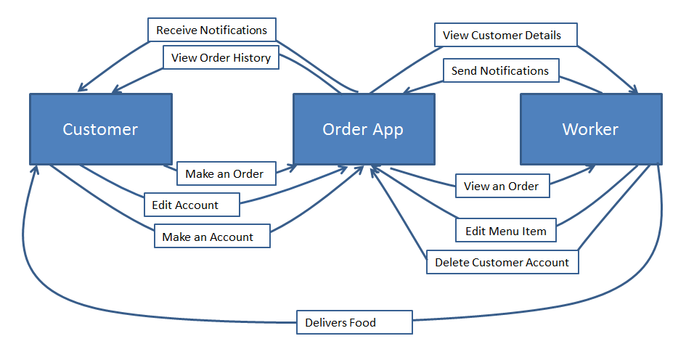

***Edit Menu Item – Level 0***

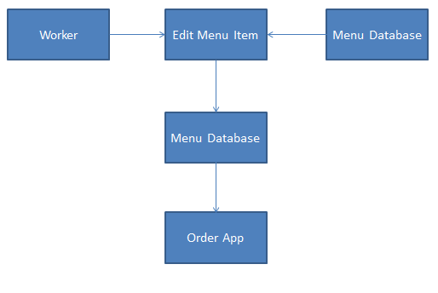

***Edit Menu Item – Level 1***

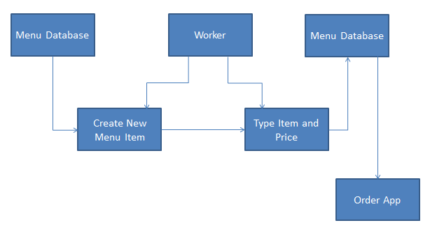

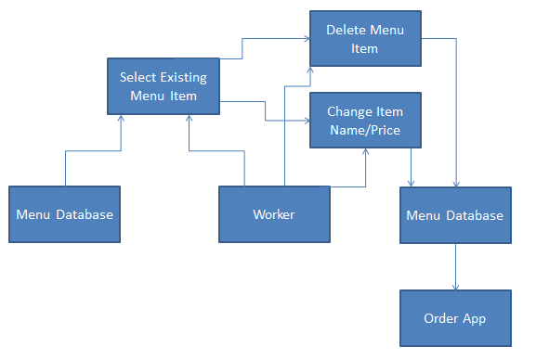

***Send Notification – Level 0***

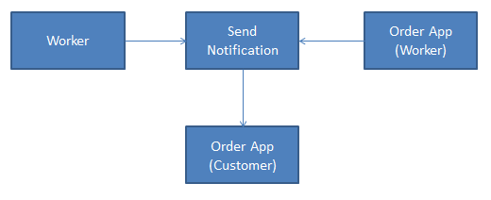

***Send Notification – Level 1***

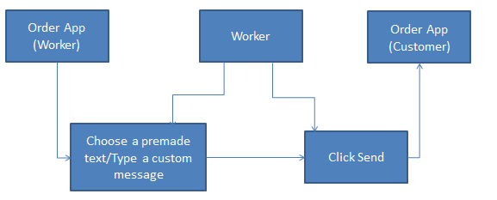

***View Order – Level 0***

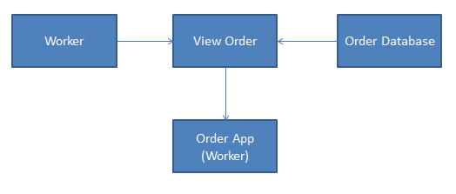

***View Order – Level 1***

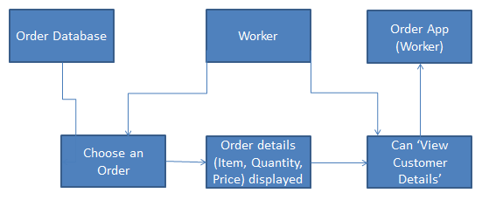

***View Customer Details – Level 0***

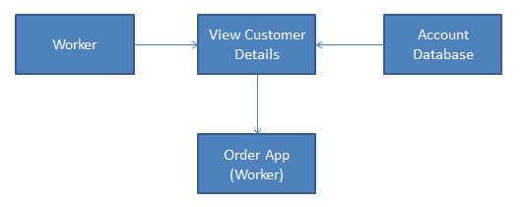

***View Customer Details – Level 1***

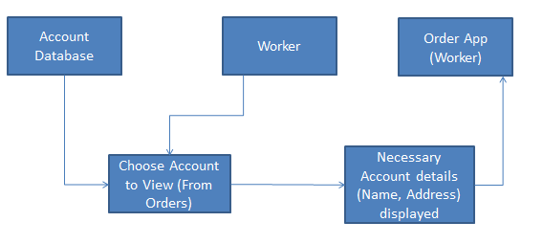

***Delete Customer Account – Level 0***

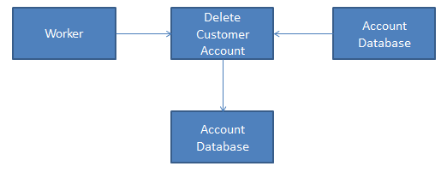

***Delete Customer Account – Level 1***

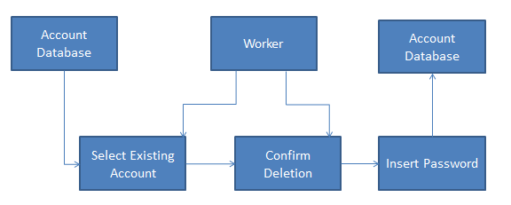

***Make an Order – Level 0***

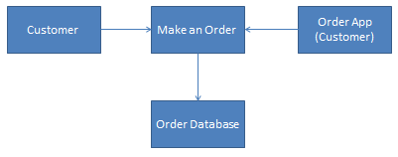

***Make an Order – Level 1***

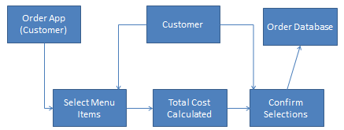

***Make an Account – Level 0***

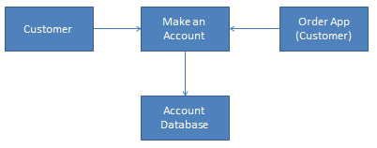

***Make an Account – Level 1***

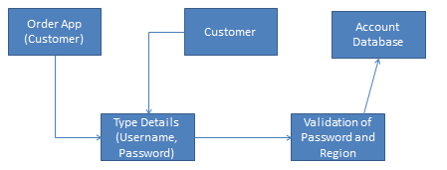

***Edit Account – Level 0***

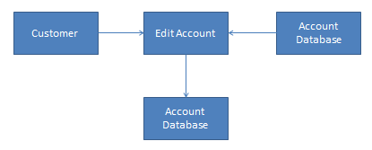

***Edit Account – Level 1***

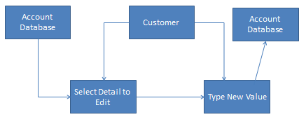

***View Order History – Level 0***

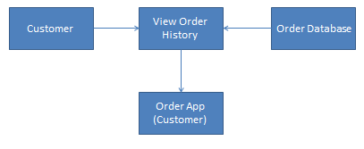

***View Order History – Level 1***

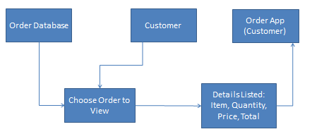

***Receive Notifications – Level 0***

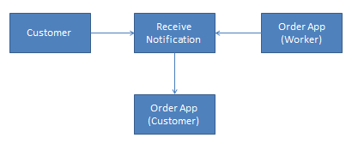

***Receive Notifications – Level 1***

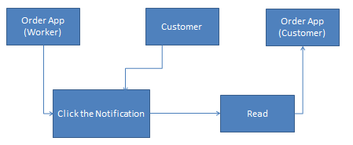

## Objectives

1. ***Functional***

*Customer App*

* 1. *Make an Order*
     1. Customers selects variety of menu items through searching by category
     2. Inputting the desired quantity of the item chosen
     3. Calculate total price of each item (tax already included with each item) by multiplying the item price with the respective quantity
     4. Calculate the total cost of the order by adding all the total prices
     5. Require password to confirm selections
     6. Customers should only be able to order from 9AM until 9PM
     7. Upload order to database, listing item id, quantity and total costs
     8. Get the time of order and make sure it is unique, for an ID
  2. *Discount Benefits*
     1. If the customer has ordered at least 15 times, there will be a 15% Discount for every purchase onwards
     2. Calculate this extra benefit in the Send Order part
  3. *Make user accounts*
     1. Customers must input username and password
     2. Password must be at least 6 characters long (No need variety, e.g. Capital letters, numbers, symbols are not needed)
     3. Customers must input region, region can only be in Ghubrah or Azaiba
     4. Customers must input Street address, House Address
     5. Give customers examples of what to type for street and house address
     6. Tell customers why only the two regions is selectable
     7. Store data in database
     8. If user didn’t input one or more fields, give a message and don’t upload to database
     9. The user’s ID will be the user’s username in lowercase letters so no other person can have the same username
     10. Do not allow if the username is already in use by someone else
  4. *Edit user accounts*
     1. Customers can change name, password, region, house address and street address
     2. Require customer password to confirm change (If the customer is changing the password then require the old password)
     3. Update data to database
     4. Same rules from Make user accounts is appliedhere
  5. *View order history*
     1. Download data from database
     2. Customers can select a month and year to view a list of orders
     3. List all orders in the selected month and year as buttons called “Order 1”, “Order 2” etc
     4. Click on an order (e.g. click on “Order 1”), and it will display all the menu items ordered, price, quantity, total price, total cost and the date ordered on a seperate page.
  6. *Exit app*
     1. Closes app completely
  7. *Receive Notifications*
     1. Get notifications from workers, status of their order
     2. Should appear on phone even if the app is not directly opened and is running in the background

Worker App

* 1. *Edit Menu Item*
     1. Require the edit menu password to access this feature (So workers can’t randomly delete, add or change menu items for no reason)
     2. Can change item name or price
     3. Can delete an item completely
     4. Can add new items, typing the item name, price and category
  2. *View Menu*
     1. *Workers can select a category to view the items under that category*
     2. *Download from database*
     3. *Item name and price will be listed*
  3. *View Order*
     1. Download order from database
     2. Display under awaiting orders
     3. List the orders in chronological order of time ordered
     4. Display items, quantity and total cost (no need each individual cost)
     5. Option to view the customer’s details (name and addresses)
     6. Option to send notifications
     7. Option to remove the order when it is completed, however a password input is required from the customer who made the order
  4. *Send Notifications*
     1. Select options (e.g. “Food is being made”, or “On the way”) and send
     2. Can also type send custom notification (e.g. “Arrived at the front of your apartment” or “Arrived at the back of your apartment”)
     3. Can also send notifications to everyone (not just customer who ordered) for things like announcements (e.g. “NEW MENU ITEM! Fish Soup for 1 OMR!”)
     4. Require the send notifications password to do so (to avoid workers from sending random notifications to users)
  5. *View Customer Details*
     1. Can check name, address of those that ordered
  6. *Delete Customer Details*
     1. Can delete the account completely
     2. Ask for confirmation prior to deletion
     3. Require Delete customer Password to do so (to avoid workers from deleting accounts for no reason)
  7. Exit app
     1. Closes app completely

1. **HCI**
   1. *User Friendly*
      1. Easy to understand
      2. Clear titles
      3. Clear instructions
   2. Buttons
      1. Buttons are clearly titled as per their functions
   3. Option Limitations
      1. Radio options to limit user input to certain things
      2. Drop down lists options to limit user input to certain things with a greater range of options
   4. Page Navigation
      1. Arrow buttons for going back a page
      2. Clear titles for advancing pages
2. **Data Storage & Security**
   1. *Cloud Storage*
      1. Using Firebase for the cloud storage
   2. Database
      1. Firebase Database is a JSON Tree Database
      2. Have 4 main branches for Menu Items, Accounts and Orders Made and Awaiting Orders
   3. *Require an Account with Username and Password to log in*
      1. Account details only known to the account creator
      2. Creating an account avoids having to type the users’ address over and over again
   4. Password Protection
      1. Password will be hashed one-way for maximum security and the hashed value will be stored in the database
      2. Inputted password (logging in, confirming order) will be hashed and compared to the one stored in the database for confirmation
3. **Environmental**
   1. *Customer Location*
      1. Only in Azaiba and Ghubrah (too far for the coffee shop to travel for other regions)
      2. Others cannot order for home delivery
      3. During sign-up there will be a Region detail to verify if they can create an account or not

## Scoping

1. *Stocks Tracking*
   1. Stocks will not be tracked as it does not belong in the application as it is not of use for both worker AND customer

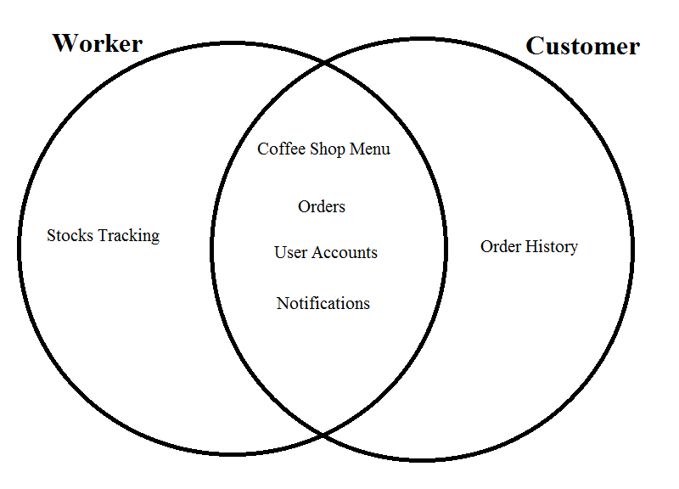

|  |  |
| --- | --- |
| Feature | Details |
| Stocks Tracking | This will help the worker in knowing what ingredients to buy if it is low or what is in full stock. This information is not useful for customers whatsoever |
| Menu | Workers can check and edit the menu, while the customers can view the menu to decide what they are going to order. |
| Orders | Customers make an order for the worker to check and make. |
| User Accounts | The address of the user is saved, hence the worker would already know where to deliver, and the user would not need to state their address over and over again. |
| Notifications | This allows the worker to communicate with the customer. |
| Order History | Only users can use this feature, to check what they ordered previously, however this can be further developed for the workers to use as well. |

1. Workers Editing Customer Details
   1. Workers won’t be able to edit customer details as the customer can do that themselves. This also avoids workers from editing customer details for no reason.
2. E-mail verification and recovery not required
   1. This isn’t required as there isn’t highly sensitive data such as credit card details
   2. Should a user forget their username or password they will simply have to make a new one

## Appendix

|  |  |  |
| --- | --- | --- |
| **Date** | **Who** | **Draft Feedback** |
| 23/10/16 | Stefan | 1) Check if the address the user input is in the Geographical Limit. Do this by automatically checking the address on Google Maps as a Validation when the user is signing up.  - I have decided to only allow the two options of Azaiba and Ghubrah to be selected during the sign up. This will show users that only those who are in these regions can sign up.  2) If a user is not sure about how to do some things on the app or have queries about something how would they have to act? Call?  -The premise of the app is fairly simple and most people would easily understand how to function the app. However for the low percentage that somehow don’t will simply have to ask help from others or go to the coffee shop.  3) How to deal with troll orders?  - In the event someone else accesses your account from your phone, when you are about to send an order, it will ask you your password to verify the order. This is the only way for me to deal with a “troll” order. |
| 28/10/16 | Leandro | 1) Is the coffee shop open 24 hours a day? If not then can the user make an order when the shop is closed?  - I have made it so the users will only be able to make an order during the time the coffee shop is opened.  2) What happens if the database has exceeded its storage limits?  - Apart from the obvious choice of paying monthly to get a bigger storage size, I have made it so that workers can delete user accounts in order to free up space. |

<https://firebase.google.com>

<https://developer.android.com>

# Documented Design

## Overview

The aim of this project is to create an app to allow customers to order food from the coffee shop without requiring to call the coffee shop and also to allow the coffee shop to handle orders more efficiently. The customers should be able to; create an account that will have their details stored, including personal and order details, create an order, edit their personal details and view their order history. The coffee shop workers should be able to; view an order, send notifications to a single user or every single user, view and edit their menu, and delete old accounts to save space.

## Description of Modular Structure of System

I have created navigation diagrams for the pages in my app. In addition to that there is a table listing the activities the user can perfrom on each page. In order for users to navigate to other pages they must click a button, either one saying the command such as “Log In”, or a simple image button of a back arrow. Every page has this activity excluding the Home page, Log In page and the transition pages.

Customer App

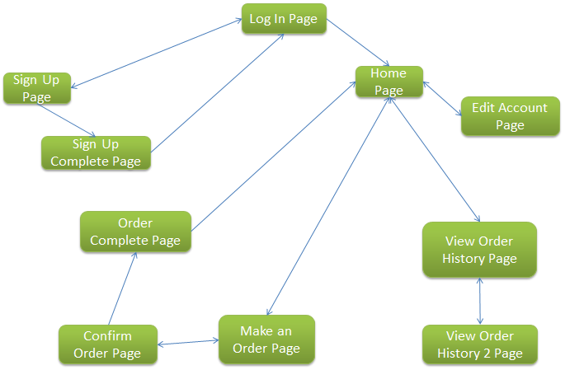

|  |  |  |
| --- | --- | --- |
| **Page Name** | **User Activities** | **Navigation** |
| Log In | Input username and password to access app functions | * Sign Up * Home |
| Sign Up | Create an account to use the app by inputting customer details Typing in name, username, password, street and house address Selecting radio button option for region | * Log In * Sign Up Complete |
| Sign Up Complete | N/A | * Log In |
| Home | Exit the app completely | * Make an Order * Edit Account * View Order History |
| Make an Order | Select food item category to display for selection Select desired food items with quantity for ordering | * Home * Confirm Order |
| Confirm Order | Viewing calculations of total price and cost Inputting password to confirm the order | * Make an Order * Order Complete |
| Order Complete | N/A | * Home |
| Edit Account | Change details of account Typing in name, password, street and house address Selecting radio button options for region Inputting password to confirm change | * Home |
| View Order History | Selecting month and year to produce a list of orders made in that time frame Select order for viewing | * Home * View Order History 2 |
| View Order History 2 | View order details of the selected order | * View Order History |

Worker’s App

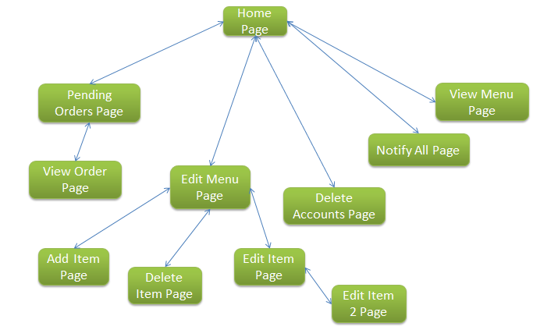

|  |  |  |
| --- | --- | --- |
| **Page Name** | **User Activities** | **Navigation** |
| Home | Exit the app completely View number of pending orders  Edit Menu, Notify All and Delete Accounts will require the user to input a password to access the pages | * Pending Order * View Menu * Edit Menu * Notify All * Delete Accounts |
| Pending Order | View who made orders | * View Order * Home |
| View Order | View the details of the user who made the order Send notification to the user that made the order Input password to delete order for completion | * Pending Order |
| View Menu | Select item category View items | * Home |
| Edit Menu | Select what type of editing the menu | * Home * Add Item * Edit Item * Delete Item |
| Add Item | Type item name Type item price Select item category | * Edit Menu |
| Edit Item | Select item category Select item for editing | * Edit Menu * Edit Item 2 |
| Edit Item 2 | Type item name Type item price | * Edit Item |
| Delete Item | Select item category Select item for deletion Confirm by pressing button | * Edit Menu |
| Notify All | Type message | * Home |

## UI Diagrams

The following diagrams consist of how each page in the app will look like. I will also describe the characteristics of each item. That being said, all text will have the font size ‘sans-serif’, font colour black (#000000) and the background will be white (#FFFFFF).

These are the UI diagrams for the Customer App:

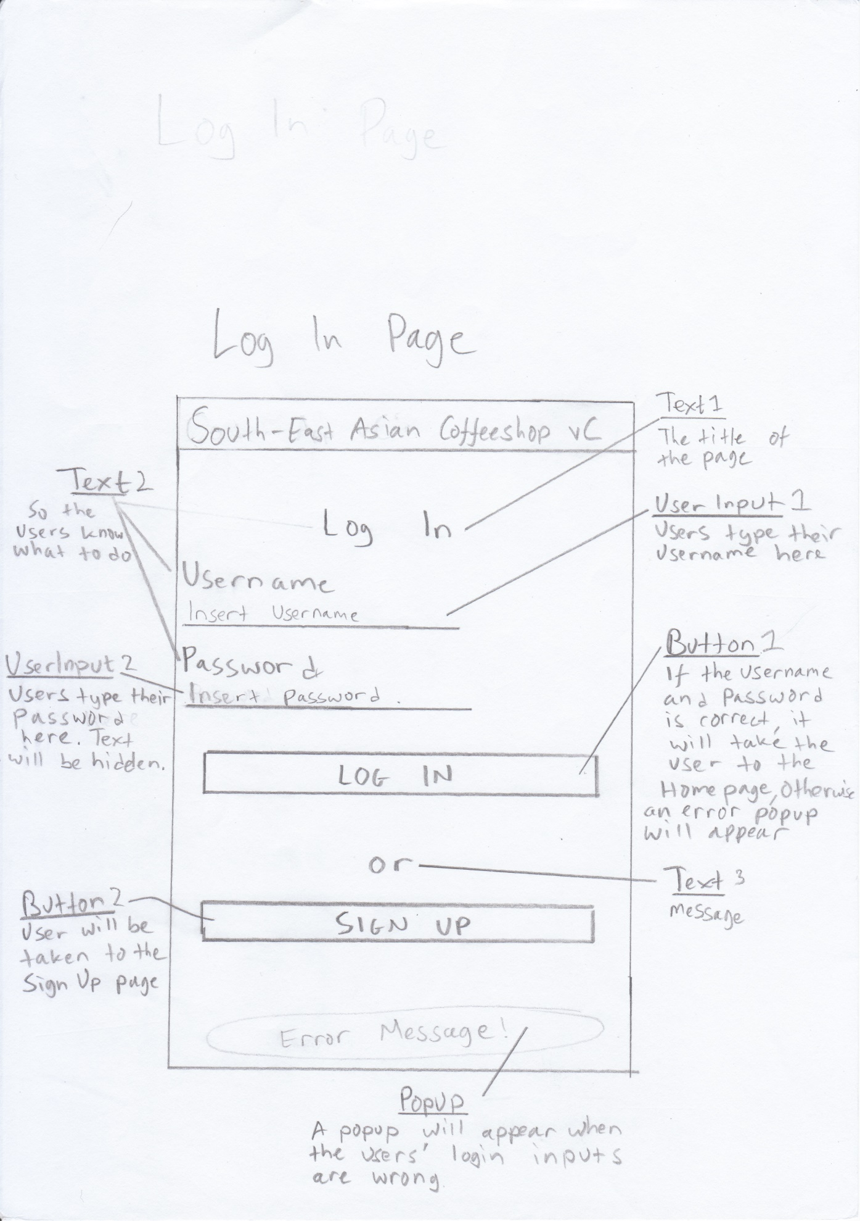

Text1 – Font size 24sp, centralised  
Text2 – Font Size 18sp, left aligned  
Text3 – Font Size 18sp, centralised  
UserInput1 – Font Size 14sp, left aligned, default text is hinted  
UserInput2 – Font Size 14sp, left aligned, default text is hinted, text type ‘password’ (to make it hidden)  
Button1 & 2 – Font Size 14sp, centralised

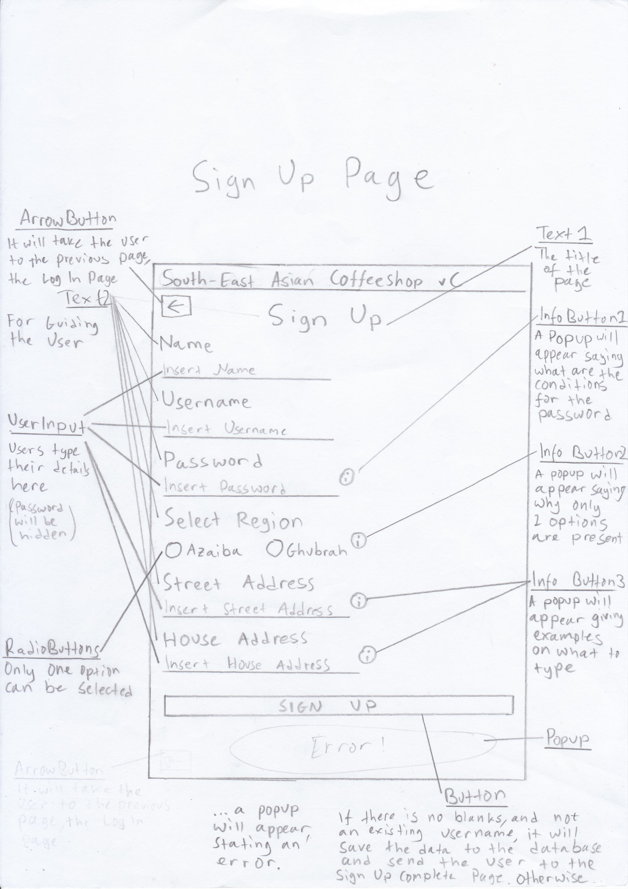  
Text1 – Font size 24sp, centralized  
Text2 – Font size 18sp, left aligned  
UserInput – Font size 14sp, left aligned, default text hinted, for the password input make text type ‘password’  
RadioButtons – Font size 14sp, left aligned, Set the radio group’s orientation as ‘horizontal’  
Button – Font size 14sp, centralised  
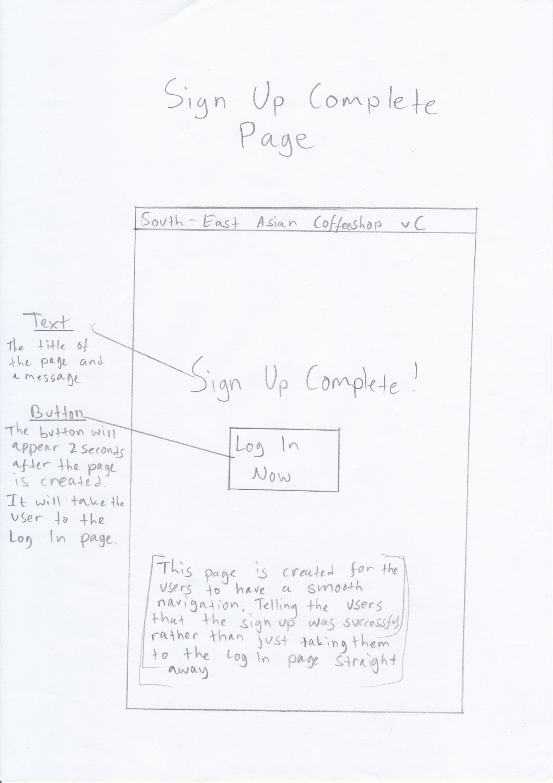  
Text – Font size 24sp, centralized  
Button – Font size 14sp, centralised  
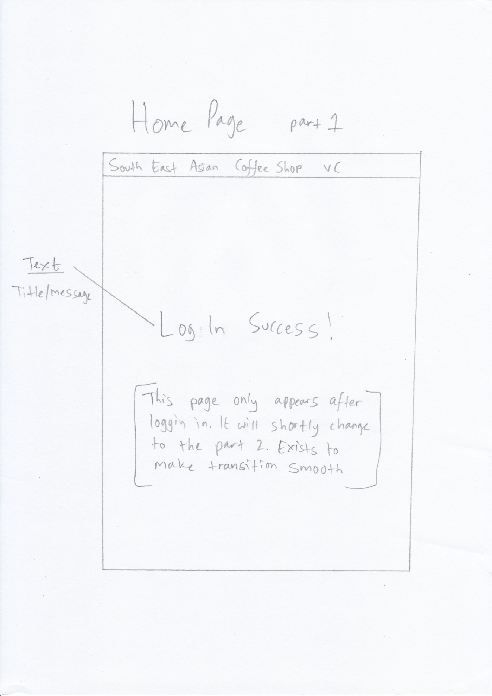  
Text – Font size 24sp, centralized  
If users change page to the Home page from any other pages that is not the log in page, this will not appear.  
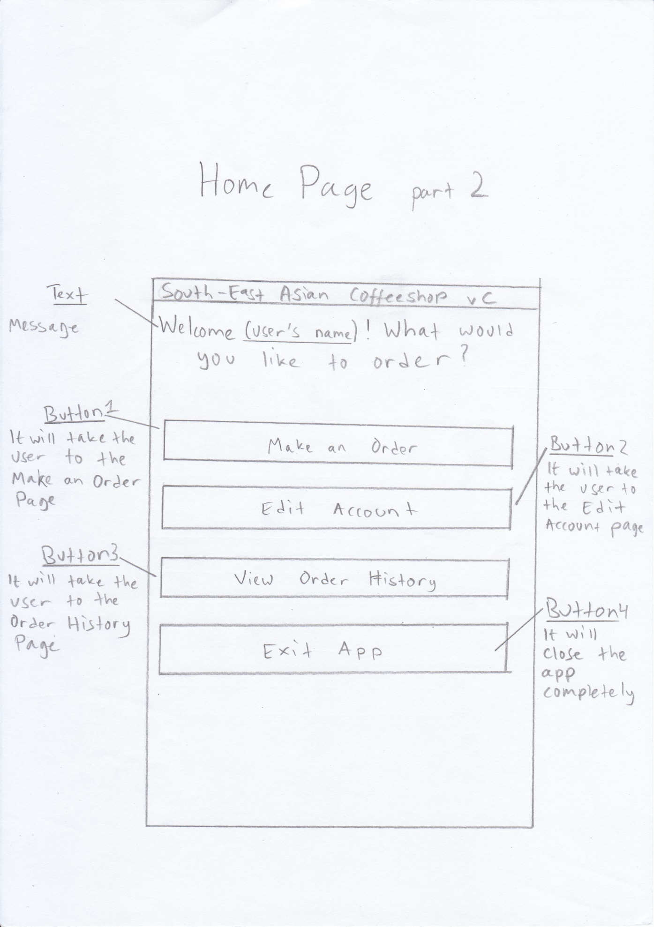  
Text – Font size 24sp, centralized  
Buttons – Font size 24sp, centralised  
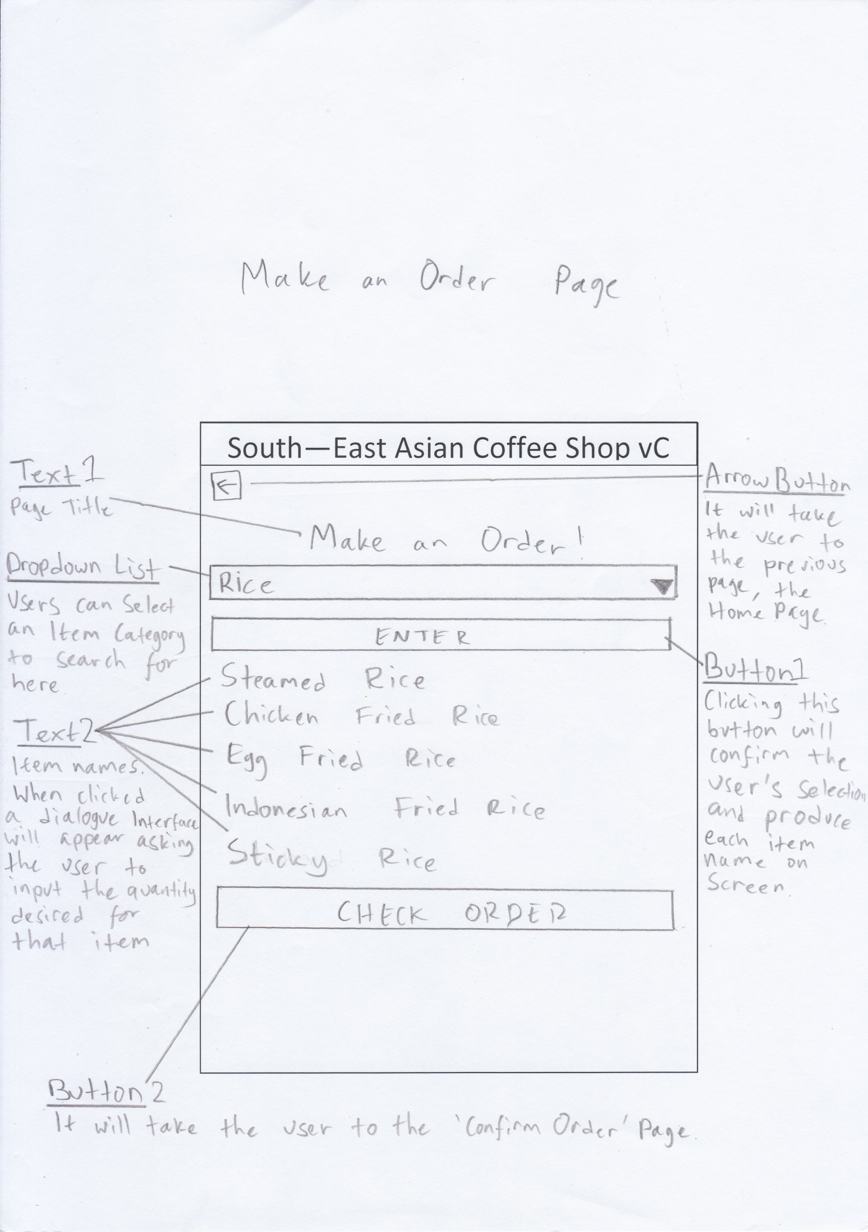  
Text1 – Font size 24sp, centralized  
Text2 – Font size 18sp, left aligned  
Button1 – Font size 14sp, centralized  
Button2 – Font size 14sp, centralized  
Should there be an error a popup will appear  
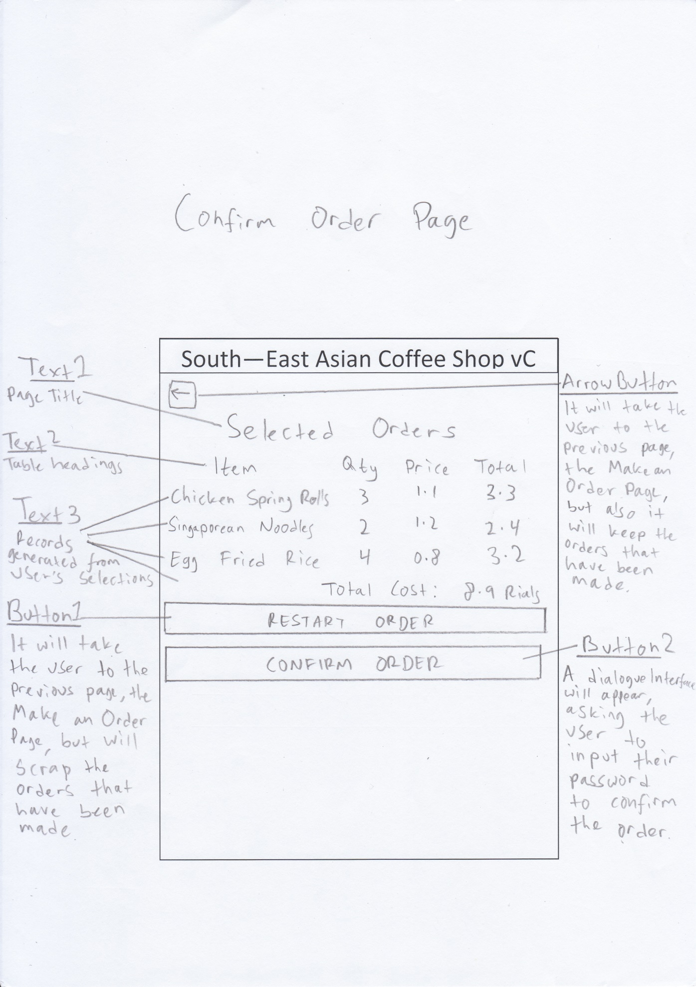  
Text1 – Font size 24sp, centralized  
Text2 – Font size 18sp, centralised  
Text3 – Font size 14sp, centralized (except the names of item, they are left aligned)  
Table – Four columns, the last row all four columns are merged into one  
Button1 – Font size 14sp, centralized, this button will empty the order list  
Button2 – Font size 14sp, centralized  
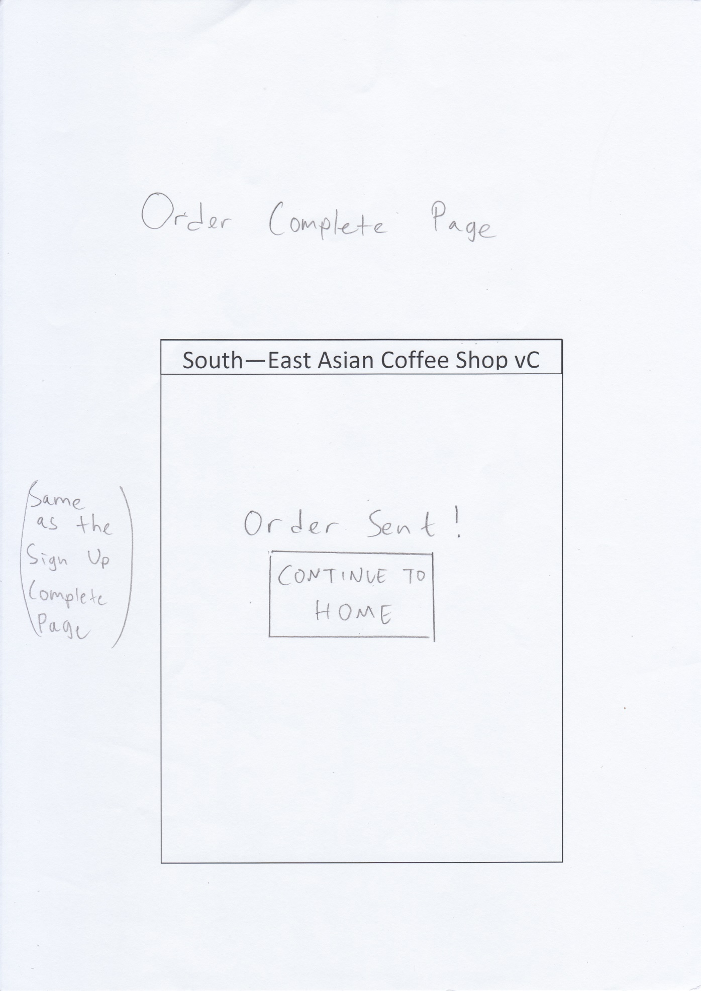  
Exactly the same as the sign up page!  
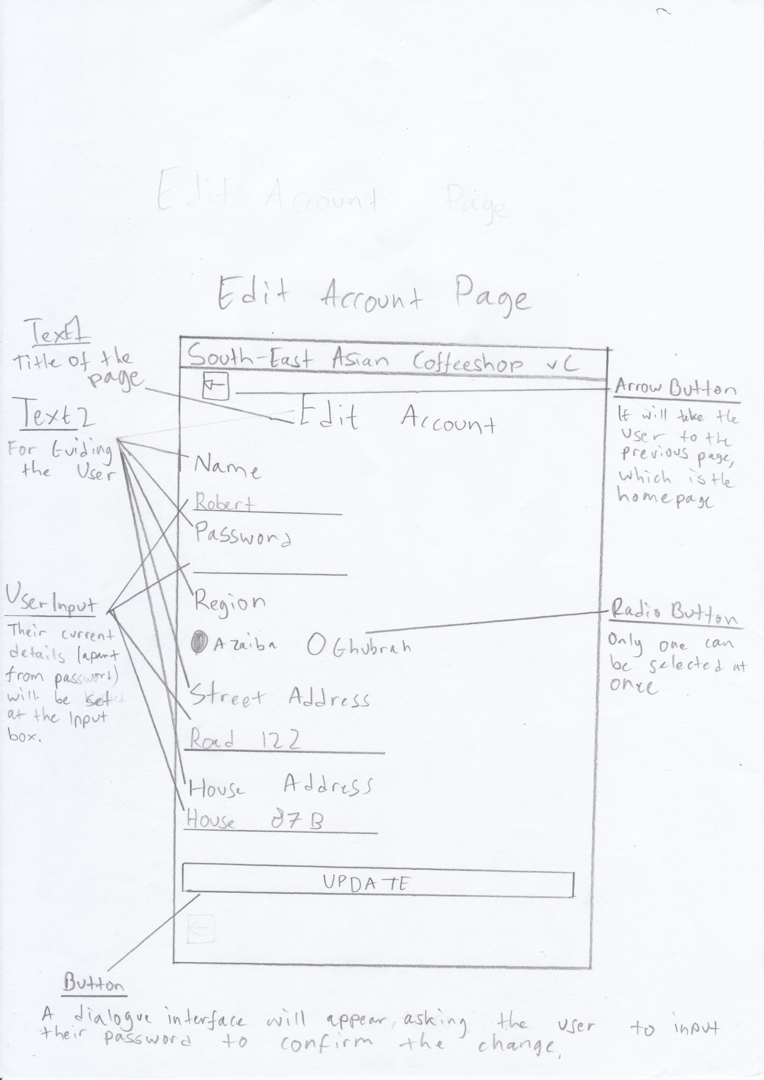  
Text1 – Font size 24sp, centralized  
Text2 – Font size 18sp, left aligned  
UserInput – Font size 14sp, left aligned, set the text as normal (except for password, leave it blank)  
RadioButton – Font size 14sp, left aligned, set the radio group orientation to ‘horizontal’  
Button – Font size 14sp, centralized  
Should there be an error a popup will appear  
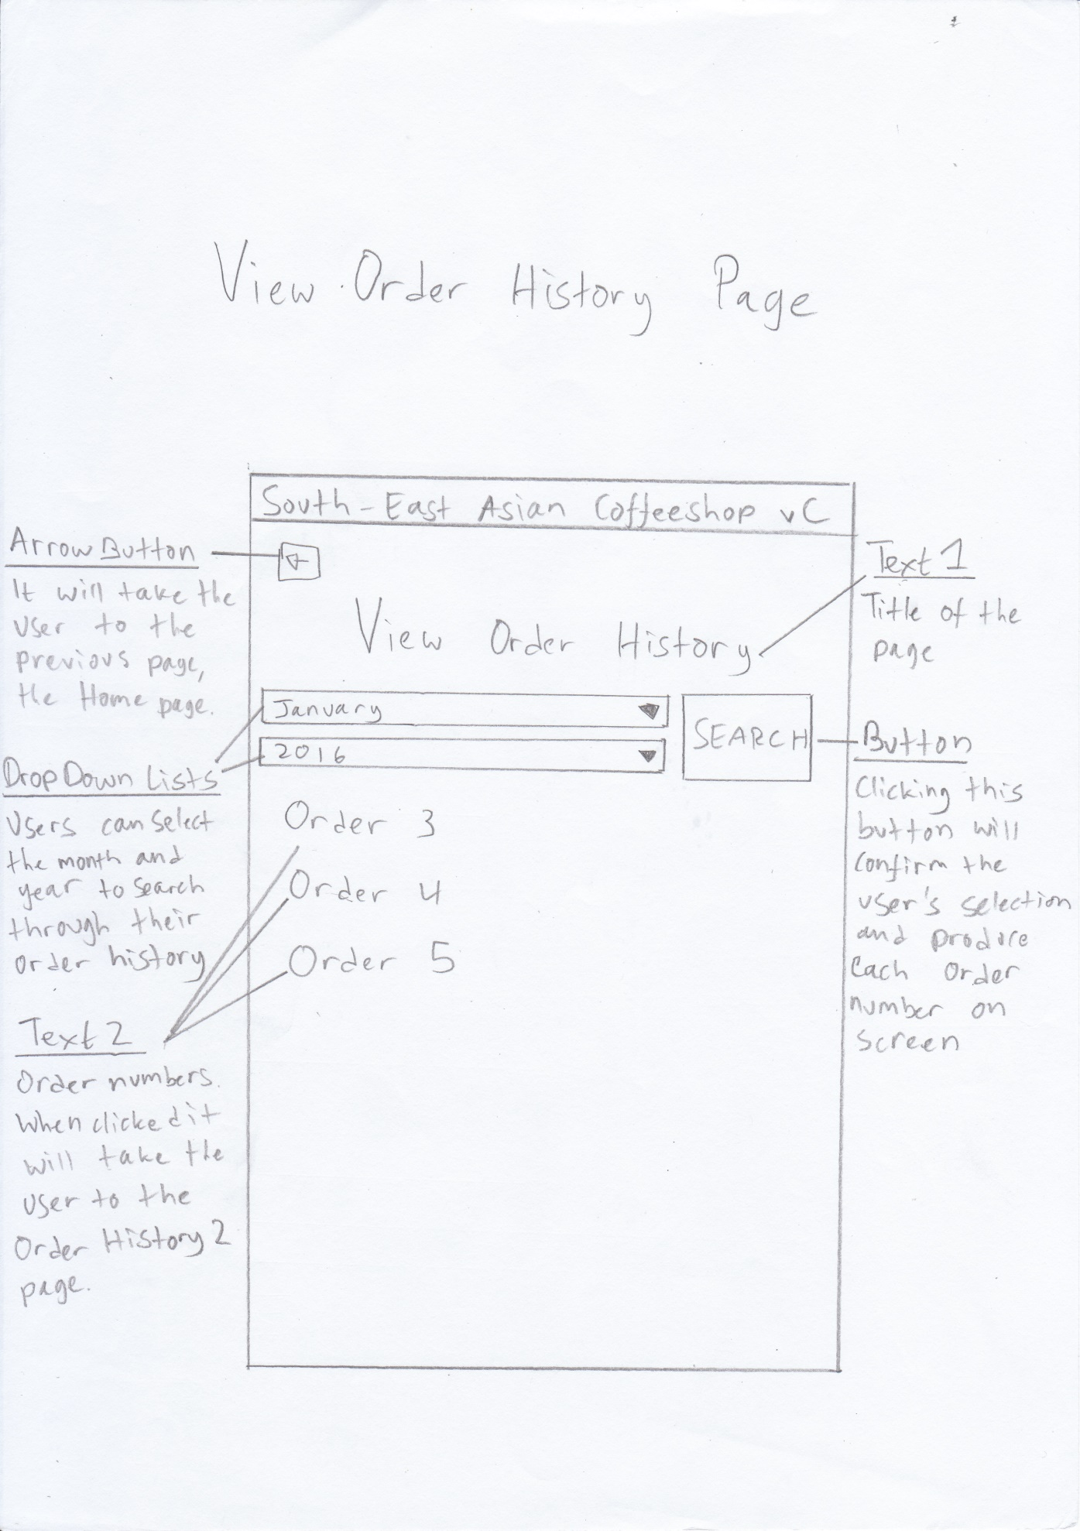  
Text1 – Font size 24sp, centralized  
Text2 – Font size 23sp, left aligned, clickable  
Button – Font size 14sp  
  
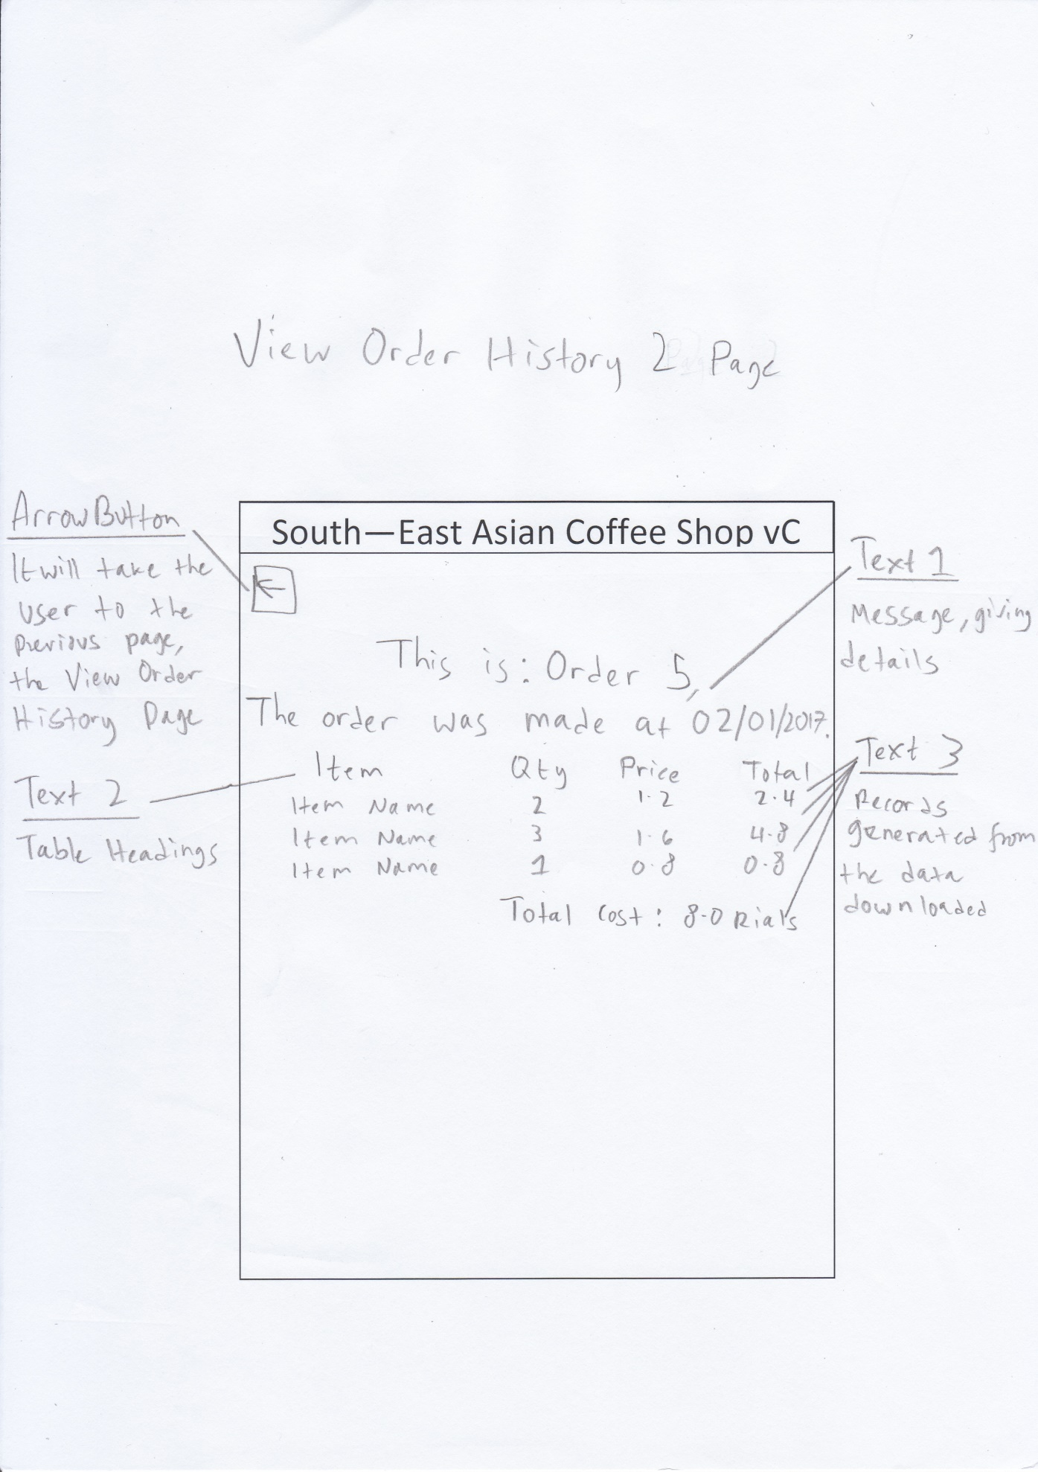  
Text1 – Font size 24sp, centralized  
Text2 – Font size 18sp, centralized  
Text3 – Font size 14sp, centralized (except the item name is left aligned and the total cost is right aligned)  
Table – Four columns, the last row all four columns are merged into one

Here are the UI diagrams for the Worker App:

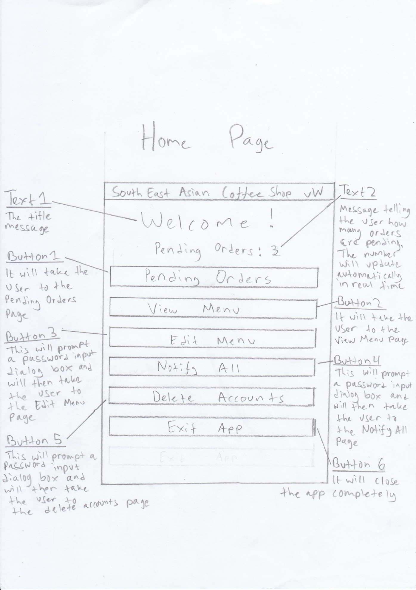  
Text1 – Font size 24sp, centralized  
Text2 – Font size 18sp, centralized  
Buttons – Font size 14sp, centralized  
Should there be an error a popup will appear  
  
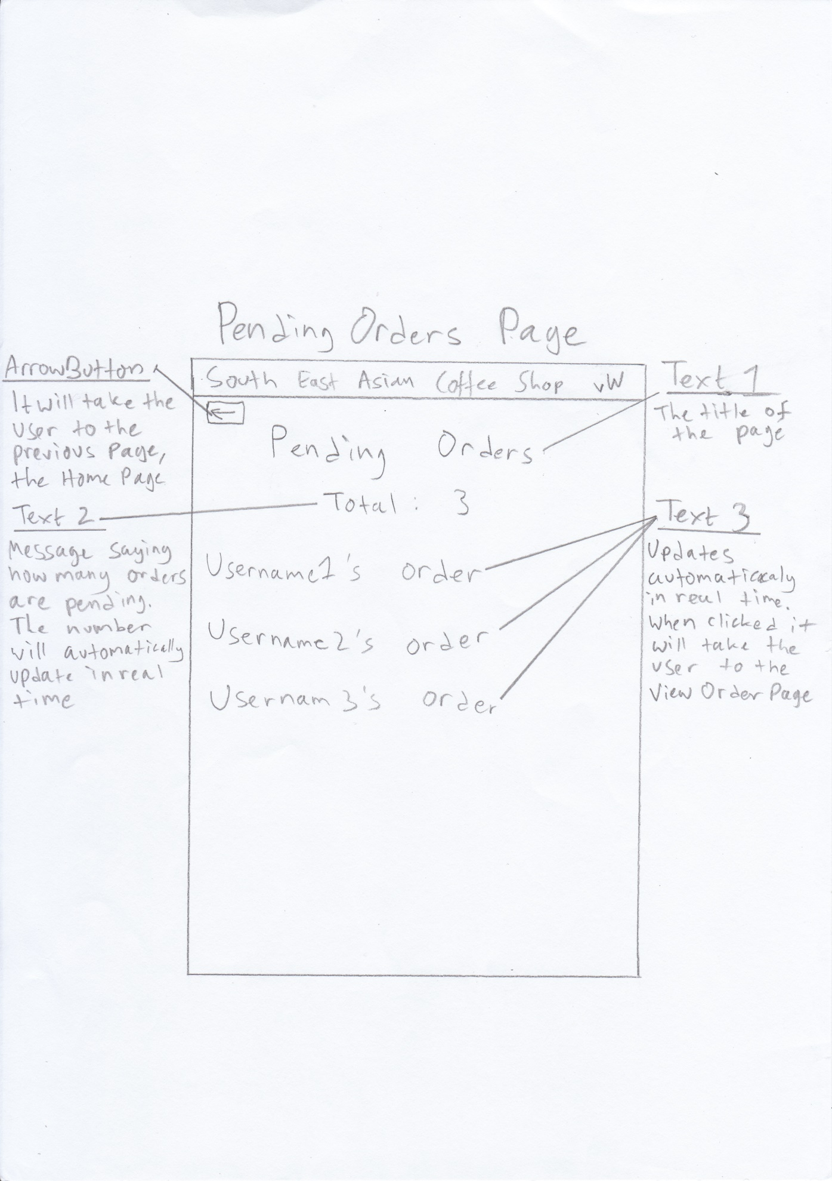  
Text1 – Font size 24sp, centralized  
Text2 – Font size 18sp, centralized  
Text3 – Font size 23sp, left alignment  
  
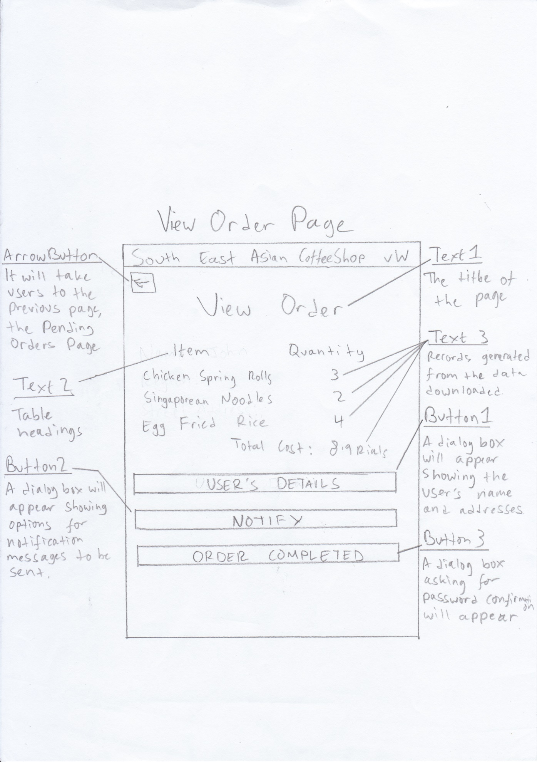  
Text1 – Font size 24sp, centralized  
Text2 – Font size 18sp, centralized  
Text3 – Font size 14sp, item name left aligned, quantity centralized, and total cost right aligned  
Table – Two columns, last row the columns are merged into one  
Buttons – Font size 14sp, centralized  
Should there be an error a popup will appear  
  
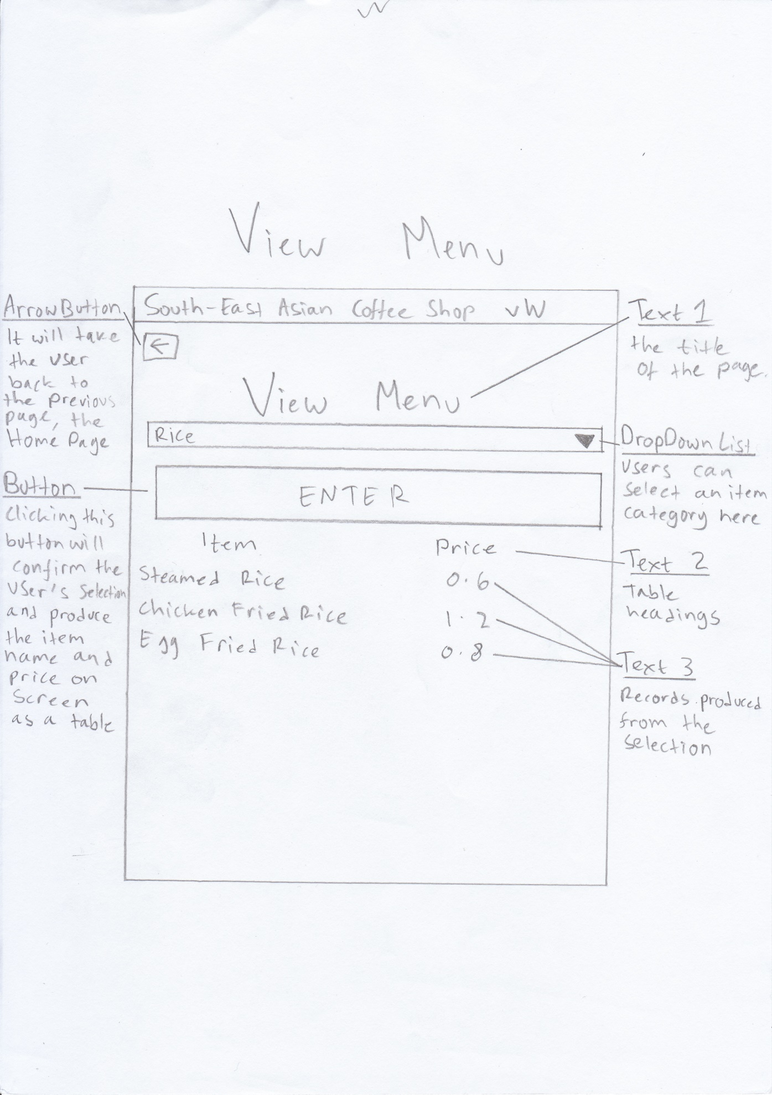  
Text1 – Font size 24sp, centralized  
Text2 – Font size 18sp, centralized  
Text3 – Font size 14sp, item names left aligned and price numbers centralized  
Table – Two columns  
Button – Font size 14sp, centralized  
  
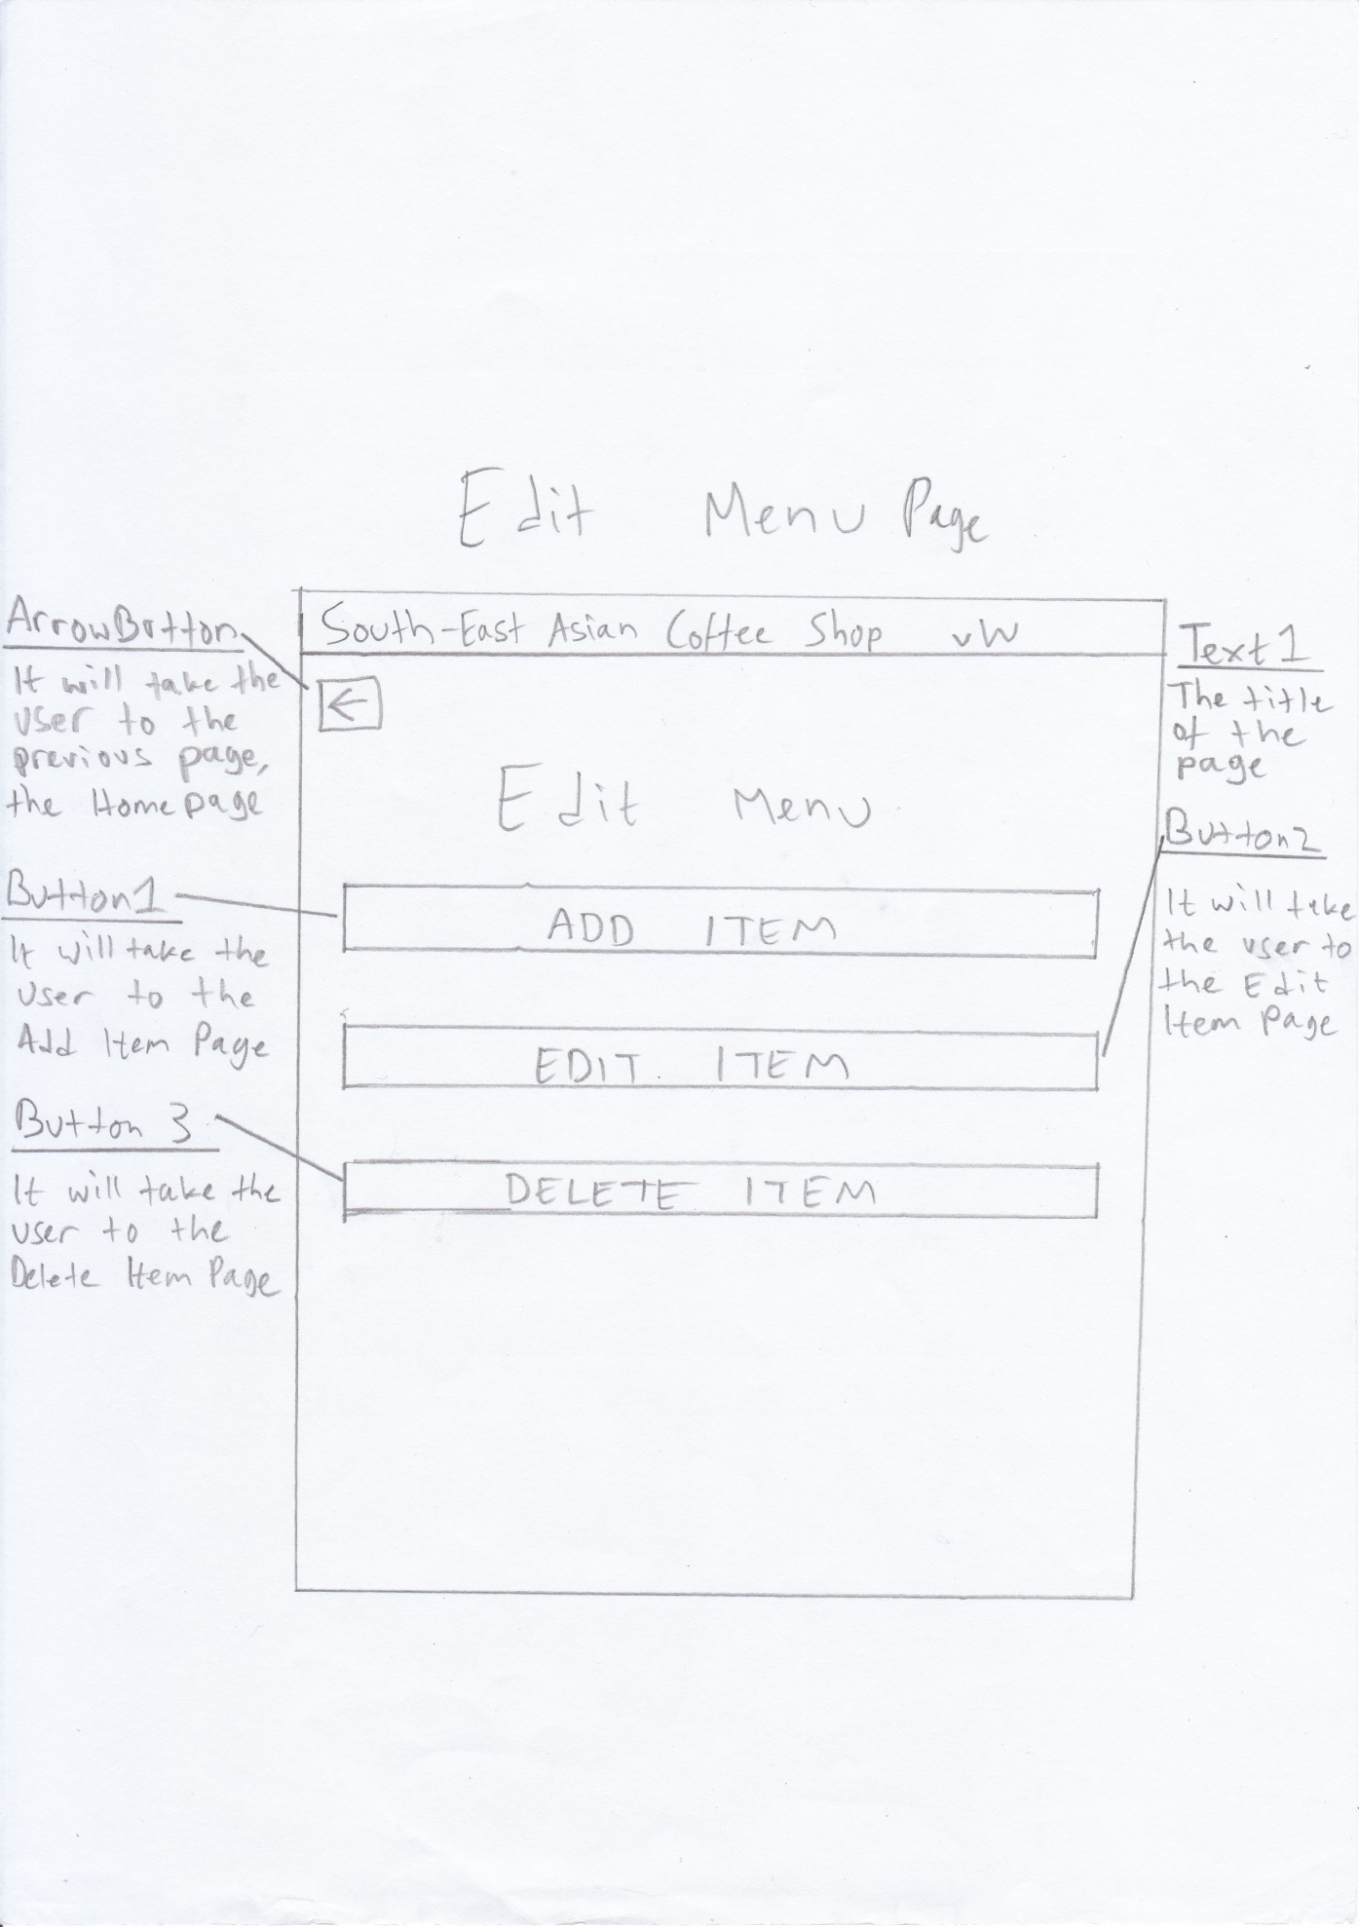  
Text1 – Font size 24sp, centralized  
Buttons – Font size 14sp, centralized  
  
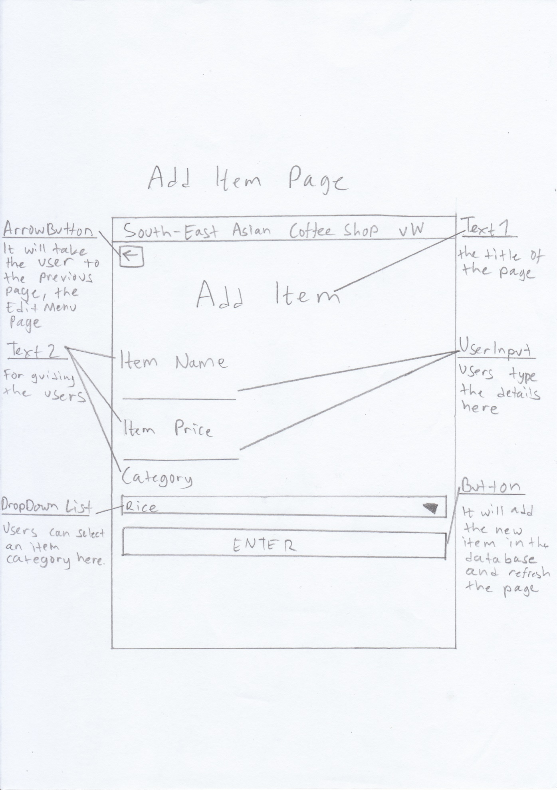  
Text1 – Font size 24sp, centralized  
Text2 – Font size 18sp, left aligned  
UserInput – Font size 14sp, left aligned, no set text  
Button – Font size 14sp, centralized  
Should there be an error a popup will appear  
  
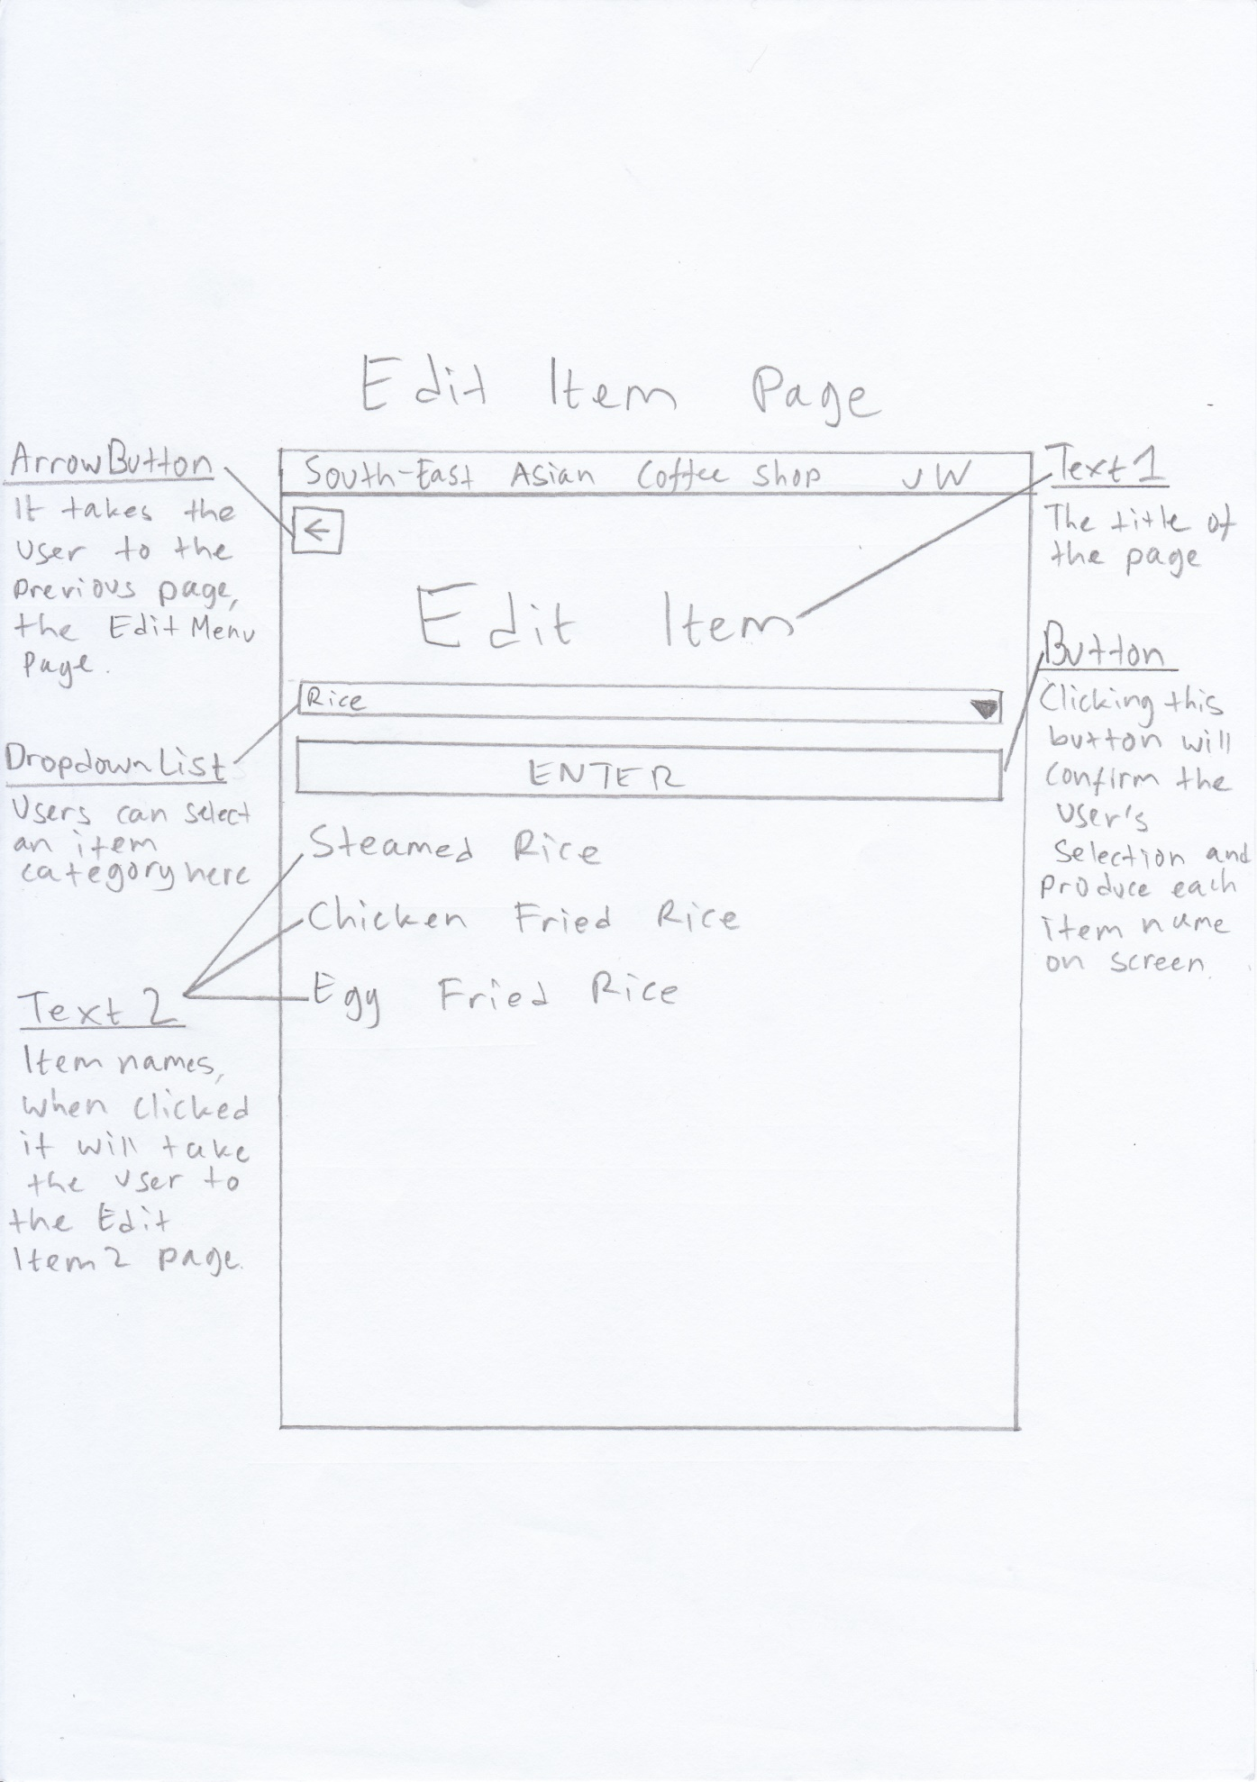  
Text1 – Font size 24sp, centralized  
Text2 – Font size 23sp, left aligned  
Button – Font size 14sp, centralized  
  
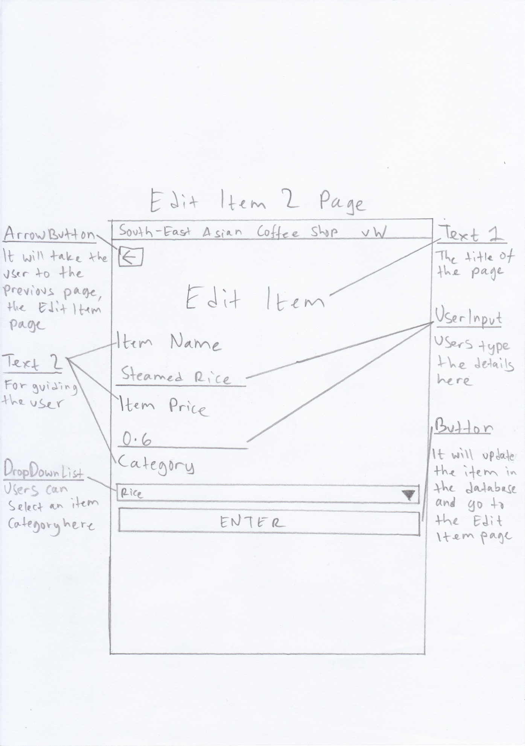  
Text1 – Font size 24sp, centralized  
Text2 – Font size 18sp, left aligned  
UserInput – Font size 14sp, left aligned, the original values are set as the text  
Button – Font size 14sp, centralized  
Should there be an error a popup will appear  
  
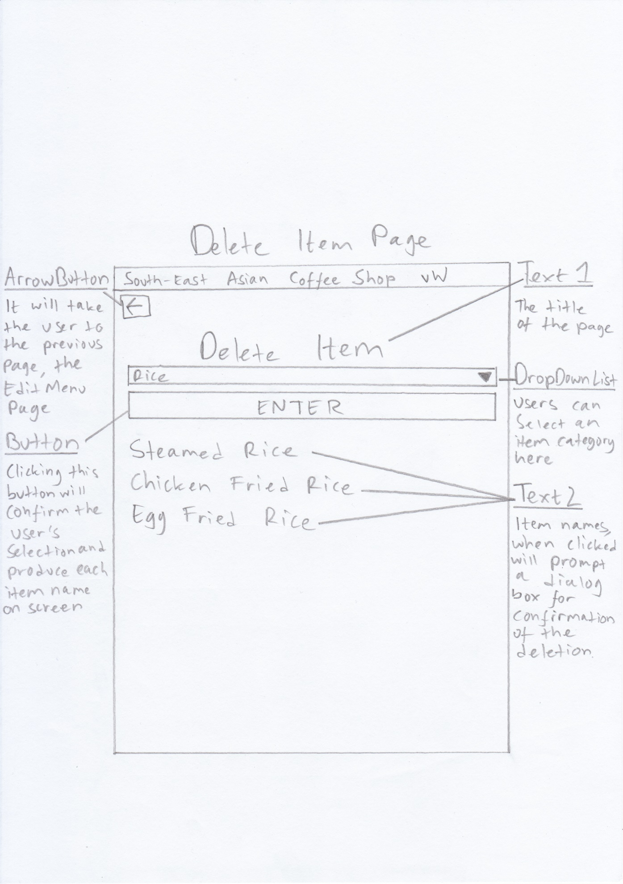  
Text1 – Font size 24sp, centralized  
Text2 – Font size 23sp, left aligned  
Button – Font size 14sp, centralized  
  
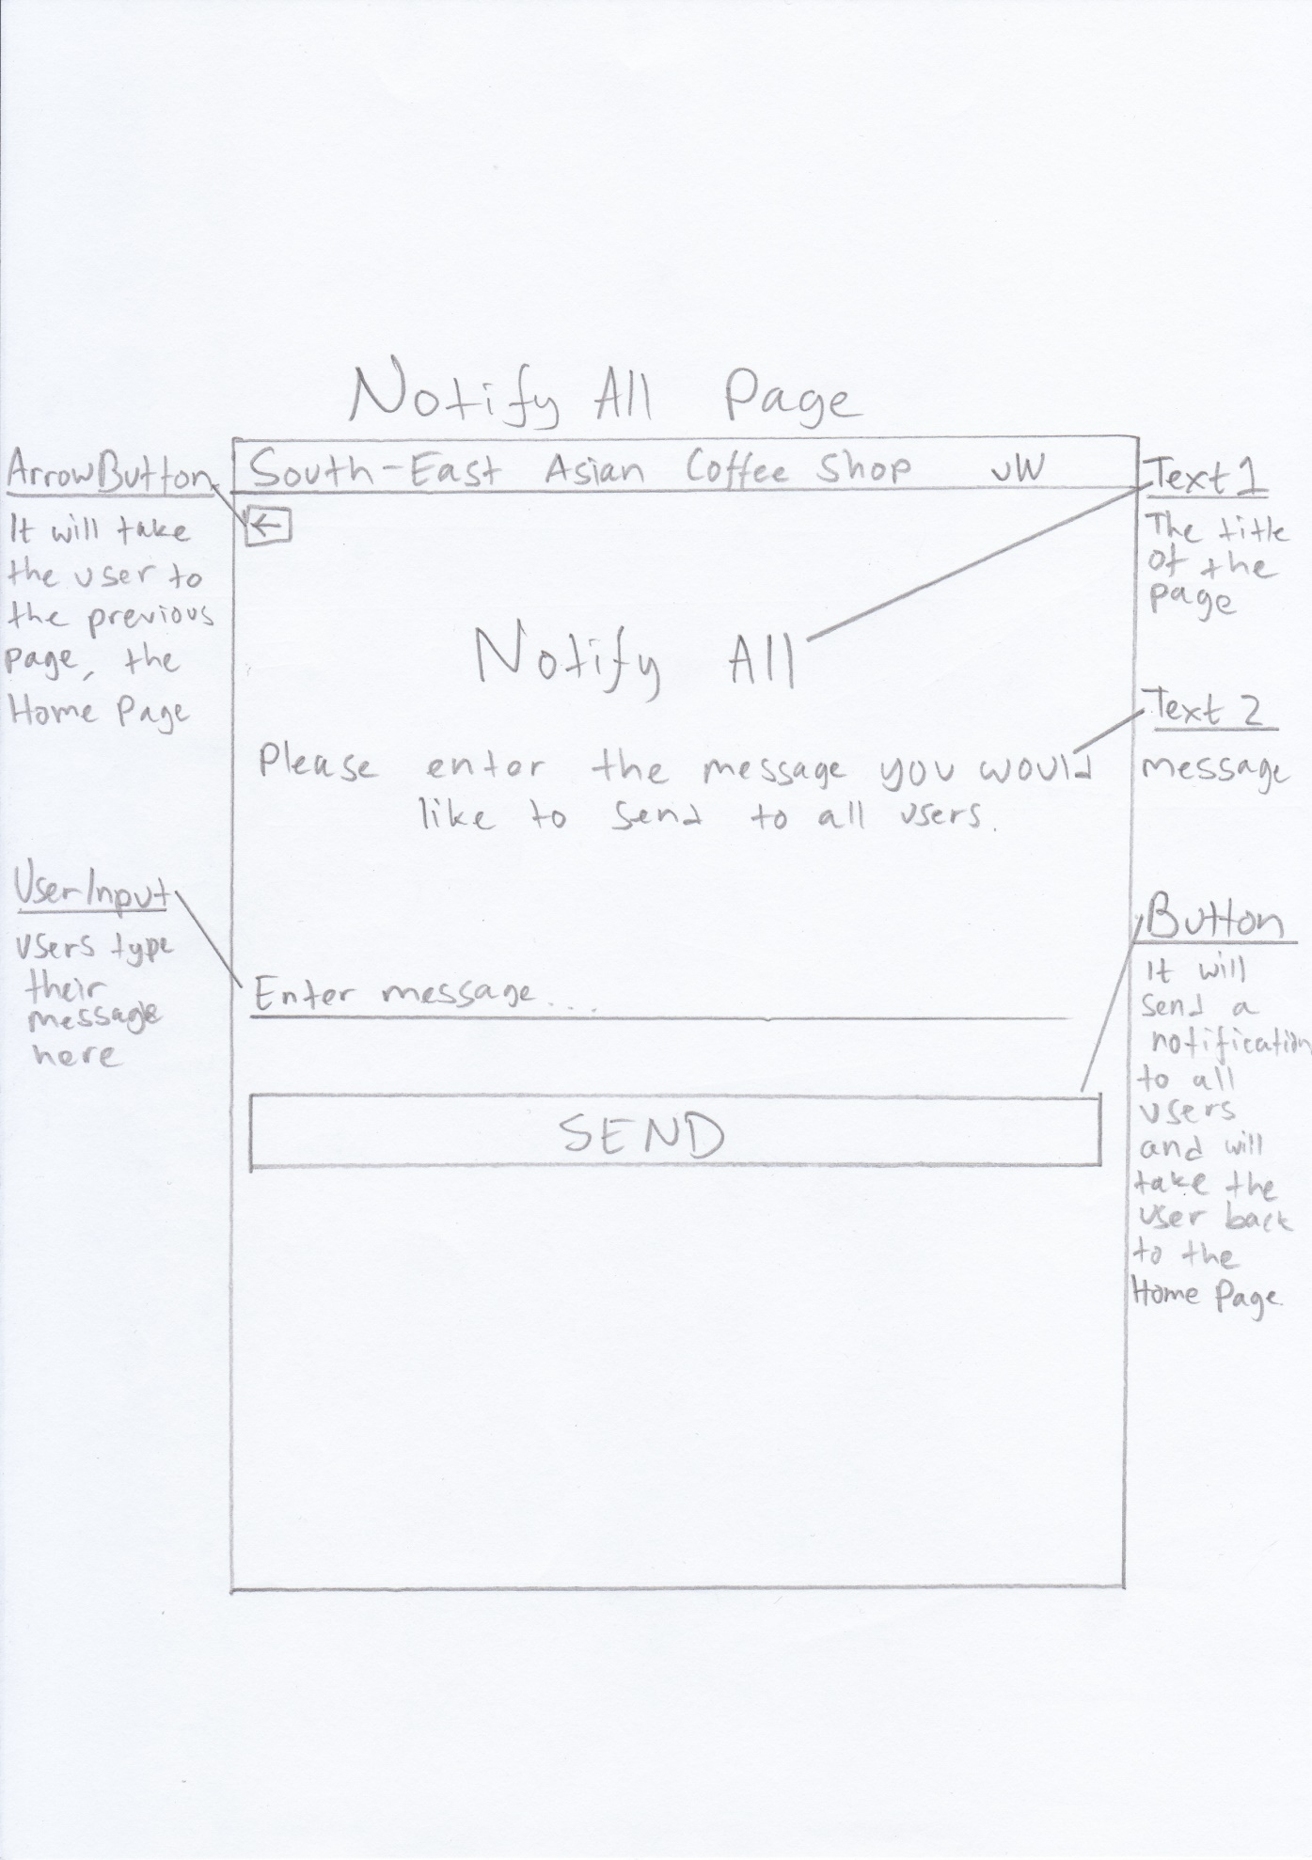  
Text1 – Font size 24sp, centralized  
Text2 – Font size 18sp, centralized  
UserInput – Font size 14sp, left aligned  
Button – Font size 14sp, centralized  
Should there be an error a popup will appear  
  
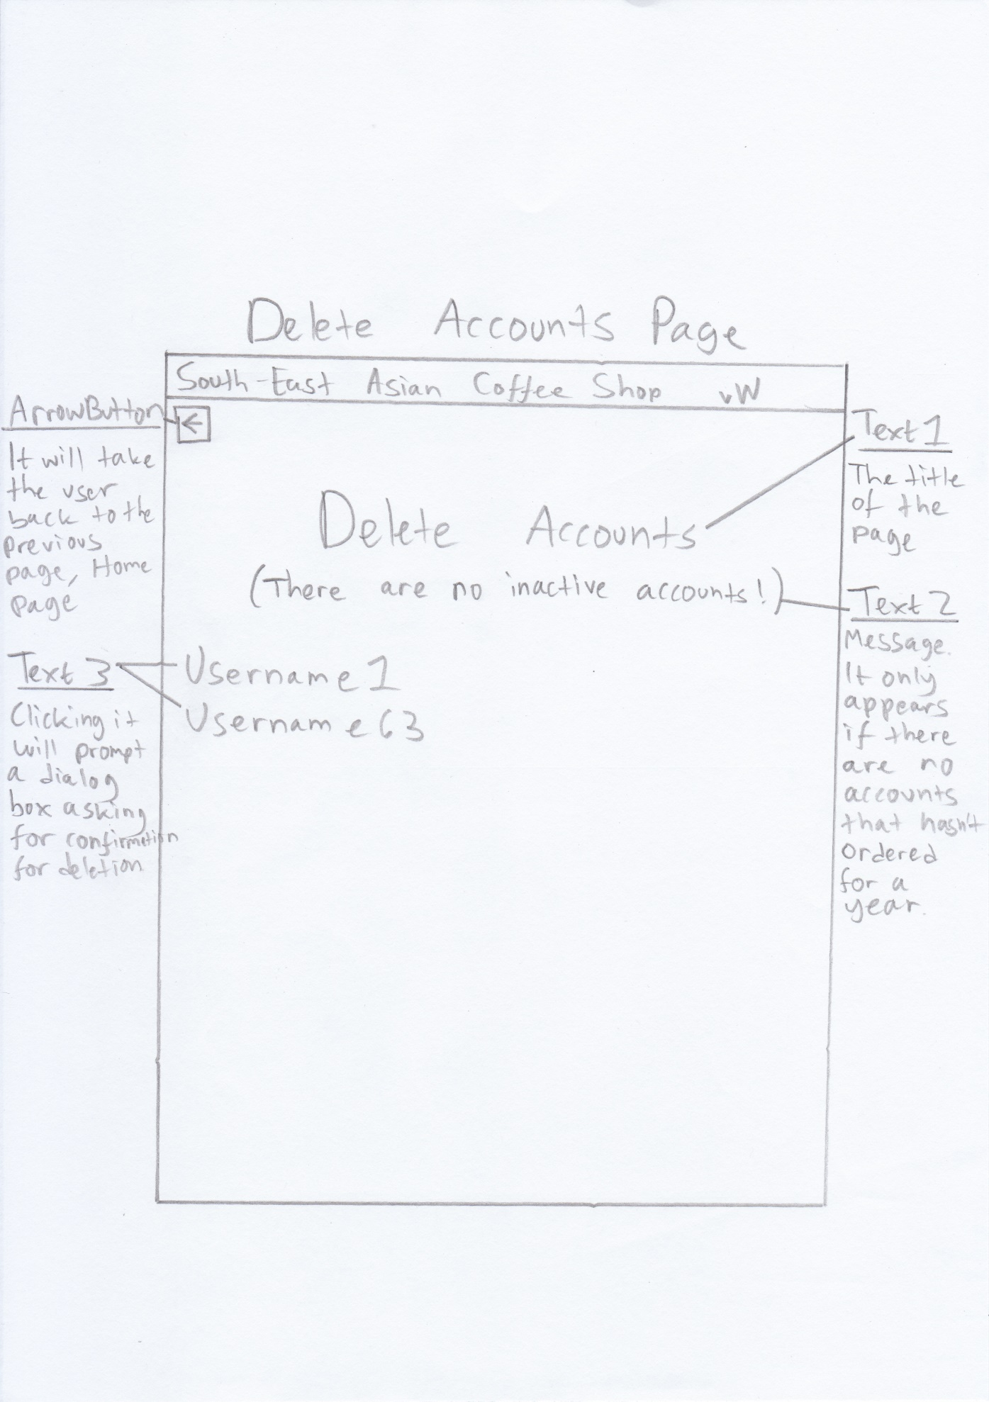  
Text1 – Font size 24sp, centralized  
Text2 – Font size 18sp, centralized  
Text3 – Font size 23sp, left aligned

## Data Entry Selections

I have used the following options for users to enter data for a reason.

|  |  |
| --- | --- |
| Entry Design/Objects | Reasoning |
| Radio Button (Option Buttons) | This will limit the input the users can make, so that there is also less room for errors. |
| Spinners (Drop Down Lists) | This will also limit the input the users can make, however with spinners I can have many options and the layout will still look professional and nice. |
| Buttons | Buttons make a good navigation button for something to happen or for a process to occur. |
| EntryText (Input Field) | This will allow the user to type what they wish, which is sometimes required for example when typing their name, because there is no way of limiting what name a user can have since it varies around the world. However, some EntryTexts will have validations when for example only numbers can be typed. |

## Font Selections

I have used the following fonts for a reason.

|  |  |
| --- | --- |
| Description | Reasoning |
| **Sizes** | |
| 24sp – Titles of pages | This is the biggest font size in all of the layouts and will be given to the title pages. The title being the biggest font size makes it stand out and ensures that the user is in the certain page. |
| 23sp – Text generated programatically that are clickable | It is slightly smaller than title because these texts need to be easily read and easily clicked by the user, if it is too small they may click the wrong text by accident. |
| 18sp – Field Titles and messages | This is one step smaller from the titles and are the next thing that will catch the user’s eyes. |
| 14sp – Entry fields and Buttons | These texts will have hints telling them to input something and they are given the smallest size as it is something they will have to change. |
| **Styles** | |
| Sans Serif | Only one font style is used to keep everything consistent and it looks professional. |
| **Colours** | |
| Green – Heading bar | These two colours were selected to represent the sign outside of the coffee shop. The sign has a green background with yellow text. Using the same colour scheme will create a sense of familiarity with the users. |
| Yellow – Text in the heading bar |
| Dark Green – Above the heading bar | A darker shade of the heading bar is used to differentiate that this is a seperate area. |
| Black – All other texts | Black and white will be used for simplicity. Black text on white background works well as it is a very strong contrast, making it easy for users to read the text. Having too many colours can also have a clash and make it hard for users to read, hence the simplicity. |
| White – The main screen |

## Data Validation

Validation will ensure that the user inputs are what I want them to be. They will exclude errors and unwanted data.

|  |  |
| --- | --- |
| Validation Check Type | Description |
| Range | Checks that the inputted data is within the specified range |
| Presence | Checks that all the data needed is present |
| List | This will only allow certain values to be selected |

|  |  |  |  |  |  |
| --- | --- | --- | --- | --- | --- |
| Activity | Validation Check | Description | Error Message | Valid Data | Erroneous Data |
| Changing the user Password or creating a new account and typing the password | Range | The string has to be grater than or equal to 6 characters | The password has to be at least 6 characters! | Banana | star |
| Typing the quantity desired for ordering | Range | The quantity has to be greater than 0 | The quantity has to be greater than 0! | 5 | 0 |
| Making a new account | Presence | Make sure every field has been entered in | You have missed out on a field! | “Trevor” | [empty] |
| Selecting item categories or selecting date for order history | List | Makes sure that the users can only select what is on the list | N/A | “Fish” | N/A |

## Data Structure

Using an XML file, values of strings are stored in a seperate resource file. This resource file will contain all the strings that will be represented in the app in buttons, textviews, spinners and so on. Main ones such as titles of pages like “Pending Orders” are stored here, and also messages such as “Insert Item Name”. String arrays will also be stored here such as the names of each item category and also the options for sending notifications. Having the strings stored in a resource files is more efficient than hard coding it in the layout file, as for example, titles with the same name will automatically changed if they are used in more than one layout when you change it from the resource file.

I also have a resource file for colors that are used.

## Security Measures

To prevent unauthorised access to other user’s password, the password that is stored will be hashed. Hashing provides a greater security than encrypting the value as it is one way. If I were to use encryption, if somehow an unauthorised person gets access to the key, they can then decrypt all the user’s password. Hence why hashing is used instead. I will use the hash SHA-256 as it is proven to be one of the strongest hashing algorithms available.

## Pseudo Code

Here are the custom methods I will use in my code:

Calculating the 15% Discount

GET UserInput

DIVIDE UserInput BY 100

MULTIPLY UserInput BY 15

ROUND UserInput TO ONE DECIMAL PLACE

RETURN UserInput

HASH password with SHA-256

GET UserInput

USE SHA-256 Hash ON UserInput

CHANGE UserInput TO ARRAYS OF BYTES

FOR EACH SET OF BYTES:

CHANGE each set to a HEXADECIMAL STRING

IF LENGTH OF HEXADECIMAL STRING equals 1:

ADD zero to the HEXADECIMAL STRING

END IF

ADD HEXADECIMAL STRING to an empty variable

END FOR

CONVERT THE variable to a STRING

RETURN STRING

Changing Page

GET PageDestination

IF needed:

PASS Variables to PageDestintion

END IF

OPEN PageDestination

CLOSE CurrentPage

Dialog Box for Password Confirmation

GET message

MAKE DialogBox

SET message TO DialogBox

MAKE UserInputField

SET UserInputField TO DialogBox

SET InputType FOR UserInputField TO Password

SET EnterButton TO DialogBox

WHEN EnterButton CLICKED:

GET UserInput

COMPARE UserInput WITH PasswordCheck

IF EQUAL:

PERFORM OPERATION

ELSE:

DISPLAY ErrorMessage

END IF

CLOSE DialogBox

SET CancelButton TO DialogBox

WHEN CancelButton CLICKED:

CLOSE DialogBox

DISPLAY DialogBox

## User Interface Designs

|  |  |
| --- | --- |
| **Key** | |
| **Diagram Language** | **XML Language** |
| UserInput | EntryText |
| Text | TextView |
| Dropdown List | Spinner |
| Radio Button | RadioButton |
| Popup | Toast |
| Button | Button |
| ArrowButton, InfoButton | ImageButton |

## Database Structure

A JSON Tree database structure will be used for this project. The data is stored neatly in their respective branches, for example all things regarding the user’s details is stored under the Accounts branch.

There will be two temporary storages, one is titled “Public Notification” which is directly under Data and “Order Status” which is under the username of the account. These will disappear after some time and only exists as temporary messages to the users.

This is an overview of the structure:

|  |  |
| --- | --- |
| Key | |
| Blue | Field dependent on User |
| Green | Field |
| Red | Record |

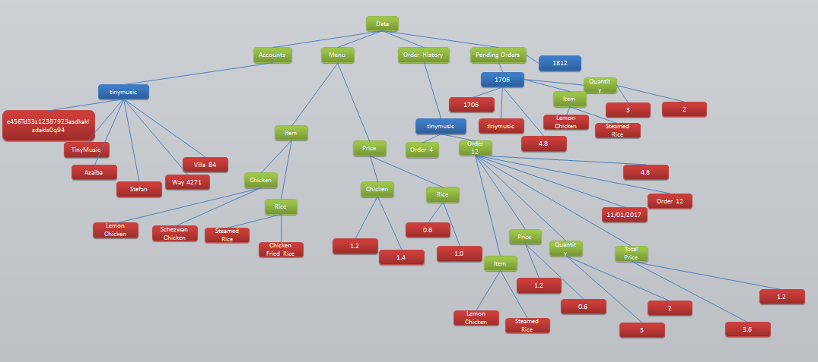

Accounts:  
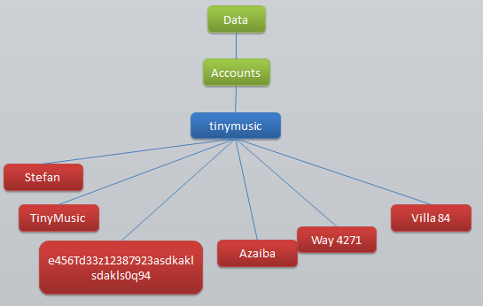

Accounts field holds the user’s field

Records under the Field:   
Name – Stefan  
Username – TinyMusic  
Password – [Hashed Value]  
Region – Azaiba  
Street Address – Way 4271  
House Address – Villa 84

Menu:  
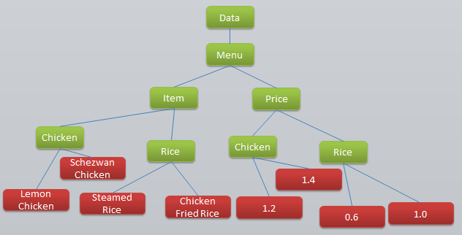

Menu field has an Item field and Price field under it.  
Both the Item and Price field will have the Category fields.

Records under the Chicken field under Item will have records with numbered IDs:   
0 - Lemon Chicken  
1 - Schezwan Chicken  
(And many more!)

Order History:  
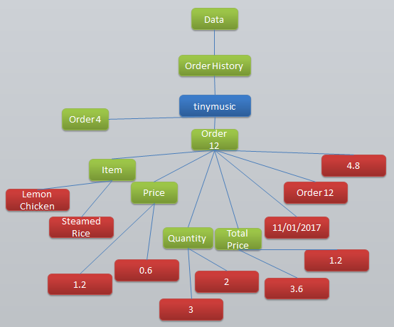

Order History field has a user’s username field followed by the order number field which contains records and further fields. Records it contains will be:  
Total Cost – 4.8  
OrderNo – Order 12

Records under the Item/Price/ Quantity/Total Price field will have records with numbered IDs:   
0 - Lemon Chicken  
1 – Steamed Rice  
(etc)

Pending Orders:

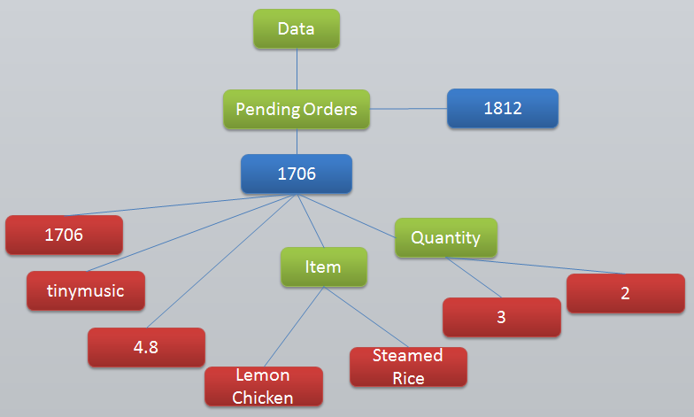

Pending Orders field has the TimeOfOrdered field which contains records and further fields. Records it contains will be:  
Time – 1706  
Username – tinymusic  
Total Cost – 4.8

Records under the Item/Quantity field will have records with numbered IDs:   
0 - Lemon Chicken  
1 – Steamed Rice  
(etc)

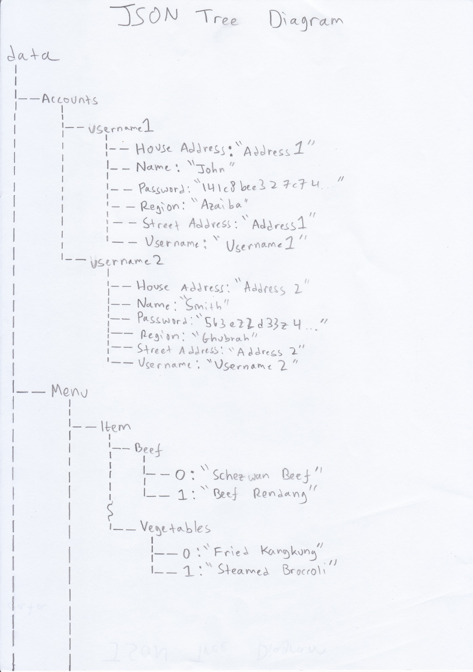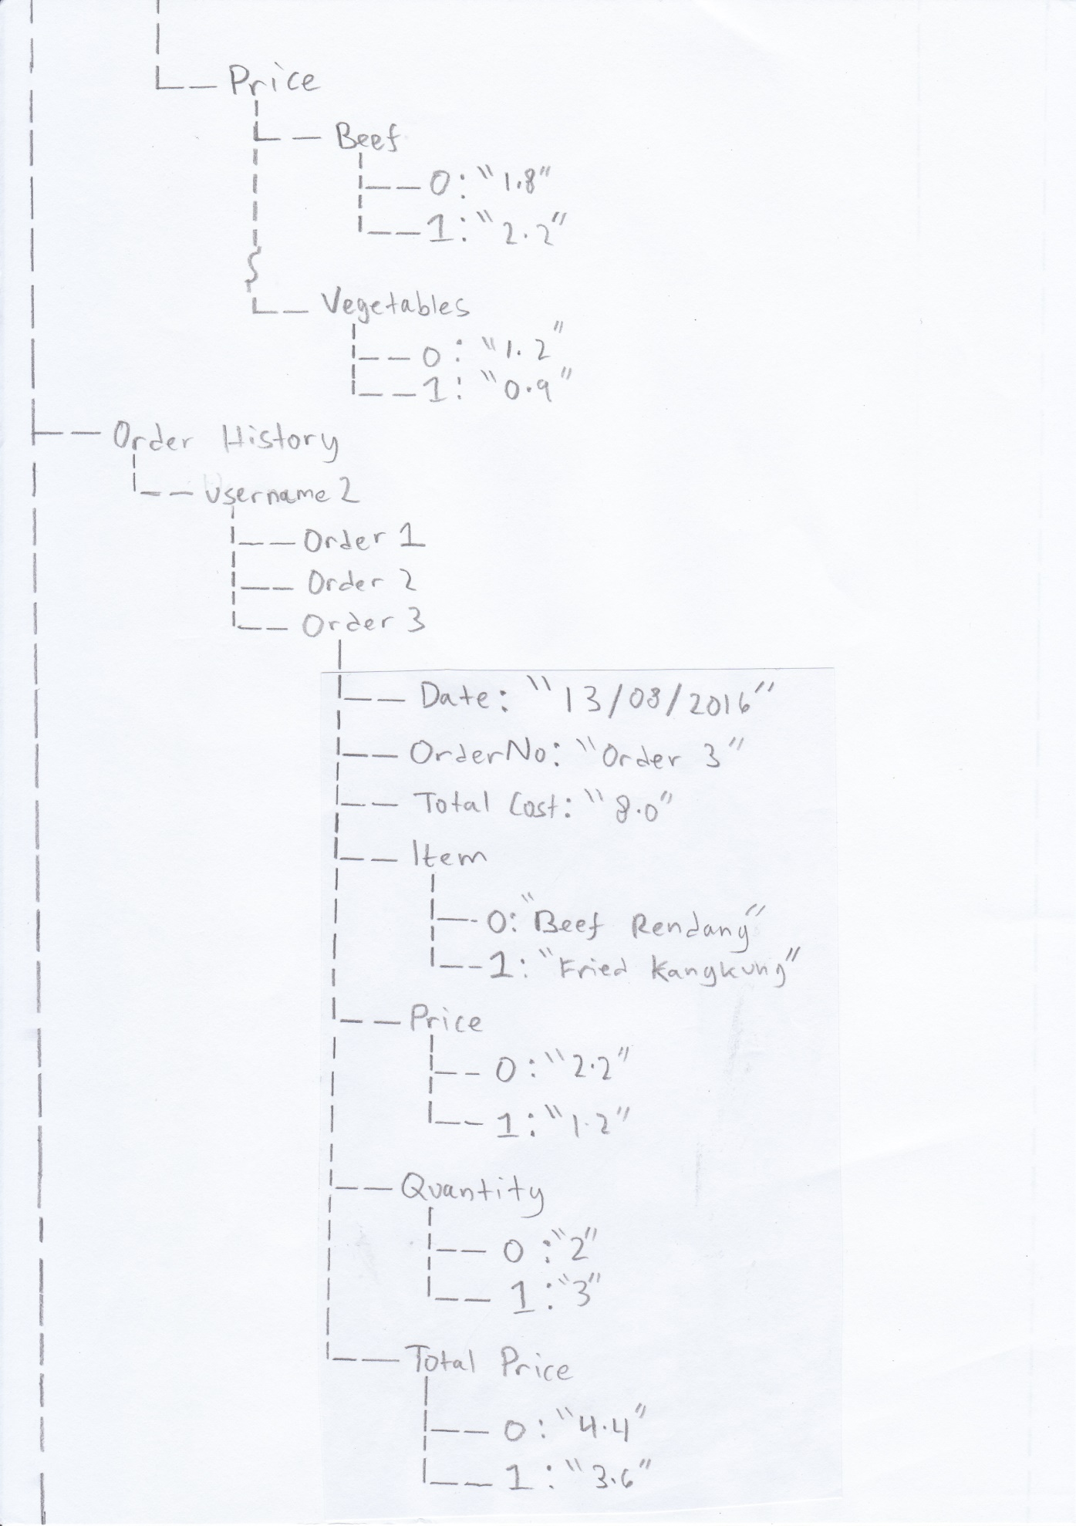

## IMG_0003Test Plan

Before the app is released for the public to use, it must be tested.

**Customer App**

Log In Page

|  |  |  |  |  |
| --- | --- | --- | --- | --- |
| Test Number | Purpose | Test Type | Test Data | Expected Outcome |
| 1 | To test the entry fields function properly (upon pressing the log in button) | Expected Data | Correct username (regardless of upper/lower case) and correct password input | Logging in success, taken to home page |
| Erroneous Data | Correct username and incorrect password input | Error Message, saying either username or password is incorrect |
| Erroneous Data | Incorrect username and correct password input | Error Message, saying either username or password is incorrect |
| Erroneous Data | Incorrect username and incorrect password input | Error Message, saying either username or password is incorrect |
| Erroneous Data | One or more fields is left blank | Error Message, saying that a field was left blank |
| 2 | To test the navigation buttons works | Expected Data | Short/Long press | Log In: Takes user to the Home Page Sign Up: Takes user to the Sign Up Page |

Sign Up Page

|  |  |  |  |  |
| --- | --- | --- | --- | --- |
| Test Number | Purpose | Test Type | Test Data | Expected Outcome |
| 3 | To test the entry fields function properly (upon pressing the sign up button) | Expected Data | Every field (including radio button) is filled, password field is at least 6 characters | Account created and stored in database, taken to sign up complete page |
| Erroneous Data | 1 or more fields is left blank | Error Message, saying that a field was left blank |
| Erroneous Data | Password field is filled with 5 characters or less | Error Message, saying the password must at least be 6 characters |
| Erroneous Data | Type a username that already exists on the database | Error Message, saying that the username is already in use |
| 4 | To test the radio buttons function properly | Expected Data | Option A is selected | Option A will be selected |
| Expected Data | Option B is selected after Option A was selected | Option B will be selected and Option A will be unselected |
| 5 | To test the info buttons function properly | Expected Data | Info button is pressed | Password info should say “minimum of 6 characters required”. House and Street info should give examples. Region info should say why only the two options is availabl. |
| 6 | To test the navigation buttons functions | Expected Data | Short/Long press | Arrow: Takes user back to the Log In page Sign Up: Takes user to the Sign Up Complete Page |

Sign Up Complete Page

|  |  |  |  |  |
| --- | --- | --- | --- | --- |
| Test Number | Purpose | Test Type | Test Data | Expected Outcome |
| 7 | To test the navigation button functions | Expected Data | Short/Long press | Continue to Log In: Takes user to the Log In Page |

Home Page

|  |  |  |  |  |
| --- | --- | --- | --- | --- |
| Test Plan | Purpose | Test Type | Test Data | Expected Outcome |
| 8 | To test exiting the app completely works | Expected Data | Short/Long press on button | Closes app |
| 9 | To test all navigation buttons function | Expected Data | Short/Long press on button | Make an Order: Takes users to the Make an Order Page Edit Account: Takes users to the Edit Account Page View Order History: Takes users to the View Order History Page |
| 10 | To test that you can only press the Make an Order button between 9AM to 9PM | Expected Data | Short/Long press on button, between 9AM and 9PM | Takes users to the Make an Order Page |
| Erroneous Data | Short/Long press on button, Before 9AM and after 9PM | Error Message, saying that you can’t order at this hour |
| 11 | To test the welcome message uses the user’s name in it | Expected Data | Log in with a few accounts | For each account their name that was stored in the database should appear |
| 12 | To test that the “Logging In Success” message doesn’t appear when coming from pages that is not the Log In Page | Expected Data | Change page to the Home Page from the 3 avaliable pages | The message will not appear. |

Edit Account Page

|  |  |  |  |  |
| --- | --- | --- | --- | --- |
| Test Number | Purpose | Test Type | Test Data | Expected Outcome |
| 13 | To test that clicking the UPDATE button will summon a Dialog Box | Expected Data | Short/Long press | A dialog box appearing asking for password confirmation |
| 14 | To test that the CANCEL and UPDATE button in the notify dialog box works | Expected Data | Short/Long press | CANCEL – Closes dialog box |
| Expected Data | Short/Long press, password typed correctly | UPDATE – Popup saying the account has been updated, takes user back to the home page |
| Erroneous Data | Short/Long press, password typed incorrectly | UPDATE – Popup saying the password was incorrect |
| 15 | To test the entry fields function properly (upon pressing the UPDATE button) | Expected Data | Every field (including radio button) is filled, password field is at least 6 characters | Database values are updated |
| Erroneous Data | 1 or more fields is left blank | Error Message, saying that a field was left blank |
| Erroneous Data | Password field is filled with 5 characters or less | Error Message, saying the password must at least be 6 characters |
| 16 | To test the radio buttons function properly | Expected Data | Option A is selected | Option A will be selected |
| Expected Data | Option B is selected after Option A was selected | Option B will be selected and Option A will be unselected |
| 17 | To test the entry fields has the user’s current data written in them (except for password, including radio button option) | Expected Data | Log In with a few accounts | Each field should have the user’s data written in them |
| 18 | To test all navigation buttons function | Expected Data | Short/Long press on button | Arrow/Update: Takes users to the Home Page |

Make an Order Page

|  |  |  |  |  |
| --- | --- | --- | --- | --- |
| Test Number | Purpose | Test Type | Test Data | Expected Outcome |
| 19 | To test the navigation button functions | Expected Data | Short/Long press | Arrow: Takes users to the Home Page Check Order: Takes users to the Confirm Order Page |
| 20 | To test the spinner selection is correct (upon pressing the enter button) | Expected Data | Select a couple of categories, cross-reference to the database | Each category chosen should get a list of every food item in that category |
| 21 | To test if users can proceed to the Check Orders Page | Expected Data | Made 1 or more selection of orders and then press button | Taken to the Confirm Order Page with selected Orders |
| Erroneous Data | Made no selections at all and then press button | Error Message, saying that the user had not made any selections |
| 22 | To test if pressing an item name will create a dialog box | Expected Data | Press a few item names | A dialog box appearing |
| 23 | To test that the food item has the correct price alongside it | Expected Data | Open up with a few food items, cross check to the database | The correct price is retrieved for each one |
| 24 | To test that users can only type integers when asked for how much portion is wanted (upon pressing OK) | Expected Data | Typing a number such as 7 | 7 is typed in the entry field and the item is added to the list |
| Erroneous Data | Typing a character that’s not a number | Not Applicable as the keyboard will be default to numbers only |
| Extreme Data | Typing a float value such as 5.6 | Not Applicable as the keyboard will not have a full stop |
| Extreme Data | Typing a negative number such as -5 | Not Applicable as the keyboard will not have a minus sign |
| Extreme Data | Typing 0 | Error Message, saying you can’t order zero portions of something |
| 25 | To test that the CANCEL and OK button in the dialog box works | Expected Data | Short/Long press | OK – Closes dialog box, saves selected item to list, popup saying it has been added CANCEL – Closes dialog box |

Confirm Order Page

|  |  |  |  |  |
| --- | --- | --- | --- | --- |
| Test Number | Purpose | Test Type | Test Data | Expected Outcome |
| 26 | To test the navigation button functions | Expected Data | Short/Long press | Arrow: Takes users to the Make an Order Page Restart Order: Takes users to the Make an Order Page |
| 27 | To test the arrow button keeps the user’s selected orders | Expected Data | Press arrow button and then press check order | List of selected orders still present |
| 28 | To test the Restart Order button gets rid of the user’s selected orders | Expected Data | Press the restart order button and then press check order | Error Message, saying that the user had not made any selections |
| 29 | To test that the calculations are done correctly | Expected Data | View page | Quantity \* Price = Total. Sum of each Total = Total Cost. |
| 30 | To test that the Confirm Order button will create a dialog box | Expected Data | Short/Long press button | A dialog box asking for password confirmation appearing |
| 31 | To test that typing the password for confirmation functions properly | Expected Data | Correct password input | Order will be uploaded to database |
| Erroneous Data | Incorrect password input | Error Message, saying password is incorrect |
| 32 | To test that the CANCEL and SEND ORDER button in the dialog box works | Expected Data | Short/Long press | SEND ORDER – Uploads order to database, takes user to the Order Complete Page CANCEL – Closes dialog box |

Order Complete Page

|  |  |  |  |  |
| --- | --- | --- | --- | --- |
| Test Number | Purpose | Test Type | Test Data | Expected Outcome |
| 33 | To test the navigation button functions properly | Expected Data | Short/Long press | Continue to Home: Takes user to the Home Page |

View Order History Page

|  |  |  |  |  |
| --- | --- | --- | --- | --- |
| Test Number | Purpose | Test Type | Test Data | Expected Outcome |
| 34 | To test the navigation button functions properly | Expected Data | Short/Long press | Arrow: Takes user to the Home Page |
| 35 | To test the spinner selection is correct (upon pressing the search button) | Expected Data | Select a month and year which the user have ordered in | Orders from that time period should be listed |
| Erroneous Data | Select a month and year which the user have not ordered in | Error Message, saying the user has not ordered anything in the month and year chosen |
| 36 | To test that an order can be clicked | Expected Data | Short/Long press | Takes the user to the View Order History 2 Page |
| 37 | To test that when it is a new year it is automatically updated in the spinner | Expected Data | View the spinner selections | There should be options from 2013 to the current year. |

View Order History 2 Page

|  |  |  |  |  |
| --- | --- | --- | --- | --- |
| Test Number | Purpose | Test Type | Test Data | Expected Outcome |
| 38 | To test the navigation button functions properly | Expected Data | Short/Long press | Arrow: Takes user to the View Order History Page |
| 39 | To test that the data downloaded is all correct | Expected Data | Do this with several orders, cross-check in database | All data correct |

**Worker App**

Home Page

|  |  |  |  |  |
| --- | --- | --- | --- | --- |
| Test Number | Purpose | Test Type | Test Data | Expected Outcome |
| 40 | To test exiting the app completely works | Expected Data | Short/Long press on button | Closes app |
| 41 | To test all navigation buttons function | Expected Data | Short/Long press on button | Pending Orders: Takes users to the pending orders page View Menu: Takes users to the view menu page |
| 42 | Clicking the edit menu, notify all and delete accounts button should prompt a password confirmation | Expected Data | Short/Long press on button | A dialog box appearing asking to input password |
| 43 | To test that the CANCEL and CONFIRM button in the dialog box works | Expected Data | Short/Long press | CANCEL – Closes dialog box |
| Expected Data | Short/Long press, password typed correctly | CONFIRM – Takes users to the respective page, dialog box closes |
| Erroneous Data | Short/Long press, password typed incorrectly | CONFIRM – Popup saying the password was incorrect |
| 44 | Text stating how many orders is pending should update in real time | Expected Data | Have home page screen open at the same time as someone making an order on the customer app | The number should increase by one |
| Expected Data | Have home page screen open at the same time as someone completing a pending order on the worker app | The number should decrease by one |

Pending Orders Page

|  |  |  |  |  |
| --- | --- | --- | --- | --- |
| Test Number | Purpose | Test Type | Test Data | Expected Outcome |
| 45 | To test the navigation button functions properly | Expected Data | Short/Long press | Arrow: Takes user to the Home Page User’s order: Takes user to the View Order Page |
| 46 | Text stating how many orders is pending should update in real time | Expected Data | Have pending order screen open at the same time as someone making an order on the customer app | The number should increase by one |
| Expected Data | Have pending order screen open at the same time as someone completing a pending order on the worker app | The number should decrease by one |
| 47 | Clickable text of a user’s orders should update in real time | Expected Data | Have pending order screen open at the same time as someone making an order on the customer app | A new text should be added at the bottom of the existing list |
| Expected Data | Have pending order screen open at the same time as someone completing a pending order on the worker app | That order should disappear from the list |

View Order Page

|  |  |  |  |  |
| --- | --- | --- | --- | --- |
| Test Number | Purpose | Test Type | Test Data | Expected Outcome |
| 48 | To test the navigation button functions properly | Expected Data | Short/Long press | Arrow: Takes user to the Home Page |
| 49 | To test that the item, quantity and cost retrieved is correct | Expected Data | Cross-check to the database | Should be correct |
| 50 | The user’s details button should prompt a dialog box stating the user’s name and address only | Expected Data | Short/Long press | Name, Region, Street Address and House Address should be displayed |
| 51 | To test that the GOTCHA button in the user’s details dialog box works | Expected Data | Short/Long press | GOTCHA – Closes dialog box |
| 52 | The notify button should prompt a dialog box for sending notification | Expected Data | Short/Long press | Default messages and a custom message with an entry field should be present |
| 53 | To test that the CANCEL button in the notify dialog box works | Expected Data | Short/Long press | CANCEL – Closes dialog box |
| 54 | To test that pressing the message options will send a notification to the user | Expected Data | Short/Long press, watch the phone of the user who made the order | A notification appearing in the user’s phone |
| Erroneous Data | When pressing the custom message but the entry field is empty | Error message saying there is no message written |
| 55 | The order completed button should prompt a dialog box asking for password confirmation | Expected Data | Short/Long press | A dialog box appearing with an entry field for the password of the user who made the order |
| 56 | To test that the CANCEL and CONFIRM button in the notify dialog box works | Expected Data | Short/Long press | CANCEL – Closes dialog box |
| Expected Data | Short/Long press, password typed correctly | CONFIRM – Popup saying order has been completed, takes user back to the pending order page, the order that was completed should have disappeared from the list |
| Erroneous Data | Short/Long press, password typed incorrectly | CONFIRM – Popup saying the password was incorrect |

View Menu Page

|  |  |  |  |  |
| --- | --- | --- | --- | --- |
| Test Number | Purpose | Test Type | Test Data | Expected Outcome |
| 57 | To test the navigation button functions properly | Expected Data | Short/Long press | Arrow: Takes user to the Home Page |
| 58 | To test that selecting an item category from the spinner will produce the correct list of items | Expected Data | Select category and press the ENTER button | List of items from the correct category produced along with its price |

Edit Menu Page

|  |  |  |  |  |
| --- | --- | --- | --- | --- |
| Test Number | Purpose | Test Type | Test Data | Expected Outcome |
| 59 | To test the navigation button functions properly | Expected Data | Short/Long press | Arrow: Takes user to the Home Page Add Item: Takes user to the Add Item Page Edit Item: Takes user to the Edit Item Page Delete Item: Takes user to the Delete Item Page |

Add Item Page

|  |  |  |  |  |
| --- | --- | --- | --- | --- |
| Test Number | Purpose | Test Type | Test Data | Expected Outcome |
| 60 | To test the navigation button functions properly | Expected Data | Short/Long press | Arrow: Takes user to the Edit Menu Page |
| 61 | To test the entry fields function properly (upon pressing the confirm button) | Expected Data | All entry fields are filled in (inluding the spinner option) | Popup saying the new item is added, added to the database, the page is then refreshed |
| Erroneous Data | 1 or more entry field is not filled in | Popup saying that 1 or more field is missing |

Edit Item Page

|  |  |  |  |  |
| --- | --- | --- | --- | --- |
| Test Number | Purpose | Test Type | Test Data | Expected Outcome |
| 62 | To test the navigation button functions properly | Expected Data | Short/Long press | Arrow: Takes user to the Edit Menu Page |
| 63 | To test that selecting an item category from the spinner will produce the correct list of items | Expected Data | Select category and press the ENTER button | List of items from the correct category produced |
| 64 | To test that the produced list of items is clickable | Expected Data | Short/Long press | User will be taken to the Edit Item 2 page with the correct details of the item selected |

Edit Item 2 Page

|  |  |  |  |  |
| --- | --- | --- | --- | --- |
| Test Number | Purpose | Test Type | Test Data | Expected Outcome |
| 65 | To test the navigation button functions properly | Expected Data | Short/Long press | Arrow: Takes user to the Edit Item Page |
| 66 | To test that the entry field has the current data for the item as text | Expected Data | Repeat a few times with different items and cross-check in database | The correct item name and price should be text values in the entry field |
| 67 | To test that the confirm button works | Expected Data | Short/Long press | The database is updated with the new values, the user will be taken to the Edit Item Page and a popup saying it was a success should appear |
| Erroneous Data | Short/Long press but one or more field is empty | Error message saying a field was left blank |

Delete Item Page

|  |  |  |  |  |
| --- | --- | --- | --- | --- |
| Test Number | Purpose | Test Type | Test Data | Expected Outcome |
| 68 | To test the navigation button functions properly | Expected Data | Short/Long press | Arrow: Takes user to the Edit Menu Page |
| 69 | To test that selecting an item category from the spinner will produce the correct list of items | Expected Data | Select category and press the ENTER button | List of items from the correct category produced |
| 70 | To test that the produced list of items is clickable | Expected Data | Short/Long press | A dialog box will prompt asking for confirmation of the deletion |
| 71 | To test that the CANCEL and CONFIRM button in the dialog box works | Expected Data | Short/Long press | CONFIRM – a popup saying the item was deleted will appear, and the dialog box will close CANCEL – Closes dialog box |

Notify All Page

|  |  |  |  |  |
| --- | --- | --- | --- | --- |
| Test Number | Purpose | Test Type | Test Data | Expected Outcome |
| 72 | To test the navigation button functions properly | Expected Data | Short/Long press | Arrow: Takes user to the Home Page |
| 73 | To test that entering nothing will prompt an error message | Expected Data | Leave the entry field blank and press SEND | An error message appearing saying there was nothing written |
| 74 | To test that all the customers gets the notification | Expected Data | Type a message and press the SEND button | All users should get the notification |

Delete Account Page

|  |  |  |  |  |
| --- | --- | --- | --- | --- |
| Test Number | Purpose | Test Type | Test Data | Expected Outcome |
| 75 | To test the navigation button functions properly | Expected Data | Short/Long press | Arrow: Takes user to the Home Page |
| 76 | To test the page functions properly | Expected Data | If an account has not ordered in more than one year | That account should appear on the page and is clickable for deletion |
| Expected Data | If there is no account that has not ordered more than one year | A text should say that there is no inactive accounts |
| 77 | To test that clicking on a name will prompt a dialog box | Expected Data | Short/Long press | A dialog box appearing |
| 78 | To test that the CONFIRM and CANCEL buttons in the dialog box works | Expected Data | Short/Long press | CONFIRM – Deletes the account from the database, account details and order history, popup saying the deletion is a success and the page is refreshed  CANCEL – closes the dialog box |

Technical Solution

# Table of Contents

[Technical Solution 1](#_Toc476636715)

[Order App vW Resources 1](#_Toc476636716)

[Order App vW Gradle Scripts 4](#_Toc476636717)

[Order App vW Layout 5](#_Toc476636718)

[Order App vW Code 19](#_Toc476636719)

[Order App vC Resources 51](#_Toc476636720)

[Order App vC Gradle Scripts 54](#_Toc476636721)

[Order App vC Layout 55](#_Toc476636722)

[Order App vC Code 72](#_Toc476636723)

My solution has met all my objectives.

## Order App vW Resources

Manifest File

*<?***xml version="1.0" encoding="utf-8"***?>*<**manifest xmlns:android="http://schemas.android.com/apk/res/android"  
 package="com.nadramon.orderappvw"**>  
  
 <**application  
 android:allowBackup="true"  
 android:icon="@mipmap/ic\_launcher"  
 android:label="South-East Asian Coffee Shop vW"  
 android:supportsRtl="true"  
 android:theme="@style/AppTheme"**>  
 <**activity android:name=".HomePage"  
 android:configChanges="orientation"  
 android:screenOrientation="portrait"**>  
 <**intent-filter**>  
 <**action android:name="android.intent.action.MAIN"** />  
  
 <**category android:name="android.intent.category.LAUNCHER"** />  
 </**intent-filter**>  
 </**activity**>  
 <**activity android:name=".PendingOrders"  
 android:configChanges="orientation"  
 android:screenOrientation="portrait"**/>  
 <**activity android:name=".ViewMenu"  
 android:configChanges="orientation"  
 android:screenOrientation="portrait"**/>  
 <**activity android:name=".EditMenu"  
 android:configChanges="orientation"  
 android:screenOrientation="portrait"**/>  
 <**activity android:name=".NotifyAll"  
 android:configChanges="orientation"  
 android:screenOrientation="portrait"**/>  
 <**activity android:name=".DeleteAccounts"  
 android:configChanges="orientation"  
 android:screenOrientation="portrait"**/>  
 <**activity android:name=".ViewOrder"  
 android:configChanges="orientation"  
 android:screenOrientation="portrait"**/>  
 <**activity android:name=".AddItem"  
 android:configChanges="orientation"  
 android:screenOrientation="portrait"**/>  
 <**activity android:name=".EditItem"  
 android:configChanges="orientation"  
 android:screenOrientation="portrait"**/>  
 <**activity android:name=".DeleteItem"  
 android:configChanges="orientation"  
 android:screenOrientation="portrait"**/>  
 <**activity android:name=".EditItem2"  
 android:configChanges="orientation"  
 android:screenOrientation="portrait"**></**activity**>  
 </**application**>  
  
</**manifest**>

Colors

*<?***xml version="1.0" encoding="utf-8"***?>*<**resources**>  
 <**color name="colorPrimary"**>#228B22</**color**>  
 <**color name="colorPrimaryDark"**>#008000</**color**>  
 <**color name="colorAccent"**>#FF4081</**color**>  
 <**color name="titleColor"**>#FFFF00</**color**>  
 <**color name="black"**>#000000</**color**>  
  
</**resources**>

Strings

<**resources**>  
 <**string name="app\_name"**>Order App vW</**string**>  
  
 <**string name="welcome"**>Welcome!</**string**>  
 <**string name="pending\_orders"**>Pending Orders</**string**>  
 <**string name="view\_menu"**>View Menu</**string**>  
 <**string name="edit\_menu"**>Edit Menu</**string**>  
 <**string name="notify\_all"**>Notify All</**string**>  
 <**string name="delete\_Accounts"**>Delete Accounts</**string**>  
 <**string name="exit\_app"**>Exit App</**string**>  
  
 <**string name="item"**>Item</**string**>  
 <**string name="price"**>Price</**string**>  
  
 <**string name="add\_item"**>Add Item</**string**>  
 <**string name="edit\_item"**>Edit Item</**string**>  
 <**string name="delete\_item"**>Delete Item</**string**>  
  
 <**string name="item\_name"**>Item Name</**string**>  
 <**string name="item\_price"**>Item Price</**string**>  
 <**string name="insert\_item\_name"**>Insert Item Name</**string**>  
 <**string name="insert\_item\_price"**>Insert Item Price</**string**>  
 <**string name="category"**>Category</**string**>  
  
 <**string name="view\_order"**>View Order</**string**>  
 <**string name="users\_details"**>User\'s Details</**string**>  
 <**string name="notify"**>Notify</**string**>  
 <**string name="order\_completed"**>Order Completed</**string**>  
  
 <**string name="enter"**>Enter</**string**>  
 <**string name="send"**>Send</**string**>  
 <**string name="processing"**>Currently Processing....</**string**>  
 <**string name="no\_inactive\_accounts"**>There are no inactive accounts!</**string**>  
 <**string name="enter\_message"**>Please enter the message you would like to send to all users.</**string**>  
  
 <**string-array name="Categories"**>  
 <**item**>Starters</**item**>  
 <**item**>Soup</**item**>  
 <**item**>Beef</**item**>  
 <**item**>Chicken</**item**>  
 <**item**>Duck</**item**>  
 <**item**>Fish</**item**>  
 <**item**>Vegetables</**item**>  
 <**item**>Rice</**item**>  
 <**item**>Noodles</**item**>  
 <**item**>Desert</**item**>  
 <**item**>Beverages</**item**>  
 </**string-array**>  
  
 <**string-array name="Processes"**>  
 <**item**>Viewed</**item**>  
 <**item**>Cooking</**item**>  
 <**item**>Delivering</**item**>  
 <**item**>Arrived</**item**>  
 <**item**>Custom Message</**item**>  
  
 </**string-array**>  
  
  
</**resources**>

Styles

<**resources**>  
  
 *<!-- Base application theme. -->* <**style name="AppTheme" parent="Theme.AppCompat.Light.DarkActionBar"**>  
 *<!-- Customize your theme here. -->* <**item name="colorPrimary"**>@color/colorPrimary</**item**>  
 <**item name="colorPrimaryDark"**>@color/colorPrimaryDark</**item**>  
 <**item name="colorAccent"**>@color/colorAccent</**item**>  
 </**style**>  
  
 <**style name="myDialog" parent="Theme.AppCompat.Dialog"**>  
 <**item name="android:windowNoTitle"**>true</**item**>  
 </**style**>  
  
</**resources**>

## Order App vW Gradle Scripts

Build.Gradle (Project: OrderAppvW)

*// Top-level build file where you can add configuration options common to all sub-projects/modules.*buildscript {  
 repositories {  
 jcenter()  
 }  
 dependencies {  
 classpath **'com.android.tools.build:gradle:2.2.0'** *// NOTE: Do not place your application dependencies here; they belong  
 // in the individual module build.gradle files* classpath **'com.google.gms:google-services:3.0.0'** }  
}  
  
allprojects {  
 repositories {  
 jcenter()  
 }  
}  
  
task clean(**type**: Delete) {  
 delete rootProject.buildDir  
}

Build.Gradle (Module: App)

apply **plugin**: **'com.android.application'**android {  
 compileSdkVersion 24  
 buildToolsVersion **"24.0.3"** defaultConfig {  
 applicationId **"com.nadramon.orderappvw"** minSdkVersion 18  
 targetSdkVersion 24  
 versionCode 1  
 versionName **"1.0"** testInstrumentationRunner **"android.support.test.runner.AndroidJUnitRunner"** }  
 buildTypes {  
 release {  
 minifyEnabled **false** proguardFiles getDefaultProguardFile(**'proguard-android.txt'**), **'proguard-rules.pro'** }  
 }  
}  
  
dependencies {  
 compile fileTree(**dir**: **'libs'**, **include**: [**'\*.jar'**])  
 androidTestCompile(**'com.android.support.test.espresso:espresso-core:2.2.2'**, {  
 exclude **group**: **'com.android.support'**, **module**: **'support-annotations'** })  
 compile **'com.android.support:appcompat-v7:24.2.1'** compile **'com.google.firebase:firebase-database:9.6.0'** testCompile **'junit:junit:4.12'**}  
  
  
apply **plugin**: **'com.google.gms.google-services'**

This allows me to connect to the firebase database, hence achieving objective 3a.

## Order App vW Layout

Home Page

*<?***xml version="1.0" encoding="utf-8"***?>*<**RelativeLayout xmlns:android="http://schemas.android.com/apk/res/android"  
 xmlns:tools="http://schemas.android.com/tools"  
 android:id="@+id/activity\_home\_page"  
 android:layout\_width="match\_parent"  
 android:layout\_height="match\_parent"  
 android:paddingBottom="@dimen/activity\_vertical\_margin"  
 android:paddingLeft="@dimen/activity\_horizontal\_margin"  
 android:paddingRight="@dimen/activity\_horizontal\_margin"  
 android:paddingTop="@dimen/activity\_vertical\_margin"  
 tools:context="com.nadramon.orderappvw.HomePage"**>  
  
 <**TextView  
 android:layout\_width="wrap\_content"  
 android:layout\_height="wrap\_content"  
 android:text="@string/welcome"  
 android:id="@+id/Welcome"  
 android:textColor="@color/black"  
 android:textAlignment="center"  
 android:layout\_alignParentEnd="true"  
 android:layout\_alignParentStart="true"  
 android:textSize="24sp"** />  
  
 <**TextView  
 android:layout\_width="wrap\_content"  
 android:layout\_height="wrap\_content"  
 android:layout\_below="@+id/Welcome"  
 android:layout\_marginTop="21dp"  
 android:textColor="@color/black"  
 android:text="@string/processing"  
 android:id="@+id/LiveCount"  
 android:layout\_alignParentEnd="true"  
 android:layout\_alignParentStart="true"  
 android:textAlignment="center"  
 android:textSize="18sp"** />  
  
 <**Button  
 android:text="@string/pending\_orders"  
 android:layout\_width="wrap\_content"  
 android:layout\_height="wrap\_content"  
 android:layout\_marginTop="26dp"  
 android:id="@+id/button"  
 android:onClick="toPO"  
 android:layout\_below="@+id/LiveCount"  
 android:layout\_alignParentEnd="true"  
 android:layout\_alignParentStart="true"** />  
  
 <**Button  
 android:text="@string/view\_menu"  
 android:layout\_width="wrap\_content"  
 android:layout\_height="wrap\_content"  
 android:layout\_marginTop="18dp"  
 android:id="@+id/button2"  
 android:onClick="toVM"  
 android:layout\_below="@+id/button"  
 android:layout\_alignParentStart="true"  
 android:layout\_alignParentEnd="true"** />  
  
 <**Button  
 android:text="@string/edit\_menu"  
 android:layout\_width="wrap\_content"  
 android:layout\_height="wrap\_content"  
 android:layout\_marginTop="18dp"  
 android:id="@+id/button3"  
 android:onClick="toEM"  
 android:layout\_below="@+id/button2"  
 android:layout\_alignParentStart="true"  
 android:layout\_alignParentEnd="true"** />  
  
 <**Button  
 android:text="@string/notify\_all"  
 android:layout\_width="wrap\_content"  
 android:layout\_height="wrap\_content"  
 android:layout\_marginTop="15dp"  
 android:id="@+id/button4"  
 android:onClick="toNA"  
 android:layout\_below="@+id/button3"  
 android:layout\_alignStart="@+id/button3"  
 android:layout\_alignParentEnd="true"** />  
  
 <**Button  
 android:text="@string/delete\_Accounts"  
 android:layout\_width="wrap\_content"  
 android:layout\_height="wrap\_content"  
 android:layout\_marginTop="16dp"  
 android:id="@+id/button5"  
 android:onClick="toDA"  
 android:layout\_below="@+id/button4"  
 android:layout\_alignStart="@+id/button4"  
 android:layout\_alignParentEnd="true"** />  
  
 <**Button  
 android:text="@string/exit\_app"  
 android:layout\_width="wrap\_content"  
 android:layout\_height="wrap\_content"  
 android:id="@+id/button6"  
 android:onClick="Shutdown"  
 android:layout\_alignParentBottom="true"  
 android:layout\_alignStart="@+id/button5"  
 android:layout\_marginBottom="12dp"  
 android:layout\_alignParentEnd="true"** />  
</**RelativeLayout**>

Pending Orders Page

*<?***xml version="1.0" encoding="utf-8"***?>*<**LinearLayout xmlns:android="http://schemas.android.com/apk/res/android"  
 xmlns:app="http://schemas.android.com/apk/res-auto"  
 xmlns:tools="http://schemas.android.com/tools"  
 android:orientation="vertical"  
 android:id="@+id/activity\_pending\_orders"  
 android:layout\_width="match\_parent"  
 android:layout\_height="match\_parent"  
 android:paddingBottom="@dimen/activity\_vertical\_margin"  
 android:paddingLeft="@dimen/activity\_horizontal\_margin"  
 android:paddingRight="@dimen/activity\_horizontal\_margin"  
 android:paddingTop="@dimen/activity\_vertical\_margin"  
 tools:context="com.nadramon.orderappvw.PendingOrders"**>  
  
 <**ImageButton  
 android:layout\_width="wrap\_content"  
 android:layout\_height="wrap\_content"  
 app:srcCompat="?attr/actionModeCloseDrawable"  
 android:id="@+id/POarrow"  
 android:onClick="Back"**/>  
  
 <**TextView  
 android:text="@string/pending\_orders"  
 android:layout\_width="match\_parent"  
 android:layout\_height="wrap\_content"  
 android:id="@+id/POtitle"  
 android:textAlignment="center"  
 android:textColor="@color/black"  
 android:textSize="24sp"** />  
  
 <**TextView  
 android:layout\_width="match\_parent"  
 android:layout\_height="wrap\_content"  
 android:text="@string/processing"  
 android:id="@+id/POlivecount"  
 android:textAlignment="center"  
 android:textColor="@color/black"  
 android:textSize="18sp"** />  
  
 <**ScrollView  
 android:layout\_width="match\_parent"  
 android:layout\_height="match\_parent"**>  
  
 <**LinearLayout  
 android:layout\_width="match\_parent"  
 android:layout\_height="wrap\_content"  
 android:id="@+id/POlinearLayout"  
 android:orientation="vertical"** />  
 </**ScrollView**>  
</**LinearLayout**>

View Order Page

*<?***xml version="1.0" encoding="utf-8"***?>*<**LinearLayout xmlns:android="http://schemas.android.com/apk/res/android"  
 xmlns:app="http://schemas.android.com/apk/res-auto"  
 xmlns:tools="http://schemas.android.com/tools"  
 android:orientation="vertical"  
 android:id="@+id/activity\_view\_order"  
 android:layout\_width="match\_parent"  
 android:layout\_height="match\_parent"  
 android:paddingBottom="@dimen/activity\_vertical\_margin"  
 android:paddingLeft="@dimen/activity\_horizontal\_margin"  
 android:paddingRight="@dimen/activity\_horizontal\_margin"  
 android:paddingTop="@dimen/activity\_vertical\_margin"  
 tools:context="com.nadramon.orderappvw.ViewOrder"  
 android:weightSum="1"**>  
  
  
 <**ImageButton  
 android:layout\_width="wrap\_content"  
 android:layout\_height="wrap\_content"  
 app:srcCompat="?attr/actionModeCloseDrawable"  
 android:onClick="Back"  
 android:id="@+id/VOarrow"** />  
  
 <**TextView  
 android:text="@string/view\_order"  
 android:layout\_width="match\_parent"  
 android:layout\_height="wrap\_content"  
 android:id="@+id/VOtitle"  
 android:textAlignment="center"  
 android:textColor="@color/black"  
 android:textSize="24sp"** />  
  
 <**TableLayout  
 android:id="@+id/VOtableLayout"  
 android:layout\_width="match\_parent"  
 android:layout\_height="wrap\_content"  
 android:orientation="vertical"**>  
 </**TableLayout**>  
  
 <**Button  
 android:text="@string/users\_details"  
 android:layout\_width="match\_parent"  
 android:layout\_height="wrap\_content"  
 android:id="@+id/VOuserdetails"  
 android:onClick="UsersDetails"** />  
  
 <**Button  
 android:text="@string/notify"  
 android:layout\_width="match\_parent"  
 android:layout\_height="wrap\_content"  
 android:id="@+id/VOnotify"  
 android:onClick="Notify"** />  
  
 <**Button  
 android:text="@string/order\_completed"  
 android:layout\_width="match\_parent"  
 android:layout\_height="wrap\_content"  
 android:id="@+id/VOcomplete"  
 android:onClick="Completed"** />  
</**LinearLayout**>

View Menu Page

*<?***xml version="1.0" encoding="utf-8"***?>*<**LinearLayout xmlns:android="http://schemas.android.com/apk/res/android"  
 xmlns:app="http://schemas.android.com/apk/res-auto"  
 xmlns:tools="http://schemas.android.com/tools"  
 android:orientation="vertical"  
 android:id="@+id/activity\_view\_order"  
 android:layout\_width="match\_parent"  
 android:layout\_height="match\_parent"  
 android:paddingBottom="@dimen/activity\_vertical\_margin"  
 android:paddingLeft="@dimen/activity\_horizontal\_margin"  
 android:paddingRight="@dimen/activity\_horizontal\_margin"  
 android:paddingTop="@dimen/activity\_vertical\_margin"  
 tools:context="com.nadramon.orderappvw.ViewMenu"**>  
  
 <**ImageButton  
 android:layout\_width="wrap\_content"  
 android:layout\_height="wrap\_content"  
 app:srcCompat="?attr/actionModeCloseDrawable"  
 android:onClick="Back"  
 android:id="@+id/VMarrow"** />  
  
 <**TextView  
 android:text="@string/view\_menu"  
 android:layout\_width="match\_parent"  
 android:layout\_height="wrap\_content"  
 android:textColor="@color/black"  
 android:id="@+id/VMtitle"  
 android:textAlignment="center"  
 android:textSize="24sp"** />  
  
 <**Spinner  
 android:layout\_width="match\_parent"  
 android:layout\_height="wrap\_content"  
 android:id="@+id/VMspinner"** />  
  
 <**Button  
 android:text="@string/enter"  
 android:layout\_width="match\_parent"  
 android:layout\_height="wrap\_content"  
 android:onClick="GetItems"  
 android:id="@+id/VMenter"** />  
  
 <**TableLayout  
 android:layout\_width="match\_parent"  
 android:layout\_height="wrap\_content"  
 android:orientation="vertical"  
 android:id="@+id/VMtableLayout"**>  
 </**TableLayout**>  
</**LinearLayout**>

Edit Menu Page

*<?***xml version="1.0" encoding="utf-8"***?>*<**RelativeLayout xmlns:android="http://schemas.android.com/apk/res/android"  
 xmlns:app="http://schemas.android.com/apk/res-auto"  
 xmlns:tools="http://schemas.android.com/tools"  
 android:id="@+id/activity\_edit\_menu"  
 android:layout\_width="match\_parent"  
 android:layout\_height="match\_parent"  
 android:paddingBottom="@dimen/activity\_vertical\_margin"  
 android:paddingLeft="@dimen/activity\_horizontal\_margin"  
 android:paddingRight="@dimen/activity\_horizontal\_margin"  
 android:paddingTop="@dimen/activity\_vertical\_margin"  
 tools:context="com.nadramon.orderappvw.EditMenu"**>  
  
 <**ImageButton  
 android:layout\_width="wrap\_content"  
 android:layout\_height="wrap\_content"  
 app:srcCompat="?attr/actionModeCloseDrawable"  
 android:layout\_alignParentTop="true"  
 android:layout\_alignParentStart="true"  
 android:id="@+id/EMarrow"  
 android:onClick="Back"** />  
  
 <**TextView  
 android:text="@string/edit\_menu"  
 android:layout\_width="wrap\_content"  
 android:layout\_height="wrap\_content"  
 android:id="@+id/EMtitle"  
 android:textColor="@color/black"  
 android:textAlignment="center"  
 android:textSize="24sp"  
 android:layout\_below="@+id/EMarrow"  
 android:layout\_alignParentStart="true"  
 android:layout\_alignParentEnd="true"** />  
  
 <**Button  
 android:text="@string/add\_item"  
 android:layout\_width="wrap\_content"  
 android:layout\_height="wrap\_content"  
 android:layout\_below="@+id/EMtitle"  
 android:layout\_marginTop="25dp"  
 android:id="@+id/EMadd"  
 android:onClick="AddItem"  
 android:layout\_alignParentEnd="true"  
 android:layout\_alignParentStart="true"** />  
  
 <**Button  
 android:text="@string/edit\_item"  
 android:layout\_width="wrap\_content"  
 android:layout\_height="wrap\_content"  
 android:layout\_below="@+id/EMadd"  
 android:layout\_alignParentStart="true"  
 android:layout\_marginTop="26dp"  
 android:id="@+id/EMedit"  
 android:layout\_alignParentEnd="true"  
 android:onClick="EditItem"** />  
  
 <**Button  
 android:text="@string/delete\_item"  
 android:layout\_width="wrap\_content"  
 android:layout\_height="wrap\_content"  
 android:layout\_below="@+id/EMedit"  
 android:layout\_alignParentStart="true"  
 android:layout\_marginTop="29dp"  
 android:id="@+id/EMdelete"  
 android:layout\_alignParentEnd="true"  
 android:onClick="DeleteItem"** />  
</**RelativeLayout**>

Add Item Page

*<?***xml version="1.0" encoding="utf-8"***?>*<**RelativeLayout xmlns:android="http://schemas.android.com/apk/res/android"  
 xmlns:app="http://schemas.android.com/apk/res-auto"  
 xmlns:tools="http://schemas.android.com/tools"  
 android:id="@+id/activity\_add\_item"  
 android:layout\_width="match\_parent"  
 android:layout\_height="match\_parent"  
 android:paddingBottom="@dimen/activity\_vertical\_margin"  
 android:paddingLeft="@dimen/activity\_horizontal\_margin"  
 android:paddingRight="@dimen/activity\_horizontal\_margin"  
 android:paddingTop="@dimen/activity\_vertical\_margin"  
 tools:context="com.nadramon.orderappvw.AddItem"**>  
  
 <**ImageButton  
 android:layout\_width="wrap\_content"  
 android:layout\_height="wrap\_content"  
 app:srcCompat="?attr/actionModeCloseDrawable"  
 android:layout\_alignParentTop="true"  
 android:layout\_alignParentStart="true"  
 android:id="@+id/AIarrow"  
 android:onClick="Back"** />  
  
 <**TextView  
 android:text="@string/add\_item"  
 android:layout\_width="wrap\_content"  
 android:layout\_height="wrap\_content"  
 android:textColor="@color/black"  
 android:id="@+id/AItitle"  
 android:textAlignment="center"  
 android:textSize="24sp"  
 android:layout\_below="@+id/AIarrow"  
 android:layout\_alignParentStart="true"  
 android:layout\_alignParentEnd="true"** />  
  
 <**TextView  
 android:text="@string/item\_name"  
 android:layout\_width="wrap\_content"  
 android:layout\_height="wrap\_content"  
 android:layout\_below="@+id/AItitle"  
 android:layout\_alignParentStart="true"  
 android:layout\_marginTop="16dp"  
 android:textColor="@color/black"  
 android:id="@+id/AIitemnameTV"  
 android:textSize="18sp"  
 android:textAlignment="viewStart"  
 android:layout\_alignEnd="@+id/AIitemnameET"** />  
  
 <**EditText  
 android:layout\_width="wrap\_content"  
 android:layout\_height="wrap\_content"  
 android:inputType="textPersonName"  
 android:ems="10"  
 android:id="@+id/AIitemnameET"  
 android:textSize="14sp"  
 android:hint="@string/insert\_item\_name"  
 android:layout\_below="@+id/AIitemnameTV"  
 android:layout\_alignParentStart="true"** />  
  
 <**TextView  
 android:text="@string/item\_price"  
 android:layout\_width="wrap\_content"  
 android:layout\_height="wrap\_content"  
 android:id="@+id/AIitempriceTV"  
 android:layout\_below="@+id/AIitemnameET"  
 android:textColor="@color/black"  
 android:layout\_alignParentStart="true"  
 android:textSize="18sp"** />  
  
 <**EditText  
 android:layout\_width="wrap\_content"  
 android:layout\_height="wrap\_content"  
 android:inputType="textPersonName"  
 android:ems="10"  
 android:layout\_below="@+id/AIitempriceTV"  
 android:layout\_alignParentStart="true"  
 android:id="@+id/AIitempriceET"  
 android:layout\_alignEnd="@+id/AIitemnameET"  
 android:textSize="14sp"  
 android:hint="@string/insert\_item\_price"** />  
  
 <**TextView  
 android:text="@string/category"  
 android:textColor="@color/black"  
 android:layout\_width="wrap\_content"  
 android:layout\_height="wrap\_content"  
 android:layout\_below="@+id/AIitempriceET"  
 android:layout\_alignParentStart="true"  
 android:id="@+id/AIcategoryTV"  
 android:layout\_alignEnd="@+id/AIitempriceET"  
 android:textSize="18sp"** />  
  
 <**Spinner  
 android:layout\_width="match\_parent"  
 android:layout\_height="wrap\_content"  
 android:layout\_marginTop="13dp"  
 android:id="@+id/AIspinner"  
 android:layout\_below="@+id/AIcategoryTV"  
 android:layout\_alignParentStart="true"** />  
  
 <**Button  
 android:text="@string/enter"  
 android:layout\_width="wrap\_content"  
 android:layout\_height="wrap\_content"  
 android:layout\_below="@+id/AIspinner"  
 android:layout\_alignParentStart="true"  
 android:layout\_marginTop="22dp"  
 android:id="@+id/AIbutton"  
 android:layout\_alignParentEnd="true"  
 android:onClick="NewEntry"** />  
  
  
</**RelativeLayout**>

Edit Item Page

*<?***xml version="1.0" encoding="utf-8"***?>*<**LinearLayout xmlns:android="http://schemas.android.com/apk/res/android"  
 xmlns:app="http://schemas.android.com/apk/res-auto"  
 xmlns:tools="http://schemas.android.com/tools"  
 android:orientation="vertical"  
 android:id="@+id/activity\_edit\_item"  
 android:layout\_width="match\_parent"  
 android:layout\_height="match\_parent"  
 android:paddingBottom="@dimen/activity\_vertical\_margin"  
 android:paddingLeft="@dimen/activity\_horizontal\_margin"  
 android:paddingRight="@dimen/activity\_horizontal\_margin"  
 android:paddingTop="@dimen/activity\_vertical\_margin"  
 tools:context="com.nadramon.orderappvw.EditItem"**>  
  
 <**ImageButton  
 android:layout\_width="wrap\_content"  
 android:layout\_height="wrap\_content"  
 app:srcCompat="?attr/actionModeCloseDrawable"  
 android:id="@+id/EIarrow"  
 android:onClick="Back"** />  
  
 <**TextView  
 android:text="@string/edit\_item"  
 android:layout\_width="match\_parent"  
 android:layout\_height="wrap\_content"  
 android:id="@+id/EItitle"  
 android:textColor="@color/black"  
 android:textAlignment="center"  
 android:textSize="24sp"** />  
  
 <**Spinner  
 android:layout\_width="match\_parent"  
 android:layout\_height="wrap\_content"  
 android:id="@+id/EIspinner"** />  
  
 <**Button  
 android:text="@string/enter"  
 android:layout\_width="match\_parent"  
 android:layout\_height="wrap\_content"  
 android:id="@+id/EIbutton"  
 android:onClick="GetItems"** />  
</**LinearLayout**>

Edit Item 2 Page

*<?***xml version="1.0" encoding="utf-8"***?>*<**RelativeLayout xmlns:android="http://schemas.android.com/apk/res/android"  
 xmlns:app="http://schemas.android.com/apk/res-auto"  
 xmlns:tools="http://schemas.android.com/tools"  
 android:id="@+id/activity\_edit\_item2"  
 android:layout\_width="match\_parent"  
 android:layout\_height="match\_parent"  
 android:paddingBottom="@dimen/activity\_vertical\_margin"  
 android:paddingLeft="@dimen/activity\_horizontal\_margin"  
 android:paddingRight="@dimen/activity\_horizontal\_margin"  
 android:paddingTop="@dimen/activity\_vertical\_margin"  
 tools:context="com.nadramon.orderappvw.EditItem2"**>  
  
 <**ImageButton  
 android:layout\_width="wrap\_content"  
 android:layout\_height="wrap\_content"  
 app:srcCompat="?attr/actionModeCloseDrawable"  
 android:layout\_alignParentTop="true"  
 android:layout\_alignParentStart="true"  
 android:onClick="Back"  
 android:id="@+id/EI2arrow"** />  
  
 <**TextView  
 android:text="@string/edit\_item"  
 android:layout\_width="wrap\_content"  
 android:layout\_height="wrap\_content"  
 android:id="@+id/EI2title"  
 android:textColor="@color/black"  
 android:textAlignment="center"  
 android:textSize="24sp"  
 android:layout\_below="@+id/EI2arrow"  
 android:layout\_alignParentStart="true"  
 android:layout\_alignParentEnd="true"** />  
  
 <**TextView  
 android:text="@string/item\_name"  
 android:layout\_width="wrap\_content"  
 android:layout\_height="wrap\_content"  
 android:textColor="@color/black"  
 android:layout\_below="@+id/EI2title"  
 android:layout\_alignParentStart="true"  
 android:layout\_marginTop="16dp"  
 android:id="@+id/EI2itemnameTV"  
 android:textSize="18sp"  
 android:textAlignment="viewStart"  
 android:layout\_alignEnd="@+id/EI2itemnameET"** />  
  
 <**EditText  
 android:layout\_width="wrap\_content"  
 android:layout\_height="wrap\_content"  
 android:inputType="textPersonName"  
 android:ems="10"  
 android:id="@+id/EI2itemnameET"  
 android:textSize="14sp"  
 android:hint="@string/insert\_item\_name"  
 android:layout\_below="@+id/EI2itemnameTV"  
 android:layout\_alignParentStart="true"** />  
  
 <**TextView  
 android:text="@string/item\_price"  
 android:layout\_width="wrap\_content"  
 android:textColor="@color/black"  
 android:layout\_height="wrap\_content"  
 android:id="@+id/EI2itempriceTV"  
 android:layout\_below="@+id/EI2itemnameET"  
 android:layout\_alignParentStart="true"  
 android:textSize="18sp"** />  
  
 <**EditText  
 android:layout\_width="wrap\_content"  
 android:layout\_height="wrap\_content"  
 android:inputType="textPersonName"  
 android:ems="10"  
 android:layout\_below="@+id/EI2itempriceTV"  
 android:layout\_alignParentStart="true"  
 android:id="@+id/EI2itempriceET"  
 android:layout\_alignEnd="@+id/EI2itemnameET"  
 android:textSize="14sp"  
 android:hint="@string/insert\_item\_price"** />  
  
 <**TextView  
 android:text="@string/category"  
 android:layout\_width="wrap\_content"  
 android:textColor="@color/black"  
 android:layout\_height="wrap\_content"  
 android:layout\_below="@+id/EI2itempriceET"  
 android:layout\_alignParentStart="true"  
 android:id="@+id/EI2categoryTV"  
 android:layout\_alignEnd="@+id/EI2itempriceET"  
 android:textSize="18sp"** />  
  
 <**Spinner  
 android:layout\_width="match\_parent"  
 android:layout\_height="wrap\_content"  
 android:layout\_marginTop="13dp"  
 android:id="@+id/EI2spinner"  
 android:layout\_below="@+id/EI2categoryTV"  
 android:layout\_alignParentStart="true"** />  
  
 <**Button  
 android:text="@string/enter"  
 android:layout\_width="wrap\_content"  
 android:layout\_height="wrap\_content"  
 android:layout\_below="@+id/EI2spinner"  
 android:layout\_alignParentStart="true"  
 android:layout\_marginTop="22dp"  
 android:id="@+id/EI2button"  
 android:layout\_alignParentEnd="true"  
 android:onClick="Update"** />  
</**RelativeLayout**>

Delete Item Page

*<?***xml version="1.0" encoding="utf-8"***?>*<**LinearLayout xmlns:android="http://schemas.android.com/apk/res/android"  
 xmlns:app="http://schemas.android.com/apk/res-auto"  
 xmlns:tools="http://schemas.android.com/tools"  
 android:orientation="vertical"  
 android:id="@+id/activity\_delete\_item"  
 android:layout\_width="match\_parent"  
 android:layout\_height="match\_parent"  
 android:paddingBottom="@dimen/activity\_vertical\_margin"  
 android:paddingLeft="@dimen/activity\_horizontal\_margin"  
 android:paddingRight="@dimen/activity\_horizontal\_margin"  
 android:paddingTop="@dimen/activity\_vertical\_margin"  
 tools:context="com.nadramon.orderappvw.DeleteItem"**>  
  
 <**ImageButton  
 android:layout\_width="wrap\_content"  
 android:layout\_height="wrap\_content"  
 app:srcCompat="?attr/actionModeCloseDrawable"  
 android:id="@+id/DIarrow"  
 android:onClick="Back"** />  
  
 <**TextView  
 android:text="@string/delete\_item"  
 android:textColor="@color/black"  
 android:layout\_width="match\_parent"  
 android:layout\_height="wrap\_content"  
 android:id="@+id/DItitle"  
 android:textAlignment="center"  
 android:textSize="24sp"** />  
  
 <**Spinner  
 android:layout\_width="match\_parent"  
 android:layout\_height="wrap\_content"  
 android:id="@+id/DIspinner"** />  
  
 <**Button  
 android:text="@string/enter"  
 android:layout\_width="match\_parent"  
 android:layout\_height="wrap\_content"  
 android:id="@+id/DIenter"  
 android:onClick="GetItems"** />  
</**LinearLayout**>

Notify All Page

*<?***xml version="1.0" encoding="utf-8"***?>*<**RelativeLayout xmlns:android="http://schemas.android.com/apk/res/android"  
 xmlns:app="http://schemas.android.com/apk/res-auto"  
 xmlns:tools="http://schemas.android.com/tools"  
 android:id="@+id/activity\_notify\_all"  
 android:layout\_width="match\_parent"  
 android:layout\_height="match\_parent"  
 android:paddingBottom="@dimen/activity\_vertical\_margin"  
 android:paddingLeft="@dimen/activity\_horizontal\_margin"  
 android:paddingRight="@dimen/activity\_horizontal\_margin"  
 android:paddingTop="@dimen/activity\_vertical\_margin"  
 tools:context="com.nadramon.orderappvw.NotifyAll"**>  
  
 <**ImageButton  
 android:layout\_width="wrap\_content"  
 android:layout\_height="wrap\_content"  
 app:srcCompat="?attr/actionModeCloseDrawable"  
 android:layout\_alignParentTop="true"  
 android:layout\_alignParentStart="true"  
 android:id="@+id/NAarrow"  
 android:onClick="Back"** />  
  
 <**TextView  
 android:text="@string/notify\_all"  
 android:layout\_width="wrap\_content"  
 android:layout\_height="wrap\_content"  
 android:layout\_below="@+id/NAarrow"  
 android:id="@+id/NAtitle"  
 android:textColor="@color/black"  
 android:layout\_alignParentEnd="true"  
 android:layout\_alignParentStart="true"  
 android:textAlignment="center"  
 android:textSize="24sp"** />  
  
 <**TextView  
 android:text="@string/enter\_message"  
 android:layout\_width="wrap\_content"  
 android:layout\_height="wrap\_content"  
 android:layout\_marginTop="32dp"  
 android:id="@+id/NAmessageTV"  
 android:textSize="18sp"  
 android:textColor="@color/black"  
 android:textAlignment="center"  
 android:layout\_below="@+id/NAtitle"  
 android:layout\_alignParentStart="true"** />  
  
 <**EditText  
 android:layout\_width="wrap\_content"  
 android:layout\_height="wrap\_content"  
 android:inputType="text"  
 android:ems="10"  
 android:layout\_below="@+id/NAmessageTV"  
 android:layout\_alignParentStart="true"  
 android:layout\_marginTop="27dp"  
 android:id="@+id/NAmessageET"  
 android:layout\_alignParentEnd="true"  
 android:hint="Enter message..."** />  
  
 <**Button  
 android:text="@string/send"  
 android:layout\_width="wrap\_content"  
 android:layout\_height="wrap\_content"  
 android:layout\_below="@+id/NAmessageET"  
 android:layout\_alignParentStart="true"  
 android:layout\_marginTop="26dp"  
 android:id="@+id/NAsend"  
 android:layout\_alignParentEnd="true"  
 android:onClick="Send"** />  
</**RelativeLayout**>

Delete Accounts Page

*<?***xml version="1.0" encoding="utf-8"***?>*<**LinearLayout xmlns:android="http://schemas.android.com/apk/res/android"  
 xmlns:app="http://schemas.android.com/apk/res-auto"  
 xmlns:tools="http://schemas.android.com/tools"  
 android:id="@+id/activity\_delete\_accounts"  
 android:orientation="vertical"  
 android:layout\_width="match\_parent"  
 android:layout\_height="match\_parent"  
 android:paddingBottom="@dimen/activity\_vertical\_margin"  
 android:paddingLeft="@dimen/activity\_horizontal\_margin"  
 android:paddingRight="@dimen/activity\_horizontal\_margin"  
 android:paddingTop="@dimen/activity\_vertical\_margin"  
 tools:context="com.nadramon.orderappvw.DeleteAccounts"  
 android:weightSum="1"**>  
  
 <**ImageButton  
 android:layout\_width="wrap\_content"  
 android:layout\_height="wrap\_content"  
 app:srcCompat="?attr/actionModeCloseDrawable"  
 android:id="@+id/DAarrow"  
 android:onClick="Back"** />  
  
 <**TextView  
 android:text="@string/delete\_Accounts"  
 android:layout\_width="match\_parent"  
 android:layout\_height="wrap\_content"  
 android:textColor="@color/black"  
 android:id="@+id/VAtitle"  
 android:textAlignment="center"  
 android:textSize="24sp"** />  
  
 <**Space  
 android:layout\_width="match\_parent"  
 android:layout\_height="wrap\_content"  
 android:layout\_weight="0.04"** />  
  
 <**TextView  
 android:text="@string/processing"  
 android:layout\_width="match\_parent"  
 android:textColor="@color/black"  
 android:layout\_height="wrap\_content"  
 android:id="@+id/VAdescription"  
 android:textAlignment="center"  
 android:textSize="18sp"** />  
</**LinearLayout**>

## Order App vW Code

Home Page

**package** com.nadramon.orderappvw;  
  
**import** android.content.DialogInterface;  
**import** android.content.Intent;  
**import** android.support.v7.app.AlertDialog;  
**import** android.support.v7.app.AppCompatActivity;  
**import** android.os.Bundle;  
**import** android.support.v7.view.ContextThemeWrapper;  
**import** android.text.InputType;  
**import** android.view.View;  
**import** android.widget.EditText;  
**import** android.widget.TextView;  
**import** android.widget.Toast;  
  
**import** com.google.firebase.database.DataSnapshot;  
**import** com.google.firebase.database.DatabaseError;  
**import** com.google.firebase.database.DatabaseReference;  
**import** com.google.firebase.database.FirebaseDatabase;  
**import** com.google.firebase.database.ValueEventListener;  
  
**public class** HomePage **extends** AppCompatActivity {  
  
 DatabaseReference **DReference** = FirebaseDatabase.*getInstance*().getReference(); *//Gets the database reference* DatabaseReference **DPending** = **DReference**.child(**"Pending Orders"**); *//Gets the reference for the Pending Orders field* TextView **LiveCounter**; *//Defining the variable type* @Override  
 **public void** onBackPressed() { *//Prevents users from pressing the back button on their phone* }  
  
 @Override  
 **protected void** onCreate(Bundle savedInstanceState) {  
 **super**.onCreate(savedInstanceState);  
 setContentView(R.layout.***activity\_home\_page***); *//Creates the page with the layout* **LiveCounter** = (TextView) findViewById(R.id.***LiveCount***); *//Gives the variable type its XML reference* **DPending**.addValueEventListener(**new** ValueEventListener() { *//Check database every time there is a change in the Pending Orders field  
 //If there is a new order, or an order was completed, the code within this method will run, regardless of which page is currently opened* @Override  
 **public void** onDataChange(DataSnapshot dataSnapshot) {  
 Long count = dataSnapshot.getChildrenCount(); *//Count how many things are stored under the pending orders field* String countString = Long.*toString*(count); *//Convert the number to a string* String Message = **"There are currently: "** + countString + **" orders pending."**; *//Append the number to a sentence* **LiveCounter**.setText(Message); *//Set the text in the layout as the sentence above* }  
 @Override  
 **public void** onCancelled(DatabaseError databaseError) {  
 }  
 });  
  
 }  
  
 *//Procedure to send the user to the specified page* **public void** ChangePage(Class page) {*//Needing a class variable* Intent Change = **new** Intent(**this**, page);  
 startActivity(Change); *//Open the designated page* finish(); *//Close the current page* }  
  
 *//Procedure to get a password confirmation dialog box* **public void** SummonDialogBox(**final** String password, **final** Class page) {*//Needing a string and a class variable* AlertDialog.Builder dialogBox = **new** AlertDialog.Builder(**new** ContextThemeWrapper(**this**, R.style.***myDialog***)); *//gets the style for the dialog box* dialogBox.setMessage(**"Please enter the password to access this feature:"**); *//sets the message in the dialog box* **final** EditText Confirmation = **new** EditText(**this**); *//creates a new EditText* Confirmation.setInputType(InputType.***TYPE\_TEXT\_VARIATION\_PASSWORD***); *//sets the input type to password so it will be hidden* dialogBox.setView(Confirmation); *//Adds the EditText to the dialog box* dialogBox.setPositiveButton(**"ENTER"**, **new** DialogInterface.OnClickListener() { *//Upon clicking the ENTER button...* @Override  
 **public void** onClick(DialogInterface dialog, **int** which) {  
 String ConfirmPassword = Confirmation.getText().toString(); *//Get the string in the EditText* **if** (password.equals(ConfirmPassword)) {*//Compare the actual password with the string from the EditText* dialog.dismiss();*//Close dialog box* ChangePage(page); *//Run the ChangePage procedure with specified variable* }  
 **else** { *//If it doesn't match* Toast.*makeText*(getApplicationContext(),**"Password is incorrect."**, Toast.***LENGTH\_SHORT***).show(); *//Create a toast* dialog.dismiss(); *//Close dialog box* }  
 }  
 });  
 dialogBox.setNegativeButton(**"CANCEL"**, **new** DialogInterface.OnClickListener() {*//Upong clicking the CANCEL button...* @Override  
 **public void** onClick(DialogInterface dialog, **int** which) {  
 dialog.dismiss();*//Close the dialog box* }  
 });  
 dialogBox.create().show(); *//Create the dialog box and make it appear on screen* }  
  
 *//Upong clicking the Pending Orders button, run the ChangePage procedure with specified variable* **public void** toPO(View view) {  
 ChangePage(PendingOrders.**class**);  
 }  
 *//Upong clicking the View Menu button, run the ChangePage procedure with specified variable* **public void** toVM(View view) {  
 ChangePage(ViewMenu.**class**);  
 }  
 *//Upong clicking the Pending Orders button, run the SummonDialogBox procedure* **public void** toEM(View view) {  
 SummonDialogBox(**"edit123"**, EditMenu.**class**);  
 }  
 *//Upong clicking the Pending Orders button, run the SummonDialogBox procedure* **public void** toNA(View view) {  
 SummonDialogBox(**"notify123"**, NotifyAll.**class**);  
 }  
 *//Upong clicking the Pending Orders button, run the SummonDialogBox procedure* **public void** toDA(View view) {  
 SummonDialogBox(**"delete123"**, DeleteAccounts.**class**);  
 }  
  
 *//If the "Exit App" button is pressed, completely shuts down the App* **public void** Shutdown(View view) {  
 finish(); *//closes the page* System.*exit*(0); *//shuts app down* }  
}

This achieves objective 1hi, 1kiv, 1miii

This achieves objective 1ni

Pending Orders Page

**package** com.nadramon.orderappvw;  
  
**import** android.content.Intent;  
**import** android.graphics.Color;  
**import** android.support.v7.app.AppCompatActivity;  
**import** android.os.Bundle;  
**import** android.view.View;  
**import** android.view.ViewGroup;  
**import** android.widget.ImageView;  
**import** android.widget.LinearLayout;  
**import** android.widget.TextView;  
  
**import** com.google.firebase.database.DataSnapshot;  
**import** com.google.firebase.database.DatabaseError;  
**import** com.google.firebase.database.DatabaseReference;  
**import** com.google.firebase.database.FirebaseDatabase;  
**import** com.google.firebase.database.ValueEventListener;  
  
**public class** PendingOrders **extends** AppCompatActivity {  
  
 DatabaseReference **DReference** = FirebaseDatabase.*getInstance*().getReference(); *//Gets the database reference* DatabaseReference **DPending** = **DReference**.child(**"Pending Orders"**); *//Gets the reference for the Pending Orders field  
  
 //Defining variable types* TextView **liveCounter**;  
 LinearLayout **Linearlayout**;  
  
 @Override  
 **public void** onBackPressed() { *//Prevents users from pressing the back button on their phone* }  
  
 **public void** Back(View view) {*//Upon pressing the arrow button...* Intent Back = **new** Intent(**this**, HomePage.**class**);*//Destination: Home Page* startActivity(Back); *//Open the new page* finish(); *//Close current page* }  
  
 @Override  
 **protected void** onCreate(Bundle savedInstanceState) {  
 **super**.onCreate(savedInstanceState);  
 setContentView(R.layout.***activity\_pending\_orders***); *//Creates the page with the layout  
  
 //Gives the variable types its reference in the XML file* **liveCounter** = (TextView) findViewById(R.id.***POlivecount***);  
 **Linearlayout** = (LinearLayout) findViewById(R.id.***POlinearLayout***);  
  
 **DPending**.addValueEventListener(**new** ValueEventListener() {*//Check database every time there is a change in the Pending Orders field  
 //If there is a new order, or an order was completed, the code within this method will run, regardless of which page is currently opened* @Override  
 **public void** onDataChange(DataSnapshot dataSnapshot) {  
 Long count = dataSnapshot.getChildrenCount();*//Count how many things are stored under the pending orders field* String countString = Long.*toString*(count);*//Convert the number to a string* String Message = **"Total: "** + countString; *//Append the number to a sentence* **liveCounter**.setText(Message); *//Set the text in the layout as the sentence above* **int** s = **Linearlayout**.getChildCount(); *//Gets number of objects in the layout* **if** (s > 0) { *//Because initially there nothing in the layout  
 //this is more for when the button is being pressed after the first time* **for** (**int** x = 0; x < s; x++) {  
 *//It will get rid of all the objects from previous button click* **Linearlayout**.removeViewAt(0);  
 }  
 }  
  
 *//For each child node under the pending order field* **for** (**final** DataSnapshot postSnapshot: dataSnapshot.getChildren()) {  
 String username = (String) postSnapshot.child(**"Username"**).getValue();

This achieves objective 1ji, 1jii, 1jiii

*//Text objects are dynamically created*

TextView Order = **new** TextView(PendingOrders.**this**); *//Creating a new view of TextView* String text = username + **"'s order"**;  
 Order.setText(text); *//Gives the view the text of the Item* Order.setTextSize(23); *//Sets the font size to 23* Order.setTextColor(Color.***BLACK***); *//Set the text colour to black* Order.setClickable(**true**); *//Allows it to be clicked on by users* **Linearlayout**.addView(Order); *//Adds the new view to the layout* Order.setOnClickListener(**new** View.OnClickListener() {*//Upon clicking the text...* @Override  
 **public void** onClick(View v) {  
 String time = (String) postSnapshot.child(**"Time"**).getValue(); *//Get the time of the order from the database* Intent Change = **new** Intent(PendingOrders.**this**, ViewOrder.**class**);  
 Change.putExtra(**"time"**, time);*//Pass this value to the next page* startActivity(Change); *//Open the next page* finish(); *//Close this page* }  
 });  
  
 *//Creates an image view* ImageView Divider = **new** ImageView(PendingOrders.**this**);  
 LinearLayout.LayoutParams div = **new** LinearLayout.LayoutParams(ViewGroup.LayoutParams.***MATCH\_PARENT***, 5);  
 div.setMargins(15, 15, 15, 15); *//sets the margins* Divider.setLayoutParams(div);  
 **Linearlayout**.addView(Divider); *//add it to the layout  
 //It's an empty image, just to create spacing between the items* }  
 }  
 @Override  
 **public void** onCancelled(DatabaseError databaseError) {  
 }  
 });  
 }  
}

View Order Page

**package** com.nadramon.orderappvw;  
  
**import** android.content.DialogInterface;  
**import** android.content.Intent;  
**import** android.graphics.Color;  
**import** android.os.Handler;  
**import** android.support.v7.app.AlertDialog;  
**import** android.support.v7.app.AppCompatActivity;  
**import** android.os.Bundle;  
**import** android.support.v7.view.ContextThemeWrapper;  
**import** android.text.InputType;  
**import** android.view.View;  
**import** android.widget.Button;  
**import** android.widget.EditText;  
**import** android.widget.RadioButton;  
**import** android.widget.RadioGroup;  
**import** android.widget.TableLayout;  
**import** android.widget.TableRow;  
**import** android.widget.TableRow.LayoutParams;  
**import** android.widget.TextView;  
**import** android.widget.Toast;  
  
**import** com.google.firebase.database.DataSnapshot;  
**import** com.google.firebase.database.DatabaseError;  
**import** com.google.firebase.database.DatabaseReference;  
**import** com.google.firebase.database.FirebaseDatabase;  
**import** com.google.firebase.database.ValueEventListener;  
  
**import** java.security.MessageDigest;  
**import** java.util.ArrayList;  
  
**public class** ViewOrder **extends** AppCompatActivity {  
  
 DatabaseReference **DReference** = FirebaseDatabase.*getInstance*().getReference(); *//Get the database reference* DatabaseReference **DAccounts** = **DReference**.child(**"Accounts"**); *//Get the reference for the accounts field* DatabaseReference **DPending** = **DReference**.child(**"Pending Orders"**); *//Get the reference for the pending orders field* DatabaseReference **DorderID**; *//define variable type  
  
 //Define variable types* ArrayList<String> **items**;  
 ArrayList<String> **quantities**;  
 ArrayList<String> **messages**;  
 String **cost**;  
 String **username**;  
 String **time**;  
 String **customerPassword**;  
 String **customerName**;  
 String **customerRegion**;  
 String **customerStreet**;  
 String **customerHouse**;  
 String **text**;  
  
*//Method for hashing password*  
 **public static** String sha256(String base) {  
 **try**{  
 MessageDigest digest = MessageDigest.*getInstance*(**"SHA-256"**); *//Get the SHA-256 hash* **byte**[] hash = digest.digest(base.getBytes(**"UTF-8"**)); *//convert input string to series of bytes* StringBuffer hexString = **new** StringBuffer(); *//make the string modifiable* **for** (**int** i = 0; i < hash.**length**; i++) { *//for each set of bytes* String hex = Integer.*toHexString*(0xff & hash[i]); *//Convert the bytes sequence to a hex string* **if** (hex.length() == 1) hexString.append(**'0'**);  
 hexString.append(hex);*//add each one to one string* }  
 **return** hexString.toString(); *//convert it back to a regular string and return the value* }  
 **catch** (Exception e){  
 **throw new** RuntimeException(e);  
 }  
 }  
  
 *//Procedure for sending notification* **private void** SendNotification(String text) {  
 **DAccounts**.child(**username**).child(**"Order Status"**).setValue(text);  
 }  
  
  
 *//Procedure for making dialog box showing user details* **private void** DetailsDialogBox(String name, String region, String street, String house) { *//Needing 4 string variables  
 //create new dialog box* AlertDialog.Builder dialogBox= **new** AlertDialog.Builder(**new** ContextThemeWrapper(ViewOrder.**this**, R.style.***myDialog***));  
 *//Set the messae, \n will make it into a new line* dialogBox.setMessage(**"Here are the details of the customer:"** + **"\nName: "** + name + **"\nRegion: "** + region + **"\nStreet Address: "** + street + **"\nHouse Address: "** + house);  
 dialogBox.setPositiveButton(**"GOTCHA!"**, **new** DialogInterface.OnClickListener() { *//Set the GOTCHA button* @Override  
 **public void** onClick(DialogInterface dialog, **int** which) {  
 dialog.dismiss(); *//Close the dialog box* }  
 });  
 dialogBox.create().show();*//Create the dialog box and make it appear* }  
  
 *//Procedure to make a dialog box that sends notifications* **private void** NotificationDialogBox() {  
 *//create new dialog box* AlertDialog.Builder dialogBox = **new** AlertDialog.Builder(**new** ContextThemeWrapper(ViewOrder.**this**, R.style.***myDialog***));  
 dialogBox.setTitle(**"What is the status of the order?"**); *//Set the title message* **final** EditText customMessage = **new** EditText(ViewOrder.**this**); *//Make a new edit text* dialogBox.setItems(R.array.***Processes***, **new** DialogInterface.OnClickListener() { *//Set a clickable list in the dialog box* @Override  
 **public void** onClick(DialogInterface dialog, **int** which) {  
 **text** = **messages**.get(which); *//Get the clicked item* **if** (**text**.equals(**messages**.get(4))) { *//If the clicked item is the custom message* **text** = customMessage.getText().toString(); *//Get the string from the edit text* **if** (**text**.equals(**""**)) { *//Error trap incase the user typed nothing* Toast.*makeText*(getApplicationContext(), **"You didn't type a custom message!"**, Toast.***LENGTH\_SHORT***).show(); *//Error pop up* }  
 **else** {  
 SendNotification(**text**); *//run send notification procedure* }  
 }  
 **else** {  
 SendNotification(**text**);*//run send notification procedure* }  
 dialog.dismiss();*//Close dialog box* }  
 });  
 dialogBox.setView(customMessage); *//Add the edit text to the dialog box* dialogBox.setNegativeButton(**"CANCEL"**, **new** DialogInterface.OnClickListener() {  
 @Override  
 **public void** onClick(DialogInterface dialog, **int** which) {  
 dialog.dismiss(); *//Close dialog box* }  
 });  
 dialogBox.create().show(); *//create dialog box and make it appear on screen* }  
  
 *//Procedure to get a password confirmation dialog box* **private void** PasswordDialogBox(**final** String password) {  
 AlertDialog.Builder dialogBox = **new** AlertDialog.Builder(**new** ContextThemeWrapper(ViewOrder.**this**, R.style.***myDialog***));  
 dialogBox.setMessage(**"Please input the customer's password."**); *//set message* **final** EditText confirmation = **new** EditText(ViewOrder.**this**); *//make a new edit text* confirmation.setInputType(InputType.***TYPE\_TEXT\_VARIATION\_PASSWORD***); *//set the input to a password so it will be hidden* dialogBox.setView(confirmation); *//Add the edit text to the dialog box* dialogBox.setPositiveButton(**"ENTER"**, **new** DialogInterface.OnClickListener() {  
 @Override  
 **public void** onClick(DialogInterface dialog, **int** which) {  
 String confirmPassword = confirmation.getText().toString(); *//Get the inputted value* **if** (password.equals(*sha256*(confirmPassword))) {*//Run hash function on the inputted value and compare to actual value from database  
 //If the same* **DorderID**.removeValue(); *//Remove the order from the pending order field* Intent Change = **new** Intent(ViewOrder.**this**, PendingOrders.**class**);  
 Toast.*makeText*(getApplicationContext(),**"The order has been completed!"**, Toast.***LENGTH\_SHORT***).show();*// success pop up* dialog.dismiss();*//close dialog box* startActivity(Change); *//Open new page* finish(); *//Close current page* }  
 **else** {  
 Toast.*makeText*(getApplicationContext(),**"Password is incorrect"**, Toast.***LENGTH\_SHORT***).show(); *//Error pop up* dialog.dismiss(); *//close dialog box* }  
 }  
 });  
 dialogBox.setNegativeButton(**"CANCEL"**, **new** DialogInterface.OnClickListener() {  
 @Override  
 **public void** onClick(DialogInterface dialog, **int** which) {  
 dialog.dismiss();*// close dialog box* }  
 });  
 dialogBox.create().show(); *//make dialog box appear* }  
  
 @Override  
 **protected void** onCreate(Bundle savedInstanceState) {  
 **super**.onCreate(savedInstanceState);  
 setContentView(R.layout.***activity\_view\_order***); *//create page with specified layout* Intent intent = getIntent(); *//get values from previous page* **time** = intent.getExtras().getString(**"time"**);  
  
 **DorderID** = **DPending**.child(**time**); *//get reference of the order id  
  
 //New lists* **items** = **new** ArrayList<>();  
 **quantities** = **new** ArrayList<>();  
  
  
 **DorderID**.addListenerForSingleValueEvent(**new** ValueEventListener() {*//Check the database just this once* @Override  
 **public void** onDataChange(DataSnapshot dataSnapshot) {  
  
 Long itemCount = dataSnapshot.child(**"Item"**).getChildrenCount(); *//get the number of records of the items  
  
//Text objects and table rows are dynamically created*

This achieves objective 1ki, 1kii

*//for each item* **for** (**int** x = 0; x < itemCount; x++) {  
 String y = Integer.*toString*(x); *//convert the number to string  
 //Get the item and price from the database* String item = (String) dataSnapshot.child(**"Item"**).child(y).getValue();  
 String quantity = (String) dataSnapshot.child(**"Quantity"**).child(y).getValue();  
 *//Add the item and price to its respective lists* **items**.add(item);  
 **quantities**.add(quantity);  
 }  
  
 *//Get the user name and total cost value* **username** = (String) dataSnapshot.child(**"Username"**).getValue();  
 **cost** = (String) dataSnapshot.child(**"Total Cost"**).getValue();  
  
 *//Create a table layout* TableLayout tableLayout = (TableLayout) findViewById(R.id.***VOtableLayout***);  
 *//Set the parameters* LayoutParams textLayout = **new** LayoutParams(LayoutParams.***FILL\_PARENT***, LayoutParams.***WRAP\_CONTENT***, 1);  
  
 *//Create the first row* TableRow FirstRow = **new** TableRow(ViewOrder.**this**);  
 *//Set layout parameters* FirstRow.setLayoutParams(**new** LayoutParams(LayoutParams.***MATCH\_PARENT***, LayoutParams.***WRAP\_CONTENT***));  
 FirstRow.setWeightSum(2); *//Make it have two columns* FirstRow.setOrientation(TableRow.***VERTICAL***); *//So that it will be for columns  
  
 //New textviews* TextView ItemTitle = **new** TextView(ViewOrder.**this**);  
 TextView QuantityTitle = **new** TextView(ViewOrder.**this**);  
  
 *//Set the text, size, color, layout parameters, and alignment* ItemTitle.setText(**"Item"**);  
 ItemTitle.setTextSize(18);  
 ItemTitle.setTextColor(Color.***BLACK***);  
 ItemTitle.setLayoutParams(textLayout);  
 ItemTitle.setTextAlignment(View.***TEXT\_ALIGNMENT\_CENTER***);  
 ItemTitle.setRight(1);  
  
 *//Set the text, size, color, layout parameters, and alignment* QuantityTitle.setText(**"Quantity"**);  
 QuantityTitle.setTextSize(18);  
 QuantityTitle.setTextColor(Color.***BLACK***);  
 QuantityTitle.setLayoutParams(textLayout);  
 QuantityTitle.setTextAlignment(View.***TEXT\_ALIGNMENT\_CENTER***);  
 QuantityTitle.setRight(1);  
  
 *//add the columns to the row* FirstRow.addView(ItemTitle);  
 FirstRow.addView(QuantityTitle);  
 tableLayout.addView(FirstRow); *//add the row to the table layout* **int** listLength = **items**.size(); *//Get the size of the item list  
  
 //For each item in the list* **for** (**int** x = 0; x < listLength; x++) {  
  
 *//Same process as above* TableRow rows = **new** TableRow(ViewOrder.**this**);  
 rows.setLayoutParams(**new** LayoutParams(LayoutParams.***MATCH\_PARENT***, LayoutParams.***WRAP\_CONTENT***));  
 rows.setWeightSum(2);  
 rows.setOrientation(TableRow.***VERTICAL***);  
  
 TextView itemTV = **new** TextView(ViewOrder.**this**);  
 TextView qtyTV = **new** TextView(ViewOrder.**this**);  
  
 itemTV.setText(**items**.get(x));  
 itemTV.setTextSize(14);  
 itemTV.setTextColor(Color.***BLACK***);  
 itemTV.setLayoutParams(textLayout);  
 itemTV.setTextAlignment(View.***TEXT\_ALIGNMENT\_TEXT\_START***);  
 itemTV.setRight(1);  
  
 qtyTV.setText(**quantities**.get(x));  
 qtyTV.setTextSize(14);  
 qtyTV.setTextColor(Color.***BLACK***);  
 qtyTV.setLayoutParams(textLayout);  
 qtyTV.setTextAlignment(View.***TEXT\_ALIGNMENT\_CENTER***);  
 qtyTV.setRight(1);  
  
 rows.addView(itemTV);  
 rows.addView(qtyTV);  
 tableLayout.addView(rows);  
 }  
  
 *//Same process as above, for the last row* TableRow lastRow = **new** TableRow(ViewOrder.**this**);  
 lastRow.setLayoutParams(**new** LayoutParams(LayoutParams.***MATCH\_PARENT***, LayoutParams.***WRAP\_CONTENT***));  
 lastRow.setWeightSum(1); *//Only one column though* lastRow.setOrientation(TableRow.***VERTICAL***);  
  
 TextView costTV = **new** TextView(ViewOrder.**this**);  
  
 String totalCost = **"Total Cost: "** + **cost** + **" Rials"**;  
  
 costTV.setText(totalCost);  
 costTV.setTextSize(14);  
 costTV.setTextColor(Color.***BLACK***);  
 costTV.setTextAlignment(View.***TEXT\_ALIGNMENT\_TEXT\_END***);  
 costTV.setLayoutParams(textLayout);  
 costTV.setRight(1);  
  
 lastRow.addView(costTV);  
 tableLayout.addView(lastRow);  
 }  
 @Override  
 **public void** onCancelled(DatabaseError databaseError) {  
 }  
 });  
 *//Messages for notification* **messages** = **new** ArrayList<>();  
 **messages**.add(**"Your order has been viewed."**);  
 **messages**.add(**"Your order is currently being cooked."**);  
 **messages**.add(**"Your order is currently being delivered."**);  
 **messages**.add(**"Your order has arrived at the designated address!"**);  
 **messages**.add(**"Custom Message:"**);  
 }  
  
  
 **public void** UsersDetails(View view) {  
 String usernameLowered = **username**.toLowerCase();  
 **DAccounts**.child(usernameLowered).addListenerForSingleValueEvent(**new** ValueEventListener() {  
 @Override  
 **public void** onDataChange(DataSnapshot dataSnapshot) {  
 *//get the user's details values from database* **customerName** = dataSnapshot.child(**"Name"**).getValue().toString();  
 **customerRegion** = dataSnapshot.child(**"Region"**).getValue().toString();  
 **customerStreet** = dataSnapshot.child(**"Street Address"**).getValue().toString();  
 **customerHouse** = dataSnapshot.child(**"House Address"**).getValue().toString();  
  
 *//Run the details procedure* DetailsDialogBox(**customerName**, **customerRegion**, **customerStreet**, **customerHouse**);  
 }  
  
 @Override  
 **public void** onCancelled(DatabaseError databaseError) {  
 }  
 });  
 }  
  
 *//Run the notification dialog box procedure upon clicking the notify button* **public void** Notify(View view) {  
 NotificationDialogBox();  
 }  
  
 **public void** Completed(View view) {  
 String usernameLowered = **username**.toLowerCase(); *//make sure username is lowercased* **DAccounts**.child(usernameLowered).addListenerForSingleValueEvent(**new** ValueEventListener() {*//Check the database just this once* @Override  
 **public void** onDataChange(DataSnapshot dataSnapshot) {  
 **customerPassword** = dataSnapshot.child(**"Password"**).getValue().toString(); *//get password from database* PasswordDialogBox(**customerPassword**); *//run password dialog procedure* }  
 @Override  
 **public void** onCancelled(DatabaseError databaseError) {  
 }  
 });  
 }  
  
 **public void** Back(View view) {  
 Intent Back = **new** Intent(**this**, PendingOrders.**class**);  
 startActivity(Back);*//open new page* finish(); *//close current page* }  
}

This achieves objective 1jiv

This achieves objective 1hv, 1li

This achieves objective 1hvi

This achieves objective 1hvii

View Menu Page

**package** com.nadramon.orderappvw;  
  
**import** android.content.Intent;  
**import** android.graphics.Color;  
**import** android.support.v7.app.AppCompatActivity;  
**import** android.os.Bundle;  
**import** android.view.View;  
**import** android.widget.ArrayAdapter;  
**import** android.widget.Spinner;  
**import** android.widget.TableLayout;  
**import** android.widget.TableRow;  
**import** android.widget.TextView;  
  
**import** com.google.firebase.database.DataSnapshot;  
**import** com.google.firebase.database.DatabaseError;  
**import** com.google.firebase.database.DatabaseReference;  
**import** com.google.firebase.database.FirebaseDatabase;  
**import** com.google.firebase.database.ValueEventListener;  
  
**import** java.util.ArrayList;  
  
**public class** ViewMenu **extends** AppCompatActivity {  
  
  
 DatabaseReference **DReference** = FirebaseDatabase.*getInstance*().getReference(); *//Get the database reference* DatabaseReference **DMenu** = **DReference**.child(**"Menu"**); *//Gets the reference for the menu field  
   
 //Define variable types* Spinner **Categories**;  
 ArrayList<String> **items**;  
 ArrayList<String> **prices**;  
  
 @Override  
 **protected void** onCreate(Bundle savedInstanceState) {  
 **super**.onCreate(savedInstanceState);  
 setContentView(R.layout.***activity\_view\_menu***);*//Creates the page with the layout  
  
 //Creating the spinner list of item categories* **Categories** = (Spinner) findViewById(R.id.***VMspinner***);  
 ArrayAdapter<CharSequence> adapter = ArrayAdapter.*createFromResource*(**this**, R.array.***Categories***, android.R.layout.***simple\_spinner\_item***);  
 adapter.setDropDownViewResource(android.R.layout.***simple\_spinner\_dropdown\_item***);  
 **Categories**.setAdapter(adapter);  
  
  
  
 }  
  
 **public void** GetItems(View view) {*//Upon clicking the ENTER button  
 //Set the list to be empty (for more than one clicks)* **items** = **new** ArrayList<>();  
 **prices** = **new** ArrayList<>();  
  
 **final** String ChosenCategory = **Categories**.getSelectedItem().toString(); *//Gets the selected item in the spinner* **final** TableLayout tableLayout = (TableLayout) findViewById(R.id.***VMtableLayout***);  
 **int** s = tableLayout.getChildCount(); *//Gets number of Views in the layout* **if** (s > 0) { *//Because initially there is nothing in the table* tableLayout.removeAllViews(); *//Removes all views* }  
   
 **DMenu**.addListenerForSingleValueEvent(**new** ValueEventListener() {*//Check the database just this once* @Override  
 **public void** onDataChange(DataSnapshot dataSnapshot) {  
   
 Long categoryLength = dataSnapshot.child(**"Item"**).child(ChosenCategory).getChildrenCount(); *//Get the number of things there are in the chosen category field* **for** (**int** x = 0; x < categoryLength; x++) {*//For every record under that field* String y = Integer.*toString*(x); *//Convert the number to a string for the ID* String item = dataSnapshot.child(**"Item"**).child(ChosenCategory).child(y).getValue().toString(); *//Get the name of the item* String price = dataSnapshot.child(**"Price"**).child(ChosenCategory).child(y).getValue().toString(); *//Get the price of the item* **items**.add(item); *//Add the item to the item list* **prices**.add(price); *//Add the price to the price list* }  
  
 TableRow.LayoutParams textLayout = **new** TableRow.LayoutParams(TableRow.LayoutParams.***FILL\_PARENT***, TableRow.LayoutParams.***WRAP\_CONTENT***, 1);*//Set parameters* TableRow FirstRow = **new** TableRow(ViewMenu.**this**); *//Create a new view of a table row* FirstRow.setLayoutParams(**new** TableRow.LayoutParams(TableRow.LayoutParams.***MATCH\_PARENT***, TableRow.LayoutParams.***WRAP\_CONTENT***)); *//Set layout parameters* FirstRow.setWeightSum(2); *//Set the columns to 2* FirstRow.setOrientation(TableRow.***VERTICAL***); *// Vertical so that it is columns* TextView ItemTitle = **new** TextView(ViewMenu.**this**); *//New textview for item heading* TextView PriceTitle = **new** TextView(ViewMenu.**this**); *//New textview for price heading* ItemTitle.setText(R.string.***item***); *//Set the text for the textview* ItemTitle.setTextSize(18); *//Set the font size* ItemTitle.setTextColor(Color.***BLACK***); *//Set the colour of the text* ItemTitle.setLayoutParams(textLayout); *//Set the paramaters* ItemTitle.setTextAlignment(View.***TEXT\_ALIGNMENT\_CENTER***); *//Set the alignment* ItemTitle.setRight(1);  
  
 PriceTitle.setText(R.string.***price***); *//Set the text for the textview* PriceTitle.setTextSize(18); *//Set the font size* PriceTitle.setTextColor(Color.***BLACK***); *//Set the colour of the text* PriceTitle.setLayoutParams(textLayout); *//Set the paramaters* PriceTitle.setTextAlignment(View.***TEXT\_ALIGNMENT\_CENTER***); *//Set the alignment* PriceTitle.setRight(1);  
  
 FirstRow.addView(ItemTitle); *//Add the textview to the first column* FirstRow.addView(PriceTitle); *//Add the textview to the second column* tableLayout.addView(FirstRow); *//Add the row to the table* **int** listLength = **items**.size(); *//Get the number of items in the list* **for** (**int** x = 0; x < listLength; x++) { *//For each item* TableRow rows = **new** TableRow(ViewMenu.**this**);*//Create a new view of a table row* rows.setLayoutParams(**new** TableRow.LayoutParams(TableRow.LayoutParams.***MATCH\_PARENT***, TableRow.LayoutParams.***WRAP\_CONTENT***));*//Set layout parameters* rows.setWeightSum(2); *//Set the columns to 2* rows.setOrientation(TableRow.***VERTICAL***); *// Vertical so that it is columns* TextView itemTV = **new** TextView(ViewMenu.**this**); *//New textview for item* TextView priceTV = **new** TextView(ViewMenu.**this**);*//New textview for price* itemTV.setText(**items**.get(x));*//Get the item name from the list* itemTV.setTextSize(14);*//Set the font size* itemTV.setTextColor(Color.***BLACK***);*//Set the colour of the text* itemTV.setLayoutParams(textLayout);*//Set the paramaters* itemTV.setTextAlignment(View.***TEXT\_ALIGNMENT\_TEXT\_START***);*//Set the alignment* itemTV.setRight(1);  
  
 priceTV.setText(**prices**.get(x));*//Get the item price from the list* priceTV.setTextSize(14);*//Set the font size* priceTV.setTextColor(Color.***BLACK***);*//Set the colour of the text* priceTV.setLayoutParams(textLayout);*//Set the paramaters* priceTV.setTextAlignment(View.***TEXT\_ALIGNMENT\_CENTER***);*//Set the alignment* priceTV.setRight(1);  
  
 rows.addView(itemTV);*//Add the textview to the first column* rows.addView(priceTV);*//Add the textview to the second column* tableLayout.addView(rows);*//Add the row to the table* }  
 }  
 @Override  
 **public void** onCancelled(DatabaseError databaseError) {  
 }  
 });  
 }  
 @Override  
 **public void** onBackPressed() {*//Prevents users from pressing the back button on their phone*

This achieves objective 1ii

This achieves objective 1iii

This achieves objective 1iiii

}  
  
 **public void** Back(View view) {*//Upon pressing the arrow button* Intent Back = **new** Intent(**this**, HomePage.**class**);  
 startActivity(Back);*//Open the new page* finish(); *//Close current page* }  
}

Edit Menu Page

**package** com.nadramon.orderappvw;  
  
**import** android.content.Intent;  
**import** android.support.v7.app.AppCompatActivity;  
**import** android.os.Bundle;  
**import** android.view.View;  
  
**public class** EditMenu **extends** AppCompatActivity {  
  
 @Override  
 **protected void** onCreate(Bundle savedInstanceState) {  
 **super**.onCreate(savedInstanceState);  
 setContentView(R.layout.***activity\_edit\_menu***);  
 }  
  
 *//Procedure to send the user to the specified page* **public void** ChangePage(Class page) {*//Needing a class variable* Intent Change = **new** Intent(**this**, page);  
 startActivity(Change); *//Open the new page* finish(); *//Close the current page* }  
  
 *//Upong clicking the Add Item button, run the ChangePage procedure with specified variable* **public void** AddItem(View view) {  
 ChangePage(AddItem.**class**);  
 }  
 *//Upong clicking the Edit Item button, run the ChangePage procedure with specified variable* **public void** EditItem(View view) {  
 ChangePage(EditItem.**class**);  
 }  
 *//Upong clicking the Delete Item button, run the ChangePage procedure with specified variable* **public void** DeleteItem(View view) {  
 ChangePage(DeleteItem.**class**);  
 }  
 *//Upong clicking the arrow button, run the ChangePage procedure with specified variable* **public void** Back(View view) {  
 ChangePage(HomePage.**class**);  
 }  
  
 @Override  
 **public void** onBackPressed() {*//Prevents users from pressing the back button on their phone* }  
}

This achieves objective 1hiv

Add Item Page

**package** com.nadramon.orderappvw;  
  
**import** android.content.Intent;  
**import** android.support.v7.app.AppCompatActivity;  
**import** android.os.Bundle;  
**import** android.view.View;  
**import** android.widget.ArrayAdapter;  
**import** android.widget.EditText;  
**import** android.widget.Spinner;  
**import** android.widget.Toast;  
  
**import** com.google.firebase.database.DataSnapshot;  
**import** com.google.firebase.database.DatabaseError;  
**import** com.google.firebase.database.DatabaseReference;  
**import** com.google.firebase.database.FirebaseDatabase;  
**import** com.google.firebase.database.ValueEventListener;  
  
**public class** AddItem **extends** AppCompatActivity {  
  
 DatabaseReference **DReference** = FirebaseDatabase.*getInstance*().getReference();*//Gets the database reference* DatabaseReference **DMenu** = **DReference**.child(**"Menu"**); *//Gets the reference for the menu field* Spinner **Categories**; *//Sets variable type  
   
  
 //Procedure to send the user to the specified page* **public void** ChangePage(Class page) {*//Needing a class variable* Intent Change = **new** Intent(**this**, page);  
 startActivity(Change); *//Open the new page* finish();*//Close current page* }  
  
 @Override  
 **protected void** onCreate(Bundle savedInstanceState) {  
 **super**.onCreate(savedInstanceState);  
 setContentView(R.layout.***activity\_add\_item***); *//Create the page with the layout  
  
 //Creating the spinner list of item categories* **Categories** = (Spinner) findViewById(R.id.***AIspinner***);  
 ArrayAdapter<CharSequence> adapter = ArrayAdapter.*createFromResource*(**this**, R.array.***Categories***, android.R.layout.***simple\_spinner\_item***);  
 adapter.setDropDownViewResource(android.R.layout.***simple\_spinner\_dropdown\_item***);  
 **Categories**.setAdapter(adapter);  
 }  
  
 **public void** NewEntry(View view) {*//Upon pressing the ENTER button...* EditText itemNameET = (EditText) findViewById(R.id.***AIitemnameET***);*//Gives the variable type its XML reference* EditText itemPriceET = (EditText) findViewById(R.id.***AIitempriceET***);*//Gives the variable type its XML reference* **final** String itemName = itemNameET.getText().toString(); *//Get the inputted value* **final** String itemPrice = itemPriceET.getText().toString();*//Get the inputted value* **final** String chosenCategory = **Categories**.getSelectedItem().toString(); *//Gets the selected item in the spinner* **if** (itemName.equals(**""**) || itemPrice.equals(**""**)) {*//Error check, if the user didn't type anything* Toast.*makeText*(getApplicationContext(), **"A field was left empty!"**, Toast.***LENGTH\_SHORT***).show(); *//Pop an error message* }  
 **else** {*//Otherwise...* **DMenu**.addListenerForSingleValueEvent(**new** ValueEventListener() {*//Check the database just this once* @Override  
 **public void** onDataChange(DataSnapshot dataSnapshot) {  
 Long counter = dataSnapshot.child(**"Item"**).child(chosenCategory).getChildrenCount(); *//Get the number of things under the item field* String counterS = Long.*toString*(counter); *//Convert the number to a string for the ID* **DMenu**.child(**"Item"**).child(chosenCategory).child(counterS).setValue(itemName); *//Add the new item to the database* **DMenu**.child(**"Price"**).child(chosenCategory).child(counterS).setValue(itemPrice);*//Add the new price to the database* Toast.*makeText*(getApplicationContext(), **"The item has been added!"**, Toast.***LENGTH\_SHORT***).show();*//Pop a success message* ChangePage(AddItem.**class**);*//Refresh the page* }  
 @Override  
 **public void** onCancelled(DatabaseError databaseError) {  
 }  
 });  
 }  
  
 }  
  
 *//Run the ChangePage procedure upon clicking the arrow button with the specified variable* **public void** Back(View view) {  
 ChangePage(EditMenu.**class**);  
 }  
}

Edit Item Page

**package** com.nadramon.orderappvw;  
  
**import** android.content.Intent;  
**import** android.graphics.Color;  
**import** android.support.v7.app.AppCompatActivity;  
**import** android.os.Bundle;  
**import** android.view.View;  
**import** android.view.ViewGroup;  
**import** android.widget.ArrayAdapter;  
**import** android.widget.ImageView;  
**import** android.widget.LinearLayout;  
**import** android.widget.Spinner;  
**import** android.widget.TextView;  
  
**import** com.google.firebase.database.DataSnapshot;  
**import** com.google.firebase.database.DatabaseError;  
**import** com.google.firebase.database.DatabaseReference;  
**import** com.google.firebase.database.FirebaseDatabase;  
**import** com.google.firebase.database.ValueEventListener;  
  
**public class** EditItem **extends** AppCompatActivity {  
  
 DatabaseReference **DReference** = FirebaseDatabase.*getInstance*().getReference();*//Gets the database reference* DatabaseReference **DMenu** = **DReference**.child(**"Menu"**);*//Gets the reference for the menu field* Spinner **Categories**;*//Sets variable type* @Override  
 **public void** onBackPressed() { *//Prevents users from pressing the back button on their phone* }  
  
 @Override  
 **protected void** onCreate(Bundle savedInstanceState) {  
 **super**.onCreate(savedInstanceState);  
 setContentView(R.layout.***activity\_edit\_item***);*//Create the page with the layout  
  
 //Creating the spinner list of item categories* **Categories** = (Spinner) findViewById(R.id.***EIspinner***);  
 ArrayAdapter<CharSequence> adapter = ArrayAdapter.*createFromResource*(**this**, R.array.***Categories***, android.R.layout.***simple\_spinner\_item***);  
 adapter.setDropDownViewResource(android.R.layout.***simple\_spinner\_dropdown\_item***);  
 **Categories**.setAdapter(adapter);  
 }  
  
 **public void** GetItems(View view) {  
  
 **final** LinearLayout linearLayout = (LinearLayout) findViewById(R.id.***activity\_edit\_item***);*//Gives the variable type its XML reference* **int** s = linearLayout.getChildCount(); *//Gets number of Views in the layout* **if** (s > 4) { *//Because initially there is the back button, text, spinner and button  
 //this is more for when the button is being pressed after the first time* **for** (**int** x = 4; x < s; x++) {  
 *//It will get rid of the views after the 4 views* linearLayout.removeViewAt(4);  
 }  
 }  
  
 **final** String ChosenCategory = **Categories**.getSelectedItem().toString(); *//Gets the selected item in the spinner* **DMenu**.addListenerForSingleValueEvent(**new** ValueEventListener() {  
 @Override  
 **public void** onDataChange(DataSnapshot dataSnapshot) {  
 Long counter = dataSnapshot.child(**"Item"**).child(ChosenCategory).getChildrenCount(); *//Gets number of items of that category* **for** (**int** x = 0; x < counter; x++) {  
 **final** String y = Integer.*toString*(x);*//Convert the number to a string for the ID* **final** String item = (String) dataSnapshot.child(**"Item"**).child(ChosenCategory).child(y).getValue();*//Get the item from the database* **final** String price = (String) dataSnapshot.child(**"Price"**).child(ChosenCategory).child(y).getValue();*//Get the price from the database* TextView Items = **new** TextView(EditItem.**this**); *//Creating a new view of TextView* Items.setText(item); *//Gives the view the text of the Item* Items.setTextSize(23); *//Sets the font size to 23* Items.setTextColor(Color.***BLACK***); *//Set the text colour to black* Items.setClickable(**true**); *//Allows it to be clicked on by users* linearLayout.addView(Items); *//Adds the new view to the layout* Items.setOnClickListener(**new** View.OnClickListener() {*//Upon clicking the item...* @Override  
 **public void** onClick(View v) {  
 Intent Change = **new** Intent(EditItem.**this**, EditItem2.**class**);  
 *//Pass these values to the next page* Change.putExtra(**"Item"**, item);  
 Change.putExtra(**"Price"**, price);  
 Change.putExtra(**"ID"**, y);  
 Change.putExtra(**"Category"**, ChosenCategory);  
 startActivity(Change);*//Open the new page* finish();*//Close current page* }  
 });  
  
 *//Creates an image view* ImageView divider = **new** ImageView(EditItem.**this**);  
 LinearLayout.LayoutParams div = **new** LinearLayout.LayoutParams(ViewGroup.LayoutParams.***MATCH\_PARENT***, 5);  
 div.setMargins(15, 15, 15, 15); *//sets the margins* divider.setLayoutParams(div);  
 linearLayout.addView(divider); *//add it to the layout  
 //It's an empty image, just to create spacing between the items* }  
 }  
 @Override  
 **public void** onCancelled(DatabaseError databaseError) {  
 }  
 });  
  
 }  
 **public void** Back(View view) {*//Upon clicking the arrow button* Intent Change = **new** Intent(**this**, EditMenu.**class**);  
 startActivity(Change);*//Open the new page* finish();*//Close current page* }  
}

This achieves objective 1hii

Edit Item 2 Page

**package** com.nadramon.orderappvw;  
  
**import** android.content.Intent;  
**import** android.support.v7.app.AppCompatActivity;  
**import** android.os.Bundle;  
**import** android.view.View;  
**import** android.widget.ArrayAdapter;  
**import** android.widget.EditText;  
**import** android.widget.Spinner;  
**import** android.widget.Toast;  
  
**import** com.google.firebase.database.DataSnapshot;  
**import** com.google.firebase.database.DatabaseError;  
**import** com.google.firebase.database.DatabaseReference;  
**import** com.google.firebase.database.FirebaseDatabase;  
**import** com.google.firebase.database.ValueEventListener;  
  
**public class** EditItem2 **extends** AppCompatActivity {  
  
 DatabaseReference **DReference** = FirebaseDatabase.*getInstance*().getReference();*//Gets the reference of the database* DatabaseReference **DMenu** = **DReference**.child(**"Menu"**);*//Gets the reference for the menu field  
  
 //Defines variable types* String **Item**;  
 String **Price**;  
 String **Category**;  
 String **ID**;  
 **int IDinteger**;  
 Spinner **Categories**;  
 EditText **itemET**;  
 EditText **priceET**;  
  
 @Override  
 **public void** onBackPressed() { *//Prevents users from pressing the back button on their phone* }  
  
 @Override  
 **protected void** onCreate(Bundle savedInstanceState) {  
 **super**.onCreate(savedInstanceState);  
 setContentView(R.layout.***activity\_edit\_item2***); *//Creates the page with the specified layout* Intent intent = getIntent();  
 *//Retrieves values from previous activity* **Item** = intent.getExtras().getString(**"Item"**);  
 **Price** = intent.getExtras().getString(**"Price"**);  
 **Category** = intent.getExtras().getString(**"Category"**);  
 **ID** = intent.getExtras().getString(**"ID"**);  
  
 **IDinteger** = Integer.*parseInt*(**ID**);*//Convert string to integer  
  
 //Give the variables its XML reference* **itemET** = (EditText) findViewById(R.id.***EI2itemnameET***);  
 **priceET** = (EditText) findViewById(R.id.***EI2itempriceET***);  
  
 *//Creating the spinner list of item categories* **Categories** = (Spinner) findViewById(R.id.***EI2spinner***);  
 ArrayAdapter<CharSequence> adapter = ArrayAdapter.*createFromResource*(**this**, R.array.***Categories***, android.R.layout.***simple\_spinner\_item***);  
 adapter.setDropDownViewResource(android.R.layout.***simple\_spinner\_dropdown\_item***);  
 **Categories**.setAdapter(adapter);  
  
 **int** position = adapter.getPosition(**Category**); *//Get the position of the item category  
  
 //Set the text of the editText and spinner* **itemET**.setText(**Item**);  
 **priceET**.setText(**Price**);  
 **Categories**.setSelection(position);  
 }  
  
 *//Procedure for changing pages* **public void** ChangePage(Class page) {*//Needing a class variable* Intent Change = **new** Intent(**this**, page);  
 startActivity(Change);*//Open the new page* finish();*//Close the current page* }  
  
 **public void** Update(View view) {*//Upon clicking the update button  
  
 //Get the values of the edit text and spinner* **final** String item = **itemET**.getText().toString();  
 **final** String price = **priceET**.getText().toString();  
 **final** String category = **Categories**.getSelectedItem().toString();  
  
 **if** (!category.equals(**Category**)) {*//If the category is different* **DMenu**.addListenerForSingleValueEvent(**new** ValueEventListener() {*//Check the database just this once* @Override  
 **public void** onDataChange(DataSnapshot dataSnapshot) {  
  
 **if** (item.equals(**""**) || price.equals(**""**)) {*//Error check, if the user didn't type anything* Toast.*makeText*(getApplicationContext(), **"A field was left empty!"**, Toast.***LENGTH\_SHORT***).show(); *//Pop an error message* }  
  
 **else** {*//Otherwise...* Long counter = dataSnapshot.child(**"Item"**).child(category).getChildrenCount(); *//Get the number of records in that category of items* String counterS = Long.*toString*(counter); *//Convert that number to a string* **DMenu**.child(**"Item"**).child(category).child(counterS).setValue(item);*//Set the new item with the ID from the counter* **DMenu**.child(**"Price"**).child(category).child(counterS).setValue(price);*//Set the new price with the ID from the counter* **DMenu**.child(**"Item"**).child(**Category**).child(**ID**).removeValue();*//Remove the item from its original position* **DMenu**.child(**"Price"**).child(**Category**).child(**ID**).removeValue();*//Remove the price from its original position* Long counter2 = dataSnapshot.child(**"Item"**).child(**Category**).getChildrenCount(); *//Get the number of records in the old category* **for** (**int** x = **IDinteger** + 1; x < counter2; x++) { *//For each records there that was after the original item* String y = Integer.*toString*(x); *//Convert number to string  
 //Get the item and price values* String itemDown = dataSnapshot.child(**"Item"**).child(**Category**).child(y).getValue().toString();  
 String priceDown = dataSnapshot.child(**"Price"**).child(**Category**).child(y).getValue().toString();  
  
 *//Minus the number by one to get a new ID* **int** z = x - 1;  
 String w = Integer.*toString*(z);*//Convert that to string  
  
 //Move the item and price down by 1 ID* **DMenu**.child(**"Item"**).child(**Category**).child(w).setValue(itemDown);  
 **DMenu**.child(**"Price"**).child(**Category**).child(w).setValue(priceDown);  
  
 *//For the last item* **if** (x == counter2-1) {  
 *//Delete the item and price* **DMenu**.child(**"Item"**).child(**Category**).child(y).removeValue();  
 **DMenu**.child(**"Price"**).child(**Category**).child(y).removeValue();  
 }  
 }  
 Toast.*makeText*(getApplicationContext(), **"The item has been updated!"**, Toast.***LENGTH\_SHORT***).show(); *//Popup for success* ChangePage(EditItem.**class**);*//Run the change page procedure with the specified variable* }  
 }  
 @Override  
 **public void** onCancelled(DatabaseError databaseError) {  
 }  
 });  
 }  
 **else** {*//If category is the same* **if** (item.equals(**""**) || price.equals(**""**)) {*//Error check, if the user didn't type anything* Toast.*makeText*(getApplicationContext(), **"A field was left empty!"**, Toast.***LENGTH\_SHORT***).show(); *//Pop an error message* }  
 **else** {  
 *//Simply update the values* **DMenu**.child(**"Item"**).child(category).child(**ID**).setValue(item);  
 **DMenu**.child(**"Price"**).child(category).child(**ID**).setValue(price);  
 Toast.*makeText*(getApplicationContext(), **"The item has been updated!"**, Toast.***LENGTH\_SHORT***).show();*//Pop a success message* ChangePage(EditItem.**class**);*//Run the change page procedure with the specified variable* }  
 }  
 }  
 *//Run the change page procedure with the specified variable* **public void** Back(View view) {  
 ChangePage(EditItem.**class**);  
 }  
}

Delete Item Page

This achieves objective 1hiii

**package** com.nadramon.orderappvw;  
  
**import** android.content.DialogInterface;  
**import** android.content.Intent;  
**import** android.graphics.Color;  
**import** android.support.v7.app.AlertDialog;  
**import** android.support.v7.app.AppCompatActivity;  
**import** android.os.Bundle;  
**import** android.support.v7.view.ContextThemeWrapper;  
**import** android.text.InputType;  
**import** android.view.View;  
**import** android.view.ViewGroup;  
**import** android.widget.ArrayAdapter;  
**import** android.widget.EditText;  
**import** android.widget.ImageView;  
**import** android.widget.LinearLayout;  
**import** android.widget.Spinner;  
**import** android.widget.TextView;  
**import** android.widget.Toast;  
  
**import** com.google.firebase.database.DataSnapshot;  
**import** com.google.firebase.database.DatabaseError;  
**import** com.google.firebase.database.DatabaseReference;  
**import** com.google.firebase.database.FirebaseDatabase;  
**import** com.google.firebase.database.ValueEventListener;  
  
**public class** DeleteItem **extends** AppCompatActivity {  
  
 DatabaseReference **DReference** = FirebaseDatabase.*getInstance*().getReference();*//Get the database reference* DatabaseReference **DMenu** = **DReference**.child(**"Menu"**); *//Get the reference for the menu field* Spinner **Categories**; *//Sets variable type  
  
 //Procedure to send the user to the specified page* **public void** ChangePage(Class page) { *//Needing a class variable* Intent Change = **new** Intent(**this**, page);  
 startActivity(Change);*//Open the new page* finish();*//Close the current page* }  
  
 @Override  
 **public void** onBackPressed() { *//Prevents users from pressing the back button on their phone* }  
  
 @Override  
 **protected void** onCreate(Bundle savedInstanceState) {  
 **super**.onCreate(savedInstanceState);  
 setContentView(R.layout.***activity\_delete\_item***);*//Create the page with the specified layout  
  
 //Creating the spinner list of item categories* **Categories** = (Spinner) findViewById(R.id.***DIspinner***);  
 ArrayAdapter<CharSequence> adapter = ArrayAdapter.*createFromResource*(**this**, R.array.***Categories***, android.R.layout.***simple\_spinner\_item***);  
 adapter.setDropDownViewResource(android.R.layout.***simple\_spinner\_dropdown\_item***);  
 **Categories**.setAdapter(adapter);  
 }  
  
  
 **public void** GetItems(View view) {*//Upon pressing the ENTER button...* **final** LinearLayout linearLayout = (LinearLayout) findViewById(R.id.***activity\_delete\_item***);  
 **int** viewCount = linearLayout.getChildCount(); *//Gets number of Views in the layout* **if** (viewCount > 4) { *//Because initially there is the back button, text, spinner and button  
 //this is more for when the button is being pressed after the first time* **for** (**int** x = 4; x < viewCount; x++) {  
 *//It will get rid of the views after the 4 views* linearLayout.removeViewAt(4);  
 }  
 }  
  
 **final** String ChosenCategory = **Categories**.getSelectedItem().toString(); *//Gets the selected item in the spinner* **DMenu**.addListenerForSingleValueEvent(**new** ValueEventListener() {*//Check the database just this once* @Override  
 **public void** onDataChange(**final** DataSnapshot dataSnapshot) {  
 **final** Long counter = dataSnapshot.child(**"Item"**).child(ChosenCategory).getChildrenCount(); *//Gets number of items of that category* **for** (**int** x = 0; x < counter; x++) {  
 **final** String y = Integer.*toString*(x); *//convert the number to string* **final** String item = (String) dataSnapshot.child(**"Item"**).child(ChosenCategory).child(y).getValue();*//Get the value from database* TextView Items = **new** TextView(DeleteItem.**this**); *//Creating a new view of TextView* Items.setText(item); *//Gives the view the text of the Item* Items.setTextSize(23); *//Sets the font size to 23* Items.setTextColor(Color.***BLACK***); *//Set the text colour to black* Items.setClickable(**true**); *//Allows it to be clicked on by users* linearLayout.addView(Items); *//Adds the new view to the layout* **final int** currentID = x; *//Current ID for items below the current item* Items.setOnClickListener(**new** View.OnClickListener() {  
 @Override  
 **public void** onClick(View v) { *//Upon clicking the text...  
  
 //make a new alert dialog box* AlertDialog.Builder dialogBox = **new** AlertDialog.Builder(**new** ContextThemeWrapper(DeleteItem.**this**, R.style.***myDialog***));  
 dialogBox.setMessage(**"Are you sure you wish to delete this item from the menu?"**); *//set the message* dialogBox.setPositiveButton(**"YES"**, **new** DialogInterface.OnClickListener() {  
 @Override  
 **public void** onClick(DialogInterface dialog, **int** which) {*//Set the YES button  
  
 //Remove the intended item and price* **DMenu**.child(**"Item"**).child(ChosenCategory).child(y).removeValue();  
 **DMenu**.child(**"Price"**).child(ChosenCategory).child(y).removeValue();  
  
 *//For each item and price under the intended ones* **for** (**int** z = currentID + 1; z < counter; z++ ) {  
  
 String currentIDs = Integer.*toString*(z); *//Convert number to string  
 //Get the current values* String itemDown = dataSnapshot.child(**"Item"**).child(ChosenCategory).child(currentIDs).getValue().toString();  
 String priceDown = dataSnapshot.child(**"Price"**).child(ChosenCategory).child(currentIDs).getValue().toString();  
  
 *//Minus the number by one to get a new ID* **int** newID = z - 1;  
 String newIDs = Integer.*toString*(newID); *//Convert the number to string  
  
 //Move the ID for the values down* **DMenu**.child(**"Item"**).child(ChosenCategory).child(newIDs).setValue(itemDown);  
 **DMenu**.child(**"Price"**).child(ChosenCategory).child(newIDs).setValue(priceDown);  
  
 *//For the last item* **if** (z == counter-1) {  
 *//Remove item and price* **DMenu**.child(**"Item"**).child(ChosenCategory).child(currentIDs).removeValue();  
 **DMenu**.child(**"Price"**).child(ChosenCategory).child(currentIDs).removeValue();  
 }  
 }  
 dialog.dismiss(); *//Close dialog box* ChangePage(DeleteItem.**class**); *//Run the Change Page procedure with the specified variable* }  
 });  
 dialogBox.setNegativeButton(**"NO"**, **new** DialogInterface.OnClickListener() {*//Set the NO button* @Override  
 **public void** onClick(DialogInterface dialog, **int** which) {  
 dialog.dismiss();*//Close the dialog* }  
 });  
 dialogBox.create().show();*//Create the dialog box and make it appear* }  
 });  
  
 *//Creates an image view* ImageView divider = **new** ImageView(DeleteItem.**this**);  
 LinearLayout.LayoutParams div = **new** LinearLayout.LayoutParams(ViewGroup.LayoutParams.***MATCH\_PARENT***, 5);  
 div.setMargins(15, 15, 15, 15); *//sets the margins* divider.setLayoutParams(div);  
 linearLayout.addView(divider); *//add it to the layout  
 //It's an empty image, just to create spacing between the items* }  
 }  
 @Override  
 **public void** onCancelled(DatabaseError databaseError) {  
 }  
 });  
 }  
 *//Run the changepage procedure with the specified variable* **public void** Back(View view) {  
 ChangePage(EditMenu.**class**);  
 }  
}

Notify All Page

This achieves objective 1kiii

**package** com.nadramon.orderappvw;  
  
**import** android.content.Intent;  
**import** android.os.Handler;  
**import** android.support.v7.app.AppCompatActivity;  
**import** android.os.Bundle;  
**import** android.view.View;  
**import** android.widget.EditText;  
**import** android.widget.Toast;  
  
**import** com.google.firebase.database.DatabaseReference;  
**import** com.google.firebase.database.FirebaseDatabase;  
  
**public class** NotifyAll **extends** AppCompatActivity {  
  
 *//Gets the database reference* DatabaseReference **DReference** = FirebaseDatabase.*getInstance*().getReference();  
  
 *//Define variable type* EditText **editText**;  
  
 @Override  
 **protected void** onCreate(Bundle savedInstanceState) {  
 **super**.onCreate(savedInstanceState);  
 setContentView(R.layout.***activity\_notify\_all***);*//Create page with the specified layout* **editText** = (EditText) findViewById(R.id.***NAmessageET***); *//Give the variable it's XML reference* }  
  
 *//Procedure to send the user to the specified page* **public void** ChangePage(Class page) {*//Needing a class variable* Intent Change = **new** Intent(**this**, page);  
 startActivity(Change);*//Open the new page* finish();*//Close current page* }  
  
 **public void** Send(View view) {*//Upon pressing the SEND button* String message = **editText**.getText().toString();*//Get the value from the edittext* **if** (message.equals(**""**)) {*//Error trap incase they typed nothing* Toast.*makeText*(getApplicationContext(), **"You didn't type anything!"**, Toast.***LENGTH\_SHORT***).show();*//error popup* }  
 **else** {*//Otherwise...* **DReference**.child(**"Public Notification"**).setValue(message);*//Get reference for public notification field* ChangePage(HomePage.**class**);*//Run the changepage procedure with the specified variable* }  
 }  
 @Override  
 **public void** onBackPressed() { *//Prevents users from pressing the back button on their phone* }  
 *//Run the changepage procedure with the specified variable* **public void** Back(View view) {  
 ChangePage(HomePage.**class**);  
 }  
}

This achieves objective 1mi

Delete Accounts Page

**package** com.nadramon.orderappvw;  
  
**import** android.content.DialogInterface;  
**import** android.content.Intent;  
**import** android.graphics.Color;  
**import** android.support.v7.app.AlertDialog;  
**import** android.support.v7.app.AppCompatActivity;  
**import** android.os.Bundle;  
**import** android.support.v7.view.ContextThemeWrapper;  
**import** android.view.View;  
**import** android.view.ViewGroup;  
**import** android.widget.ImageView;  
**import** android.widget.LinearLayout;  
**import** android.widget.TextView;  
**import** android.widget.Toast;  
  
**import** com.google.firebase.database.DataSnapshot;  
**import** com.google.firebase.database.DatabaseError;  
**import** com.google.firebase.database.DatabaseReference;  
**import** com.google.firebase.database.FirebaseDatabase;  
**import** com.google.firebase.database.ValueEventListener;  
  
**import** java.text.SimpleDateFormat;  
**import** java.util.Date;  
  
**public class** DeleteAccounts **extends** AppCompatActivity {  
  
 DatabaseReference **DReference** = FirebaseDatabase.*getInstance*().getReference();*//Get the database reference* DatabaseReference **DOrderHistory** = **DReference**.child(**"Order History"**); *//Get the reference for the order history field* DatabaseReference **DAccounts** = **DReference**.child(**"Accounts"**); *//Get the reference for the accounts field  
  
 //Procedure to send the user to the specified page* **public void** ChangePage(Class page) { *//Needing a class variable* Intent Change = **new** Intent(**this**, page);  
 startActivity(Change);*//Open the new page* finish();*//Close the current page* }  
  
 @Override  
 **protected void** onCreate(Bundle savedInstanceState) {  
 **super**.onCreate(savedInstanceState);  
 setContentView(R.layout.***activity\_delete\_accounts***);*//Create page with the specified layout* **DOrderHistory**.addListenerForSingleValueEvent(**new** ValueEventListener() {*//Check the database just this once* @Override  
 **public void** onDataChange(DataSnapshot dataSnapshot) {  
  
 Date now = **new** Date(); *//Get the current date* **int** counter = 0; *//Set counter to 0* SimpleDateFormat JustYear = **new** SimpleDateFormat(**"yyyy"**); *//Get just the year* SimpleDateFormat JustMonth = **new** SimpleDateFormat(**"MM"**); *//Get just the month* SimpleDateFormat JustDay = **new** SimpleDateFormat(**"dd"**); *//Get just the day  
 //Convert them to string* String CurrentYear = JustYear.format(now);  
 String CurrentMonth = JustMonth.format(now);  
 String CurrentDay = JustDay.format(now);  
 *//Convert them to integer* **int** CurrentYearINT = Integer.*parseInt*(CurrentYear);  
 **int** CurrentMonthINT = Integer.*parseInt*(CurrentMonth);  
 **int** CurrentDayINT = Integer.*parseInt*(CurrentDay);  
  
 LinearLayout linearLayout = (LinearLayout) findViewById(R.id.***activity\_delete\_accounts***); *//Gets the XML reference for the layout* TextView message = (TextView) findViewById(R.id.***VAdescription***); *//Gets the XML reference for the view  
   
 //For every single order history* **for** (DataSnapshot snapshot: dataSnapshot.getChildren()) {  
 Long orderCounter = snapshot.getChildrenCount(); *//Get the number of orders for each account* String orderCounterS = Long.*toString*(orderCounter); *//Convert that to string* String orderName = **"Order "** + orderCounterS; *//To get the last order* String date = snapshot.child(orderName).child(**"Date"**).getValue().toString(); *//Get the date of the last order* String year = date.substring(6,10); *//Get just the year* String month = date.substring(3,5); *//Get just the month* String day = date.substring(0,2); *//Get just the day  
 //Convert them to integer values* **int** yearINT = Integer.*parseInt*(year);  
 **int** monthINT = Integer.*parseInt*(month);  
 **int** dayINT = Integer.*parseInt*(day);  
  
 **if** (yearINT == CurrentYearINT) {  
 *//pass* }  
 **else if** (CurrentYearINT == yearINT+1 && CurrentMonthINT > monthINT) {  
 *//pass* }  
 **else if** (CurrentYearINT == yearINT+1 && CurrentMonthINT == monthINT && CurrentDayINT > dayINT) {  
 *//pass* }  
 **else** { *//If the order is more than one year old from the current date* **final** String username = snapshot.getKey(); *//Get the username* TextView Accounts = **new** TextView(DeleteAccounts.**this**); *//Creating a new view of TextView* Accounts.setText(username); *//Gives the view the text of the Item* Accounts.setTextSize(23); *//Sets the font size to 23* Accounts.setTextColor(Color.***BLACK***); *//Sets the font colour to black* Accounts.setClickable(**true**); *//Allows it to be clicked on by users* linearLayout.addView(Accounts); *//Adds the new view to the layout* Accounts.setOnClickListener(**new** View.OnClickListener() {  
 @Override  
 **public void** onClick(View v) {*//Upon clicking the text  
  
 //Create a new dialog box* AlertDialog.Builder dialogBox = **new** AlertDialog.Builder(**new** ContextThemeWrapper(DeleteAccounts.**this**, R.style.***myDialog***));  
 dialogBox.setMessage(**"Are you sure you wish to completely remove this account from the database?"**); *//Set the message* dialogBox.setPositiveButton(**"CONFIRM"**, **new** DialogInterface.OnClickListener() {  
 @Override  
 **public void** onClick(DialogInterface dialog, **int** which) {*//Set the CONFIRM button  
  
 //If the user clicks the CONFIRM button* **DOrderHistory**.child(username).removeValue(); *//Remove all traces of their order history* **DAccounts**.child(username).removeValue(); *//Remove all traces of their account details* dialog.dismiss();*//Close dialog box  
 //Success pop up* Toast.*makeText*(getApplicationContext(), **"The account has been successfully removed."**, Toast.***LENGTH\_SHORT***).show();  
 ChangePage(DeleteAccounts.**class**); *//Run Changepage procedure with the specified variable* }  
 });  
 dialogBox.setNegativeButton(**"CANCEL"**, **new** DialogInterface.OnClickListener() {*//set the CANCEL button* @Override  
 **public void** onClick(DialogInterface dialog, **int** which) {  
 dialog.dismiss();*//close dialog box* }  
 });  
 dialogBox.create().show(); *//Create the dialog box and make it appear* }  
 });  
   
 *//Creates an image view* ImageView divider = **new** ImageView(DeleteAccounts.**this**);  
 LinearLayout.LayoutParams div = **new** LinearLayout.LayoutParams(ViewGroup.LayoutParams.***MATCH\_PARENT***, 5);  
 div.setMargins(15, 15, 15, 15); *//sets the margins* divider.setLayoutParams(div);  
 linearLayout.addView(divider); *//add it to the layout  
 //It's an empty image, just to create spacing between the items* counter ++; *//Increment counter* }  
 }  
 **if** (counter == 0) { *//If no accounts were 1 year old* message.setText(R.string.***no\_inactive\_accounts***); *//Set text* }  
 **else** { *//Otherwise* String counterS = Integer.*toString*(counter); *//Convert counter to string* message.setText(**"There are "** + counterS + **" accounts eligible for removal."**); *//Set text* }  
 }  
 @Override  
 **public void** onCancelled(DatabaseError databaseError) {  
  
 }  
 });  
 }  
  
 @Override  
 **public void** onBackPressed() { *//Prevents users from pressing the back button on their phone* }  
  
 **public void** Back(View view) {  
 ChangePage(HomePage.**class**);  
 }*//Run change page procedure with specified variable*}

This achieves objective 1mii

## Order App vC Resources

Manifest File

*<?***xml version="1.0" encoding="utf-8"***?>*<**manifest xmlns:android="http://schemas.android.com/apk/res/android"  
 package="com.nadramon.test92"**>  
  
 <**application  
 android:allowBackup="true"  
 android:icon="@mipmap/ic\_launcher"  
 android:label="@string/app\_name"  
 android:supportsRtl="true"  
 android:theme="@style/AppTheme"**>  
 <**activity  
 android:name=".MainActivity"  
 android:configChanges="orientation"  
 android:screenOrientation="portrait"**>  
 <**intent-filter**>  
 <**action android:name="android.intent.action.MAIN"** />  
  
 <**category android:name="android.intent.category.LAUNCHER"** />  
 </**intent-filter**>  
 </**activity**>  
 <**activity  
 android:name=".Main2Activity"  
 android:configChanges="orientation"  
 android:screenOrientation="portrait"** />  
 <**activity  
 android:name=".signupcomplete"  
 android:configChanges="orientation"  
 android:screenOrientation="portrait"** />  
 <**activity  
 android:name=".homepagev2"  
 android:configChanges="orientation"  
 android:screenOrientation="portrait"** />  
 <**activity  
 android:name=".MakeAnOrder"  
 android:configChanges="orientation"  
 android:screenOrientation="portrait"** />  
 <**activity  
 android:name=".OrderHistory"  
 android:configChanges="orientation"  
 android:screenOrientation="portrait"** />  
 <**activity android:name=".CheckOrder"  
 android:configChanges="orientation"  
 android:screenOrientation="portrait"**/>  
 <**activity android:name=".AfterOrderTransition"  
 android:configChanges="orientation"  
 android:screenOrientation="portrait"**/>  
 <**activity android:name=".ViewHistory"  
 android:configChanges="orientation"  
 android:screenOrientation="portrait"**/>  
 <**activity android:name=".EditAccount"  
 android:configChanges="orientation"  
 android:screenOrientation="portrait"**/>  
 </**application**>  
   
</**manifest**>

Colours

*<?***xml version="1.0" encoding="utf-8"***?>*<**resources**>  
 <**color name="colorPrimary"**>#228B22</**color**>  
 <**color name="colorPrimaryDark"**>#008000</**color**>  
 <**color name="colorAccent"**>#FF4081</**color**>  
 <**color name="titleColor"**>#FFFF00</**color**>  
 <**color name="black"**>#000000</**color**>  
</**resources**>

Strings

<**resources**>  
 <**string name="app\_name"**>South-East Asian Coffeeshop vC</**string**>  
 //Log In and Sign Up screen  
 <**string name="insert\_username"**>Insert Username</**string**>  
 <**string name="insert\_password"**>Insert Password</**string**>  
 <**string name="insert\_name"**>Insert Name</**string**>  
 <**string name="insert\_street\_address"**>Insert Street Address</**string**>  
 <**string name="insert\_house\_address"**>Insert House Address</**string**>  
 <**string name="select\_region"**>Select Region</**string**>  
 <**string name="name"**>Name</**string**>  
 <**string name="username"**>Username</**string**>  
 <**string name="password"**>Password</**string**>  
 <**string name="region"**>Region</**string**>  
 <**string name="street\_address"**>Street Address</**string**>  
 <**string name="house\_address"**>House Address</**string**>  
 <**string name="sign\_up"**>Sign Up</**string**>  
 <**string name="log\_in"**>Log In</**string**>  
 <**string name="or"**>Or</**string**>  
 <**string name="azaiba"**>Azaiba</**string**>  
 <**string name="ghubrah"**>Ghubrah</**string**>  
 <**string name="make\_order"**>Make an Order!</**string**>  
 <**string name="check\_order"**>Check Order</**string**>  
 <**string name="edit\_account"**>Edit Account</**string**>  
 <**string name="view\_history"**>View Order History</**string**>  
 <**string name="exit\_app"**>Exit App</**string**>  
 <**string name="update\_details"**>Update</**string**>  
 <**string name="order\_sent"**>Order Sent!</**string**>  
 <**string name="return"**>Return</**string**>  
 <**string name="search"**>Search</**string**>  
 <**string name="sign\_up\_complete"**>Sign Up Complete!</**string**>  
 <**string name="selected\_orders"**>Selected Orders</**string**>  
 <**string name="login\_success"**>Logging in Success!</**string**>  
  
 <**string name="continue\_login"**>Continue to Log In!</**string**>  
 <**string name="continue\_home"**>Continue to Home!</**string**>  
  
 <**string name="item"**>Item</**string**>  
 <**string name="qty"**> Qty </**string**>  
 <**string name="price"**>Price</**string**>  
 <**string name="total"**>Total</**string**>  
  
 <**string name="restart\_order"**>Restart Order</**string**>  
 <**string name="confirm\_order"**>Confirm Order</**string**>  
  
 <**string name="enter"**>Enter</**string**>  
 <**string-array name="Categories"**>  
 <**item**>Starters</**item**>  
 <**item**>Soup</**item**>  
 <**item**>Beef</**item**>  
 <**item**>Chicken</**item**>  
 <**item**>Duck</**item**>  
 <**item**>Fish</**item**>  
 <**item**>Vegetables</**item**>  
 <**item**>Rice</**item**>  
 <**item**>Noodles</**item**>  
 <**item**>Desert</**item**>  
 <**item**>Beverages</**item**>  
 </**string-array**>  
  
 <**string-array name="months"**>  
 <**item**>January</**item**>  
 <**item**>February</**item**>  
 <**item**>March</**item**>  
 <**item**>April</**item**>  
 <**item**>May</**item**>  
 <**item**>June</**item**>  
 <**item**>July</**item**>  
 <**item**>August</**item**>  
 <**item**>September</**item**>  
 <**item**>October</**item**>  
 <**item**>November</**item**>  
 <**item**>December</**item**>  
 </**string-array**>  
</**resources**>

Styles

<**resources**>  
  
 *<!-- Base application theme. -->* <**style name="AppTheme" parent="Theme.AppCompat.Light.DarkActionBar"**>  
 *<!-- Customize your theme here. -->* <**item name="colorPrimary"**>@color/colorPrimary</**item**>  
 <**item name="colorPrimaryDark"**>@color/colorPrimaryDark</**item**>  
 <**item name="colorAccent"**>@color/colorAccent</**item**>  
 </**style**>  
  
 <**style name="myDialog" parent="Theme.AppCompat.Dialog"**>  
 <**item name="android:windowNoTitle"**>true</**item**>  
 </**style**>  
  
</**resources**>

## Order App vC Gradle Scripts

Build.Gradle (Project: test92) [[[[#I need to change name of project to OrderAppvC]]]]

*// Top-level build file where you can add configuration options common to all sub-projects/modules.*buildscript {  
 repositories {  
 jcenter()  
 }  
 dependencies {  
 classpath **'com.android.tools.build:gradle:2.2.0'** *// NOTE: Do not place your application dependencies here; they belong  
 // in the individual module build.gradle files* classpath **'com.google.gms:google-services:3.0.0'** }  
}  
  
allprojects {  
 repositories {  
 jcenter()  
 }  
}  
  
task clean(**type**: Delete) {  
 delete rootProject.buildDir  
}

Build.Gradle (Module: App)

apply **plugin**: **'com.android.application'**android {  
 compileSdkVersion 24  
 buildToolsVersion **"24.0.3"** defaultConfig {  
 applicationId **"com.nadramon.test92"** minSdkVersion 17  
 targetSdkVersion 24  
 versionCode 1  
 versionName **"1.0"** testInstrumentationRunner **"android.support.test.runner.AndroidJUnitRunner"** }  
 buildTypes {  
 release {  
 minifyEnabled **false** proguardFiles getDefaultProguardFile(**'proguard-android.txt'**), **'proguard-rules.pro'** }  
 }  
 productFlavors {  
 }  
}  
  
dependencies {  
 compile fileTree(**include**: [**'\*.jar'**], **dir**: **'libs'**)  
 androidTestCompile(**'com.android.support.test.espresso:espresso-core:2.2.2'**, {  
 exclude **group**: **'com.android.support'**, **module**: **'support-annotations'** })  
 compile **'com.android.support:appcompat-v7:24.2.1'** compile **'com.google.firebase:firebase-database:9.6.0'** testCompile **'junit:junit:4.12'**}  
  
  
apply **plugin**: **'com.google.gms.google-service**

## Order App vC Layout

Log In Page

*<?***xml version="1.0" encoding="utf-8"***?>*<**RelativeLayout xmlns:android="http://schemas.android.com/apk/res/android"  
 xmlns:tools="http://schemas.android.com/tools"  
 android:id="@+id/activity\_main"  
 android:layout\_width="match\_parent"  
 android:layout\_height="match\_parent"  
 android:paddingBottom="@dimen/activity\_vertical\_margin"  
 android:paddingLeft="@dimen/activity\_horizontal\_margin"  
 android:paddingRight="@dimen/activity\_horizontal\_margin"  
 android:paddingTop="@dimen/activity\_vertical\_margin"  
 tools:context="com.nadramon.test92.MainActivity"**>  
  
 <**EditText  
 android:layout\_width="wrap\_content"  
 android:layout\_height="wrap\_content"  
 android:inputType="textPersonName"  
 android:hint="@string/insert\_username"  
 android:ems="10"  
 android:layout\_below="@+id/LIusernameTV"  
 android:layout\_alignLeft="@+id/LIusernameTV"  
 android:layout\_alignStart="@+id/LIusernameTV"  
 android:id="@+id/LIusernameET"  
 android:textSize="14sp"  
 android:layout\_alignRight="@+id/LItitle"  
 android:layout\_alignEnd="@+id/LItitle"** />  
  
 <**TextView  
 android:text="@string/username"  
 android:layout\_width="wrap\_content"  
 android:layout\_height="wrap\_content"  
 android:id="@+id/LIusernameTV"  
 android:textSize="18sp"  
 android:textColor="@color/black"  
 android:layout\_below="@+id/LItitle"  
 android:layout\_alignParentRight="true"  
 android:layout\_alignParentEnd="true"  
 android:layout\_alignParentLeft="true"  
 android:layout\_alignParentStart="true"** />  
  
 <**TextView  
 android:text="@string/password"  
 android:layout\_width="wrap\_content"  
 android:layout\_height="wrap\_content"  
 android:layout\_below="@+id/LIusernameET"  
 android:layout\_alignParentLeft="true"  
 android:textColor="@color/black"  
 android:layout\_alignParentStart="true"  
 android:id="@+id/LIpasswordTV"  
 android:textSize="18sp"** />  
  
 <**EditText  
 android:layout\_width="wrap\_content"  
 android:layout\_height="wrap\_content"  
 android:inputType="textPassword"  
 android:ems="10"  
 android:id="@+id/LIpasswordET"  
 android:layout\_below="@+id/LIpasswordTV"  
 android:layout\_alignParentLeft="true"  
 android:layout\_alignParentStart="true"  
 android:hint="@string/insert\_password"  
 android:textSize="14sp"  
 android:layout\_alignRight="@+id/LIusernameET"  
 android:layout\_alignEnd="@+id/LIusernameET"** />  
  
 <**TextView  
 android:text="@string/log\_in"  
 android:layout\_width="wrap\_content"  
 android:layout\_height="wrap\_content"  
 android:id="@+id/LItitle"  
 android:textSize="24sp"  
 android:textColor="@color/black"  
 android:layout\_marginTop="38dp"  
 android:layout\_below="@+id/textView2"  
 android:layout\_centerHorizontal="true"** />  
  
 <**Button  
 android:text="@string/log\_in"  
 android:layout\_width="wrap\_content"  
 android:layout\_height="wrap\_content"  
 android:id="@+id/LIlogin"  
 android:onClick="LogIn"  
 android:layout\_centerVertical="true"  
 android:layout\_alignParentLeft="true"  
 android:layout\_alignParentStart="true"  
 android:layout\_alignParentRight="true"  
 android:layout\_alignParentEnd="true"** />  
  
 <**TextView  
 android:text="@string/or"  
 android:layout\_width="wrap\_content"  
 android:layout\_height="wrap\_content"  
 android:layout\_marginTop="39dp"  
 android:textColor="@color/black"  
 android:id="@+id/LIor"  
 android:textAlignment="center"  
 android:layout\_below="@+id/LIlogin"  
 android:layout\_centerHorizontal="true"** />  
  
 <**TextView  
 android:text="TextView"  
 android:layout\_width="wrap\_content"  
 android:layout\_height="wrap\_content"  
 android:visibility="invisible"  
 android:id="@+id/textView2"  
 android:layout\_alignParentTop="true"  
 android:textColor="@color/black"  
 android:layout\_alignParentLeft="true"  
 android:layout\_alignParentStart="true"** />  
  
 <**Button  
 android:text="@string/sign\_up"  
 android:layout\_width="wrap\_content"  
 android:layout\_height="wrap\_content"  
 android:id="@+id/LIsignup"  
 android:onClick="SignUp"  
 android:layout\_marginTop="34dp"  
 android:layout\_below="@+id/LIor"  
 android:layout\_alignParentStart="true"  
 android:layout\_alignParentEnd="true"** />  
  
</**RelativeLayout**>

Sign Up Page

*<?***xml version="1.0" encoding="utf-8"***?>*<**ScrollView xmlns:android="http://schemas.android.com/apk/res/android"  
 android:id="@+id/scrollView"  
 android:layout\_width="fill\_parent"  
 android:layout\_height="fill\_parent"**>  
  
 <**RelativeLayout xmlns:android="http://schemas.android.com/apk/res/android"  
 xmlns:app="http://schemas.android.com/apk/res-auto"  
 xmlns:tools="http://schemas.android.com/tools"  
 android:id="@+id/activity\_main"  
 android:layout\_width="match\_parent"  
 android:layout\_height="match\_parent"  
 android:paddingBottom="@dimen/activity\_vertical\_margin"  
 android:paddingLeft="@dimen/activity\_horizontal\_margin"  
 android:paddingRight="@dimen/activity\_horizontal\_margin"  
 android:paddingTop="@dimen/activity\_vertical\_margin"  
 tools:context="com.nadramon.test92.Main2Activity"**>  
  
 <**TextView  
 android:text="@string/username"  
 android:layout\_width="wrap\_content"  
 android:layout\_height="wrap\_content"  
 android:layout\_below="@+id/SUnameET"  
 android:layout\_alignParentLeft="true"  
 android:textColor="@color/black"  
 android:layout\_alignParentStart="true"  
 android:id="@+id/SUusernameTV"  
 android:textSize="18sp"** />  
  
 <**EditText  
 android:layout\_width="wrap\_content"  
 android:layout\_height="wrap\_content"  
 android:inputType="textPersonName"  
 android:hint="@string/insert\_username"  
 android:ems="10"  
 android:id="@+id/SUusernameET"  
 android:textSize="14sp"  
 android:layout\_below="@+id/SUusernameTV"  
 android:layout\_alignParentLeft="true"  
 android:layout\_alignParentStart="true"** />  
  
 <**TextView  
 android:text="@string/password"  
 android:layout\_width="wrap\_content"  
 android:layout\_height="wrap\_content"  
 android:layout\_below="@+id/SUusernameET"  
 android:layout\_alignParentLeft="true"  
 android:textColor="@color/black"  
 android:layout\_alignParentStart="true"  
 android:id="@+id/SUpasswordTV"  
 android:textSize="18sp"** />  
  
  
 <**TextView  
 android:text="@string/select\_region"  
 android:layout\_width="wrap\_content"  
 android:layout\_height="wrap\_content"  
 android:layout\_below="@+id/SUpasswordET"  
 android:layout\_alignParentLeft="true"  
 android:layout\_alignParentStart="true"  
 android:textColor="@color/black"  
 android:id="@+id/SUregionradio"  
 android:textSize="18sp"** />  
  
 <**RadioGroup  
 android:id="@+id/regiongroup"  
 android:layout\_height="wrap\_content"  
 android:layout\_width="wrap\_content"  
 android:orientation="horizontal"  
 android:layout\_below="@+id/SUregionradio"  
 android:layout\_alignParentLeft="true"  
 android:layout\_alignParentStart="true"**>  
 <**RadioButton  
 android:text="@string/azaiba"  
 android:layout\_width="wrap\_content"  
 android:layout\_height="wrap\_content"  
 android:layout\_below="@+id/SUregionradio"  
 android:layout\_alignParentLeft="true"  
 android:layout\_alignParentStart="true"  
 android:onClick="onRadioButtonClicked"  
 android:id="@+id/Azaiba"** />  
  
 <**RadioButton  
 android:text="@string/ghubrah"  
 android:layout\_width="wrap\_content"  
 android:layout\_height="wrap\_content"  
 android:layout\_below="@+id/SUregionradio"  
 android:layout\_toRightOf="@+id/Azaiba"  
 android:layout\_toEndOf="@+id/Azaiba"  
 android:onClick="onRadioButtonClicked"  
 android:id="@+id/Ghubrah"** />  
 </**RadioGroup**>  
  
 <**TextView  
 android:text="@string/street\_address"  
 android:layout\_width="wrap\_content"  
 android:layout\_height="wrap\_content"  
 android:layout\_below="@+id/regiongroup"  
 android:layout\_alignParentLeft="true"  
 android:layout\_alignParentStart="true"  
 android:textColor="@color/black"  
 android:id="@+id/SUstreetTV"  
 android:textSize="18sp"** />  
  
 <**EditText  
 android:layout\_width="wrap\_content"  
 android:layout\_height="wrap\_content"  
 android:inputType="textPersonName"  
 android:hint="@string/insert\_street\_address"  
 android:ems="10"  
 android:id="@+id/SUstreetET"  
 android:textSize="14sp"  
 android:layout\_below="@+id/SUstreetTV"  
 android:layout\_alignParentLeft="true"  
 android:layout\_alignParentStart="true"** />  
  
 <**TextView  
 android:text="@string/house\_address"  
 android:layout\_width="wrap\_content"  
 android:layout\_height="wrap\_content"  
 android:layout\_below="@+id/SUstreetET"  
 android:textColor="@color/black"  
 android:layout\_alignParentLeft="true"  
 android:layout\_alignParentStart="true"  
 android:id="@+id/SUhouseTV"  
 android:textSize="18sp"** />  
  
 <**EditText  
 android:layout\_width="wrap\_content"  
 android:layout\_height="wrap\_content"  
 android:inputType="textPersonName"  
 android:hint="@string/insert\_house\_address"  
 android:ems="10"  
 android:id="@+id/SUhouseET"  
 android:textSize="14sp"  
 android:layout\_below="@+id/SUhouseTV"  
 android:layout\_alignParentLeft="true"  
 android:layout\_alignParentStart="true"** />  
  
 <**EditText  
 android:layout\_width="wrap\_content"  
 android:layout\_height="wrap\_content"  
 android:inputType="textPassword"  
 android:hint="@string/insert\_password"  
 android:textColor="@color/black"  
 android:ems="10"  
 android:id="@+id/SUpasswordET"  
 android:textSize="14sp"  
 android:layout\_below="@+id/SUpasswordTV"  
 android:layout\_alignParentLeft="true"  
 android:layout\_alignParentStart="true"  
 android:fontFamily="sans-serif"** />  
  
 <**EditText  
 android:layout\_width="wrap\_content"  
 android:layout\_height="wrap\_content"  
 android:inputType="textPersonName"  
 android:hint="@string/insert\_name"  
 android:ems="10"  
 android:id="@+id/SUnameET"  
 android:textSize="14sp"  
 android:layout\_below="@+id/SUnameTV"  
 android:layout\_alignParentLeft="true"  
 android:layout\_alignParentStart="true"** />  
  
 <**ImageView  
 android:layout\_width="wrap\_content"  
 android:layout\_height="wrap\_content"  
 app:srcCompat="@android:drawable/ic\_menu\_info\_details"  
 android:id="@+id/SUinfo1"  
 android:onClick="PasswordHelp"  
 android:layout\_below="@+id/SUusernameET"  
 android:layout\_toRightOf="@+id/SUregionradio"  
 android:layout\_toEndOf="@+id/SUregionradio"  
 android:layout\_marginTop="11dp"  
 android:clickable="true"** />  
  
 <**ImageView  
 android:layout\_width="wrap\_content"  
 android:layout\_height="wrap\_content"  
 app:srcCompat="@android:drawable/ic\_menu\_info\_details"  
 android:id="@+id/SUinfo2"  
 android:onClick="RegionHelp"  
 android:layout\_centerVertical="true"  
 android:layout\_toRightOf="@+id/SUpasswordET"  
 android:layout\_toEndOf="@+id/SUpasswordET"  
 android:clickable="true"** />  
  
 <**ImageView  
 android:layout\_width="wrap\_content"  
 android:layout\_height="wrap\_content"  
 app:srcCompat="@android:drawable/ic\_menu\_info\_details"  
 android:id="@+id/SUinfo3"  
 android:layout\_below="@+id/regiongroup"  
 android:layout\_toRightOf="@+id/SUinfo1"  
 android:layout\_toEndOf="@+id/SUinfo1"  
 android:clickable="true"  
 android:onClick="StreetHelp"  
 android:layout\_marginTop="10dp"** />  
  
 <**ImageView  
 android:layout\_width="wrap\_content"  
 android:layout\_height="wrap\_content"  
 app:srcCompat="@android:drawable/ic\_menu\_info\_details"  
 android:id="@+id/SUinfo4"  
 android:layout\_below="@+id/SUstreetET"  
 android:layout\_alignLeft="@+id/SUinfo3"  
 android:layout\_alignStart="@+id/SUinfo3"  
 android:clickable="true"  
 android:onClick="HouseHelp"  
 android:layout\_marginTop="11dp"** />  
  
 <**TextView  
 android:text="@string/name"  
 android:layout\_width="wrap\_content"  
 android:layout\_height="wrap\_content"  
 android:id="@+id/SUnameTV"  
 android:textSize="18sp"  
 android:textColor="@color/black"  
 android:layout\_marginTop="10dp"  
 android:layout\_below="@+id/SUtitle"  
 android:layout\_alignParentLeft="true"  
 android:layout\_alignParentStart="true"** />  
  
 <**Button  
 android:text="@string/sign\_up"  
 android:layout\_width="wrap\_content"  
 android:layout\_height="wrap\_content"  
 android:id="@+id/SUSignUp"  
 android:onClick="b"  
 android:layout\_below="@+id/SUhouseET"  
 android:layout\_alignParentLeft="true"  
 android:layout\_alignParentStart="true"  
 android:layout\_alignParentRight="true"  
 android:layout\_alignParentEnd="true"  
 android:textSize="14sp"  
 android:fontFamily="sans-serif"** />  
  
 <**TextView  
 android:text="TextView"  
 android:layout\_width="wrap\_content"  
 android:layout\_height="wrap\_content"  
 android:layout\_alignBottom="@+id/SUnameET"  
 android:layout\_alignParentRight="true"  
 android:layout\_alignParentEnd="true"  
 android:visibility="invisible"  
 android:id="@+id/debugger"** />  
  
 <**TextView  
 android:text="@string/sign\_up"  
 android:layout\_width="wrap\_content"  
 android:layout\_height="wrap\_content"  
 android:id="@+id/SUtitle"  
 android:textAlignment="center"  
 android:textSize="24sp"  
 android:layout\_alignParentTop="true"  
 android:layout\_alignParentStart="true"  
 android:layout\_marginTop="41dp"  
 android:textColor="@color/black"  
 android:layout\_alignParentEnd="true"  
 android:fontFamily="sans-serif"** />  
  
 <**ImageButton  
 android:layout\_width="wrap\_content"  
 android:layout\_height="wrap\_content"  
 app:srcCompat="?attr/actionModeCloseDrawable"  
 android:onClick="Back"  
 android:id="@+id/SUBack"  
 android:textSize="18sp"  
 android:layout\_alignParentTop="true"  
 android:layout\_alignParentStart="true"** />  
  
 </**RelativeLayout**>  
  
</**ScrollView**>

This achieves objective 1cvi

This achieves objective 1cv

Sign Up Complete Page

*<?***xml version="1.0" encoding="utf-8"***?>*<**RelativeLayout xmlns:android="http://schemas.android.com/apk/res/android"  
 xmlns:tools="http://schemas.android.com/tools"  
 android:id="@+id/activity\_signupcomplete"  
 android:layout\_width="match\_parent"  
 android:layout\_height="match\_parent"  
 android:paddingBottom="@dimen/activity\_vertical\_margin"  
 android:paddingLeft="@dimen/activity\_horizontal\_margin"  
 android:paddingRight="@dimen/activity\_horizontal\_margin"  
 android:paddingTop="@dimen/activity\_vertical\_margin"  
 tools:context="com.nadramon.test92.signupcomplete"**>  
  
 <**TextView  
 android:text="@string/sign\_up\_complete"  
 android:layout\_width="wrap\_content"  
 android:layout\_height="wrap\_content"  
 android:layout\_marginLeft="130dp"  
 android:layout\_marginTop="156dp"  
 android:textColor="@color/black"  
 android:id="@+id/SUPmessage"  
 android:layout\_alignParentTop="true"  
 android:layout\_centerHorizontal="true"** />  
  
 <**Button  
 android:text="@string/return"  
 android:layout\_width="wrap\_content"  
 android:layout\_height="wrap\_content"  
 android:layout\_marginLeft="10dp"  
 android:layout\_marginTop="25dp"  
 android:onClick="Success"  
 android:id="@+id/SUPreturn"  
 android:visibility="invisible"  
 android:layout\_below="@+id/SUPmessage"  
 android:layout\_centerHorizontal="true"** />  
</**RelativeLayout**>

Home Page

*<?***xml version="1.0" encoding="utf-8"***?>*<**RelativeLayout xmlns:android="http://schemas.android.com/apk/res/android"  
 xmlns:tools="http://schemas.android.com/tools"  
 android:id="@+id/activity\_homepagev2"  
 android:layout\_width="match\_parent"  
 android:layout\_height="match\_parent"  
 android:paddingBottom="@dimen/activity\_vertical\_margin"  
 android:paddingLeft="@dimen/activity\_horizontal\_margin"  
 android:paddingRight="@dimen/activity\_horizontal\_margin"  
 android:paddingTop="@dimen/activity\_vertical\_margin"  
 tools:context="com.nadramon.test92.homepagev2"**>  
  
 <**TextView  
 android:layout\_width="wrap\_content"  
 android:layout\_height="wrap\_content"  
 android:layout\_alignParentTop="true"  
 android:layout\_alignParentLeft="true"  
 android:textColor="@color/black"  
 android:layout\_alignParentStart="true"  
 android:id="@+id/HPWelcome"  
 android:layout\_alignParentRight="true"  
 android:layout\_alignParentEnd="true"  
 android:textAlignment="center"  
 android:textSize="24sp"** />  
  
 <**Button  
 android:text="@string/make\_order"  
 android:layout\_width="wrap\_content"  
 android:layout\_height="wrap\_content"  
 android:id="@+id/HPMakeOrder"  
 android:visibility="invisible"  
 android:onClick="MakeOrder"  
 android:layout\_marginTop="72dp"  
 android:layout\_below="@+id/HPWelcome"  
 android:layout\_alignParentLeft="true"  
 android:layout\_alignParentStart="true"  
 android:layout\_alignParentRight="true"  
 android:layout\_alignParentEnd="true"** />  
  
 <**Button  
 android:text="@string/view\_history"  
 android:layout\_width="wrap\_content"  
 android:layout\_height="wrap\_content"  
 android:id="@+id/HPViewHistory"  
 android:visibility="invisible"  
 android:onClick="ViewHistory"  
 android:layout\_below="@+id/HPEditAccount"  
 android:layout\_alignParentLeft="true"  
 android:layout\_alignParentStart="true"  
 android:layout\_marginTop="22dp"  
 android:layout\_alignParentRight="true"  
 android:layout\_alignParentEnd="true"** />  
  
 <**Button  
 android:text="@string/exit\_app"  
 android:layout\_width="wrap\_content"  
 android:layout\_height="wrap\_content"  
 android:id="@+id/HPExitApp"  
 android:visibility="invisible"  
 android:layout\_below="@+id/HPViewHistory"  
 android:layout\_alignParentLeft="true"  
 android:layout\_alignParentStart="true"  
 android:layout\_marginTop="23dp"  
 android:layout\_alignParentRight="true"  
 android:onClick="ShutDown"  
 android:layout\_alignParentEnd="true"** />  
  
 <**Button  
 android:text="@string/edit\_account"  
 android:layout\_width="wrap\_content"  
 android:layout\_height="wrap\_content"  
 android:id="@+id/HPEditAccount"  
 android:visibility="invisible"  
 android:onClick="EditAcc"  
 android:layout\_marginTop="24dp"  
 android:layout\_below="@+id/HPMakeOrder"  
 android:layout\_alignParentLeft="true"  
 android:layout\_alignParentStart="true"  
 android:layout\_alignParentRight="true"  
 android:layout\_alignParentEnd="true"** />  
  
 <**TextView  
 android:text="@string/login\_success"  
 android:layout\_width="wrap\_content"  
 android:layout\_height="wrap\_content"  
 android:id="@+id/HPStarter"  
 android:textColor="@color/black"  
 android:textSize="36sp"  
 android:textAlignment="center"  
 android:layout\_alignTop="@+id/HPEditAccount"  
 android:layout\_alignParentLeft="true"  
 android:layout\_alignParentStart="true"  
 android:layout\_alignParentRight="true"  
 android:layout\_alignParentEnd="true"** />  
  
</**RelativeLayout**>

Make an Order Page

*<?***xml version="1.0" encoding="utf-8"***?>*<**LinearLayout xmlns:android="http://schemas.android.com/apk/res/android"  
 xmlns:app="http://schemas.android.com/apk/res-auto"  
 xmlns:tools="http://schemas.android.com/tools"  
 android:orientation="vertical"  
 android:id="@+id/activity\_make\_an\_order"  
 android:layout\_width="match\_parent"  
 android:layout\_height="match\_parent"  
 android:paddingBottom="@dimen/activity\_vertical\_margin"  
 android:paddingLeft="@dimen/activity\_horizontal\_margin"  
 android:paddingRight="@dimen/activity\_horizontal\_margin"  
 android:paddingTop="@dimen/activity\_vertical\_margin"  
 tools:context="com.nadramon.test92.MakeAnOrder"  
 android:weightSum="1"**>  
  
 <**ImageButton  
 android:layout\_width="wrap\_content"  
 android:layout\_height="wrap\_content"  
 app:srcCompat="?attr/actionModeCloseDrawable"  
 android:id="@+id/MOBack"  
 android:elevation="0dp"  
 android:onClick="Back"** />  
  
 <**TextView  
 android:text="@string/make\_order"  
 android:textColor="@color/black"  
 android:layout\_width="match\_parent"  
 android:layout\_height="wrap\_content"  
 android:id="@+id/MOtitle"  
 android:textAlignment="center"  
 android:textSize="24sp"** />  
  
 <**Spinner  
 android:layout\_width="match\_parent"  
 android:layout\_height="wrap\_content"  
 android:id="@+id/MOspinner"  
 android:layout\_weight="0.05"** />  
  
 <**Button  
 android:text="@string/enter"  
 android:layout\_width="match\_parent"  
 android:layout\_height="wrap\_content"  
 android:id="@+id/MOenter"  
 android:onClick="GetCategory"  
 android:layout\_weight="0.00"** />  
  
 <**ScrollView  
 android:layout\_width="match\_parent"  
 android:layout\_height="193dp"**>  
  
 <**LinearLayout  
 android:layout\_width="match\_parent"  
 android:layout\_height="wrap\_content"  
 android:id="@+id/forItems"  
 android:orientation="vertical"** />  
 </**ScrollView**>  
  
 <**Button  
 android:text="@string/check\_order"  
 android:layout\_width="match\_parent"  
 android:layout\_height="wrap\_content"  
 android:id="@+id/MOcheck"  
 android:onClick="CheckOrder"** />  
  
</**LinearLayout**>

Check Order Page

*<?***xml version="1.0" encoding="utf-8"***?>*<**LinearLayout xmlns:android="http://schemas.android.com/apk/res/android"  
 xmlns:app="http://schemas.android.com/apk/res-auto"  
 xmlns:tools="http://schemas.android.com/tools"  
 android:orientation="vertical"  
 android:id="@+id/activity\_check\_order"  
 android:layout\_width="match\_parent"  
 android:layout\_height="match\_parent"  
 android:paddingBottom="@dimen/activity\_vertical\_margin"  
 android:paddingLeft="@dimen/activity\_horizontal\_margin"  
 android:paddingRight="@dimen/activity\_horizontal\_margin"  
 android:paddingTop="@dimen/activity\_vertical\_margin"  
 tools:context="com.nadramon.test92.CheckOrder"  
 android:weightSum="1"**>  
  
  
 <**ImageButton  
 android:layout\_width="wrap\_content"  
 android:layout\_height="wrap\_content"  
 app:srcCompat="?attr/actionModeCloseDrawable"  
 android:id="@+id/COarrow"  
 android:elevation="0dp"  
 android:onClick="Back"** />  
  
 <**TextView  
 android:text="@string/selected\_orders"  
 android:layout\_width="match\_parent"  
 android:layout\_height="wrap\_content"  
 android:id="@+id/COtitle"  
 android:textAlignment="center"  
 android:textColor="@color/black"  
 android:textSize="24sp"** />  
  
 <**TableLayout  
 android:id="@+id/COTableLayoutID"  
 android:layout\_width="match\_parent"  
 android:layout\_height="wrap\_content"  
 android:orientation="vertical"** >  
 </**TableLayout**>  
  
</**LinearLayout**>

After Order Complete Page

*<?***xml version="1.0" encoding="utf-8"***?>*<**RelativeLayout xmlns:android="http://schemas.android.com/apk/res/android"  
 xmlns:tools="http://schemas.android.com/tools"  
 android:id="@+id/activity\_after\_order\_transition"  
 android:layout\_width="match\_parent"  
 android:layout\_height="match\_parent"  
 android:paddingBottom="@dimen/activity\_vertical\_margin"  
 android:paddingLeft="@dimen/activity\_horizontal\_margin"  
 android:paddingRight="@dimen/activity\_horizontal\_margin"  
 android:paddingTop="@dimen/activity\_vertical\_margin"  
 tools:context="com.nadramon.test92.AfterOrderTransition"**>  
  
 <**TextView  
 android:text="@string/order\_sent"  
 android:layout\_width="wrap\_content"  
 android:layout\_height="wrap\_content"  
 android:layout\_marginLeft="130dp"  
 android:layout\_marginTop="156dp"  
 android:id="@+id/AOTmessage"  
 android:layout\_alignParentTop="true"  
 android:layout\_centerHorizontal="true"  
 android:textColor="@color/black"** />  
  
 <**Button  
 android:text="@string/return"  
 android:layout\_width="wrap\_content"  
 android:layout\_height="wrap\_content"  
 android:layout\_marginLeft="10dp"  
 android:layout\_marginTop="27dp"  
 android:onClick="Success"  
 android:id="@+id/AOTenter"  
 android:visibility="invisible"  
 android:layout\_below="@+id/AOTmessage"  
 android:layout\_centerHorizontal="true"** />  
  
</**RelativeLayout**>

Edit Account Page

*<?***xml version="1.0" encoding="utf-8"***?>*<**RelativeLayout xmlns:android="http://schemas.android.com/apk/res/android"  
 xmlns:app="http://schemas.android.com/apk/res-auto"  
 xmlns:tools="http://schemas.android.com/tools"  
 android:id="@+id/activity\_edit\_account"  
 android:layout\_width="match\_parent"  
 android:layout\_height="match\_parent"  
 android:paddingBottom="@dimen/activity\_vertical\_margin"  
 android:paddingLeft="@dimen/activity\_horizontal\_margin"  
 android:paddingRight="@dimen/activity\_horizontal\_margin"  
 android:paddingTop="@dimen/activity\_vertical\_margin"  
 tools:context="com.nadramon.test92.EditAccount"**>  
  
  
 <**TextView  
 android:text="@string/name"  
 android:layout\_width="wrap\_content"  
 android:layout\_height="wrap\_content"  
 android:layout\_below="@+id/EATitle"  
 android:layout\_alignParentStart="true"  
 android:id="@+id/EATName"  
 android:textColor="@color/black"  
 android:textSize="18sp"** />  
  
 <**EditText  
 android:layout\_width="wrap\_content"  
 android:layout\_height="wrap\_content"  
 android:inputType="textPersonName"  
 android:ems="10"  
 android:layout\_below="@+id/EATName"  
 android:layout\_alignParentStart="true"  
 android:id="@+id/EAEName"  
 android:textSize="14sp"** />  
  
 <**TextView  
 android:text="@string/password"  
 android:layout\_width="wrap\_content"  
 android:layout\_height="wrap\_content"  
 android:layout\_below="@+id/EAEName"  
 android:textColor="@color/black"  
 android:layout\_alignParentStart="true"  
 android:id="@+id/EATPassword"  
 android:textSize="18sp"** />  
  
 <**EditText  
 android:layout\_width="wrap\_content"  
 android:layout\_height="wrap\_content"  
 android:inputType="textPassword"  
 android:ems="10"  
 android:layout\_below="@+id/EATPassword"  
 android:layout\_alignParentStart="true"  
 android:id="@+id/EAEPassword"  
 android:textSize="14sp"** />  
  
 <**TextView  
 android:text="@string/region"  
 android:layout\_width="wrap\_content"  
 android:textColor="@color/black"  
 android:layout\_height="wrap\_content"  
 android:layout\_below="@+id/EAEPassword"  
 android:layout\_alignParentStart="true"  
 android:id="@+id/EATRegion"  
 android:textSize="18sp"** />  
  
 <**RadioGroup  
 android:layout\_width="wrap\_content"  
 android:layout\_height="wrap\_content"  
 android:orientation="horizontal"  
 android:id="@+id/EARgroup"  
 android:layout\_below="@+id/EATRegion"  
 android:layout\_alignParentStart="true"  
 android:layout\_marginTop="10dp"**>  
  
 <**RadioButton  
 android:text="@string/azaiba"  
 android:layout\_width="wrap\_content"  
 android:layout\_height="wrap\_content"  
 android:onClick="AzaibaB"  
 android:id="@+id/EARAzaiba"  
 android:layout\_weight="1"** />  
  
 <**RadioButton  
 android:text="@string/ghubrah"  
 android:layout\_width="wrap\_content"  
 android:layout\_height="wrap\_content"  
 android:onClick="GhubrahB"  
 android:id="@+id/EARGhubrah"  
 android:layout\_weight="1"** />  
 </**RadioGroup**>  
  
 <**TextView  
 android:text="@string/street\_address"  
 android:layout\_width="wrap\_content"  
 android:layout\_height="wrap\_content"  
 android:textColor="@color/black"  
 android:id="@+id/EATStreet"  
 android:textSize="18sp"  
 android:layout\_below="@+id/EARgroup"  
 android:layout\_alignParentStart="true"** />  
  
 <**EditText  
 android:layout\_width="wrap\_content"  
 android:layout\_height="wrap\_content"  
 android:inputType="textPersonName"  
 android:ems="10"  
 android:layout\_below="@+id/EATStreet"  
 android:layout\_alignParentStart="true"  
 android:id="@+id/EAEStreet"  
 android:textSize="14sp"** />  
  
 <**TextView  
 android:text="@string/house\_address"  
 android:layout\_width="wrap\_content"  
 android:layout\_height="wrap\_content"  
 android:layout\_below="@+id/EAEStreet"  
 android:textColor="@color/black"  
 android:layout\_alignParentStart="true"  
 android:id="@+id/EATHouse"  
 android:textSize="18sp"** />  
  
 <**EditText  
 android:layout\_width="wrap\_content"  
 android:layout\_height="wrap\_content"  
 android:inputType="textPersonName"  
 android:ems="10"  
 android:layout\_below="@+id/EATHouse"  
 android:layout\_alignParentStart="true"  
 android:id="@+id/EAEHouse"  
 android:textSize="14sp"** />  
  
 <**Button  
 android:text="Update"  
 android:layout\_width="wrap\_content"  
 android:layout\_height="wrap\_content"  
 android:layout\_below="@+id/EAEHouse"  
 android:layout\_alignParentStart="true"  
 android:layout\_marginTop="18dp"  
 android:id="@+id/EAUpdateDetails"  
 android:onClick="Change"  
 android:layout\_alignParentEnd="true"** />  
  
 <**TextView  
 android:text="@string/edit\_account"  
 android:layout\_width="wrap\_content"  
 android:layout\_height="wrap\_content"  
 android:id="@+id/EATitle"  
 android:textSize="24sp"  
 android:textAlignment="center"  
 android:layout\_alignParentTop="true"  
 android:textColor="@color/black"  
 android:layout\_centerHorizontal="true"  
 android:layout\_marginTop="39dp"** />  
  
 <**ImageButton  
 android:layout\_width="wrap\_content"  
 android:layout\_height="wrap\_content"  
 app:srcCompat="?attr/actionModeCloseDrawable"  
 android:onClick="EABack"  
 android:id="@+id/EABBack"  
 android:layout\_alignParentTop="true"  
 android:layout\_alignParentStart="true"** />  
</**RelativeLayout**>

Order History Page

*<?***xml version="1.0" encoding="utf-8"***?>*<**RelativeLayout xmlns:android="http://schemas.android.com/apk/res/android"  
 xmlns:app="http://schemas.android.com/apk/res-auto"  
 xmlns:tools="http://schemas.android.com/tools"  
 android:id="@+id/activity\_order\_history"  
 android:layout\_width="match\_parent"  
 android:layout\_height="match\_parent"  
 android:paddingBottom="@dimen/activity\_vertical\_margin"  
 android:paddingLeft="@dimen/activity\_horizontal\_margin"  
 android:paddingRight="@dimen/activity\_horizontal\_margin"  
 android:paddingTop="@dimen/activity\_vertical\_margin"  
 tools:context="com.nadramon.test92.OrderHistory"**>  
  
 <**ImageButton  
 android:layout\_width="wrap\_content"  
 android:layout\_height="wrap\_content"  
 app:srcCompat="?attr/actionModeCloseDrawable"  
 android:layout\_alignParentTop="true"  
 android:layout\_alignParentStart="true"  
 android:onClick="Back"  
 android:id="@+id/OHBack"** />  
  
 <**TextView  
 android:text="@string/view\_history"  
 android:layout\_width="wrap\_content"  
 android:layout\_height="wrap\_content"  
 android:textColor="@color/black"  
 android:id="@+id/OHtitle"  
 android:layout\_below="@+id/OHBack"  
 android:layout\_alignParentStart="true"  
 android:layout\_alignParentEnd="true"  
 android:textAlignment="center"  
 android:textSize="24sp"** />  
  
 <**Spinner  
 android:layout\_width="match\_parent"  
 android:layout\_height="wrap\_content"  
 android:id="@+id/OHspinner"  
 android:layout\_below="@+id/OHtitle"  
 android:layout\_alignParentStart="true"  
 android:layout\_toStartOf="@+id/OHsearch"** />  
  
 <**Spinner  
 android:layout\_width="match\_parent"  
 android:layout\_height="wrap\_content"  
 android:layout\_alignBottom="@+id/OHsearch"  
 android:layout\_alignParentStart="true"  
 android:id="@+id/OHspinner2"  
 android:layout\_toStartOf="@+id/OHsearch"** />  
  
 <**Button  
 android:text="@string/search"  
 android:layout\_width="wrap\_content"  
 android:layout\_height="wrap\_content"  
 android:id="@+id/OHsearch"  
 android:onClick="GetHistory"  
 android:layout\_below="@+id/OHtitle"  
 android:layout\_alignParentEnd="true"** />  
  
 <**LinearLayout  
 android:orientation="vertical"  
 android:layout\_width="match\_parent"  
 android:layout\_height="match\_parent"  
 android:layout\_alignParentStart="true"  
 android:weightSum="1"  
 android:id="@+id/linearLayout"  
 android:layout\_below="@+id/OHsearch"**>  
  
 </**LinearLayout**>  
  
</**RelativeLayout**>

View History Page

*<?***xml version="1.0" encoding="utf-8"***?>*<**LinearLayout xmlns:android="http://schemas.android.com/apk/res/android"  
 xmlns:app="http://schemas.android.com/apk/res-auto"  
 xmlns:tools="http://schemas.android.com/tools"  
 android:orientation="vertical"  
 android:id="@+id/activity\_check\_order"  
 android:layout\_width="match\_parent"  
 android:layout\_height="match\_parent"  
 android:paddingBottom="@dimen/activity\_vertical\_margin"  
 android:paddingLeft="@dimen/activity\_horizontal\_margin"  
 android:paddingRight="@dimen/activity\_horizontal\_margin"  
 android:paddingTop="@dimen/activity\_vertical\_margin"  
 tools:context="com.nadramon.test92.ViewHistory"  
 android:weightSum="1"**>  
  
  
 <**ImageButton  
 android:layout\_width="wrap\_content"  
 android:layout\_height="wrap\_content"  
 app:srcCompat="?attr/actionModeCloseDrawable"  
 android:id="@+id/VHBack"  
 android:elevation="0dp"  
 android:onClick="Back"** />  
  
 <**TextView  
 android:layout\_width="match\_parent"  
 android:layout\_height="wrap\_content"  
 android:id="@+id/VHsentence"  
 android:textColor="@color/black"  
 android:textAlignment="center"  
 android:textSize="24sp"** />  
  
 <**TableLayout  
 android:id="@+id/TableLayoutID2"  
 android:layout\_width="match\_parent"  
 android:layout\_height="wrap\_content"  
 android:orientation="vertical"** >  
 </**TableLayout**>  
  
</**LinearLayout**>

## Order App vC Code

Log In Page

**package** com.nadramon.test92;  
*//LOG IN ACTIVITY  
//Import stuff***import** android.app.Notification;  
**import** android.content.Context;  
**import** android.content.Intent;  
**import** android.graphics.Color;  
**import** android.support.v4.app.NotificationManagerCompat;  
**import** android.support.v7.app.AppCompatActivity;  
**import** android.os.Bundle;  
**import** android.support.v7.app.NotificationCompat;  
**import** android.view.View;  
**import** android.widget.EditText;  
**import** android.widget.TextView;  
**import** android.widget.Toast;  
  
**import** com.google.firebase.database.DataSnapshot;  
**import** com.google.firebase.database.DatabaseError;  
**import** com.google.firebase.database.DatabaseReference;  
**import** com.google.firebase.database.FirebaseDatabase;  
**import** com.google.firebase.database.ValueEventListener;  
  
**import** java.security.MessageDigest;  
  
  
**public class** MainActivity **extends** AppCompatActivity {  
  
 DatabaseReference **DReference** = FirebaseDatabase.*getInstance*().getReference(); *//get the database reference* DatabaseReference **DAccounts** = **DReference**.child(**"Accounts"**); *//get the reference for the accounts field  
  
 //Defining data types for variables* TextView **textView**;  
 Context **Popup**;  
 CharSequence **LogInError**;  
 **int PopupDuration**;  
 EditText **Username**;  
 EditText **Password**;  
 String **username**;  
 String **password**;  
 **int First**;  
 String **PasswordHash**;  
  
 *//When this activity is launched* @Override  
 **protected void** onCreate(Bundle savedInstanceState) {  
 **super**.onCreate(savedInstanceState);  
 setContentView(R.layout.***activity\_main***); *//make page with the specified layout  
  
 //Giving the variables a reference to the xml file* **textView** = (TextView) findViewById(R.id.***textView2***);  
 **Username** = (EditText) findViewById(R.id.***LIusernameET***);  
 **Password** = (EditText) findViewById(R.id.***LIpasswordET***);  
  
 *//For Popup* **Popup** = getApplicationContext();  
 **LogInError** = **"The username or password is incorrect."**;  
 **PopupDuration** = Toast.***LENGTH\_SHORT***;  
  
 *//If logging in* **First** = 0;  
 }  
  
 *//If they click the sign up button* **public void** SignUp(View view) {  
 Intent intent = **new** Intent(**this**, Main2Activity.**class**); *//selecting which activity to go to* startActivity(intent); *//Starts the sign up activity* finish(); *//close current activity* }

*//Method for hashing password*  
 **public static** String sha256(String base) {  
 **try**{  
 MessageDigest digest = MessageDigest.*getInstance*(**"SHA-256"**); *//Get the SHA-256 hash* **byte**[] hash = digest.digest(base.getBytes(**"UTF-8"**)); *//convert input string to series of bytes* StringBuffer hexString = **new** StringBuffer(); *//make the string modifiable* **for** (**int** i = 0; i < hash.**length**; i++) { *//for each set of bytes* String hex = Integer.*toHexString*(0xff & hash[i]); *//Convert the bytes sequence to a hex string* **if** (hex.length() == 1) hexString.append(**'0'**);  
 hexString.append(hex);*//add each one to one string* }  
 **return** hexString.toString(); *//convert it back to a regular string and return the value* }  
 **catch** (Exception e){  
 **throw new** RuntimeException(e);  
 }  
 }  
  
 @Override  
 **public void** onBackPressed() { *//To prevent users from pressing the back button on their phone* }  
  
  
 *//If they click log in button* **public void** LogIn(**final** View view) {  
 *//Gets the user inputs and converted it to strings* **username** = **Username**.getText().toString();  
 **final** String usernameLowered = **username**.toLowerCase();  
 **password** = **Password**.getText().toString();  
  
 **PasswordHash** = *sha256*(**password**); *//hashes the input password  
  
 //Reading the Database Values for the Accounts field* **DAccounts**.addListenerForSingleValueEvent(**new** ValueEventListener() {  
 @Override  
 **public void** onDataChange(DataSnapshot dataSnapshot) { *//Getting the Database Values for the Accounts field* Long count = dataSnapshot.child(usernameLowered).getChildrenCount(); *//Gets number of values is under the account field* **if** (count > 1){ *//Error trapping, an existing user should have more than 1 thing under them* String PasswordCheck = (String) dataSnapshot.child(usernameLowered).child(**"Password"**).getValue(); *//Gets a hashed password from the account data* **if** (PasswordCheck.equals(**PasswordHash**)) {  
 *//Gets the rest of the values* String NameCheck = (String) dataSnapshot.child(usernameLowered).child(**"Name"**).getValue();  
 String RegionCheck = (String) dataSnapshot.child(usernameLowered).child(**"Region"**).getValue();  
 String StreetCheck = (String) dataSnapshot.child(usernameLowered).child(**"Street Address"**).getValue();  
 String HouseCheck = (String) dataSnapshot.child(usernameLowered).child(**"House Address"**).getValue();  
  
 Intent intent = **new** Intent(view.getContext(), homepagev2.**class**); *//selecting which activity to go to  
  
 //Sends the values of user data to the next activity* intent.putExtra(**"Name"**, NameCheck);  
 intent.putExtra(**"Username"**, usernameLowered);  
 intent.putExtra(**"Password"**, PasswordCheck);  
 intent.putExtra(**"Region"**, RegionCheck);  
 intent.putExtra(**"Street"**, StreetCheck);  
 intent.putExtra(**"House"**, HouseCheck);  
 intent.putExtra(**"First"**, **First**);  
 startActivity(intent); *//Starts the homepage activity* finish(); *//Closes this activity* }  
 **else** {  
 Toast.*makeText*(**Popup**, **LogInError**, **PopupDuration**).show();  
 }  
 }  
 **else** { *//No username* Toast.*makeText*(**Popup**, **LogInError**, **PopupDuration**).show();  
 }  
 }  
 *//If an error occurs when trying to read database values* @Override  
 **public void** onCancelled(DatabaseError databaseError) {  
  
 }  
 });  
 }  
  
 *//Procedure to receive notifications* **private void** GetNotification(String message) { *//needs a string variable* NotificationCompat.Builder builder = **new** NotificationCompat.Builder(**this**); *//notification builder* builder.setSmallIcon(R.drawable.***ic\_notification\_alert***); *//set the icon* builder.setContentTitle(**"UPDATE!"**); *//set the title of the notification* builder.setContentText(message); *//set the message* builder.setVibrate(**new long**[] {1000L, 1000L, 1000L,}); *//set the length of the vibration* builder.setLights(Color.***RED***, 3000, 3000); *//set the flashing lights on phone* Notification notification = builder.build(); *//build the notification* NotificationManagerCompat.*from*(**this**).notify(0, notification); *//play the notification* }  
  
 @Override  
 **protected void** onStart() {  
 **super**.onStart();  
  
 **DReference**.addValueEventListener(**new** ValueEventListener() {*//read the database just this once* @Override  
 **public void** onDataChange(DataSnapshot dataSnapshot) {  
 *//get the value from the public notification field* String message = (String) dataSnapshot.child(**"Public Notification"**).getValue();  
 **if** (message != **null**) {*//if the field isn't empty* GetNotification(message); *//Run the getnotification procedure* }  
 }  
 @Override  
 **public void** onCancelled(DatabaseError databaseError) {  
 }  
 });  
 }  
}

This achieves objective 3dii

Sign Up Page

**package** com.nadramon.test92;  
*//SIGN UP ACTIVITY  
//Import stuffs***import** android.content.Context;  
**import** android.content.Intent;  
**import** android.os.Handler;  
**import** android.support.v7.app.AppCompatActivity;  
**import** android.os.Bundle;  
**import** android.view.View;  
**import** android.widget.Button;  
**import** android.widget.EditText;  
**import** android.widget.RadioButton;  
**import** android.widget.TextView;  
**import** android.widget.Toast;  
  
**import** com.google.firebase.database.DataSnapshot;  
**import** com.google.firebase.database.DatabaseError;  
**import** com.google.firebase.database.DatabaseReference;  
**import** com.google.firebase.database.FirebaseDatabase;  
**import** com.google.firebase.database.ValueEventListener;  
  
**import** java.security.MessageDigest;  
  
**public class** Main2Activity **extends** AppCompatActivity {  
   
 DatabaseReference **DReference** = FirebaseDatabase.*getInstance*().getReference();*//get the database reference* DatabaseReference **DAccounts** = **DReference**.child(**"Accounts"**); *//get the reference for the accounts field  
  
  
 //Defines variable data type* EditText **Name**;  
 EditText **Username**;  
 EditText **Password**;  
 EditText **Street**;  
 EditText **House**;  
 Button **SignUp**;  
 RadioButton **Region**;  
 String **region**;  
 Context **Popup**;  
 CharSequence **ErrorMessage**;  
 CharSequence **Taken**;  
 CharSequence **PasswordHelpM**;  
 CharSequence **RegionHelpM**;  
 CharSequence **StreetHelpM**;  
 CharSequence **HouseHelpM**;  
 **int PopupDuration**;  
 String **name**;  
 String **username**;  
 String **password**;  
 String **street**;  
 String **house**;  
 DatabaseReference **DID**;  
 DatabaseReference **DName**;  
 DatabaseReference **DUserName**;  
 DatabaseReference **DPassword**;  
 DatabaseReference **DRegion**;  
 DatabaseReference **DStreet**;  
 DatabaseReference **DHouse**;  
 TextView **debugger**;  
 Long **count**;  
 String **PasswordHash**;  
  
  
  
  
 @Override  
 **protected void** onCreate(Bundle savedInstanceState) {  
 **super**.onCreate(savedInstanceState);  
 setContentView(R.layout.***activity\_main2***); *//Creates this activity's page with the specified layout  
  
  
 //Giving the variable a reference to the xml file* **Name** = (EditText) findViewById(R.id.***SUnameET***);  
 **Username** = (EditText) findViewById(R.id.***SUusernameET***);  
 **Password** = (EditText) findViewById(R.id.***SUpasswordET***);  
 **Street** = (EditText) findViewById(R.id.***SUstreetET***);  
 **House** = (EditText) findViewById(R.id.***SUhouseET***);  
 **SignUp** = (Button) findViewById(R.id.***SUSignUp***);  
  
 **debugger** = (TextView) findViewById(R.id.***debugger***);  
  
 *//setting the messages* **Popup** = getApplicationContext();  
 **ErrorMessage** = **"You have left a field blank!"**;  
 **Taken** = **"That Username is already in use."**;  
 **RegionHelpM** = **"We cannot deliver outside of Azaiba and Ghubrah."**;  
 **PasswordHelpM** = **"Password must be at least 6 characters."**;  
 **StreetHelpM** = **"For Example: Way 4618, 12th Road, Natih Street"**;  
 **HouseHelpM** = **"For Example: Villa 1100A, House 3A, Al Noor Gardens Complex"**;  
 **PopupDuration** = Toast.***LENGTH\_SHORT***;  
  
  
 *//intially set region to equal a value* **region** = **""**;  
  
  
 }  
  
 *//when the user clicks on the radio buttons* **public void** onRadioButtonClicked(View view) {  
 **boolean** checked = ((RadioButton) view).isChecked(); *//checks that an option is chosen* **switch**(view.getId()) {  
 **case** R.id.***Azaiba***: *//if the selected one has an id called "Azaiba"* **if** (checked) {  
 **Region** = (RadioButton) findViewById(R.id.***Azaiba***);  
 **region** = **Region**.getText().toString();  
 }  
 **break**;  
 **case** R.id.***Ghubrah***:  
 **if** (checked) {  
 **Region** = (RadioButton) findViewById(R.id.***Ghubrah***);  
 **region** = **Region**.getText().toString();  
 }  
 **break**;  
 }  
 }  
  
 *//Takes users back to the previous page, the Log In page* **public void** Back(View view) {  
 Intent Back = **new** Intent(**this**, MainActivity.**class**);  
 startActivity(Back);*//opens new page* finish(); *//closes current page* }  
  
 *//If the info buttons are pressed, pop up a message:* **public void** RegionHelp(View view) {  
 Toast.*makeText*(**Popup**, **RegionHelpM**, **PopupDuration**).show();  
 }  
 **public void** PasswordHelp(View view) {  
 Toast.*makeText*(**Popup**, **PasswordHelpM**, **PopupDuration**).show();  
 }  
 **public void** StreetHelp(View view) {  
 Toast.*makeText*(**Popup**, **StreetHelpM**, **PopupDuration**).show();  
 }  
 **public void** HouseHelp(View view) {  
 Toast.*makeText*(**Popup**, **HouseHelpM**, **PopupDuration**).show();  
 }  
  
*//Method for hashing password*

**public static** String sha256(String base) {  
 **try**{  
 MessageDigest digest = MessageDigest.*getInstance*(**"SHA-256"**); *//Get the SHA-256 hash* **byte**[] hash = digest.digest(base.getBytes(**"UTF-8"**)); *//convert input string to series of bytes* StringBuffer hexString = **new** StringBuffer(); *//make the string modifiable* **for** (**int** i = 0; i < hash.**length**; i++) { *//for each set of bytes* String hex = Integer.*toHexString*(0xff & hash[i]); *//Convert the bytes sequence to a hex string* **if** (hex.length() == 1) hexString.append(**'0'**);  
 hexString.append(hex);*//add each one to one string* }  
 **return** hexString.toString(); *//convert it back to a regular string and return the value* }  
 **catch** (Exception e){  
 **throw new** RuntimeException(e);  
 }  
 }  
  
  
 @Override  
 **public void** onBackPressed() {*//To prevent users from pressing the back button on their phone* }  
  
  
  
 @Override  
 **public void** onStart() {  
 **super**.onStart();  
  
  
 *//when the sign up button is pressed* **SignUp**.setOnClickListener(**new** View.OnClickListener() {  
 @Override  
 **public void** onClick(**final** View v) {  
 *//get the inputted values* **name** = **Name**.getText().toString();  
 **username** = **Username**.getText().toString();  
 **password** = **Password**.getText().toString();  
 **street** = **Street**.getText().toString();  
 **house** = **House**.getText().toString();  
  
 String usernameLowered = **username**.toLowerCase(); *//convert the username to all lowercase* **PasswordHash** = *sha256*(**password**); *//run the hash function on the password value  
  
 //Get references for the database fields* **DID** = **DAccounts**.child(usernameLowered);  
 **DName** = **DID**.child(**"Name"**);  
 **DUserName** = **DID**.child(**"Username"**);  
 **DPassword** = **DID**.child(**"Password"**);  
 **DRegion** = **DID**.child(**"Region"**);  
 **DStreet** = **DID**.child(**"Street Address"**);  
 **DHouse** = **DID**.child(**"House Address"**);  
  
  
 **DID**.addValueEventListener(**new** ValueEventListener() { *//Read the database just this once* @Override  
 **public void** onDataChange(DataSnapshot dataSnapshot) {  
 **count** = dataSnapshot.getChildrenCount(); *//Get the number of records that is under the username* **if** (**count** > 1) { *//an account should at least have 1 record, hence the username is already taken* **debugger**.setText(**"Block"**);  
 }  
 **else** { *//Othewise, username not taken* **debugger**.setText(**"Pass"**);  
 }  
 }  
  
 @Override  
 **public void** onCancelled(DatabaseError databaseError) {  
  
 }  
 });  
  
 Handler timer = **new** Handler(); *//new handler* timer.postDelayed(**new** Runnable() { *//Wait 2 seconds* @Override  
 **public void** run() {  
 String text = **debugger**.getText().toString(); *//get the text for taken/not taken username* **int** lengthPassword = **password**.length(); *//get the length of the password  
  
  
 //Makes sure no field is left blank* **if** (**name**.equals(**""**) || **username**.equals(**""**) || **password**.equals(**""**) || **region**.equals(**""**) || **street**.equals(**""**) || **house**.equals(**""**)) {  
 Toast.*makeText*(**Popup**, **ErrorMessage**, **PopupDuration**).show();  
 }  
 *//Makes sure the account doesn't already exist* **else if** (text.equals(**"Block"**)) {  
 Toast.*makeText*(**Popup**, **Taken**, **PopupDuration**).show();  
 }  
 *//Makes sure the password is at a suitable length* **else if** (lengthPassword < 6) {  
 Toast.*makeText*(**Popup**, **"Your password is too short."**, **PopupDuration**).show();  
 }  
 **else** {  
 *//Writes to database, the values under the fields* **DName**.setValue(**name**);  
 **DUserName**.setValue(**username**);  
 **DPassword**.setValue(**PasswordHash**);  
 **DRegion**.setValue(**region**);  
 **DStreet**.setValue(**street**);  
 **DHouse**.setValue(**house**);  
   
 Intent intent = **new** Intent(v.getContext(),signupcomplete.**class**);  
 startActivity(intent); *//open new page* finish(); *//close current page* }  
 }  
 }, 2000);  
 }  
 });  
 }  
}

This achieves objective 3di

This achieves objective 1ci, 1ciii, 1civ

This achieves objective 1cix

This achieves objective 1cx

This achieves objective 1cviii

This achieves objective 1cii

This achieves objective 1vii

Sign Up Complete Page

**package** com.nadramon.test92;  
  
**import** android.content.Intent;  
**import** android.os.Handler;  
**import** android.support.v7.app.AppCompatActivity;  
**import** android.os.Bundle;  
**import** android.view.View;  
**import** android.widget.Button;  
  
**public class** signupcomplete **extends** AppCompatActivity {  
  
 *//define variable types* Handler **timer**;  
 Button **button**;  
  
 @Override  
 **protected void** onCreate(Bundle savedInstanceState) {  
 **super**.onCreate(savedInstanceState);  
 setContentView(R.layout.***activity\_signupcomplete***); *//create page with the specified layout* **timer** = **new** Handler(); *// new handler* **timer**.postDelayed(**new** Runnable() { *//wait for 1 second* @Override  
 **public void** run() {  
 **button** = (Button) findViewById(R.id.***SUPreturn***); *//Get XML reference of the button* **button**.setText(R.string.***continue\_login***); *//Set the text* **button**.setVisibility(View.***VISIBLE***); *//Make it visible* }  
 }, 1000);  
 }  
  
 **public void** Success(View view) { *//upon pressing the button* Intent intent = **new** Intent(**this**, MainActivity.**class**);  
 startActivity(intent); *//Open the new page* finish(); *//Close current page* }  
  
 @Override  
 **public void** onBackPressed() {*//To prevent users from pressing the back button on their phone* }  
}

Home Page

**package** com.nadramon.test92;  
  
*//import stuff***import** android.app.Notification;  
**import** android.content.Intent;  
**import** android.graphics.Color;  
**import** android.os.Handler;  
**import** android.support.v4.app.NotificationManagerCompat;  
**import** android.support.v7.app.AppCompatActivity;  
**import** android.os.Bundle;  
**import** android.support.v7.app.NotificationCompat;  
**import** android.view.View;  
**import** android.widget.Button;  
**import** android.widget.TextView;  
**import** android.widget.Toast;  
  
**import** com.google.firebase.database.DataSnapshot;  
**import** com.google.firebase.database.DatabaseError;  
**import** com.google.firebase.database.DatabaseReference;  
**import** com.google.firebase.database.FirebaseDatabase;  
**import** com.google.firebase.database.ValueEventListener;  
  
**import** java.text.SimpleDateFormat;  
**import** java.util.ArrayList;  
**import** java.util.Date;  
  
**public class** homepagev2 **extends** AppCompatActivity {  
  
 DatabaseReference **DReference** = FirebaseDatabase.*getInstance*().getReference();*//Get database reference* DatabaseReference **DAccounts** = **DReference**.child(**"Accounts"**); *//get reference for the accounts field* DatabaseReference **DUserAcc**; *//define variable type  
  
 //Defining data types for variables* Handler **timer2**;  
 TextView **Starter**;  
 TextView **Welcome**;  
 Button **MakeOrder**;  
 Button **EditAccount**;  
 Button **ViewHistory**;  
 Button **ExitApp**;  
 String **Name**;  
 String **Username**;  
 String **Password**;  
 String **Region**;  
 String **Street**;  
 String **House**;  
 **int First**;  
 ArrayList<String> **SelectedItem**;  
 ArrayList<String> **SelectedPrice**;  
 ArrayList<Integer> **Quantity**;  
  
 @Override  
 **protected void** onCreate(Bundle savedInstanceState) {  
 **super**.onCreate(savedInstanceState);  
 setContentView(R.layout.***activity\_homepagev2***); *//Creates the layout* Intent intent = getIntent();  
 *//Retrieves values from previous activity* **Name** = intent.getExtras().getString(**"Name"**);  
 **Username** = intent.getExtras().getString(**"Username"**);  
 **Password** = intent.getExtras().getString(**"Password"**);  
 **Region** = intent.getExtras().getString(**"Region"**);  
 **Street** = intent.getExtras().getString(**"Street"**);  
 **House** = intent.getExtras().getString(**"House"**);  
 **First** = intent.getExtras().getInt(**"First"**);  
  
  
 *//new lists* **SelectedItem** = **new** ArrayList<>();  
 **SelectedPrice** = **new** ArrayList<>();  
 **Quantity** = **new** ArrayList<>();  
  
  
 *//Gives the variables their respective values* **MakeOrder** = (Button) findViewById(R.id.***HPMakeOrder***);  
 **EditAccount** = (Button) findViewById(R.id.***HPEditAccount***);  
 **ViewHistory** = (Button) findViewById(R.id.***HPViewHistory***);  
 **ExitApp** = (Button) findViewById(R.id.***HPExitApp***);  
 **Starter** = (TextView) findViewById(R.id.***HPStarter***);  
 **Welcome** = (TextView) findViewById(R.id.***HPWelcome***);  
  
 *//If first time landing on the home page (coming from the log in page)* **if** (**First** == 0) {  
 **timer2** = **new** Handler();*//new handler* **timer2**.postDelayed(**new** Runnable() { *//wait for 3 seconds* @Override  
 **public void** run() {  
 *//reveal all the buttons and message and hide the starter message* **Starter**.setVisibility(View.***INVISIBLE***);  
 **Welcome**.setText(**"Welcome "** + **Name** + **"! What would you like to order?"**);  
 **MakeOrder**.setVisibility(View.***VISIBLE***);  
 **EditAccount**.setVisibility(View.***VISIBLE***);  
 **ViewHistory**.setVisibility(View.***VISIBLE***);  
 **ExitApp**.setVisibility(View.***VISIBLE***);  
 }  
 }, 3000);  
 }  
 *//otherwise...* **else** {  
 *//do the same without waiting 3 seconds* **Starter**.setVisibility(View.***INVISIBLE***);  
 **Welcome**.setText(**"Welcome "** + **Name** + **"! What would you like to order?"**);  
 **MakeOrder**.setVisibility(View.***VISIBLE***);  
 **EditAccount**.setVisibility(View.***VISIBLE***);  
 **ViewHistory**.setVisibility(View.***VISIBLE***);  
 **ExitApp**.setVisibility(View.***VISIBLE***);  
 }  
  
 *//Change first to 1 since we have visited the home page* **First** = 1;  
   
 *//get reference for the username* **DUserAcc** = **DAccounts**.child(**Username**);  
  
 }  
  
 *//If the "Exit App" button is pressed, completely shuts down the App* **public void** ShutDown(View view) {  
 finish(); *//close this page* System.*exit*(0); *//shut down* }  
  
  
 *//Procedure to receive notifications* **private void** GetNotification(String message) { *//needs a string variable* NotificationCompat.Builder builder = **new** NotificationCompat.Builder(**this**); *//notification builder* builder.setSmallIcon(R.drawable.***ic\_notification\_alert***); *//set the icon* builder.setContentTitle(**"Order Status Update!"**); *//set the title of the notification* builder.setContentText(message); *//set the message* builder.setVibrate(**new long**[] {1000L, 1000L, 1000L,}); *//set the length of the vibration* builder.setLights(Color.***RED***, 3000, 3000); *//set the flashing lights on phone* Notification notification = builder.build(); *//build the notification* NotificationManagerCompat.*from*(**this**).notify(1, notification); *//play the notification* }  
  
  
  
 *//procedure to change page* **private void** ChangePage(Class page, **boolean** makeOrder) {*//need class and boolean variable* Intent change = **new** Intent(**this**, page);  
 *//pass these values to the next page* change.putExtra(**"Name"**, **Name**);  
 change.putExtra(**"Username"**, **Username**);  
 change.putExtra(**"Password"**, **Password**);  
 change.putExtra(**"Region"**, **Region**);  
 change.putExtra(**"Street"**, **Street**);  
 change.putExtra(**"House"**, **House**);  
 change.putExtra(**"First"**, **First**);  
 **if** (makeOrder) { *//if going to the make an order page  
 //pass these lists there* change.putStringArrayListExtra(**"SelectedItem"**, **SelectedItem**);  
 change.putStringArrayListExtra(**"SelectedPrice"**, **SelectedPrice**);  
 change.putIntegerArrayListExtra(**"Quantity"**,**Quantity**);  
 }  
 startActivity(change); *//open the new page* finish(); *//close current page* }  
  
 **public void** EditAcc(View view) { *//run change page procedure* ChangePage(EditAccount.**class**, **false**);  
 }  
  
 **public void** MakeOrder(View view) { *//run change page procedure* Date now = **new** Date(); *//get current date* SimpleDateFormat currentTime = **new** SimpleDateFormat(**"HH"**); *//get just the hour* String currentTimeS = currentTime.format(now); *// convert it to string* **int** currentTimeI = Integer.*parseInt*(currentTimeS); *//convert it to integer* **if** (currentTimeI >= 21 || currentTimeI < 9) {*//If the number is smaller than 9 or bigger than 21...* *//error popup* Toast.*makeText*(getApplicationContext(), **"You cannot order for home delivery at this hour."**, Toast.***LENGTH\_SHORT***).show();  
 }  
 **else** {  
 *//otherwise run change page procedure* ChangePage(MakeAnOrder.**class**, **true**);  
 }  
 }  
  
 **public void** ViewHistory(View view) {*//run change page procedure* ChangePage(OrderHistory.**class**, **false**);  
 }  
  
 @Override  
 **protected void** onStart() {  
 **super**.onStart();  
  
 **DUserAcc**.addValueEventListener(**new** ValueEventListener() {*//Check the database just this once* @Override  
 **public void** onDataChange(DataSnapshot dataSnapshot) {  
 *//Get a value of the order status from the username field* String message = (String) dataSnapshot.child(**"Order Status"**).getValue();  
 *//is the record wasn't empy* **if** (message != **null**) {  
 GetNotification(message);*//run get notification procedure* }  
 }  
 @Override  
 **public void** onCancelled(DatabaseError databaseError) {  
 }  
 });  
 }  
 @Override  
 **public void** onBackPressed() {*//To prevent users from pressing the back button on their phone* }  
}

This achieves objective 1fi

This achieves objective 1gi, 1gii

This achieves objective 1avi

Make an Order Page

**package** com.nadramon.test92;  
  
*//import stuff***import** android.content.DialogInterface;  
**import** android.content.Intent;  
**import** android.graphics.Color;  
**import** android.os.Handler;  
**import** android.support.v7.app.AlertDialog;  
**import** android.support.v7.app.AppCompatActivity;  
**import** android.os.Bundle;  
**import** android.support.v7.view.ContextThemeWrapper;  
**import** android.text.InputType;  
**import** android.view.View;  
**import** android.view.ViewGroup;  
**import** android.widget.ArrayAdapter;  
**import** android.widget.Button;  
**import** android.widget.EditText;  
**import** android.widget.ImageView;  
**import** android.widget.LinearLayout;  
**import** android.widget.Spinner;  
**import** android.widget.TextView;  
**import** android.widget.Toast;  
  
**import** com.google.firebase.database.DataSnapshot;  
**import** com.google.firebase.database.DatabaseError;  
**import** com.google.firebase.database.DatabaseReference;  
**import** com.google.firebase.database.FirebaseDatabase;  
**import** com.google.firebase.database.ValueEventListener;  
  
**import** java.util.ArrayList;  
  
**public class** MakeAnOrder **extends** AppCompatActivity {  
  
 *//Getting Database references* DatabaseReference **DReference** = FirebaseDatabase.*getInstance*().getReference();  
 DatabaseReference **DMenu** = **DReference**.child(**"Menu"**);  
  
 *//Defining variable types globally* Spinner **Categories**;  
 LinearLayout **linearLayout**;  
 ArrayList<String> **SelectedItem**;  
 ArrayList<String> **SelectedPrice**;  
 ArrayList<Float> **SelectedPriceF**;  
 ArrayList<Integer> **Quantity**;  
 String **Name**;  
 String **Username**;  
 String **Password**;  
 String **Region**;  
 String **Street**;  
 String **House**;  
 **int First**;  
  
  
  
 @Override  
 **protected void** onCreate(Bundle savedInstanceState) {  
 **super**.onCreate(savedInstanceState);  
 setContentView(R.layout.***activity\_make\_an\_order***);  
 **linearLayout** = (LinearLayout) findViewById(R.id.***forItems***); *//creates the initial layout  
  
  
 //Creating the spinner list of item categories* **Categories** = (Spinner) findViewById(R.id.***MOspinner***);  
 ArrayAdapter<CharSequence> adapter = ArrayAdapter.*createFromResource*(**this**, R.array.***Categories***, android.R.layout.***simple\_spinner\_item***);  
 adapter.setDropDownViewResource(android.R.layout.***simple\_spinner\_dropdown\_item***);  
 **Categories**.setAdapter(adapter);  
  
 *//Creating Lists for customers' orders* **SelectedPriceF** = **new** ArrayList<>();  
  
 Intent intent = getIntent();  
 *//Retrieves values from previous activity* **Name** = intent.getExtras().getString(**"Name"**);  
 **Username** = intent.getExtras().getString(**"Username"**);  
 **Password** = intent.getExtras().getString(**"Password"**);  
 **Region** = intent.getExtras().getString(**"Region"**);  
 **Street** = intent.getExtras().getString(**"Street"**);  
 **House** = intent.getExtras().getString(**"House"**);  
 **First** = intent.getExtras().getInt(**"First"**);  
 **SelectedItem** = intent.getStringArrayListExtra(**"SelectedItem"**);  
 **SelectedPrice** = intent.getStringArrayListExtra(**"SelectedPrice"**);  
 **Quantity** = intent.getIntegerArrayListExtra(**"Quantity"**);  
  
  
 }  
  
 @Override  
 **public void** onBackPressed() {*//To prevent users from pressing the back button on their phone* }  
  
 *//Takes users back to the previous page, the Home Page* **public void** Back(View view) {  
 Intent Back = **new** Intent(**this**, homepagev2.**class**);  
 *//pass these values to the next page* Back.putExtra(**"Name"**, **Name**);  
 Back.putExtra(**"Username"**, **Username**);  
 Back.putExtra(**"Password"**, **Password**);  
 Back.putExtra(**"Region"**, **Region**);  
 Back.putExtra(**"Street"**, **Street**);  
 Back.putExtra(**"House"**, **House**);  
 Back.putExtra(**"First"**, **First**);  
 startActivity(Back); *//open the new page* finish();*//close current page* }  
  
  
  
 *//Displays the items within the category* **public void** GetCategory(View view) {  
  
 **int** s = **linearLayout**.getChildCount(); *//Gets number of Views in the layout* **if** (s > 0) { *//Because initially there is nothing  
 //this is more for when the button is being pressed after the first time* **for** (**int** x = 0; x < s; x++) {  
 *//It will get rid of the views after the 0 views* **linearLayout**.removeViewAt(0);  
 }  
 }  
 **final** String ChosenCategory = **Categories**.getSelectedItem().toString(); *//Gets the selected item in the spinner* **DMenu**.addValueEventListener(**new** ValueEventListener() { *//Connect to the firebase database* @Override  
 **public void** onDataChange(**final** DataSnapshot dataSnapshot) {  
 Long count = dataSnapshot.child(**"Item"**).child(ChosenCategory).getChildrenCount(); *//Gets number of items of that category* **for** (**int** x = 0; x < count; x++) {  
  
 **final** String y = Integer.*toString*(x);  
 **final** String item = (String) dataSnapshot.child(**"Item"**).child(ChosenCategory).child(y).getValue(); *//Gets value of Item* **final** String price = (String) dataSnapshot.child(**"Price"**).child(ChosenCategory).child(y).getValue(); *//Gets value of the corresponding price* TextView Items = **new** TextView(MakeAnOrder.**this**); *//Creating a new view of TextView* Items.setText(item); *//Gives the view the text of the Item* Items.setTextSize(23); *//Sets the font size to 23* Items.setTextColor(Color.***BLACK***); *//Set the text colour to black* Items.setClickable(**true**); *//Allows it to be clicked on by users* **linearLayout**.addView(Items); *//Adds the new view to the layout* Items.setOnClickListener(**new** View.OnClickListener() { *//Sets something to happen when it is clicked* @Override  
 **public void** onClick(View v) {  
  
 String CompleteSentence = item + **": "** + price + **" OMR"** + **'\n'** + **"How many portions would you like?"**;  
  
 *//Creates a Dialog Box* **final** AlertDialog.Builder dialogBox = **new** AlertDialog.Builder(**new** ContextThemeWrapper(MakeAnOrder.**this**, R.style.***myDialog***));  
 dialogBox.setMessage(CompleteSentence); *//Giving the Dialog box a message* **final** EditText quantity = **new** EditText(MakeAnOrder.**this**); *//Creating a new Entry box in the layout* quantity.setInputType(InputType.***TYPE\_CLASS\_NUMBER***); *//This only lets user put integers, no decimals or other characters* dialogBox.setView(quantity); *//Puts the new entry box inside the dialog box* dialogBox.setPositiveButton(**"OK"**, **new** DialogInterface.OnClickListener() { *//Sets the positive button for the dialog box* @Override  
 **public void** onClick(DialogInterface dialog, **int** which) {  
 String number = quantity.getText().toString(); *//Gets the input from the user* **if** (number.equals(**""**)) { *//Error trap, in the event they just press "OK" and not insert any number* Toast.*makeText*(getApplicationContext(), **"You did not type any number."**, Toast.***LENGTH\_SHORT***).show(); *//Popup* dialog.dismiss(); *//closes dialog box* }  
 **else** {  
 **int** number2 = Integer.*parseInt*(number); *//Converts input to an integer* **if** (number2 > 0) { *//Error trap, in case they type 0* Float PricePer = Float.*parseFloat*(price); *//Converts price value to a float* **SelectedItem**.add(item); *//Adds the item to the Item List* **SelectedPrice**.add(price); *//Adds the price (String) to the Price List* **SelectedPriceF**.add(PricePer); *//Adds the price (float) to the Price f list* **Quantity**.add(number2); *//Adds the quantity to the Quantity List* CharSequence added = number + **" portions of "** + item + **" has been added to your order."**;  
 Toast.*makeText*(getApplicationContext(), added, Toast.***LENGTH\_SHORT***).show(); *//Popup* dialog.dismiss(); *//closes dialog box* }  
 **else** {  
 Toast.*makeText*(getApplicationContext(), **"You can't order zero amount of something."**, Toast.***LENGTH\_SHORT***).show(); *//Popup* dialog.dismiss(); *//closes dialog box* }  
 }  
 }  
 });  
 dialogBox.setNegativeButton(**"CANCEL"**, **new** DialogInterface.OnClickListener() {  
 @Override  
 **public void** onClick(DialogInterface dialog, **int** which) {  
 dialog.dismiss(); *//closes dialog box* }  
 });  
 AlertDialog Dialog = dialogBox.create(); *//Creates the dialog box* Dialog.show(); *// Making the dialog box appear* }  
 });  
  
 *//Creates an image view* ImageView divider = **new** ImageView(MakeAnOrder.**this**);  
 LinearLayout.LayoutParams div = **new** LinearLayout.LayoutParams(ViewGroup.LayoutParams.***MATCH\_PARENT***, 5);  
 div.setMargins(15, 15, 15, 15); *//sets the margins* divider.setLayoutParams(div);  
 **linearLayout**.addView(divider); *//add it to the layout  
 //It's an empty image, just to create spacing between the items* }  
 }  
 @Override  
 **public void** onCancelled(DatabaseError databaseError) {  
 }  
 });  
 }  
  
 **public void** CheckOrder(View view) {  
 **if** (**SelectedItem**.size() == 0) { *//error trap so they do not move forward without ordering anything* Toast.*makeText*(getApplicationContext(), **"You have not selected any items!"**, Toast.***LENGTH\_SHORT***).show();  
 }  
 **else** {  
 Intent intent = **new** Intent(**this**, CheckOrder.**class**);  
 *//pass these values and lists to the next page* intent.putExtra(**"Name"**, **Name**);  
 intent.putExtra(**"Username"**, **Username**);  
 intent.putExtra(**"Password"**, **Password**);  
 intent.putExtra(**"Region"**, **Region**);  
 intent.putExtra(**"Street"**, **Street**);  
 intent.putExtra(**"House"**, **House**);  
 intent.putExtra(**"First"**, **First**);  
 intent.putStringArrayListExtra(**"SelectedItem"**, **SelectedItem**);  
 intent.putStringArrayListExtra(**"SelectedPrice"**, **SelectedPrice**);  
 intent.putIntegerArrayListExtra(**"Quantity"**,**Quantity**);  
 startActivity(intent); *//open the next page* finish();*//close current page* }  
 }  
}

This achieves objective 1ai

This achieves objective 1aii

Check Order Page

**package** com.nadramon.test92;  
  
**import** android.content.DialogInterface;  
**import** android.content.Intent;  
**import** android.graphics.Color;  
**import** android.support.v7.app.AlertDialog;  
**import** android.support.v7.app.AppCompatActivity;  
**import** android.os.Bundle;  
**import** android.support.v7.view.ContextThemeWrapper;  
**import** android.text.InputType;  
**import** android.view.View;  
**import** android.widget.Button;  
**import** android.widget.EditText;  
**import** android.widget.LinearLayout;  
**import** android.widget.TableLayout;  
**import** android.widget.TableRow;  
**import** android.widget.TextView;  
**import** android.widget.TableRow.LayoutParams;  
**import** android.widget.Toast;  
  
**import** com.google.firebase.database.DataSnapshot;  
**import** com.google.firebase.database.DatabaseError;  
**import** com.google.firebase.database.DatabaseReference;  
**import** com.google.firebase.database.FirebaseDatabase;  
**import** com.google.firebase.database.ValueEventListener;  
  
**import** java.math.RoundingMode;  
**import** java.security.MessageDigest;  
**import** java.text.DecimalFormat;  
**import** java.text.SimpleDateFormat;  
**import** java.util.ArrayList;  
**import** java.util.Date;  
  
**public class** CheckOrder **extends** AppCompatActivity {  
  
 DatabaseReference **DReference** = FirebaseDatabase.*getInstance*().getReference(); *//get the database reference* DatabaseReference **DOrderH** = **DReference**.child(**"Order History"**); *// get reference for the order history field* DatabaseReference **DPendingO** = **DReference**.child(**"Pending Orders"**); *//get reference for the pending orders field  
  
 //Define the variable types* ArrayList<String> **SelectedItem**;  
 ArrayList<String> **SelectedPrice**;  
 ArrayList<Integer> **Quantity**;  
 String **Name**;  
 String **Username**;  
 String **Password**;  
 String **Region**;  
 String **Street**;  
 String **House**;  
 String **TCostS**;  
 **int First**;  
 Float **TCost**;  
 Long **childcount**;  
 Long **childcount2**;  
 Boolean **Discount**;  
 ArrayList<String> **QuantityS**;  
 ArrayList<String> **TotalPrices**;  
 DatabaseReference **DAcc**;

*//Method for hashing password*

**public static** String sha256(String base) {  
 **try**{  
 MessageDigest digest = MessageDigest.*getInstance*(**"SHA-256"**); *//Get the SHA-256 hash* **byte**[] hash = digest.digest(base.getBytes(**"UTF-8"**)); *//convert input string to series of bytes* StringBuffer hexString = **new** StringBuffer(); *//make the string modifiable* **for** (**int** i = 0; i < hash.**length**; i++) { *//for each set of bytes* String hex = Integer.*toHexString*(0xff & hash[i]); *//Convert the bytes sequence to a hex string* **if** (hex.length() == 1) hexString.append(**'0'**);  
 hexString.append(hex);*//add each one to one string* }  
 **return** hexString.toString(); *//convert it back to a regular string and return the value* }  
 **catch** (Exception e){  
 **throw new** RuntimeException(e);  
 }  
 }  
  
 *//function to calculate the new total cost with discount* **private static** String discountCalculate(Float OriginalCost) {  
 Float a = 100F;  
 Float b = 15F;  
 Float c = OriginalCost / a;  
 Float d = c \* b;  
 *//Calculation to get 15% off  
 //Makes sure it only goes to one decimal place* DecimalFormat decimalFormat = **new** DecimalFormat(**"#.#"**);  
 *//round the value to one dp* decimalFormat.setRoundingMode(RoundingMode.***CEILING***);  
 *//return the value* **return** decimalFormat.format(d);  
  
 }  
  
 @Override  
 **protected void** onCreate(Bundle savedInstanceState) {  
 **super**.onCreate(savedInstanceState);  
 setContentView(R.layout.***activity\_check\_order***); *//creates the page with the specified layout* Intent intent = getIntent();  
 *//Retrieves values from previous activity* **Name** = intent.getExtras().getString(**"Name"**);  
 **Username** = intent.getExtras().getString(**"Username"**);  
 **Password** = intent.getExtras().getString(**"Password"**);  
 **Region** = intent.getExtras().getString(**"Region"**);  
 **Street** = intent.getExtras().getString(**"Street"**);  
 **House** = intent.getExtras().getString(**"House"**);  
 **First** = intent.getExtras().getInt(**"First"**);  
 **SelectedItem** = intent.getStringArrayListExtra(**"SelectedItem"**);  
 **SelectedPrice** = intent.getStringArrayListExtra(**"SelectedPrice"**);  
 **Quantity** = intent.getIntegerArrayListExtra(**"Quantity"**);  
  
 **final int** length = **SelectedItem**.size(); *//get size of the item list* **Discount** = **false**; *//set by default the discount to false* **DAcc** = **DOrderH**.child(**Username**); *//get reference for the username's order history* **DAcc**.addListenerForSingleValueEvent(**new** ValueEventListener() { *//Check database just this once* @Override  
 **public void** onDataChange(DataSnapshot dataSnapshot) {  
 Long numberOfOrders = dataSnapshot.getChildrenCount(); *//Get number of things under the field* **if** (numberOfOrders >= 15) { *//If it is greater than or equal to 15...* **Discount** = **true**; *//Change discount to true* }  
 }  
 @Override  
 **public void** onCancelled(DatabaseError databaseError) {  
 }  
 });  
  
 *//New list for the price in FLOAT* ArrayList<Float> SelectedPriceF = **new** ArrayList<>();  
  
 *//for each price* **for** (**int** x = 0; x < length; x++) {  
 String number = **SelectedPrice**.get(x); *//geth the price* Float real = Float.*parseFloat*(number); *//Convert string to float* SelectedPriceF.add(real); *//add the float value to the new list* }  
  
 *//new list for total price* **TotalPrices** = **new** ArrayList<>();  
 **TCost** = 0.0F; *//initial total cost is 0  
  
 //for each price* **for** (**int** x = 0; x < length; x++) {  
 *//multiply the price with the quantity* Float total = SelectedPriceF.get(x) \* **Quantity**.get(x);  
 String Total = Float.*toString*(total); *//convert from float to a string* **TotalPrices**.add(Total);*//Add the total price to the new list* **TCost** += total; *//Add the total price to the total cost* }  
 **if** (**Discount**) { *//If the user gets a discount* **TCostS** = *discountCalculate*(**TCost**);*//run the discount function* }  
 **else** { *//otherwise* **TCostS** = Float.*toString*(**TCost**); *//simply convert the total cost from float to a string* }  
  
 *//new list for quantity string version* **QuantityS** = **new** ArrayList<>();  
  
 *//for each quantity* **for** (**int** x = 0; x < length; x++) {  
 **int** giveme = **Quantity**.get(x); *//get the value* String stringed = Integer.*toString*(giveme); *//convert from integer to string* **QuantityS**.add(stringed); *//add to the new list* }  
  
  
 TableLayout tableLayout = (TableLayout) findViewById(R.id.***COTableLayoutID***); *//get table layout reference* LayoutParams textLayout = **new** LayoutParams(LayoutParams.***FILL\_PARENT***, LayoutParams.***WRAP\_CONTENT***, 1);*// set the layout parameters  
  
 //make a new table row (first row)* TableRow Frow = **new** TableRow(**this**);  
 *//set layout parameter* Frow.setLayoutParams(**new** LayoutParams(LayoutParams.***MATCH\_PARENT***, LayoutParams.***WRAP\_CONTENT***));  
 Frow.setWeightSum(4); *//have 4 columns* Frow.setOrientation(TableRow.***VERTICAL***); *//make it go across  
  
 //make new textviews* TextView ItemT = **new** TextView(**this**);  
 TextView QtyT = **new** TextView(**this**);  
 TextView PriceT = **new** TextView(**this**);  
 TextView TotalT = **new** TextView(**this**);  
  
 ItemT.setText(R.string.***item***);*//set the text* ItemT.setTextSize(18); *//set the text size* ItemT.setTextColor(Color.***BLACK***); *//set the font colour* ItemT.setLayoutParams(textLayout); *//set the layout parameters* ItemT.setTextAlignment(View.***TEXT\_ALIGNMENT\_CENTER***); *//set the alignment* ItemT.setRight(1);  
  
 QtyT.setText(R.string.***qty***);*//set the text* QtyT.setTextSize(18);*//set the text size* QtyT.setTextColor(Color.***BLACK***);*//set the font colour* QtyT.setLayoutParams(textLayout);*//set the layout parameters* QtyT.setTextAlignment(View.***TEXT\_ALIGNMENT\_CENTER***);*//set the alignment* QtyT.setRight(1);  
  
 PriceT.setText(R.string.***price***);*//set the text* PriceT.setTextSize(18);*//set the text size* PriceT.setTextColor(Color.***BLACK***);*//set the font colour* PriceT.setLayoutParams(textLayout);*//set the layout parameters* PriceT.setTextAlignment(View.***TEXT\_ALIGNMENT\_CENTER***);*//set the alignment* PriceT.setRight(1);  
  
 TotalT.setText(R.string.***total***);*//set the text* TotalT.setTextSize(18);*//set the text size* TotalT.setTextColor(Color.***BLACK***);*//set the font colour* TotalT.setLayoutParams(textLayout);*//set the layout parameters* TotalT.setTextAlignment(View.***TEXT\_ALIGNMENT\_CENTER***);*//set the alignment* TotalT.setRight(1);  
  
 *//add the textviews into each column* Frow.addView(ItemT);  
 Frow.addView(QtyT);  
 Frow.addView(PriceT);  
 Frow.addView(TotalT);  
 tableLayout.addView(Frow); *//add this row to the table  
  
 //for each item in the list* **for** (**int** x = 0; x < length; x++) {  
  
 *//same like above, just for the middle rows* TableRow row = **new** TableRow(**this**);  
 row.setLayoutParams(**new** LayoutParams(LayoutParams.***MATCH\_PARENT***, LayoutParams.***WRAP\_CONTENT***));  
 row.setWeightSum(4);  
 row.setOrientation(TableRow.***VERTICAL***);  
  
 TextView item = **new** TextView(**this**);  
 TextView qty = **new** TextView(**this**);  
 TextView price = **new** TextView(**this**);  
 TextView totalprice = **new** TextView(**this**);  
  
  
 item.setText(**SelectedItem**.get(x));  
 item.setTextSize(14);  
 item.setTextColor(Color.***BLACK***);  
 item.setTextAlignment(View.***TEXT\_ALIGNMENT\_TEXT\_START***);  
 item.setLayoutParams(textLayout);  
 item.setRight(1);  
  
 qty.setText(**QuantityS**.get(x));  
 qty.setTextSize(14);  
 qty.setTextColor(Color.***BLACK***);  
 qty.setTextAlignment(View.***TEXT\_ALIGNMENT\_CENTER***);  
 qty.setLayoutParams(textLayout);  
 qty.setRight(1);  
  
 price.setText(**SelectedPrice**.get(x));  
 price.setTextSize(14);  
 price.setTextColor(Color.***BLACK***);  
 price.setTextAlignment(View.***TEXT\_ALIGNMENT\_CENTER***);  
 price.setLayoutParams(textLayout);  
 price.setRight(1);  
  
 totalprice.setText(**TotalPrices**.get(x));  
 totalprice.setTextSize(14);  
 totalprice.setTextColor(Color.***BLACK***);  
 totalprice.setTextAlignment(View.***TEXT\_ALIGNMENT\_CENTER***);  
 totalprice.setLayoutParams(textLayout);  
 totalprice.setRight(1);  
  
  
 row.addView(item);  
 row.addView(qty);  
 row.addView(price);  
 row.addView(totalprice);  
  
 tableLayout.addView(row);  
  
  
 }  
  
 *//same as above, just for last row* TableRow Lrow = **new** TableRow(**this**);  
 Lrow.setLayoutParams(**new** LayoutParams(LayoutParams.***MATCH\_PARENT***, LayoutParams.***WRAP\_CONTENT***));  
 Lrow.setWeightSum(1); *//only 1 column* Lrow.setOrientation(TableRow.***VERTICAL***);  
  
 TextView costT = **new** TextView(**this**);  
  
 **final** String TotalCost = **"Total Cost: "** + **TCostS** + **" Rials"**;  
  
 costT.setText(TotalCost);  
 costT.setTextSize(14);  
 costT.setTextColor(Color.***BLACK***);  
 costT.setTextAlignment(View.***TEXT\_ALIGNMENT\_TEXT\_END***);  
 costT.setLayoutParams(textLayout);  
 costT.setRight(1);  
  
 Lrow.addView(costT);  
  
 tableLayout.addView(Lrow);  
  
  
 LinearLayout linearLayout = (LinearLayout) findViewById(R.id.***activity\_check\_order***);  
  
  
 *//make a new button* Button Restart = **new** Button(CheckOrder.**this**);  
 Restart.setText(R.string.***restart\_order***);*//set text* Restart.setClickable(**true**);*//make it clickable* linearLayout.addView(Restart);*//add it to the layout* Restart.setOnClickListener(**new** View.OnClickListener() {  
 @Override  
 **public void** onClick(View v) {*//upon clicking  
 //clear the lists* **SelectedPrice**.clear();  
 **SelectedItem**.clear();  
 **Quantity**.clear();  
 Intent intent = **new** Intent(v.getContext(), MakeAnOrder.**class**);  
 *//pass these values and lists to the next page* intent.putExtra(**"Name"**, **Name**);  
 intent.putExtra(**"Username"**, **Username**);  
 intent.putExtra(**"Password"**, **Password**);  
 intent.putExtra(**"Region"**, **Region**);  
 intent.putExtra(**"Street"**, **Street**);  
 intent.putExtra(**"House"**, **House**);  
 intent.putExtra(**"First"**, **First**);  
 intent.putStringArrayListExtra(**"SelectedItem"**, **SelectedItem**);  
 intent.putStringArrayListExtra(**"SelectedPrice"**, **SelectedPrice**);  
 intent.putIntegerArrayListExtra(**"Quantity"**,**Quantity**);  
 startActivity(intent);*//open next page* finish();*//close current page* }  
 });  
  
  
 *//make a new button* Button Confirm = **new** Button(CheckOrder.**this**);  
 Confirm.setText(R.string.***confirm\_order***);  
 Confirm.setClickable(**true**); *//same as above* linearLayout.addView(Confirm);  
 Confirm.setOnClickListener(**new** View.OnClickListener() {  
 @Override  
 **public void** onClick(View v) { *//upon clicking...  
  
 //make a dialog box* AlertDialog.Builder dialogBox = **new** AlertDialog.Builder(**new** ContextThemeWrapper(CheckOrder.**this**, R.style.***myDialog***));  
 dialogBox.setMessage(**"Please enter your account password to confirm your order:"**); *//set the message* **final** EditText Confirmation = **new** EditText(CheckOrder.**this**); *//make a new edit text* Confirmation.setInputType(InputType.***TYPE\_TEXT\_VARIATION\_PASSWORD***); *//set the input type so that it is hidden* dialogBox.setView(Confirmation); *// add the edit text to the dialog box* dialogBox.setPositiveButton(**"SEND ORDER"**, **new** DialogInterface.OnClickListener() {  
 @Override  
 **public void** onClick(DialogInterface dialog, **int** which) { *//Set the SEND ORDER button* String ConfirmPassword = Confirmation.getText().toString();*//Get the value from the edit text* **if** (*sha256*(ConfirmPassword).equals(**Password**)) { *//Compare password, if success* **DAcc**.addListenerForSingleValueEvent(**new** ValueEventListener() { *//read database just this once* @Override  
 **public void** onDataChange(DataSnapshot dataSnapshot) {  
 **childcount** = dataSnapshot.getChildrenCount(); *//Get how many records there are under the account* Long newVal = **childcount** + 1; *//Get a the new ID* String NewVal = Long.*toString*(newVal); *// convert from long to string* String newOrder = **"Order "** + NewVal; *//set text for new ID  
  
 //get reference of database for the new records* DatabaseReference NewOrder = **DAcc**.child(newOrder);  
 DatabaseReference DItem = NewOrder.child(**"Item"**);  
 DatabaseReference DPrice = NewOrder.child(**"Price"**);  
 DatabaseReference DQuantity = NewOrder.child(**"Quantity"**);  
 DatabaseReference DTotal = NewOrder.child(**"Total Price"**);  
 DatabaseReference DCost = NewOrder.child(**"Total Cost"**);  
  
 *//for each item* **for** (**int** x = 0; x < length; x++) {  
 String y = Integer.*toString*(x); *//convert counter to string  
 //add the order details to the database* DItem.child(y).setValue(**SelectedItem**.get(x));  
 DPrice.child(y).setValue(**SelectedPrice**.get(x));  
 DQuantity.child(y).setValue(**QuantityS**.get(x));  
 DTotal.child(y).setValue(**TotalPrices**.get(x));  
 }  
  
 *//get current date* Date now = **new** Date();  
 SimpleDateFormat CurrentDate = **new** SimpleDateFormat(**"dd/MM/yyyy"**); *//get date* String CurrentDateS = CurrentDate.format(now); *//convert it to string  
 //add details to database* NewOrder.child(**"Date"**).setValue(CurrentDateS);   
 NewOrder.child(**"OrderNo"**).setValue(newOrder);  
 DCost.setValue(**TCostS**);  
 }  
  
 @Override  
 **public void** onCancelled(DatabaseError databaseError) {  
 }  
 });  
  
 **DPendingO**.addListenerForSingleValueEvent(**new** ValueEventListener() {*//Read database just this once* @Override  
 **public void** onDataChange(DataSnapshot dataSnapshot) {  
  
 **childcount2** = 5L; *//set value of the count initially as 5* Date now = **new** Date(); *//get current date* SimpleDateFormat CurrentTime = **new** SimpleDateFormat(**"HHmm"**); *//get hour and minutes together* String CurrentTimeS = CurrentTime.format(now); *//change it to string  
  
 //Error trap, in the event two or more people make the order at the same time* **while** (**childcount2** == 5) {*//while the count is still 5* **childcount2** = dataSnapshot.child(CurrentTimeS).getChildrenCount(); *//Get count of the pending order ID* **if** (**childcount2** == 5) {*//if that time id has 5 things under it* **int** CurrentTimeI = Integer.*parseInt*(CurrentTimeS); *//Change the count to integer* CurrentTimeI = CurrentTimeI + 1; *//add one* CurrentTimeS = Integer.*toString*(CurrentTimeI); *// change it back to string and try again* }  
  
 }  
  
  
 *//Get reference of database for the new pending orders* DatabaseReference DiD = **DPendingO**.child(CurrentTimeS);  
 DatabaseReference DTime = DiD.child(**"Time"**);  
 DatabaseReference DItem2 = DiD.child(**"Item"**);  
 DatabaseReference DQuantity2 = DiD.child(**"Quantity"**);  
 DatabaseReference DUser = DiD.child(**"Username"**);  
 DatabaseReference DCost = DiD.child(**"Total Cost"**);  
  
 *//for each item and quantity add to the database* **for** (**int** x = 0; x < length; x++) {  
 String y = Integer.*toString*(x);  
 DItem2.child(y).setValue(**SelectedItem**.get(x));  
 DQuantity2.child(y).setValue(**QuantityS**.get(x));  
 }  
 *//Add the other values to the database* DTime.setValue(CurrentTimeS);  
 DUser.setValue(**Username**);  
 DCost.setValue(**TCostS**);  
 }  
 @Override  
 **public void** onCancelled(DatabaseError databaseError) {  
 }  
 });  
 *//new activity to homepage (like signupcomplete thing)* Intent intent = **new** Intent(CheckOrder.**this**, AfterOrderTransition.**class**);  
 *//pass these values to the next page* intent.putExtra(**"Name"**, **Name**);  
 intent.putExtra(**"Username"**, **Username**);  
 intent.putExtra(**"Password"**, **Password**);  
 intent.putExtra(**"Region"**, **Region**);  
 intent.putExtra(**"Street"**, **Street**);  
 intent.putExtra(**"House"**, **House**);  
 intent.putExtra(**"First"**, **First**);  
 dialog.dismiss(); *//close dialog box* startActivity(intent); *//open the new page* finish(); *//close the current page* }  
 **else** {  
 Toast.*makeText*(getApplicationContext(),**"Password is incorrect"**, Toast.***LENGTH\_SHORT***).show(); *//error pop up* dialog.dismiss(); *//close the dialog* }  
 }  
 });  
 dialogBox.setNegativeButton(**"CANCEL"**, **new** DialogInterface.OnClickListener() {  
 @Override  
 **public void** onClick(DialogInterface dialog, **int** which) {  
 dialog.dismiss(); *//close the dialog box* }  
 });  
 dialogBox.create().show(); *//make the dialog box and make it appear on screen* }  
 });  
  
 }  
  
 **public void** Back(View view) { *//upon pressing the arrow button* Intent intent = **new** Intent(**this**, MakeAnOrder.**class**);  
 *//pass these values and lists to the next page* intent.putExtra(**"Name"**, **Name**);  
 intent.putExtra(**"Username"**, **Username**);  
 intent.putExtra(**"Password"**, **Password**);  
 intent.putExtra(**"Region"**, **Region**);  
 intent.putExtra(**"Street"**, **Street**);  
 intent.putExtra(**"House"**, **House**);  
 intent.putExtra(**"First"**, **First**);  
 intent.putStringArrayListExtra(**"SelectedItem"**, **SelectedItem**);  
 intent.putStringArrayListExtra(**"SelectedPrice"**, **SelectedPrice**);  
 intent.putIntegerArrayListExtra(**"Quantity"**,**Quantity**);  
 startActivity(intent); *//open new page* finish();*//close current page* }  
  
 @Override  
 **public void** onBackPressed() {*//To prevent users from pressing the back button on their phone* }  
}

This achieves objective 1bi

This achieves objective 1aiii

This achieves objective 1aiv

This achieves objective 1bii

This achieves objective 1av

This achieves objective 1avii

This achieves objective 1aviii

After Order Complete Page

**package** com.nadramon.test92;  
  
**import** android.content.Intent;  
**import** android.os.Handler;  
**import** android.support.v7.app.AppCompatActivity;  
**import** android.os.Bundle;  
**import** android.view.View;  
**import** android.widget.Button;  
  
**public class** AfterOrderTransition **extends** AppCompatActivity {  
  
 *//Define variable types* Handler **timer**;  
 Button **button**;  
 String **Name**;  
 String **Username**;  
 String **Password**;  
 String **Region**;  
 String **Street**;  
 String **House**;  
 **int First**;  
  
 @Override  
 **protected void** onCreate(Bundle savedInstanceState) {  
 **super**.onCreate(savedInstanceState);  
 setContentView(R.layout.***activity\_after\_order\_transition***); *//create page with specified layout* **timer** = **new** Handler(); *//new handler* **timer**.postDelayed(**new** Runnable() { *//wait for 1 second* @Override  
 **public void** run() {  
 **button** = (Button) findViewById(R.id.***AOTenter***); *//get the XML reference for the button* **button**.setText(R.string.***continue\_home***); *//Set the text* **button**.setVisibility(View.***VISIBLE***); *//Make it visible* }  
 }, 1000);  
  
  
 Intent intent = getIntent();  
 *//Retrieves values from previous activity* **Name** = intent.getExtras().getString(**"Name"**);  
 **Username** = intent.getExtras().getString(**"Username"**);  
 **Password** = intent.getExtras().getString(**"Password"**);  
 **Region** = intent.getExtras().getString(**"Region"**);  
 **Street** = intent.getExtras().getString(**"Street"**);  
 **House** = intent.getExtras().getString(**"House"**);  
 **First** = intent.getExtras().getInt(**"First"**);  
  
 }  
  
 **public void** Success(View view) {*//Upon clicking the button* Intent intent = **new** Intent(**this**, homepagev2.**class**);  
 *//pass these values to the next page* intent.putExtra(**"Name"**, **Name**);  
 intent.putExtra(**"Username"**, **Username**);  
 intent.putExtra(**"Password"**, **Password**);  
 intent.putExtra(**"Region"**, **Region**);  
 intent.putExtra(**"Street"**, **Street**);  
 intent.putExtra(**"House"**, **House**);  
 intent.putExtra(**"First"**, **First**);  
 startActivity(intent); *//open new page* finish(); *//close current page* }  
 @Override  
 **public void** onBackPressed() {*//To prevent users from pressing the back button on their phone* }  
}

Edit Account Page

**package** com.nadramon.test92;  
  
**import** android.content.DialogInterface;  
**import** android.content.Intent;  
**import** android.support.v7.app.AlertDialog;  
**import** android.support.v7.app.AppCompatActivity;  
**import** android.os.Bundle;  
**import** android.support.v7.view.ContextThemeWrapper;  
**import** android.text.InputType;  
**import** android.view.View;  
**import** android.widget.EditText;  
**import** android.widget.RadioButton;  
**import** android.widget.Toast;  
  
**import** com.google.firebase.database.DatabaseReference;  
**import** com.google.firebase.database.FirebaseDatabase;  
  
**import** java.security.MessageDigest;  
  
**public class** EditAccount **extends** AppCompatActivity {  
  
 *//Define variable types* String **Name**;  
 String **Username**;  
 String **Password**;  
 String **Region**;  
 String **Street**;  
 String **House**;  
 **int First**;  
 EditText **ETname**;  
 EditText **ETpassword**;  
 EditText **ETstreet**;  
 EditText **EThouse**;  
 RadioButton **Azaiba**;  
 RadioButton **Ghubrah**;  
 String **NName**;  
 String **NPassword**;  
 String **NRegion**;  
 String **NStreet**;  
 String **NHouse**;  
  
 DatabaseReference **DReference** = FirebaseDatabase.*getInstance*().getReference(); *//get database reference* DatabaseReference **DAccounts** = **DReference**.child(**"Accounts"**); *//get reference for the accounts field* DatabaseReference **DUserAcc**; *//define variable type* @Override  
 **protected void** onCreate(Bundle savedInstanceState) {  
 **super**.onCreate(savedInstanceState);  
 setContentView(R.layout.***activity\_edit\_account***); *//create page with the specified layout* Intent intent = getIntent();  
 *//Retrieves values from previous activity* **Name** = intent.getExtras().getString(**"Name"**);  
 **Username** = intent.getExtras().getString(**"Username"**);  
 **Password** = intent.getExtras().getString(**"Password"**);  
 **Region** = intent.getExtras().getString(**"Region"**);  
 **Street** = intent.getExtras().getString(**"Street"**);  
 **House** = intent.getExtras().getString(**"House"**);  
 **First** = intent.getExtras().getInt(**"First"**);  
  
 **DUserAcc** = **DAccounts**.child(**Username**); *//get reference for the username field  
  
 //Gives the variables its XML reference* **ETname** = (EditText) findViewById(R.id.***EAEName***);  
 **ETpassword** = (EditText) findViewById(R.id.***EAEPassword***);  
 **ETstreet** = (EditText) findViewById(R.id.***EAEStreet***);  
 **EThouse** = (EditText) findViewById(R.id.***EAEHouse***);  
  
 *//Set the text of the EditTexts* **ETname**.setText(**Name**);  
 **ETstreet**.setText(**Street**);  
 **EThouse**.setText(**House**);  
 *//Gives the variables its XML reference* **Azaiba** = (RadioButton) findViewById(R.id.***EARAzaiba***);  
 **Ghubrah** = (RadioButton) findViewById(R.id.***EARGhubrah***);  
  
 *//Set the radio option in accordance to the user's detail* **if** (**Region**.equals(**"Azaiba"**)) {  
 **Azaiba**.setChecked(**true**);  
 }  
 **else** {  
 **Ghubrah**.setChecked(**true**);  
 }  
  
 }  
  
 *//upon clicking the azaiba button, azaiba becomes true and ghubrah becomes false* **public void** AzaibaB(View view) {  
 **Azaiba**.setChecked(**true**);  
 **Ghubrah**.setChecked(**false**);  
 }  
  
 *//vice versa* **public void** GhubrahB(View view) {  
 **Azaiba**.setChecked(**false**);  
 **Ghubrah**.setChecked(**true**);  
 }

*//Method for hashing password*

**public static** String sha256(String base) {  
 **try**{  
 MessageDigest digest = MessageDigest.*getInstance*(**"SHA-256"**); *//Get the SHA-256 hash* **byte**[] hash = digest.digest(base.getBytes(**"UTF-8"**)); *//convert input string to series of bytes* StringBuffer hexString = **new** StringBuffer(); *//make the string modifiable* **for** (**int** i = 0; i < hash.**length**; i++) { *//for each set of bytes* String hex = Integer.*toHexString*(0xff & hash[i]); *//Convert the bytes sequence to a hex string* **if** (hex.length() == 1) hexString.append(**'0'**);  
 hexString.append(hex);*//add each one to one string* }  
 **return** hexString.toString(); *//convert it back to a regular string and return the value* }  
 **catch** (Exception e){  
 **throw new** RuntimeException(e);  
 }  
 }  
  
 **public void** Change(View view) { *//upon clicking the change button  
  
 //make a new dialog box* AlertDialog.Builder dialogBox = **new** AlertDialog.Builder(**new** ContextThemeWrapper(**this**, R.style.***myDialog***));  
 dialogBox.setMessage(**"Please enter your account password (old password if you just changed it) to confirm your change:"**); *//set the message* **final** EditText Confirmation = **new** EditText(**this**); *//make a new edit text* Confirmation.setInputType(InputType.***TYPE\_TEXT\_VARIATION\_PASSWORD***); *//set input type so it is hidden* dialogBox.setView(Confirmation); *//add the edit text in thedialog box* dialogBox.setPositiveButton(**"UPDATE"**, **new** DialogInterface.OnClickListener() {  
 @Override  
 **public void** onClick(DialogInterface dialog, **int** which) {  
 String ConfirmPassword = Confirmation.getText().toString(); *//Get the value from the edit text* **NPassword** = **ETpassword**.getText().toString(); *//Get the value from the password edit text on the page* **int** NPasswordLength = **NPassword**.length(); *//Get the length of the new password* **if** (!*sha256*(ConfirmPassword).equals(**Password**)) {*//Compare the confirmation password with actual password, if not match* Toast.*makeText*(getApplicationContext(),**"Password is incorrect"**, Toast.***LENGTH\_SHORT***).show(); *//error popup* dialog.dismiss(); *//close dialog box* }  
  
 **else if** (!**NPassword**.equals(**""**) && NPasswordLength < 6) { *//If the new password is not blank or less than 6 characters* Toast.*makeText*(getApplicationContext(),**"Password has to be at least 6 characters."**, Toast.***LENGTH\_SHORT***).show(); *//error popup* dialog.dismiss();*//close dialog box* }  
  
 **else** { *//otherwise  
  
 //get the new values (or the same ones if unchanged)* **NName** = **ETname**.getText().toString();  
 **NStreet** = **ETstreet**.getText().toString();  
 **NHouse** = **EThouse**.getText().toString();  
  
 **if** (**Azaiba**.isChecked()) {  
 **NRegion** = **"Azaiba"**;  
 }  
 **else** {  
 **NRegion** = **"Ghubrah"**;  
 }  
  
 *//If password is not blank, then change of password* **if** (!**NPassword**.equals(**""**)) {  
 **Password** = *sha256*(**NPassword**); *//hash the new password* **DUserAcc**.child(**"Password"**).setValue(**Password**); *//set the new password in database* }*//otherwise if password is blank, there is no change  
  
 //update new values to the database* **DUserAcc**.child(**"Name"**).setValue(**NName**);  
 **DUserAcc**.child(**"Region"**).setValue(**NRegion**);  
 **DUserAcc**.child(**"Street Address"**).setValue(**NStreet**);  
 **DUserAcc**.child(**"House Address"**).setValue(**NHouse**);  
  
 *//success pop up* Toast.*makeText*(getApplicationContext(), **"Updating Complete!"**, Toast.***LENGTH\_SHORT***).show();  
  
 dialog.dismiss(); *//close dialog box* Intent home = **new** Intent(EditAccount.**this**, homepagev2.**class**);  
 *//pass these values to the next page* home.putExtra(**"Name"**, **NName**);  
 home.putExtra(**"Username"**, **Username**);  
 home.putExtra(**"Password"**, **Password**);  
 home.putExtra(**"Region"**, **NRegion**);  
 home.putExtra(**"Street"**, **NStreet**);  
 home.putExtra(**"House"**, **NHouse**);  
 home.putExtra(**"First"**, **First**);  
 startActivity(home); *//open the new page* finish(); *//close current page* }  
 }  
 });  
 dialogBox.setNegativeButton(**"CANCEL"**, **new** DialogInterface.OnClickListener() {  
 @Override  
 **public void** onClick(DialogInterface dialog, **int** which) {  
 dialog.dismiss(); *//close dialog box* }  
 });  
 dialogBox.create().show(); *//make the dialog box and make it appear on screen* }  
  
 **public void** EABack(View view) {  
 Intent home = **new** Intent(**this**, homepagev2.**class**);  
 *//pass these values to the next page* home.putExtra(**"Name"**, **Name**);  
 home.putExtra(**"Username"**, **Username**);  
 home.putExtra(**"Password"**, **Password**);  
 home.putExtra(**"Region"**, **Region**);  
 home.putExtra(**"Street"**, **Street**);  
 home.putExtra(**"House"**, **House**);  
 home.putExtra(**"First"**, **First**);  
 startActivity(home); *//open the new page* finish(); *//close current page* }  
  
 @Override  
 **public void** onBackPressed() {*//To prevent users from pressing the back button on their phone* }  
}

This achieves objective 1dii

This achieves objective 1di

This achieves objective 1diii

View History Page

**package** com.nadramon.test92;  
  
**import** android.content.Intent;  
**import** android.graphics.Color;  
**import** android.support.v7.app.AppCompatActivity;  
**import** android.os.Bundle;  
**import** android.view.View;  
**import** android.view.ViewGroup;  
**import** android.widget.ArrayAdapter;  
**import** android.widget.ImageView;  
**import** android.widget.LinearLayout;  
**import** android.widget.Spinner;  
**import** android.widget.TextView;  
  
**import** com.google.firebase.database.DataSnapshot;  
**import** com.google.firebase.database.DatabaseError;  
**import** com.google.firebase.database.DatabaseReference;  
**import** com.google.firebase.database.FirebaseDatabase;  
**import** com.google.firebase.database.ValueEventListener;  
  
**import** java.text.SimpleDateFormat;  
**import** java.util.ArrayList;  
**import** java.util.Date;  
  
**public class** OrderHistory **extends** AppCompatActivity {  
  
 DatabaseReference **DReference** = FirebaseDatabase.*getInstance*().getReference(); *//Get the database reference* DatabaseReference **DOrderHistory** = **DReference**.child(**"Order History"**); *//Get the reference for the order history field* DatabaseReference **DAcc**; *//define variable type  
  
 //Define variable types* Spinner **Month**;  
 Spinner **Year**;  
 String **Name**;  
 String **Username**;  
 String **Password**;  
 String **Region**;  
 String **Street**;  
 String **House**;  
 String **MonthN**;  
 **int First**;  
 LinearLayout **linearLayout**;  
  
  
  
 @Override  
 **protected void** onCreate(Bundle savedInstanceState) {  
 **super**.onCreate(savedInstanceState);  
 setContentView(R.layout.***activity\_order\_history***); *//create page with specified layout  
  
 //get its XML reference* **linearLayout** = (LinearLayout) findViewById(R.id.***linearLayout***);  
  
 Intent intent = getIntent();  
 *//Retrieves values from previous activity* **Name** = intent.getExtras().getString(**"Name"**);  
 **Username** = intent.getExtras().getString(**"Username"**);  
 **Password** = intent.getExtras().getString(**"Password"**);  
 **Region** = intent.getExtras().getString(**"Region"**);  
 **Street** = intent.getExtras().getString(**"Street"**);  
 **House** = intent.getExtras().getString(**"House"**);  
 **First** = intent.getExtras().getInt(**"First"**);  
  
 **DAcc** = **DOrderHistory**.child(**Username**); *//get reference for the username in order history* Date now = **new** Date(); *//get current date* SimpleDateFormat JustYear = **new** SimpleDateFormat(**"yyyy"**); *//get just the year* String CurrentYear = JustYear.format(now); *//change to string* **int** CurrentYearINT = Integer.*parseInt*(CurrentYear); *//change to integer* **int** StartingYear = 2013; *//set a starting year (Changeable)  
  
 //new list for years* ArrayList<String> Years = **new** ArrayList<>();  
 Years.add(**"2013"**); *//add the starting year  
  
 //for each year between the current year and the starting year* **for** (**int** a = 1; a < ((CurrentYearINT-StartingYear) + 1); a++ ) {  
 **int** CircleYear = StartingYear + a;  
 String CircularYear = Integer.*toString*(CircleYear);  
 Years.add(CircularYear); *//add it to the list* }  
   
 *//Create spinner for the months* **Month** = (Spinner) findViewById(R.id.***OHspinner***);  
 ArrayAdapter<CharSequence> adapter = ArrayAdapter.*createFromResource*(**this**, R.array.***months***, android.R.layout.***simple\_spinner\_item***);  
 adapter.setDropDownViewResource(android.R.layout.***simple\_spinner\_dropdown\_item***);  
 **Month**.setAdapter(adapter);  
  
 *//create spinner for the years* **Year** = (Spinner) findViewById(R.id.***OHspinner2***);  
 ArrayAdapter<String> adapter2 = **new** ArrayAdapter<String>(**this**, android.R.layout.***simple\_spinner\_item***, Years);  
 adapter2.setDropDownViewResource(android.R.layout.***simple\_spinner\_dropdown\_item***);  
 **Year**.setAdapter(adapter2);  
 }  
  
 **public void** Back(View view) {  
 Intent Back = **new** Intent(**this**, homepagev2.**class**);  
 *//pass these values to the next page* Back.putExtra(**"Name"**, **Name**);  
 Back.putExtra(**"Username"**, **Username**);  
 Back.putExtra(**"Password"**, **Password**);  
 Back.putExtra(**"Region"**, **Region**);  
 Back.putExtra(**"Street"**, **Street**);  
 Back.putExtra(**"House"**, **House**);  
 Back.putExtra(**"First"**, **First**);  
 startActivity(Back); *//open the new page* finish(); *//close current page* }  
  
 **public void** GetHistory(View view) {  
   
 **if** (**linearLayout** != **null**) {  
 *//this is more for when the button is being pressed after the first time* **int** s = **linearLayout**.getChildCount(); *//Gets number of Views in the layout* **for** (**int** x = 0; x < s; x++) {  
 *//It will get rid of all the views* **linearLayout**.removeViewAt(0);  
 }  
 }  
  
 *//Get the selected month and year* String ChosenMonth = **Month**.getSelectedItem().toString();  
 String ChosenYear = **Year**.getSelectedItem().toString();  
  
 *//Get the numerical month from the textual month* **if** (ChosenMonth.equals(**"January"**)) {  
 **MonthN** = **"01"**;  
 }  
 **else if** (ChosenMonth.equals(**"February"**)) {  
 **MonthN** = **"02"**;  
 }  
 **else if** (ChosenMonth.equals(**"March"**)) {  
 **MonthN** = **"03"**;  
 }  
 **else if** (ChosenMonth.equals(**"April"**)) {  
 **MonthN** = **"04"**;  
 }  
 **else if** (ChosenMonth.equals(**"May"**)) {  
 **MonthN** = **"05"**;  
 }  
 **else if** (ChosenMonth.equals(**"June"**)) {  
 **MonthN** = **"06"**;  
 }  
 **else if** (ChosenMonth.equals(**"July"**)) {  
 **MonthN** = **"07"**;  
 }  
 **else if** (ChosenMonth.equals(**"August"**)) {  
 **MonthN** = **"08"**;  
 }  
 **else if** (ChosenMonth.equals(**"September"**)) {  
 **MonthN** = **"09"**;  
 }  
 **else if** (ChosenMonth.equals(**"October"**)) {  
 **MonthN** = **"10"**;  
 }  
 **else if** (ChosenMonth.equals(**"November"**)) {  
 **MonthN** = **"11"**;  
 }  
 **else** {  
 **MonthN** = **"12"**;  
  
 }  
  
 *//join them together* **final** String SeeDate = **MonthN** + **"/"** + ChosenYear;  
  
 **DAcc**.addListenerForSingleValueEvent(**new** ValueEventListener() { *//read database just this once* @Override  
 **public void** onDataChange(DataSnapshot dataSnapshot) {  
  
 *//for each order history* **for** (DataSnapshot snapshot: dataSnapshot.getChildren()) {  
 **final** String ExistingDate = (String) snapshot.child(**"Date"**).getValue(); *//get the date* String ExistingDateWD = ExistingDate.substring(3,10); *//cut it so it is just the month and year  
   
 //Make a new list* **final** ArrayList<String> DItems = **new** ArrayList<>();  
 **final** ArrayList<String> DPrices = **new** ArrayList<>();  
 **final** ArrayList<String> DTPrices = **new** ArrayList<>();  
 **final** ArrayList<String> DQuantities = **new** ArrayList<>();  
  
 *//if the month and year matches with the selected ones* **if** (SeeDate.equals(ExistingDateWD)) {  
 **final** String OrderNumber = (String) snapshot.child(**"OrderNo"**).getValue();*//Get the order number* TextView Items = **new** TextView(OrderHistory.**this**); *//Creating a new view of TextView* Items.setText(OrderNumber); *//Gives the view the text of the Item* Items.setTextSize(23); *//Sets the font size to 23* Items.setTextColor(Color.***BLACK***); *//Set the text colour to black* Items.setClickable(**true**); *//Allows it to be clicked on by users* **linearLayout**.addView(Items); *//Adds the new view to the layout* **final** String Title = **"This is: "** + OrderNumber + **", the order was made at "** + ExistingDate + **"."**;  
  
 **final** String DTCost = (String) snapshot.child(**"Total Cost"**).getValue();  
 Long counter = snapshot.child(**"Item"**).getChildrenCount();  
 *//get number of records of items  
  
 //for each item* **for** (**int** x = 0; x < counter; x++) {  
  
 *//get the values* String y = Integer.*toString*(x); *//convert counter to string* String DItem = (String) snapshot.child(**"Item"**).child(y).getValue();  
 String DPrice = (String) snapshot.child(**"Price"**).child(y).getValue();  
 String DTPrice = (String) snapshot.child(**"Total Price"**).child(y).getValue();  
 String DQuantity = (String) snapshot.child(**"Quantity"**).child(y).getValue();  
  
 *//add it to the lists* DItems.add(DItem);  
 DPrices.add(DPrice);  
 DTPrices.add(DTPrice);  
 DQuantities.add(DQuantity);  
 }  
  
 *//upon clicking the text* Items.setOnClickListener(**new** View.OnClickListener() {  
 @Override  
 **public void** onClick(View v) {  
  
 Intent History = **new** Intent(OrderHistory.**this**, ViewHistory.**class**);  
 *//Pass these values and lists to the next page* History.putExtra(**"Name"**, **Name**);  
 History.putExtra(**"Username"**, **Username**);  
 History.putExtra(**"Password"**, **Password**);  
 History.putExtra(**"Region"**, **Region**);  
 History.putExtra(**"Street"**, **Street**);  
 History.putExtra(**"House"**, **House**);  
 History.putExtra(**"First"**, **First**);  
 History.putStringArrayListExtra(**"DItems"**,DItems);  
 History.putStringArrayListExtra(**"DPrices"**,DPrices);  
 History.putStringArrayListExtra(**"DTPrices"**,DTPrices);  
 History.putStringArrayListExtra(**"DQuantities"**,DQuantities);  
 History.putExtra(**"DTCost"**,DTCost);  
 History.putExtra(**"Title"**,Title);  
 startActivity(History);*//open new page* finish();*//close current page* }  
 });  
  
 *//Creates an image view* ImageView divider = **new** ImageView(OrderHistory.**this**);  
 LinearLayout.LayoutParams div = **new** LinearLayout.LayoutParams(ViewGroup.LayoutParams.***MATCH\_PARENT***, 5);  
 div.setMargins(15, 15, 15, 15); *//sets the margins* divider.setLayoutParams(div);  
 **linearLayout**.addView(divider); *//add it to the layout  
 //It's an empty image, just to create spacing between the items* }  
 }  
 }  
 @Override  
 **public void** onCancelled(DatabaseError databaseError) {  
 }  
 });  
   
 }  
 @Override  
 **public void** onBackPressed() {*//To prevent users from pressing the back button on their phone* }  
}

This achieves objective 1eii

This achieves objective 1eiii

This achieves objective 1eiv

This achieves objective 1eiv

View History 2 Page

**package** com.nadramon.test92;  
  
**import** android.content.Intent;  
**import** android.graphics.Color;  
**import** android.support.v7.app.AppCompatActivity;  
**import** android.os.Bundle;  
**import** android.view.View;  
**import** android.widget.TableLayout;  
**import** android.widget.TableRow;  
**import** android.widget.TextView;  
  
**import** java.util.ArrayList;  
  
**public class** ViewHistory **extends** AppCompatActivity {  
  
 *//Define variable types* ArrayList<String> **DItems**;  
 ArrayList<String> **DPrices**;  
 ArrayList<String> **DTPrices**;  
 ArrayList<String> **DQuantities**;  
 String **DTCost**;  
 String **Name**;  
 String **Username**;  
 String **Password**;  
 String **Region**;  
 String **Street**;  
 String **House**;  
 String **Title**;  
 **int First**;  
 TextView **Heading**;  
 **int length**;  
  
 @Override  
 **protected void** onCreate(Bundle savedInstanceState) {  
 **super**.onCreate(savedInstanceState);  
 setContentView(R.layout.***activity\_view\_history***); *//Create page with specified layout* Intent intent = getIntent();  
 *//Retrieves values from previous activity* **Name** = intent.getExtras().getString(**"Name"**);  
 **Username** = intent.getExtras().getString(**"Username"**);  
 **Password** = intent.getExtras().getString(**"Password"**);  
 **Region** = intent.getExtras().getString(**"Region"**);  
 **Street** = intent.getExtras().getString(**"Street"**);  
 **House** = intent.getExtras().getString(**"House"**);  
 **First** = intent.getExtras().getInt(**"First"**);  
 **DItems** = intent.getStringArrayListExtra(**"DItems"**);  
 **DPrices** = intent.getStringArrayListExtra(**"DPrices"**);  
 **DTPrices** = intent.getStringArrayListExtra(**"DTPrices"**);  
 **DQuantities** = intent.getStringArrayListExtra(**"DQuantities"**);  
 **DTCost** = intent.getExtras().getString(**"DTCost"**);  
 **Title** = intent.getExtras().getString(**"Title"**);  
  
 *//set the message title of the page* **Heading** = (TextView) findViewById(R.id.***VHsentence***);  
 **Heading**.setText(**Title**);  
  
 *//Get the size of items in the lists* **length** = **DItems**.size();  
  
 TableLayout tableLayout = (TableLayout) findViewById(R.id.***TableLayoutID2***);*//Get XML reference for table layout  
 //set layout parameters* TableRow.LayoutParams textLayout = **new** TableRow.LayoutParams(TableRow.LayoutParams.***FILL\_PARENT***, TableRow.LayoutParams.***WRAP\_CONTENT***, 1);  
  
 *//make a new table row (first row)* TableRow Frow = **new** TableRow(**this**);  
 *//set layout parameter* Frow.setLayoutParams(**new** TableRow.LayoutParams(TableRow.LayoutParams.***MATCH\_PARENT***, TableRow.LayoutParams.***WRAP\_CONTENT***));  
 Frow.setWeightSum(4);*//have 4 columns* Frow.setOrientation(TableRow.***VERTICAL***); *//make it go across  
  
 //make new textviews* TextView ItemT = **new** TextView(**this**);  
 TextView QtyT = **new** TextView(**this**);  
 TextView PriceT = **new** TextView(**this**);  
 TextView TotalT = **new** TextView(**this**);  
  
 ItemT.setText(R.string.***item***);*//set the text* ItemT.setTextSize(18);*//set the text size* ItemT.setTextColor(Color.***BLACK***);*//set the font colour* ItemT.setLayoutParams(textLayout);*//set the layout parameters* ItemT.setTextAlignment(View.***TEXT\_ALIGNMENT\_CENTER***);*//set the alignment* ItemT.setRight(1);  
  
 QtyT.setText(R.string.***qty***);*//set the text* QtyT.setTextSize(18);*//set the text size* QtyT.setTextColor(Color.***BLACK***);*//set the font colour* QtyT.setLayoutParams(textLayout);*//set the layout parameters* QtyT.setTextAlignment(View.***TEXT\_ALIGNMENT\_CENTER***);*//set the alignment* QtyT.setRight(1);  
  
 PriceT.setText(R.string.***price***);*//set the text* PriceT.setTextSize(18);*//set the text size* PriceT.setTextColor(Color.***BLACK***);*//set the font colour* PriceT.setLayoutParams(textLayout);*//set the layout parameters* PriceT.setTextAlignment(View.***TEXT\_ALIGNMENT\_CENTER***);*//set the alignment* PriceT.setRight(1);  
  
 TotalT.setText(R.string.***total***);*//set the text* TotalT.setTextSize(18);*//set the text size* TotalT.setTextColor(Color.***BLACK***);*//set the font colour* TotalT.setLayoutParams(textLayout);*//set the layout parameters* TotalT.setTextAlignment(View.***TEXT\_ALIGNMENT\_CENTER***);*//set the alignment* TotalT.setRight(1);  
  
 *//add the textviews into each column* Frow.addView(ItemT);  
 Frow.addView(QtyT);  
 Frow.addView(PriceT);  
 Frow.addView(TotalT);  
 tableLayout.addView(Frow);*//add this row to the table  
  
 //for each item in the list* **for** (**int** x = 0; x < **length**; x++) {  
  
 *//same like above, just for the middle rows* TableRow row = **new** TableRow(**this**);  
 row.setLayoutParams(**new** TableRow.LayoutParams(TableRow.LayoutParams.***MATCH\_PARENT***, TableRow.LayoutParams.***WRAP\_CONTENT***));  
 row.setWeightSum(4);  
 row.setOrientation(TableRow.***VERTICAL***);  
  
 TextView item = **new** TextView(**this**);  
 TextView qty = **new** TextView(**this**);  
 TextView price = **new** TextView(**this**);  
 TextView totalprice = **new** TextView(**this**);  
  
  
 item.setText(**DItems**.get(x));  
 item.setTextSize(14);  
 item.setTextColor(Color.***BLACK***);  
 item.setTextAlignment(View.***TEXT\_ALIGNMENT\_TEXT\_START***);  
 item.setLayoutParams(textLayout);  
 item.setRight(1);  
  
 qty.setText(**DQuantities**.get(x));  
 qty.setTextSize(14);  
 qty.setTextColor(Color.***BLACK***);  
 qty.setTextAlignment(View.***TEXT\_ALIGNMENT\_CENTER***);  
 qty.setLayoutParams(textLayout);  
 qty.setRight(1);  
  
 price.setText(**DPrices**.get(x));  
 price.setTextSize(14);  
 price.setTextColor(Color.***BLACK***);  
 price.setTextAlignment(View.***TEXT\_ALIGNMENT\_CENTER***);  
 price.setLayoutParams(textLayout);  
 price.setRight(1);  
  
 totalprice.setText(**DTPrices**.get(x));  
 totalprice.setTextSize(14);  
 totalprice.setTextColor(Color.***BLACK***);  
 totalprice.setTextAlignment(View.***TEXT\_ALIGNMENT\_CENTER***);  
 totalprice.setLayoutParams(textLayout);  
 totalprice.setRight(1);  
  
  
 row.addView(item);  
 row.addView(qty);  
 row.addView(price);  
 row.addView(totalprice);  
  
 tableLayout.addView(row);  
  
  
 }  
  
 *//same as above, just for last row* TableRow Lrow = **new** TableRow(**this**);  
 Lrow.setLayoutParams(**new** TableRow.LayoutParams(TableRow.LayoutParams.***MATCH\_PARENT***, TableRow.LayoutParams.***WRAP\_CONTENT***));  
 Lrow.setWeightSum(1); *//only 1 column* Lrow.setOrientation(TableRow.***VERTICAL***);  
  
 TextView costT = **new** TextView(**this**);  
  
 **final** String TotalCost = **"Total Cost: "** + **DTCost** + **" Rials"**;  
  
 costT.setText(TotalCost);  
 costT.setTextSize(14);  
 costT.setTextColor(Color.***BLACK***);  
 costT.setTextAlignment(View.***TEXT\_ALIGNMENT\_TEXT\_END***);  
 costT.setLayoutParams(textLayout);  
 costT.setRight(1);  
  
 Lrow.addView(costT);  
  
 tableLayout.addView(Lrow);  
  
 }  
  
 **public void** Back(View view) {  
 Intent Back = **new** Intent(**this**, OrderHistory.**class**);  
 *//Pass these values to the next page* Back.putExtra(**"Name"**, **Name**);  
 Back.putExtra(**"Username"**, **Username**);  
 Back.putExtra(**"Password"**, **Password**);  
 Back.putExtra(**"Region"**, **Region**);  
 Back.putExtra(**"Street"**, **Street**);  
 Back.putExtra(**"House"**, **House**);  
 Back.putExtra(**"First"**, **First**);  
 startActivity(Back); *//open new page* finish();*//close current page* }  
  
 @Override  
 **public void** onBackPressed() {*//To prevent users from pressing the back button on their phone* }  
}

# Testing

## Test Plan

I will describe what the outcome of the test is. There are also videos and screenshots found to support my claims.

**Customer App**

Log In Page

|  |  |  |  |  |
| --- | --- | --- | --- | --- |
| Test Number | Purpose | Test Type | Test Data | Expected Outcome |
| 1 | To test the entry fields function properly (upon pressing the log in button) | Expected Data | Correct username (regardless of upper/lower case) and correct password input | Logging in success, taken to home page |
| Erroneous Data | Correct username and incorrect password input | Error Message, saying either username or password is incorrect |
| Erroneous Data | Incorrect username and correct password input | Error Message, saying either username or password is incorrect |
| Erroneous Data | Incorrect username and incorrect password input | Error Message, saying either username or password is incorrect |
| Erroneous Data | One or more fields is left blank | Error Message, saying that a field was left blank |
| 2 | To test the navigation buttons works | Expected Data | Short/Long press | Log In: Takes user to the Home Page Sign Up: Takes user to the Sign Up Page |

Sign Up Page

|  |  |  |  |  |
| --- | --- | --- | --- | --- |
| Test Number | Purpose | Test Type | Test Data | Expected Outcome |
| 3 | To test the entry fields function properly (upon pressing the sign up button) | Expected Data | Every field (including radio button) is filled, password field is at least 6 characters | Account created and stored in database, taken to sign up complete page |
| Erroneous Data | 1 or more fields is left blank | Error Message, saying that a field was left blank |
| Erroneous Data | Password field is filled with 5 characters or less | Error Message, saying the password must at least be 6 characters |
| Erroneous Data | Type a username that already exists on the database | Error Message, saying that the username is already in use |
| 4 | To test the radio buttons function properly | Expected Data | Option A is selected | Option A will be selected |
| Expected Data | Option B is selected after Option A was selected | Option B will be selected and Option A will be unselected |
| 5 | To test the info buttons function properly | Expected Data | Info button is pressed | Password info should say “minimum of 6 characters required”. House and Street info should give examples. Region info should say why only the two options is availabl. |
| 6 | To test the navigation buttons functions | Expected Data | Short/Long press | Arrow: Takes user back to the Log In page Sign Up: Takes user to the Sign Up Complete Page |

Sign Up Complete Page

|  |  |  |  |  |
| --- | --- | --- | --- | --- |
| Test Number | Purpose | Test Type | Test Data | Expected Outcome |
| 7 | To test the navigation button functions | Expected Data | Short/Long press | Continue to Log In: Takes user to the Log In Page |

Home Page

|  |  |  |  |  |
| --- | --- | --- | --- | --- |
| Test Plan | Purpose | Test Type | Test Data | Expected Outcome |
| 8 | To test exiting the app completely works | Expected Data | Short/Long press on button | Closes app |
| 9 | To test all navigation buttons function | Expected Data | Short/Long press on button | Make an Order: Takes users to the Make an Order Page Edit Account: Takes users to the Edit Account Page View Order History: Takes users to the View Order History Page |
| 10 | To test that you can only press the Make an Order button between 9AM to 9PM | Expected Data | Short/Long press on button, between 9AM and 9PM | Takes users to the Make an Order Page |
| Erroneous Data | Short/Long press on button, Before 9AM and after 9PM | Error Message, saying that you can’t order at this hour |
| 11 | To test the welcome message uses the user’s name in it | Expected Data | Log in with a few accounts | For each account their name that was stored in the database should appear |
| 12 | To test that the “Logging In Success” message doesn’t appear when coming from pages that is not the Log In Page | Expected Data | Change page to the Home Page from the 3 avaliable pages | The message will not appear. |

Edit Account Page

|  |  |  |  |  |
| --- | --- | --- | --- | --- |
| Test Number | Purpose | Test Type | Test Data | Expected Outcome |
| 13 | To test that clicking the UPDATE button will summon a Dialog Box | Expected Data | Short/Long press | A dialog box appearing asking for password confirmation |
| 14 | To test that the CANCEL and UPDATE button in the notify dialog box works | Expected Data | Short/Long press | CANCEL – Closes dialog box |
| Expected Data | Short/Long press, password typed correctly | UPDATE – Popup saying the account has been updated, takes user back to the home page |
| Erroneous Data | Short/Long press, password typed incorrectly | UPDATE – Popup saying the password was incorrect |
| 15 | To test the entry fields function properly (upon pressing the UPDATE button) | Expected Data | Every field (including radio button) is filled, password field is at least 6 characters | Database values are updated |
| Erroneous Data | 1 or more fields is left blank | Error Message, saying that a field was left blank |
| Erroneous Data | Password field is filled with 5 characters or less | Error Message, saying the password must at least be 6 characters |
| 16 | To test the radio buttons function properly | Expected Data | Option A is selected | Option A will be selected |
| Expected Data | Option B is selected after Option A was selected | Option B will be selected and Option A will be unselected |
| 17 | To test the entry fields has the user’s current data written in them (except for password, including radio button option) | Expected Data | Log In with a few accounts | Each field should have the user’s data written in them |
| 18 | To test all navigation buttons function | Expected Data | Short/Long press on button | Arrow/Update: Takes users to the Home Page |

Make an Order Page

|  |  |  |  |  |
| --- | --- | --- | --- | --- |
| Test Number | Purpose | Test Type | Test Data | Expected Outcome |
| 19 | To test the navigation button functions | Expected Data | Short/Long press | Arrow: Takes users to the Home Page Check Order: Takes users to the Confirm Order Page |
| 20 | To test the spinner selection is correct (upon pressing the enter button) | Expected Data | Select a couple of categories, cross-reference to the database | Each category chosen should get a list of every food item in that category |
| 21 | To test if users can proceed to the Check Orders Page | Expected Data | Made 1 or more selection of orders and then press button | Taken to the Confirm Order Page with selected Orders |
| Erroneous Data | Made no selections at all and then press button | Error Message, saying that the user had not made any selections |
| 22 | To test if pressing an item name will create a dialog box | Expected Data | Press a few item names | A dialog box appearing |
| 23 | To test that the food item has the correct price alongside it | Expected Data | Open up with a few food items, cross check to the database | The correct price is retrieved for each one |
| 24 | To test that users can only type integers when asked for how much portion is wanted (upon pressing OK) | Expected Data | Typing a number such as 7 | 7 is typed in the entry field and the item is added to the list |
| Erroneous Data | Typing a character that’s not a number | Not Applicable as the keyboard will be default to numbers only |
| Extreme Data | Typing a float value such as 5.6 | Not Applicable as the keyboard will not have a full stop |
| Extreme Data | Typing a negative number such as -5 | Not Applicable as the keyboard will not have a minus sign |
| Extreme Data | Typing 0 | Error Message, saying you can’t order zero portions of something |
| 25 | To test that the CANCEL and OK button in the dialog box works | Expected Data | Short/Long press | OK – Closes dialog box, saves selected item to list, popup saying it has been added CANCEL – Closes dialog box |

Confirm Order Page

|  |  |  |  |  |
| --- | --- | --- | --- | --- |
| Test Number | Purpose | Test Type | Test Data | Expected Outcome |
| 26 | To test the navigation button functions | Expected Data | Short/Long press | Arrow: Takes users to the Make an Order Page Restart Order: Takes users to the Make an Order Page |
| 27 | To test the arrow button keeps the user’s selected orders | Expected Data | Press arrow button and then press check order | List of selected orders still present |
| 28 | To test the Restart Order button gets rid of the user’s selected orders | Expected Data | Press the restart order button and then press check order | Error Message, saying that the user had not made any selections |
| 29 | To test that the calculations are done correctly | Expected Data | View page | Quantity \* Price = Total. Sum of each Total = Total Cost. |
| 30 | To test that the Confirm Order button will create a dialog box | Expected Data | Short/Long press button | A dialog box asking for password confirmation appearing |
| 31 | To test that typing the password for confirmation functions properly | Expected Data | Correct password input | Order will be uploaded to database |
| Erroneous Data | Incorrect password input | Error Message, saying password is incorrect |
| 32 | To test that the CANCEL and SEND ORDER button in the dialog box works | Expected Data | Short/Long press | SEND ORDER – Uploads order to database, takes user to the Order Complete Page CANCEL – Closes dialog box |

Order Complete Page

|  |  |  |  |  |
| --- | --- | --- | --- | --- |
| Test Number | Purpose | Test Type | Test Data | Expected Outcome |
| 33 | To test the navigation button functions properly | Expected Data | Short/Long press | Continue to Home: Takes user to the Home Page |

View Order History Page

|  |  |  |  |  |
| --- | --- | --- | --- | --- |
| Test Number | Purpose | Test Type | Test Data | Expected Outcome |
| 34 | To test the navigation button functions properly | Expected Data | Short/Long press | Arrow: Takes user to the Home Page |
| 35 | To test the spinner selection is correct (upon pressing the search button) | Expected Data | Select a month and year which the user have ordered in | Orders from that time period should be listed |
| Erroneous Data | Select a month and year which the user have not ordered in | Error Message, saying the user has not ordered anything in the month and year chosen |
| 36 | To test that an order can be clicked | Expected Data | Short/Long press | Takes the user to the View Order History 2 Page |
| 37 | To test that when it is a new year it is automatically updated in the spinner | Expected Data | View the spinner selections | There should be options from 2013 to the current year. |

View Order History 2 Page

|  |  |  |  |  |
| --- | --- | --- | --- | --- |
| Test Number | Purpose | Test Type | Test Data | Expected Outcome |
| 38 | To test the navigation button functions properly | Expected Data | Short/Long press | Arrow: Takes user to the View Order History Page |
| 39 | To test that the data downloaded is all correct | Expected Data | Do this with several orders, cross-check in database | All data correct |

**Worker App**

Home Page

|  |  |  |  |  |
| --- | --- | --- | --- | --- |
| Test Number | Purpose | Test Type | Test Data | Expected Outcome |
| 40 | To test exiting the app completely works | Expected Data | Short/Long press on button | Closes app |
| 41 | To test all navigation buttons function | Expected Data | Short/Long press on button | Pending Orders: Takes users to the pending orders page View Menu: Takes users to the view menu page |
| 42 | Clicking the edit menu, notify all and delete accounts button should prompt a password confirmation | Expected Data | Short/Long press on button | A dialog box appearing asking to input password |
| 43 | To test that the CANCEL and CONFIRM button in the dialog box works | Expected Data | Short/Long press | CANCEL – Closes dialog box |
| Expected Data | Short/Long press, password typed correctly | CONFIRM – Takes users to the respective page, dialog box closes |
| Erroneous Data | Short/Long press, password typed incorrectly | CONFIRM – Popup saying the password was incorrect |
| 44 | Text stating how many orders is pending should update in real time | Expected Data | Have home page screen open at the same time as someone making an order on the customer app | The number should increase by one |
| Expected Data | Have home page screen open at the same time as someone completing a pending order on the worker app | The number should decrease by one |

Pending Orders Page

|  |  |  |  |  |
| --- | --- | --- | --- | --- |
| Test Number | Purpose | Test Type | Test Data | Expected Outcome |
| 45 | To test the navigation button functions properly | Expected Data | Short/Long press | Arrow: Takes user to the Home Page User’s order: Takes user to the View Order Page |
| 46 | Text stating how many orders is pending should update in real time | Expected Data | Have pending order screen open at the same time as someone making an order on the customer app | The number should increase by one |
| Expected Data | Have pending order screen open at the same time as someone completing a pending order on the worker app | The number should decrease by one |
| 47 | Clickable text of a user’s orders should update in real time | Expected Data | Have pending order screen open at the same time as someone making an order on the customer app | A new text should be added at the bottom of the existing list |
| Expected Data | Have pending order screen open at the same time as someone completing a pending order on the worker app | That order should disappear from the list |

View Order Page

|  |  |  |  |  |
| --- | --- | --- | --- | --- |
| Test Number | Purpose | Test Type | Test Data | Expected Outcome |
| 48 | To test the navigation button functions properly | Expected Data | Short/Long press | Arrow: Takes user to the Home Page |
| 49 | To test that the item, quantity and cost retrieved is correct | Expected Data | Cross-check to the database | Should be correct |
| 50 | The user’s details button should prompt a dialog box stating the user’s name and address only | Expected Data | Short/Long press | Name, Region, Street Address and House Address should be displayed |
| 51 | To test that the GOTCHA button in the user’s details dialog box works | Expected Data | Short/Long press | GOTCHA – Closes dialog box |
| 52 | The notify button should prompt a dialog box for sending notification | Expected Data | Short/Long press | Default messages and a custom message with an entry field should be present |
| 53 | To test that the CANCEL button in the notify dialog box works | Expected Data | Short/Long press | CANCEL – Closes dialog box |
| 54 | To test that pressing the message options will send a notification to the user | Expected Data | Short/Long press, watch the phone of the user who made the order | A notification appearing in the user’s phone |
| Erroneous Data | When pressing the custom message but the entry field is empty | Error message saying there is no message written |
| 55 | The order completed button should prompt a dialog box asking for password confirmation | Expected Data | Short/Long press | A dialog box appearing with an entry field for the password of the user who made the order |
| 56 | To test that the CANCEL and CONFIRM button in the notify dialog box works | Expected Data | Short/Long press | CANCEL – Closes dialog box |
| Expected Data | Short/Long press, password typed correctly | CONFIRM – Popup saying order has been completed, takes user back to the pending order page, the order that was completed should have disappeared from the list |
| Erroneous Data | Short/Long press, password typed incorrectly | CONFIRM – Popup saying the password was incorrect |

View Menu Page

|  |  |  |  |  |
| --- | --- | --- | --- | --- |
| Test Number | Purpose | Test Type | Test Data | Expected Outcome |
| 57 | To test the navigation button functions properly | Expected Data | Short/Long press | Arrow: Takes user to the Home Page |
| 58 | To test that selecting an item category from the spinner will produce the correct list of items | Expected Data | Select category and press the ENTER button | List of items from the correct category produced along with its price |

Edit Menu Page

|  |  |  |  |  |
| --- | --- | --- | --- | --- |
| Test Number | Purpose | Test Type | Test Data | Expected Outcome |
| 59 | To test the navigation button functions properly | Expected Data | Short/Long press | Arrow: Takes user to the Home Page Add Item: Takes user to the Add Item Page Edit Item: Takes user to the Edit Item Page Delete Item: Takes user to the Delete Item Page |

Add Item Page

|  |  |  |  |  |
| --- | --- | --- | --- | --- |
| Test Number | Purpose | Test Type | Test Data | Expected Outcome |
| 60 | To test the navigation button functions properly | Expected Data | Short/Long press | Arrow: Takes user to the Edit Menu Page |
| 61 | To test the entry fields function properly (upon pressing the confirm button) | Expected Data | All entry fields are filled in (inluding the spinner option) | Popup saying the new item is added, added to the database, the page is then refreshed |
| Erroneous Data | 1 or more entry field is not filled in | Popup saying that 1 or more field is missing |

Edit Item Page

|  |  |  |  |  |
| --- | --- | --- | --- | --- |
| Test Number | Purpose | Test Type | Test Data | Expected Outcome |
| 62 | To test the navigation button functions properly | Expected Data | Short/Long press | Arrow: Takes user to the Edit Menu Page |
| 63 | To test that selecting an item category from the spinner will produce the correct list of items | Expected Data | Select category and press the ENTER button | List of items from the correct category produced |
| 64 | To test that the produced list of items is clickable | Expected Data | Short/Long press | User will be taken to the Edit Item 2 page with the correct details of the item selected |

Edit Item 2 Page

|  |  |  |  |  |
| --- | --- | --- | --- | --- |
| Test Number | Purpose | Test Type | Test Data | Expected Outcome |
| 65 | To test the navigation button functions properly | Expected Data | Short/Long press | Arrow: Takes user to the Edit Item Page |
| 66 | To test that the entry field has the current data for the item as text | Expected Data | Repeat a few times with different items and cross-check in database | The correct item name and price should be text values in the entry field |
| 67 | To test that the confirm button works | Expected Data | Short/Long press | The database is updated with the new values, the user will be taken to the Edit Item Page and a popup saying it was a success should appear |
| Erroneous Data | Short/Long press but one or more field is empty | Error message saying a field was left blank |

Delete Item Page

|  |  |  |  |  |
| --- | --- | --- | --- | --- |
| Test Number | Purpose | Test Type | Test Data | Expected Outcome |
| 68 | To test the navigation button functions properly | Expected Data | Short/Long press | Arrow: Takes user to the Edit Menu Page |
| 69 | To test that selecting an item category from the spinner will produce the correct list of items | Expected Data | Select category and press the ENTER button | List of items from the correct category produced |
| 70 | To test that the produced list of items is clickable | Expected Data | Short/Long press | A dialog box will prompt asking for confirmation of the deletion |
| 71 | To test that the CANCEL and CONFIRM button in the dialog box works | Expected Data | Short/Long press | CONFIRM – a popup saying the item was deleted will appear, and the dialog box will close CANCEL – Closes dialog box |

Notify All Page

|  |  |  |  |  |
| --- | --- | --- | --- | --- |
| Test Number | Purpose | Test Type | Test Data | Expected Outcome |
| 72 | To test the navigation button functions properly | Expected Data | Short/Long press | Arrow: Takes user to the Home Page |
| 73 | To test that entering nothing will prompt an error message | Expected Data | Leave the entry field blank and press SEND | An error message appearing saying there was nothing written |
| 74 | To test that all the customers gets the notification | Expected Data | Type a message and press the SEND button | All users should get the notification |

Delete Account Page

|  |  |  |  |  |
| --- | --- | --- | --- | --- |
| Test Number | Purpose | Test Type | Test Data | Expected Outcome |
| 75 | To test the navigation button functions properly | Expected Data | Short/Long press | Arrow: Takes user to the Home Page |
| 76 | To test the page functions properly | Expected Data | If an account has not ordered in more than one year | That account should appear on the page and is clickable for deletion |
| Expected Data | If there is no account that has not ordered more than one year | A text should say that there is no inactive accounts |
| 77 | To test that clicking on a name will prompt a dialog box | Expected Data | Short/Long press | A dialog box appearing |
| 78 | To test that the CONFIRM and CANCEL buttons in the dialog box works | Expected Data | Short/Long press | CONFIRM – Deletes the account from the database, account details and order history, popup saying the deletion is a success and the page is refreshed  CANCEL – closes the dialog box |

## Test Results

|  |  |  |
| --- | --- | --- |
| Test Number | Success? | Results and Evidence |
| 1 | Yes | When logging in with the correct username and wrong password, I received an error message. (The actual username is John111) When logging in with the wrong username and correct password, I received an error message. (The password is not even 6 letters) When logging in with both username and password incorrect, I received an error message. (Both Wrong)  When logging in with the correct username and password (regardless of upper/lower case for the username) I was successfully taken to the homepage. The evidence for this can be found in the video “Video 1.mp4” |
| 2 | Yes | Pressing the Log in button takes me to the home page. Pressing the Sign Up button takes me to the Sign Up Page  The evidence for this can be found in the video “Video 2.mp4” |
| 3 | Yes | When 1 or more field was left blank I received an error message. When the password field is less than 6 characters I received an error message. When I type a username that already exists I received an error message. (I try typing John111 again)  When all the fields are filled in and the password is at least 6 characters, I was taken to the sign up complete page (The evidence for this can be found in the video “Video 3.mp4”), and the account data was added to the database:  Initially the database had these accounts:    Then after I made the account john111 appeared between james and kentucky:  Here you can see the data that was saved in the database, they are the same as what I typed in the app, except that the password is stored as the hashed value. |
| 4 | Yes | Initially when the page is launched neither region is selected  Upon clicking the Azaiba option it became selected.  Upon clicking the Ghubrah option it became selected AND the Azaiba option became unselected. |
| 5 | Yes | Pressing the info buttons pops up a help message for guidance  First one for the password info, second one for the region info, third one for the street info and the last one for the house info |
| 6 | Yes | Pressing the arrow button did take me to the Log In Page, The evidence for this can be found in the video “Video 4.mp4”. Pressing the Sign Up button did take me to the Sign Up Complete Page, The evidence for this can be found in the video “Video 3.mp4”. |
| 7 | Yes | Pressing the button did take me to the Log In Page, The evidence for this can be found in the video “Video 5.mp4”. |
| 8 | Yes | Upon clicking the Exit App button I was taken to my home screen on my phone, The evidence for this can be found in the video “Video 6.mp4”. |
| 9 | Yes | Each button took me to the correct pages, The evidence for this can be found in the video “Video 7.mp4”. |
| 10 | Yes | I was able to go to the page in the allowed hours, the evidence for this can be found in the video “Video 7.mp4”.  I was not able to go to the page in the disallowed hours, as you can see I tried accessing the page at 00:52 and I received a popup instead: |
| 11 | Yes | Every time I logged on with a different account, they got the correct name in the welcome message. The evidence for this can be found in the video “Video 8.mp4”. |
| 12 | Yes | When I go to the Homepage from the Make an order page, edit account page, and view order history page, the message did not appear. The evidence for this can be found in the video “Video 9.mp4”. |
| 13 | Yes | When I click the UPDATE button a dialog box does indeed appear asking for a password confirmation. The evidence for this can be found in the video “Video 10.mp4”. |
| 14 | Yes | When I click the CANCEL button the dialog box simply closes. The evidence for this can be found in the video “Video 10.mp4”.  When I click the UPDATE button but the password I typed in is incorrect, I received an error message:    When I click the UPDATE button and the password I typed is correct, I get taken to the home page and a popup appears saying the account has been updated. The evidence for this can be found in the video “Video 10.mp4”. |
| 15 | No | When every field is filled, the account gets updated and the user gets taken to the home page. The evidence for this can be found in the video “Video 10.mp4”. As you can see the data in the database has updated, John’s street address has changed:  When the password is less than 6 characters, an error message pops up.  However when a field (excluding the password field) is left blank, the account still gets updated and the user taken to the home page. This is simply because I have forgotten to error trap this. The evidence for this can be found in the video “Video 11.mp4”. |
| 16 | Yes | This functions exactly like Test 4, please see the example given in Test 4, since it has been tested in test 4, it must also work here. |
| 17 | Yes | Each time I open the Edit Accounts page the correct data is set in the EditTexts.  For John:    For James:    For Erwin:    As you can see the data is exactly the same in the edit accounts page as it is on the database. |
| 18 | Yes | Navigation buttons act exactly the same for every single page, the arrow button taking the user to the previous page, and the normal buttons taking the user to what is written on it. This has been tested in Test 6, Test 9 and Test 12; hence since it is the same it will definitely work for this Test as well. |
| 19 | Yes | Navigation buttons act exactly the same for every single page, the arrow button taking the user to the previous page, and the normal buttons taking the user to what is written on it. This has been tested in Test 6, Test 9 and Test 12; hence since it is the same it will definitely work for this Test as well. |
| 20 | Yes | Initially the page looks like this:    Upon choosing the category and pressing the button, I get a list of the items in that category:    As you can see, the list produced is correct as seen from the database: |
| 21 | Yes | When I pressed the button with 1 or more selections, I was taken to the Confirm Order Page. The evidence for this can be found in the video “Video 13.mp4”.  When I pressed the button without making any selections, I received an error message: |
| 22 | Yes | Upon clicking an item name a dialog box did appear, asking me to input the desired quantity of the item. The evidence for this can be found in the video “Video 12.mp4”. |
| 23 | Yes | The price of the item is correct for each item I have opened: |
| 24 | Yes | When I type a number greater than or equal to 1, I get a popup saying the item was added to the list:    When I type 0 for my quantity, I get an error message:    I am not able to type other characters, a decimal point or a negative number as the defaulted keyboard is numbers only. |
| 25 | Yes | Pressing the cancel button simply closes the dialog box. The evidence for this can be found in the video “Video 12.mp4”.  Pressing the OK button closes the dialog box and saves my selection to a list. The evidence for this can be found in the video “Video 13.mp4”. |
| 26 | Yes | Navigation buttons act exactly the same for every single page, the arrow button taking the user to the previous page, and the normal buttons taking the user to what is written on it. This has been tested in Test 6, Test 9 and Test 12; hence since it is the same it will definitely work for this Test as well. |
| 27 | Yes | When I clicked the back button I get taken to the make an order page, and following that when I click the check order button I get taken back to the check order page with my order still present. The evidence for this can be found in the video “Video 14.mp4”. |
| 28 | Yes | When I clicked the restart button I get taken to the make an order page, and following that when I click the check order button I get an error message saying I haven’t made any selections. The evidence for this can be found in the video “Video 15.mp4”. |
| 29 | Yes and No? | The calculations were done correctly. As you can see 5 \* 1.2 does equal 6, 2 \* 0.6 does equal 1.2 and finally 2 \* 1.2 does equal 2.4. 6 + 1.2 + 2.4 does equal 9.6. Hence the calculations were done perfectly.    However, there seems to be a problem when the program is calculating with a quantity of 3:    It seems to be some sort of float error. |
| 30 | Yes | Upon clicking the button a dialog box did appear, asking for my password confirmation. The evidence for this can be found in the video “Video 16.mp4”. |
| 31 | Yes | When I type my password wrong and try to send the order, I get an error message:    When I type my password correctly and send the order, I get taken to the order complete page and the data was uploaded in the database. The evidence for this can be found in the video “Video 17.mp4”.    As you can see the data of the order was successfully uploaded to the database. |
| 32 | Yes | When I press the CANCEL button the dialog box simply closes. The evidence for this can be found in the video “Video 16.mp4”.  When I press the SEND ORDER button and typed the correct password, I was taken to the order complete page and the data was uploaded to the database. The evidence for this can be found in test number 31. |
| 33 | Yes | Navigation buttons act exactly the same for every single page, the arrow button taking the user to the previous page, and the normal buttons taking the user to what is written on it. This has been tested in Test 6, Test 9 and Test 12; hence since it is the same it will definitely work for this Test as well. But there is evidence in the video “Video 18.mp4”. |
| 34 | Yes | Navigation buttons act exactly the same for every single page, the arrow button taking the user to the previous page, and the normal buttons taking the user to what is written on it. This has been tested in Test 6, Test 9 and Test 12; hence since it is the same it will definitely work for this Test as well. |
| 35 | Yes | Using the ‘witchcat’ account, I selected the date of December 2016 and February 2017. The result is successful as follows:    As you can see order 1 was ordered on the 12/2016 so it did appear when I searched for it.    As you can see, order 3 and 4 were ordered on the 02/2017 (Believe me it is 2017 and not 201/ in the database) so it did appear when I searched for it.  When I select a month and year that I didn’t order in, I get an error message: |
| 36 | Yes | Upon pressing an order number I was taken to the View Order History 2 page. The evidence for this can be found in the video “Video 19.mp4”. |
| 37 | Yes | I have tested this by manually changing the year on my phone. Here I changed the year to 2016 and these were the options available:    Here I changed it to 2018 and these were the options available:    As you can see the spinner selections for updating each new year is a success! |
| 38 | Yes | Navigation buttons act exactly the same for every single page, the arrow button taking the user to the previous page, and the normal buttons taking the user to what is written on it. This has been tested in Test 6, Test 9 and Test 12; hence since it is the same it will definitely work for this Test as well. |
| 39 | Yes | I checked the order history for the account ‘witchcat’. I made the orders in December 2016, January 2017 and February 2017. By checking the database I can see that the downloaded data are correct: |
| 40 | Yes | Exiting the app functions exactly the same way it does in the customer app. It has been tested in Test number 8; hence it must also work since it is the same. |
| 41 | Yes | Navigation buttons act exactly the same for every single page, the arrow button taking the user to the previous page, and the normal buttons taking the user to what is written on it. This has been tested in Test 6, Test 9 and Test 12; hence since it is the same it will definitely work for this Test as well. |
| 42 | Yes | Upon clicking the specified buttons, a dialog box did appear asking for a password confirmation. The evidence for this can be found in the video “Video 20.mp4”. |
| 43 | Yes | Clicking the CANCEL button simply closes the dialog box. The evidence for this can be found in the video “Video 20.mp4”.  When I type the wrong password and click CONFIRM I received an error message:    When I type the correct password and click CONFIRM I was taken to the specific page. The evidence for this can be found in the video “Video 21.mp4”. |
| 44 | Yes | I used two phones, one for the worker app and one for the customer app. As I make an order in the customer app, the number of pending orders updated straight away in the worker app, it increases by one. The evidence for this can be found in the video “Video 22.mp4”.  I used both phones for the worker app. As I finish an order on one phone, the other phone gets updated straight away and the pending orders number goes down by one. The evidence for this can be found in the video “Video 23.mp4”. |
| 45 | Yes | Navigation buttons act exactly the same for every single page, the arrow button taking the user to the previous page, and the normal buttons taking the user to what is written on it. This has been tested in Test 6, Test 9 and Test 12; hence since it is the same it will definitely work for this Test as well. |
| 46 | Yes | The test for this is the same as Test 44, where I use two phones and check one for the number to update and the other to make an order or to finish an order. The evidence for this can be found in the video “Video 24.mp4” for the number decreasing by one. The evidence for this can be found in the video “Video 25.mp4” for increasing by one. |
| 47 | Yes | When I finish an order, the clickable text of that order disappears straight away. The evidence for this can be found in the video “Video 24.mp4”.  When I make an order, the clickable text of that order appears straight away. The evidence for this can be found in the video “Video 25.mp4”. |
| 48 | Yes | Navigation buttons act exactly the same for every single page, the arrow button taking the user to the previous page, and the normal buttons taking the user to what is written on it. This has been tested in Test 6, Test 9 and Test 12; hence since it is the same it will definitely work for this Test as well. |
| 49 | Yes | From this, I can see that the data on the page is the same as the data in the database, hence it worked: |
| 50 | Yes | When I click the user’s detail button, a dialog box with the user’s address details does appear. The evidence for this can be found in the video “Video 26.mp4”.  From cross checking the database I can see that the data downloaded is correct: |
| 51 | Yes | When I click the GOTCHA button the dialog box closes. The evidence for this can be found in the video “Video 26.mp4”. |
| 52 | Yes | When I click the notify button a dialog box appears with options to choose from. The evidence for this can be found in the video “Video 26.mp4”. |
| 53 | Yes | When I click the CANCEL button the dialog box simply closes. The evidence for this can be found in the video “Video 26.mp4”. |
| 54 | Yes | When I clicked on a notification option, a notification was sent to the customer’s phone. This will work as long as they have the app running in the background and are signed in to their account. The evidence for this can be found in the video “Video 27.mp4” and “Video 28.mp4”.  When I click the custom notification option but didn’t write any message, I get an error message: |
| 55 | Yes | When I click the order completed button a dialog box appears asking for password confirmation. The evidence for this can be found in the video “Video 26.mp4”. |
| 56 | Yes | When I click the CANCEL button the dialog box closes. The evidence for this can be found in the video “Video 26.mp4”.  When I click the CONFIRM button and type the wrong password, I get an error message:    When I click the CONFIRM button and type the correct password, the order was removed from the list and in the database under the pending orders branch. The evidence for this can be found in the video “Video 29.mp4”. As you can see I chose the last john111 order, and when I complete the order there is only 2 john111 orders left, and the last one was something different. |
| 57 | Yes | Navigation buttons act exactly the same for every single page, the arrow button taking the user to the previous page, and the normal buttons taking the user to what is written on it. This has been tested in Test 6, Test 9 and Test 12; hence since it is the same it will definitely work for this Test as well. |
| 58 | Yes | I have selected three categories to check, and from cross-referencing the database I can see that they are downloaded correctly: |
| 59 | Yes | Navigation buttons act exactly the same for every single page, the arrow button taking the user to the previous page, and the normal buttons taking the user to what is written on it. This has been tested in Test 6, Test 9 and Test 12; hence since it is the same it will definitely work for this Test as well. |
| 60 | Yes | Navigation buttons act exactly the same for every single page, the arrow button taking the user to the previous page, and the normal buttons taking the user to what is written on it. This has been tested in Test 6, Test 9 and Test 12; hence since it is the same it will definitely work for this Test as well. |
| 61 | Yes | When I add a new item and press confirm, the page was refreshed and a popup appeared saying that the item has been added to the database. The evidence for this can be found in the video “Video 30.mp4”.    When I press the confirm button with 1 or more fields missing, I get an error message: |
| 62 | Yes | Navigation buttons act exactly the same for every single page, the arrow button taking the user to the previous page, and the normal buttons taking the user to what is written on it. This has been tested in Test 6, Test 9 and Test 12; hence since it is the same it will definitely work for this Test as well. |
| 63 | Yes | This functions exactly the same way it does in Test 20 and Test 35. Since it functions the exact same way, it will then work as well. |
| 64 | Yes | This functions exactly the same way it does in Test 36, that the produced text is clickable and will take me to the next page. Since it functions the same way, it will then work as well. |
| 65 | Yes | Navigation buttons act exactly the same for every single page, the arrow button taking the user to the previous page, and the normal buttons taking the user to what is written on it. This has been tested in Test 6, Test 9 and Test 12; hence since it is the same it will definitely work for this Test as well. |
| 66 | Yes | I selected three items to check and as you can see the data that was set is correctly downloaded from the database:  For Chicken Spring Rolls:    For Lemon Chicken:    For Duck with Pancakes: |
| 67 | Yes | When I press the button but had a field left blank I get an error message:    When I filled in the fields and pressed ENTER I was taken to the previous page and a popup saying the update was done. The evidence for this can be found in the video “Video 31.mp4”. From the video you can see I mistakenly had Lemongrass Tea under the Chicken category and decided to edit it. This is the database before the change:    This is after the change, as you can see lemongrass tea was moved and the ID for chicken curry was shifted down: |
| 68 | Yes | Navigation buttons act exactly the same for every single page, the arrow button taking the user to the previous page, and the normal buttons taking the user to what is written on it. This has been tested in Test 6, Test 9 and Test 12; hence since it is the same it will definitely work for this Test as well. |
| 69 | Yes | This functions exactly the same way it does in Test 20 and Test 35. Since it functions the exact same way, it will then work as well. |
| 70 | Yes | This functions exactly the same way it does in Test 22, that the produced text is clickable and will create a dialog box (for this case a confirmation). Since it functions the same way, it will then work as well. |
| 71 | Yes | When I click the CANCEL button it simply closes the dialog box.  When I click the CONFIRM button the page becomes refreshed and the item was deleted and the items below that had their ID’s shifted by one. The evidence for this can be found in the video “Video 32.mp4”.  Upon clicking the chicken category again, Chicken Satay is gone from the list:    And here you can see it gets deleted and the ID’s shifting: |
| 72 | Yes | Navigation buttons act exactly the same for every single page, the arrow button taking the user to the previous page, and the normal buttons taking the user to what is written on it. This has been tested in Test 6, Test 9 and Test 12; hence since it is the same it will definitely work for this Test as well. |
| 73 | Yes | When I didn’t type anything and press the SEND button I got an error message: |
| 74 | Yes | Upon clicking the SEND button, any phone that has the customer app opened or running in the background, regardless of signing in, will get the notification. The evidence for this can be found in the video “Video 33.mp4”. |
| 75 | Yes | Navigation buttons act exactly the same for every single page, the arrow button taking the user to the previous page, and the normal buttons taking the user to what is written on it. This has been tested in Test 6, Test 9 and Test 12; hence since it is the same it will definitely work for this Test as well. |
| 76 | Yes | Upon going to the page I get this when there are no accounts that have not ordered in one year:    I manually changed the date on john111’s last order:    When I then opened up the page this appeared: |
| 77 | Yes | When I click john111 a dialog box did appear asking for confirmation of the deletion. The evidence for this can be found in the video “Video 34.mp4”. |
| 78 | Yes | When I click CANCEL the dialog box simply closes.  When I click CONFIRM the john111 account was successfully deleted and the page was refreshed. The evidence for this can be found in the video “Video 34.mp4”.  As you can see john111 is not in the database anymore: |

# Evaluation

Were the objectives met?

## Functional Objectives

Here:

|  |  |  |
| --- | --- | --- |
| Objective | Met? | Comment |
| **Customer App** | | |
| Make an Order | | |
| 1ai - Customers selects variety of menu items through searching by category | Yes | The users were able to choose a category item which would produce a list of the menu items under that category. The list is produced in order of how they will appear in a typical menu, starting from Starters and ending in Beverages. |
| 1aii - Inputting the desired quantity of the item chosen | Yes | The users were able to enter their desired quantity when clicking the item that they chose. Errors have been minimized by only allowing the user to input a number greater than 0 for the quantity, and choosing auto-generated items for the chose item instead of typing it themselves. |
| 1aiii - Calculate total price of each item (tax already included with each item) by multiplying the item price with the respective quantity | Yes | The program calculates this by multiplying the price with the quantity for each item. |
| 1aiv - Calculate the total cost of the order by adding all the total prices | Yes | The program calculates this by adding the total prices of each item to get the total cost |
| 1av – Require password to confirm selections | Yes | Upon confirming the order, a dialog box for password confirmation will appear. This prevents people from making ‘troll’ orders, like if someone uses their friend’s phone to order a 50 OMR meal that they didn’t want, they won’t be able to since they won’t (probably) know the password. |
| 1avi – Customers should only be able to order from 9AM until 9PM | Yes | Users cannot access the ‘Make an Order’ page between 9PM and 9AM. The coffee shop isn’t running between those times so it makes sense the users would not be able to order in that time. |
| 1avii - Upload order to database, listing item id, quantity and total costs | Yes | Upon the user completing the order, the item name, price, quantity and total cost are uploaded into the database in the “Order History” field and the “Pending Order” field. Uploading the total costs prevents the same calculation occurring again within the app. |
| 1aviii - Get the time of order and make sure it is unique, for an ID | Yes | The time of order is gotten to use as an ID. Should there be an existing ID for this time, it is simply increased by 1 until it becomes a unique ID. This will automatically generate the list of orders in chronological order of time ordered. |
| Discount Benefits | | |
| 1bi - If the customer has ordered at least 15 times, there will be a 15% Discount for every purchase onwards | Yes | The program checks how many orders the user has made from the database, if it is 15 or more it will then calculate a new total cost which is 85% of the original |
| Make user accounts | | |
| 1ci – Customers must input username and password | Yes | The user will not be able to make an account without filling in those details |
| 1cii - Password must be at least 6 characters long (No need variety, e.g. Capital letters, numbers, symbols are not needed) | Yes | Should the user input a value with 5 characters or less an error message will pop up. The user can make the password with any combinations of characters as long as they are 6 characters at least. This creates a somewhat slightly more secure password. |
| 1ciii - Customers must input region, region can only be in Ghubrah or Azaiba | Yes | The user will not be able to make an account without filling in those details. Having only those two options for regions shows that people from other regions cannot make an account |
| 1civ - Customers must input Street address, House Address | Yes | The user will not be able to make an account without filling in those details |
| 1cv - Give customers examples of what to type for street and house address | Yes | An information button is present for the user to press that will provide them with examples. Three examples are given since there are varieties of ways someone’s house/street address can be written. |
| 1cvi - Tell customers why only the two regions is selectable | Yes | An information button is present for the users to press that will provide them with why there are only two options |
| 1cvii - Store data in database | Yes | If all values are correct, the account will be stored in the database under the “Accounts” field. This data will be used by the worker so that they know where to deliver the food. |
| 1cviii - If user didn’t input one or more fields, give a message and don’t upload to database | Yes | An error message will pop up should this happen, and nothing will be uploaded to the database. This prevents lack of information from the users, if the user didn’t type their street address then the worker will not know where to go, since house addresses can be the same in different streets and regions. |
| 1cix - The user’s ID will be the user’s username in lowercase letters so no other person can have the same username | Yes | The program will make all characters lowercased for the user’s username which will be the ID of the user’s account details. This prevents other users from having the exact same username, despite upper/lower case, because it will be confusing if you have 5 users ordering at the same time with the usernames: WitchCat, witchcat, WITchCAT, witchCAT and witchcaT. Also it makes logging in easier as you won’t need to capitalize any letters you may have capitalized when making it. |
| 1cx – Do not allow if the username is already in use by someone else | Yes | The program checks the database to see if the username already has records under it or not. |
| Edit user accounts | | |
| 1di - Customers can change name, password, region, house address and street address | Yes | The user has the ability to change any of these details. The user cannot change their username as it is used as their unique identifier, and if you can frequently change it then it’s not really unique. Also if the user had made more than 50 orders all those orders would have to be downloaded and uploaded to the new username ID which could take a big toll on the phone. |
| 1dii - Require customer password to confirm change (If the customer is changing the password then require the old password) | Yes | Upon updating their details, a password confirmation prompt will appear to confirm the change of their details. This is just to make sure they want to change it, and also in case someone is changing their friend’s password as a joke they would not be able to since they don’t (probably) know the password, hence another method to get rid of ‘trolls’. |
| 1diii - Update data to database | Yes | If all values are correct, the account details will be updated in the database |
| 1div – Same rules from Make user accounts is applied here | Yes | The password has to be at least 6 characters long, and there must not be any blank fields. To keep it consistent with what the user had to do initially. |
| View order history | | |
| 1ei – Download data from database | Yes | Get the data needed from the database |
| 1eii - Customers can select a month and year to view a list of orders | Yes | The users get a drop down list selection for the month and year to see. This prevents the users typing the month and year themselves and typing it wrong or differently, e.g. you can type January or 1 for January and my code might only accept ‘1’, hence a drop down list being used to limit their options. The year that is selectable is automatically updated with each new year. |
| 1eiii - List all orders in the selected month and year as buttons called “Order 1”, “Order 2” etc | Yes | If the order exists in that time period then they will appear as clickable texts on screen, otherwise a popup will appear saying that the user didn’t order anything in that time period. |
| 1eiv - Click on an order (e.g. click on “Order 1”), and it will display all the menu items ordered, price, quantity, total price, total cost and the date ordered on a seperate page. | Yes | Upon clicking the text, it will take the users to a separate page listing the details. Having it on a separate page is neater to display. |
| Exit App | | |
| 1fi – Closes app completely | Yes | Pressing the button to exit the app, closes the app. When the app is launched it will take the user to the starting page, the log in page. |
| Receive Notifications | | |
| 1gi - Get notifications from workers, status of their order | Yes | The customer app can receive notifications about their orders or a general notification. This allows interaction from the worker without requiring a mobile phone number. |
| 1gii - Should appear on phone even if the app is not directly opened and is running in the background | Yes | Changing tabs to a different app, the phone still receives notifications. This is good as the user can do other things on their phone while waiting to get a notification from the worker about their order. |
| **Worker App** | | |
| Edit Menu Item | | |
| 1hi - Require the edit menu password to access this feature (So workers can’t randomly delete, add or change menu items for no reason) | Yes | Upon clicking the button to access the Edit Menu page, a password confirmation dialog box will prompt in order to access the page. This prevents from new workers from changing the menu at their leisure, so only workers with the password will be able to access the feature. |
| 1hii - Can change item name or price | Yes | Users can change the name and price and categories of items. This is in case the worker added an item to the wrong category, so they can simply change the categories instead of deleting it and adding a new one |
| 1hiii - Can delete an item completely | Yes | Users can get rid of an item completely, which will shift the ID’s of the items below it |
| 1hiv - Can add new items, typing the item name, price and category | Yes | Users can add a new item, which will be added at the bottom of the category |
| View Menu | | |
| 1ii - Workers can select a category to view the items under that category | Yes | Users can select a category from a drop down list which will produce the items from that category below it |
| 1iii - Download from database | Yes | The data of the item name and price is downloaded from the database |
| 1iiii - Item name and price will be listed | Yes | Item name and price is listed upon selecting a category and is produced in a table. This is a nice way to check the menu on the app, to cross check with the physical menu in case anything is missing or something needs to be deleted. |
| View Order | | |
| 1ji - Download order from database | Yes | The data of the orders are downloaded from the database |
| 1jii - Display under awaiting orders | Yes | All orders are displayed on screen |
| 1jiii - List the orders in chronological order of time ordered | Yes | The orders displayed are in chronological order of time. This will tell the workers that the orders at the top of the list are the highest priority since they ordered first. |
| 1jiv - Display items, quantity and total cost (no need each individual cost) | Yes | The user can see the item names, quantity and total cost upon clicking an order. The individual cost of each item is not needed as the worker simply needs to know how much the customer owes them. |
| 1jv - Option to view the customer’s details (name and addresses) | Yes | The user can press a button to see the customer’s name and addresses, so that they know where to deliver the food to. |
| 1jvi - Option to send notifications | Yes | The user can press a button to send notifications about the customer’s order to the customer, this allows interaction with the customer without requiring the mobile phone number of the customer. |
| 1jvii - Option to remove the order when it is completed, however a password input is required from the customer who made the order | Yes | The user can press a button which will prompt a password confirmation dialog box that the customer has to fill in to delete the order. This prevents the workers from simply getting rid of orders for no reason, hence they need to actually go to the user that made the order to get rid of the order. |
| Send Notifications | | |
| 1ki - Select options (e.g. “Food is being made”, or “On the way”) and send | Yes | Users have the option to select ready-made messages on screen when notifying the customer about their order. This prevents the workers from typing the same message over and over again for each individual customer since that is time consuming, hence ready-made messages are provided where they simply have to click an option and it is sent. |
| 1kii - Can also type send custom notification (e.g. “Arrived at the front of your apartment” or “Arrived at the back of your apartment” ) | Yes | Users also have the option to type a custom message to notify the customer about their order. This option is provided in case there are multiple areas for parking in the customer’s address and to tell the customer which exact one the worker is at, and also other similar situations of uncertainty. |
| 1kiii - Can also send notifications to everyone (not just customer who ordered) for things like announcements (e.g. “NEW MENU ITEM! Fish Soup for 1 OMR!”) | Yes | Users can send notifications that will go to every single customer, by typing a custom message. This is to broadcast a message to advertise a new menu item for example to every single customer. |
| 1kiv - Require the send notifications password to do so (to avoid workers from sending random notifications to users) | Yes | Upon pressing a button to access the Notify All page, a password prompt will appear in order to access the page. This prevents workers from sending random notifications to customers. |
| View Customer Details | | |
| 1li - Can check name, address of those that ordered | Yes | The user can check the names and addresses of those that made an order |
| Delete Customer Details | | |
| 1mi - Can delete the account completely | Yes | The user can delete accounts that appear on the page, if the account is more than 1 year inactive then it appears on the page. This option is available for workers to get rid of old accounts that are not used to save up space |
| 1mii - Ask for confirmation prior to deletion | Yes | Upon clicking the account username for deletion a confirmation dialog box will appear just to confirm the deletion |
| 1miii - Require Delete customer Password to do so (to avoid workers from deleting accounts for no reason) | Yes | Upon clicking a button to access the Delete Accounts page a password prompt will appear in order to access the page |
| Exit App | | |
| 1ni - Closes app completely | Yes | Upon pressing the button to exit the app the app indeed closes |

## HCI Objectives

Here:

|  |  |  |
| --- | --- | --- |
| Objective | Met? | Comment |
| User Friendly | | |
| 2ai – Easy to understand | Yes | The texts in the apps are pretty straight forward |
| 2aii – Clear titles | Yes | The titles of the pages are clear, ensuring the users that they are on a certain page. It has the biggest font size to show what page it is as it will be the most eye catching thing on the page. |
| 2aiii – Clear instructions | Yes | Info buttons are provided for helpful information, buttons labeled in a way users will know what to do |
| Buttons | | |
| 2bi – Buttons are clearly titled as per their functions | Yes | Each button is titled as what they do, buttons that take you to a different page are titled the name of that page, and buttons that will produce a list have names such as “Enter” |
| Option Limitations | | |
| 2ci – Radio options to limit user input to certain things | Yes | Radio Buttons have been used for selections of the Region, since only two can be selected it limits the choice greatly. |
| 2cii – Drop down lists options to limit user input to certain things with a greater range of options | Yes | Spinners have been used for selections of Month, Year and Item Category. Users cannot type their own values and have to choose one from the list. Since there are a range of months and years to choose from, a spinner is most suitable. |
| Page Navigation | | |
| 2di – Arrow buttons for going back a page | Yes | All navigations for going back a page require the user to press the arrow button. An arrow pointing to the left represents going back hence users will definitely know what its functions are. |
| 2dii – Clear titles for advancing pages | Yes | Each button that will take the user to a new page is clearly labeled with the title of the next page. This ensures clearness of where the button will take the user |

## Data Storage & Security Objectives

Here:

|  |  |  |
| --- | --- | --- |
| Objective | Met? | Comment |
| Cloud Storage | | |
| 3ai – Using Firebase for the cloud storage | Yes | Firebase has been used for the cloud storage. It stores the account details of the customers, the menu details and the order history of the customers. It has plenty of storage space which is great since the app only stores text |
| Database | | |
| 3bi – Firebase Database is a JSON Tree Database | Yes | N/A |
| 3bii – Have 4 main branches for Menu Items, Accounts, Orders Made and Awaiting Orders | Yes | Accounts, Menu, Order History and Pending Orders are the 4 main branches in the database |
| Require an Account with Username and Password to log in | | |
| 3ci - Account details only known to the account creator | Yes | Apart from the name and addresses, which can be seen by the workers. Ensures that the account is safe and for personal use. Name and address needed by the workers so that they know who to address and where to deliver |
| 3cii - Creating an account avoids having to type the users’ address over and over again | Yes | N/A |
| Password Protection | | |
| 3di - Password will be hashed one-way for maximum security and the hashed value will be stored in the database | Yes | The user’s passwords have been hashed one way with SHA-256 and the hashed value is the one stored in the database. SHA-256 was chosen because it is one of the strongest hashes as of now, hence it will have the best secureness |
| 3dii - Inputted password (logging in, confirming order) will be hashed and compared to the one stored in the database for confirmation | Yes | Inputted passwords are hashed one way with SHA-256 and compared with the password stored in the database for logging in or confirmations. This prevents the download of the user’s real password in case of someone downloading the data for malicious purposes. |

## Environmental Objectives

Here:

|  |  |  |
| --- | --- | --- |
| Objective | Met? | Comment |
| Customer Location | | |
| 4ai - Only in Azaiba and Ghubrah (too far for the coffee shop to travel for other regions) | Yes | When registering an account there will only be two options of Azaiba or Ghubrah for the region data. This will show that customers living in neither region will not be able to make an account as there are no other options |
| 4aii – Others cannot order for home delivery | Yes | No other possible regions to select from |
| 4aiii - During sign-up there will be a Region detail to verify if they can create an account or not | Yes | An info button is provided telling the users that the coffee shop can only deliver to Azaiba and Ghubrah |

I have achieved 100% of my objectives.

Overall, I believe my solution has achieved a level that is usable and comfortable for the users. The solution is definitely a better system than what the original system was. Data is stored which is accesible to both parties of workers and customers, and can also be used in the future. People can order at the same time, which gets rid of the trouble of the coffee shop phone being busy.

However, there are obviously improvements that coul be made to my system, which I will discuss along with feedbacks I received from my peers.

## Feedback

My peer Tomas gave me feedback on his use of the customerapp.  
“I think it’s well done. The setup actually give you the info you need when signing up and not just after you hit the registration button. I liked how the menu items stemmed off of the main dish. For instance, Fish and the Sweet and Sour Fish; that’s some good design right there. Another great perk is the efficiency of the app.”  
Tomas has a smaller phone than mine, and it appears that the layout wasn’t produced too well. For example, in the log in page, the password input field is blocked by the log in button.

My peer Mairi says “Overall it is pretty good. However, there should be limits when ordering the food. For example, I am able to order 9000 Lemon Chicken, and I am fairly sure that the coffee shop will not have enough time and resources to make 9000 lemon chickens. There is a time period limit for ordering so that was good. Also, if say I wanted to change the quantity for an item, I would have to restart the whole list. Selecting the same item twice will produce two of that item in the list, which doesn’t look as neat.”

My peer Erhovwo says “It was a good idea to require passwords for big features in the worker app, however, what if a worker that doesn’t work in the coffee shop anymore still has access to the app. There should be a feature where you can change the password for accessing those features. I like how the numbers for the pending orders are updated automatically, it’s a quick thing to look at to see how many orders is left, instead of counting the list manually.”

My peer Yanal says “I think there are ways of making the system more smooth. Perhaps when choosing something from a spinner it should automatically produce the list, with no need of pressing a button. Another one would be that the selection in the spinner should stay as the selected one when going back to the page.

## Analysis of Feeback

Overall, there are definitely a lot of improvements that I can make to my system and my peers have suggested a lot of ideas. From what Tomas has said, I can safely say that my app is easy to understand and very clear. It is also well designed with the fluidity of selecting the menu items. I can see that the idea of having limits is very important, as said by Mairi, as it does make the app more realistic for both design and for the coffee shop. Security is very important, and not just for user accounts, as Erhovwo suggested, I should also make the access to features in the worker app more secure. Fluidity and smoothness is preferable when using apps, as said by Yanal.

## Possible Improvements of System

I should make the layout so that it is suited to all sizes of phone.

In the analysis section I mentioned about features needing to be usable to both customer and worker. As for this solution, the order history feature is only useful for the customers. The system could be further improved so that this feature is also useful for workers. The workers could have access to each customer’s order histories. The data from this could then be analysed and processed in order to get information, for example, which menu item is the most popular in the coffee shop, or what’s the most frequent item that is bought by a certain customer, or whether there’s a correlation between an item and its price for popularity. This could lead to knowing which menu items to market to certain users and also to come up with potential new dishes.

In the worker app, perhaps I can add a feature where if you tap the title of the home page 10 times a dialog box will appear that allows you to change the access passwords to the features in the app. Of course, this will only be known to the owner. This will add to the secureness that Erhovwo had suggested.

During the making an order section, I should make it so that if you choose the same item for the second time, it should merge with the first one and the quantity be added to the first one. I believe a limit of 10 for the quantity is also good. Furthermore, I should also make it so that users can only order something every one hour, otherwise they can spam orders and keep ordering 10 lemon chickens every minute!